Test Cases

Two-Stream Instablity

The first test of my code was the two-stream instability or more specifically the Buneman instablility. This is a specific case of the two stream instability that occurs when two electron beams are propagating in opposite directions inside a neutralising ,stationary ion background. A system such as this is known to be unstable, density perturbations in one beam are reinforced by forces acting on it due to a density perturbation in the other beam. The perturbation grows exponentially in time (reference Birdsall) but reaches a maximum once the beams have become fully thermalised.

The code is set up with periodic boundary conditions and only the electrons are followed. Electrons that exit on one side of the domain are re-injected into the other side with the velocity they had on exit. The number of electrons is the same in both beams and this is fixed from the beginning. No further particles are injected and none are killed. Positions of all the electrons are outputted every 5000 times steps while drift, thermal and electric field energy are calculated and outputted at every time step.

Initially we start with two cold beams moving with an equal and opposite uniform drift velocity. As the instability begins to take place we expect to see an exponentially increasing electric field form as particles bunch together that is proportional to the plasma frequency. This field then acts on the particles to accelerate and decelerate them resulting in a widening of the velocity distribution. Initially all of the energy will be contained in the form of kinetic energy due to the drifting motion of the particles. This will then be converted to field and thermal energy as the instability progresses and so the drift energy will decrease.
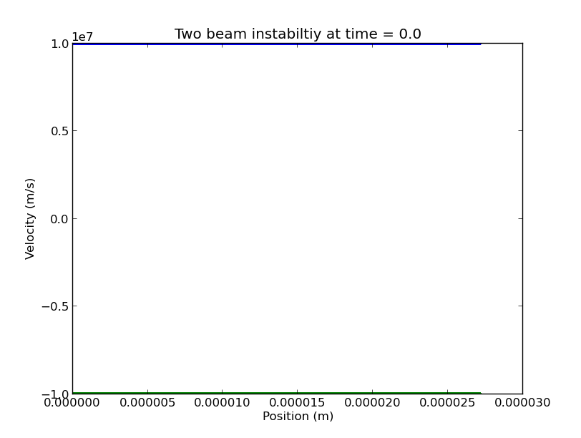

Below are phase space plots for the electrons at different times during the simulation. In these runs there were 4096 electrons in each beam over 1024 grid cells. The total length of the domain was 27.1 micrometers.

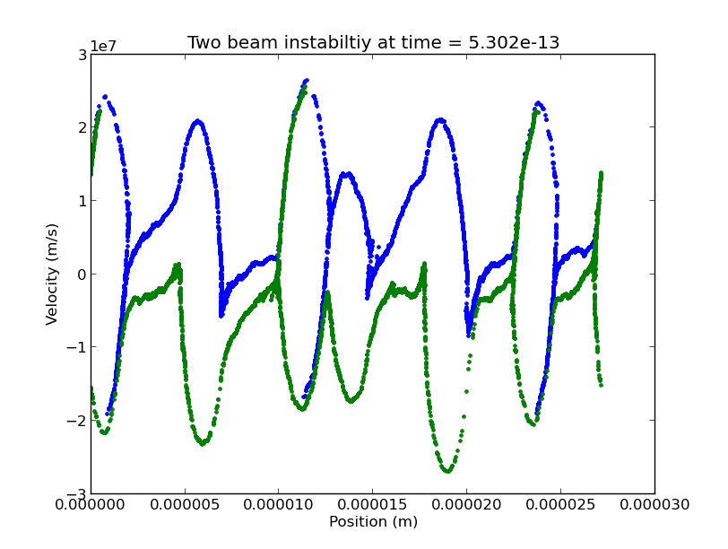
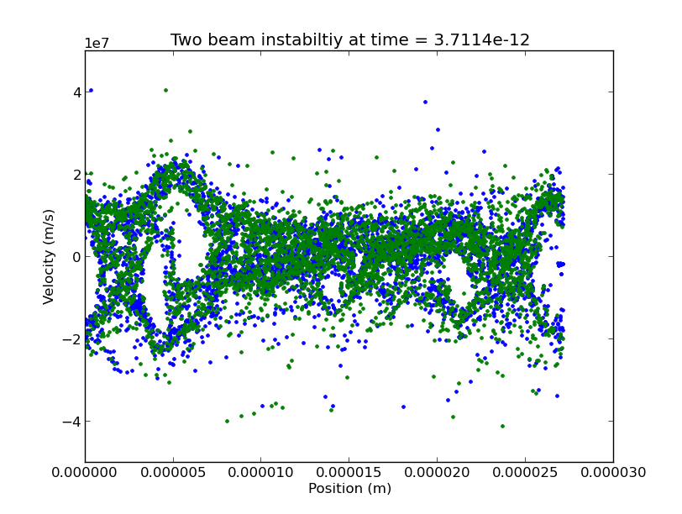

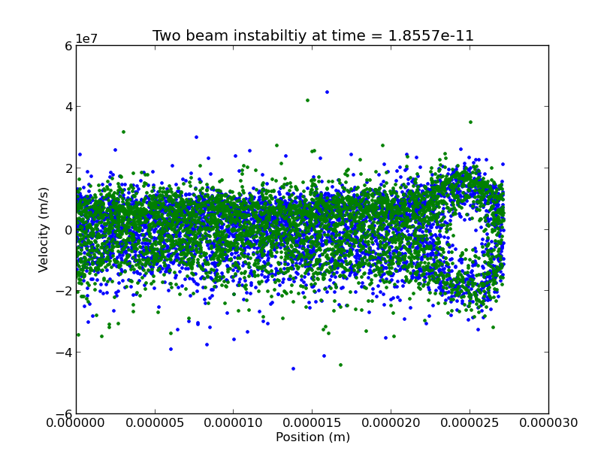

Large electric forces cause some of the particles to reverse direction forming vortices where the two beams interact with each other. Initially many phase-space vortices are observed and these eventually merge to leave one vertices. Some of the particles are accelerated to over three times their initial speed. A plot of the various energies provides more insight into what is going on .

Initially all the energy is contained in the drift energy of the particles, this is quickly converted into electric field energy which exponentially increases. As field energy increases particles are accelerated and decelerated causing the beam velocity width to increase. Field energy is quickly converted to thermal energy which then makes up the majority of the total energy in the system. The total energy in the system initially rises which is an unphysical result this may suggest the electric field energy is being over estimated. The growth is exponential so it is possible to measure the growth rate by plotting the natural log of field energy against time.

0
The red line shows the natural log of the electric field energy and the dashed line shows the maximum growth rate of the electric field predicted by theory. This depends on the plasma frequency. The growth of the field energy does not exceed this maximum limit.

Measured growth rate against calculated Plasma frequency, shows it is directly proportional.

Note to self
This code is stored in the two_stream folder. After running the simulation run ./peak before plotting energies.

Floating Case

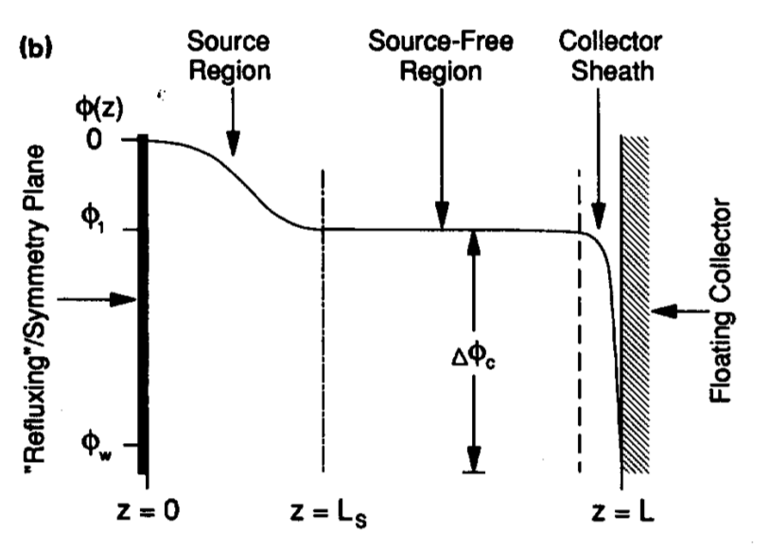

Electron-ion pairs injected into source region

dx = 1e-4
Injecting 5eV electrons and ions
Source region =0.5 *L
gridpoints = 400
injecting 20 particles per time step
Average debye length at end of simulation = 0.001033133 m
Floating potential fluctuates between -3.6 and -4V
Expect -5.2V based on the mass and injection temperature
Bohm criterion is not met for injection temperature but is for reduced temperature
Start with 125 particles per grid cell ends with roughly 2000 per cell

Grid values
- Obtained potential between -3.6V → -4V
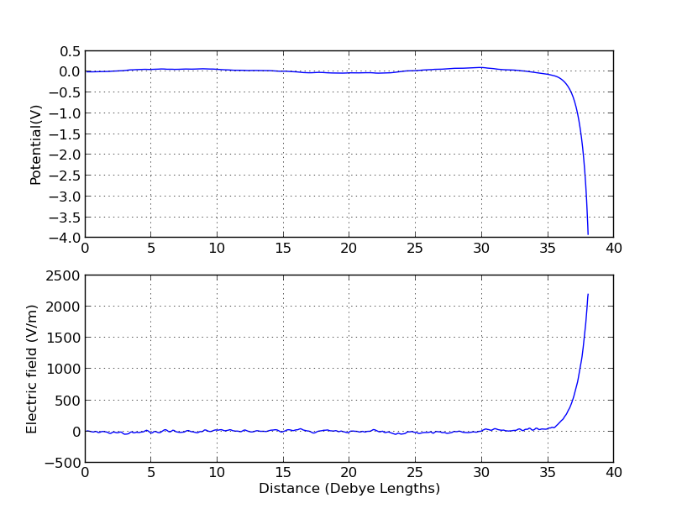
- Expect -5.2V based on an injection temperature of 5eV

Density Plot
- Positive sheath forms over last few Debye Lengths
- Little peak at start flattens out over time
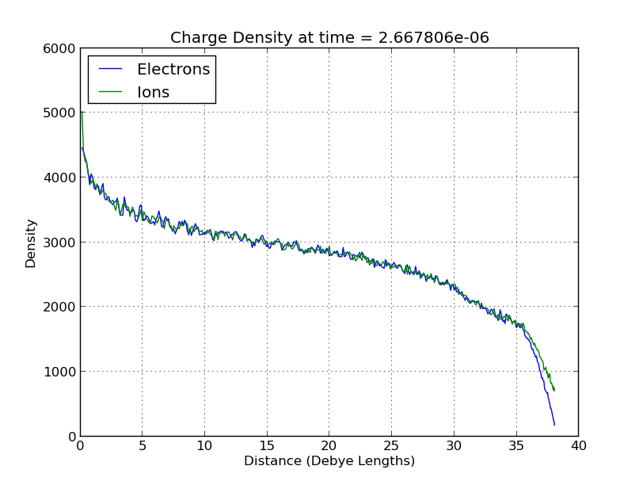

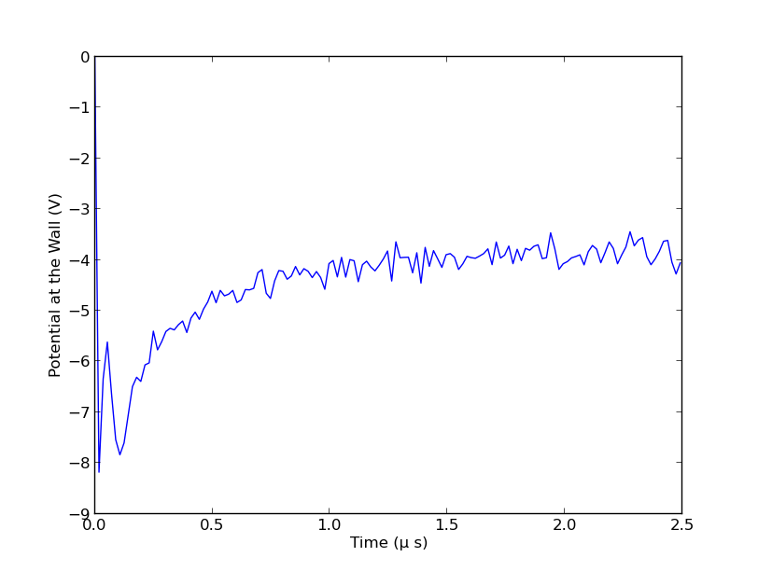
How does Floating potential vary with time

Velocity of particles

Ion velocity at end of simulation

- Ions enter the sheath with a velocity of 60000m/s
- Expect them to have a speed of 90000m/s with their reduced mass at an injection temperature of 5eV
- But the global temperature is now around 1.5eV
- Which would lower the Bohm velocity to 52000 in which case the criterion is met
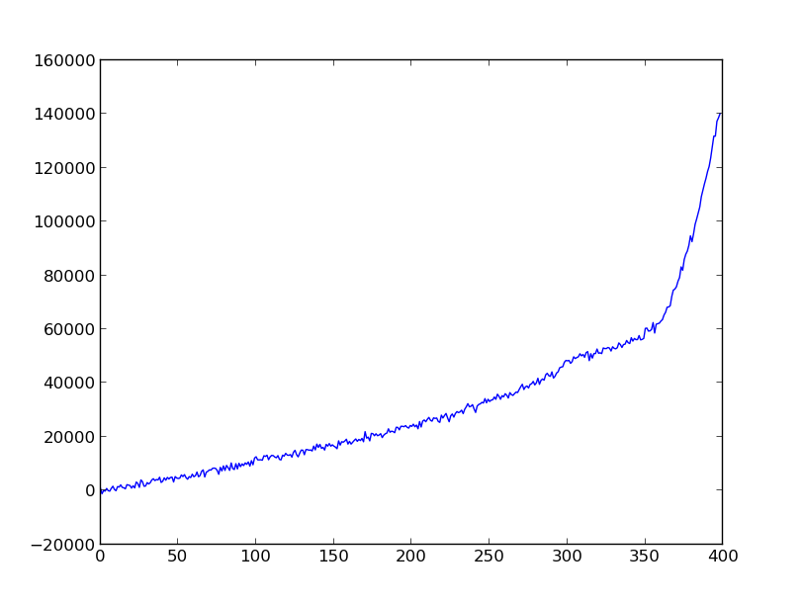

Electron velocity at end of simulation

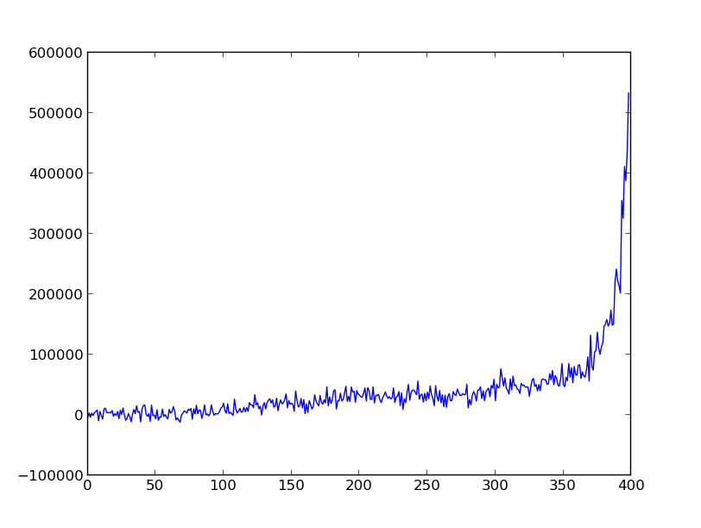
- Only the fastest electrons make it through to the sheath
- Electrons average velocity is the same as that of ions up to the sheath

Plot of both
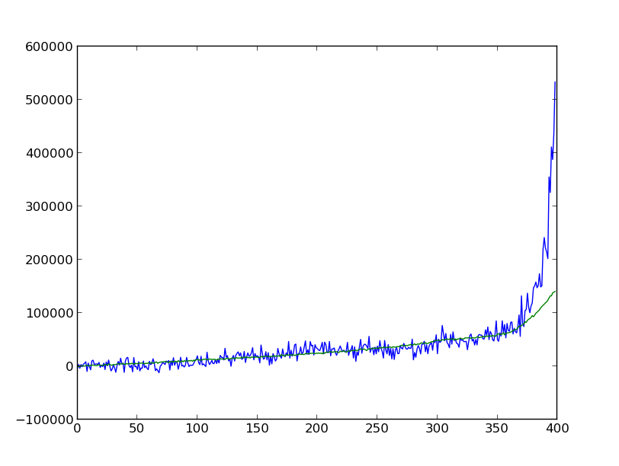

Temperature plots

Ions at end of simulation
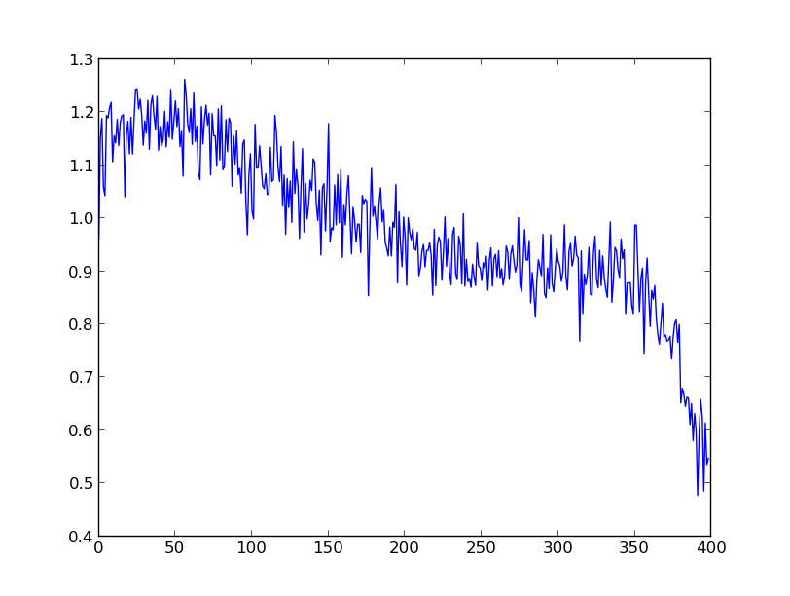
Electrons and end of simulation
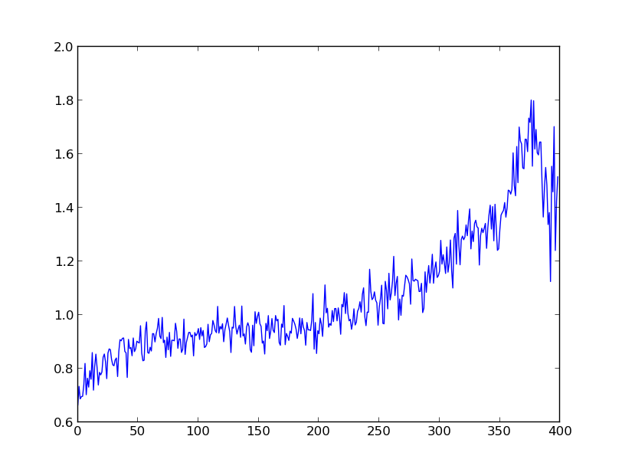

Are the distributions Maxwellian any more?

Electrons in the source region
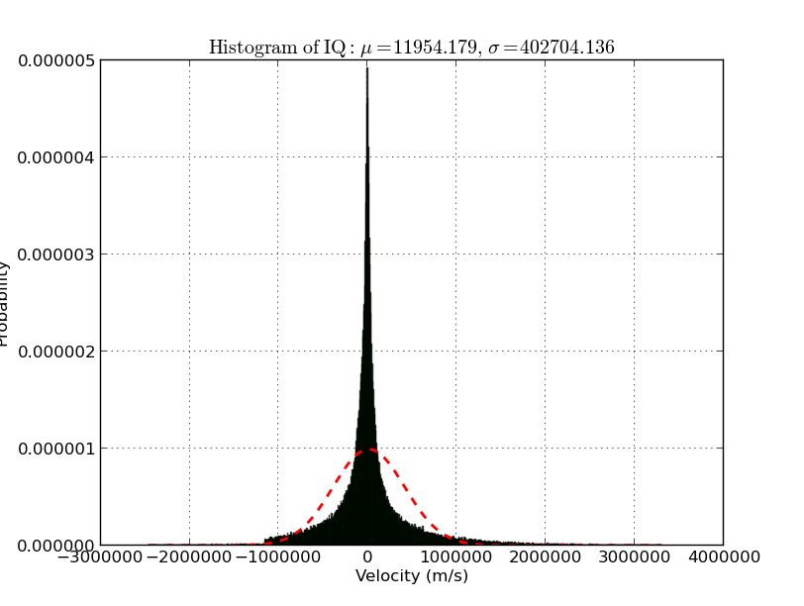
Ion in the source region

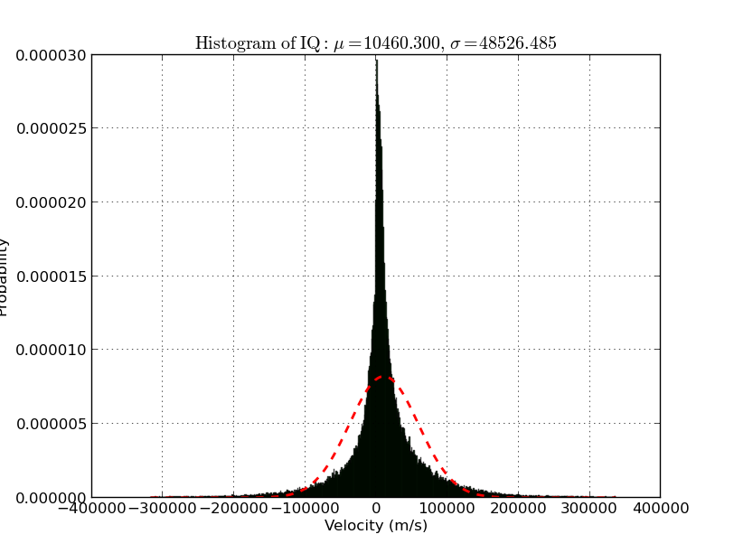

Electrons in the sheath
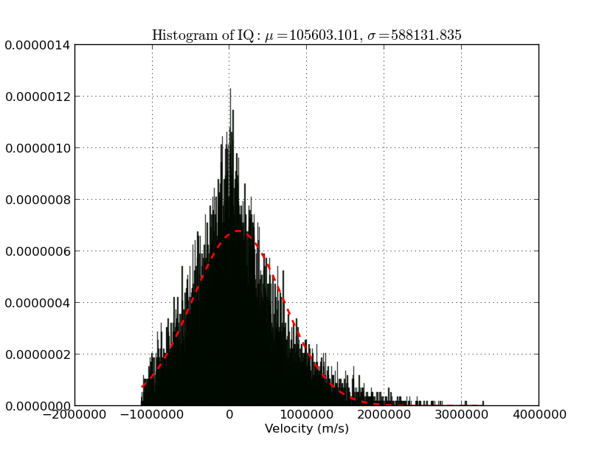

Ions in the sheath

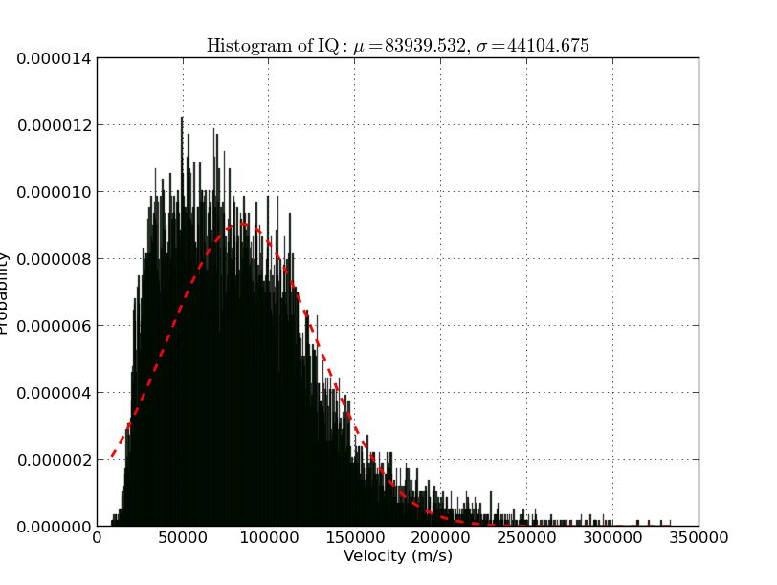

Summary
Sheath forms with expected length
Temperature drops as time goes on in simulation
As temperature is not well defined it is not known what floating potential or bohm criterion is
Need to investigate refluxing method

Name of code | Group/company website | Description
Vsim | Tech x http://www.txcorp.com/home/vsim/vsim-overview | Commercial but does have wall interactions and "allows you to hook in your own physics using Python, accelerated by performance libraries." . Has tools to modify the geometry
SCEPTIC3D | https://github.com/plasmasim/sceptic3D | Used to model the edge of magnetic devices and probes. Hybrid. Fully 3d 3v. Has charge- exchange collisions. Can download source code.
SPICE3 |  | 3D3V Cartesian PIC code.  Used to simulate sheath and magnetic pre-sheath of PFCs in tokamaks.  Has been used to simulate probes.  Nick colloborates with author.  Able to change magnetic inclination and magnitude

