Test Cases

Two-Stream Instablity

The first test of my code was the two-stream instability or more specifically the Buneman instablility. This is a specific case of the two stream instability that occurs when two electron beams are propagating in opposite directions inside a neutralising ,stationary ion background. A system such as this is known to be unstable, density perturbations in one beam are reinforced by forces acting on it due to a density perturbation in the other beam. The perturbation grows exponentially in time (reference Birdsall) but reaches a maximum once the beams have become fully thermalised.

The code is set up with periodic boundary conditions and only the electrons are followed. Electrons that exit on one side of the domain are re-injected into the other side with the velocity they had on exit. The number of electrons is the same in both beams and this is fixed from the beginning. No further particles are injected and none are killed. Positions of all the electrons are outputted every 5000 times steps while drift, thermal and electric field energy are calculated and outputted at every time step.

Initially we start with two cold beams moving with an equal and opposite uniform drift velocity. As the instability begins to take place we expect to see an exponentially increasing electric field form as particles bunch together. This field then acts on the particles to accelerate and decelerate them resulting in a widening of the velocity distribution. Initially all of the energy will be contained in the form of kinetic energy due to the drifting motion of the particles. This will then be converted to field and thermal energy as the instability progresses and so the drift energy will decrease.
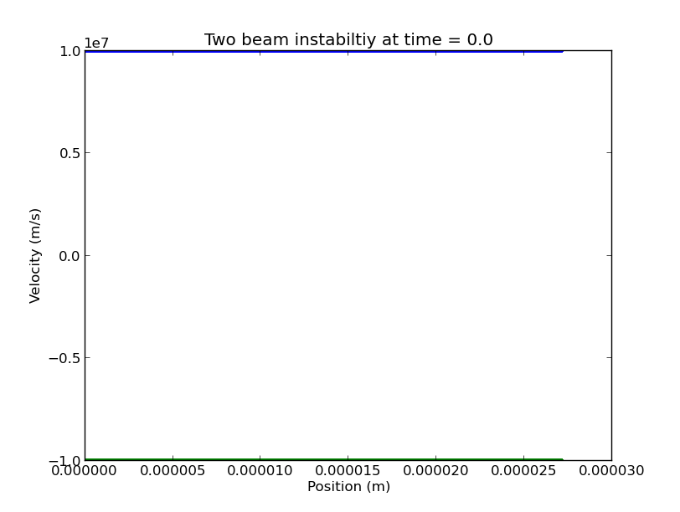

Below are phase space plots for the electrons at different times during the simulation. In these runs there were 4096 electrons in each beam over 1024 grid cells. The total length of the domain was 27.1 micrometers.

