Test Cases

Two-Stream Instablity

The first test of my code was the two-stream instability or more specifically the Buneman instablility. This is a specific case of the two stream instability that occurs when two electron beams are propagating in opposite directions inside a neutralising ,stationary ion background. A system such as this is known to be unstable, density perturbations in one beam are reinforced by forces acting on it due to a density perturbation in the other beam. The perturbation grows exponentially in time (reference Birdsall) but reaches a maximum once the beams have become fully thermalised.

The code is set up with periodic boundary conditions and only the electrons are followed. Electrons that exit on one side of the domain are re-injected into the other side with the velocity they had on exit. The number of electrons is the same in both beams and this is fixed from the beginning. No further particles are injected and none are killed. Positions of all the electrons are outputted every 5000 times steps while drift, thermal and electric field energy are calculated and outputted at every time step.

Initially we start with two cold beams moving with an equal and opposite uniform drift velocity. As the instability begins to take place we expect to see an exponentially increasing electric field form as particles bunch together that is proportional to the plasma frequency. This field then acts on the particles to accelerate and decelerate them resulting in a widening of the velocity distribution. Initially all of the energy will be contained in the form of kinetic energy due to the drifting motion of the particles. This will then be converted to field and thermal energy as the instability progresses and so the drift energy will decrease.
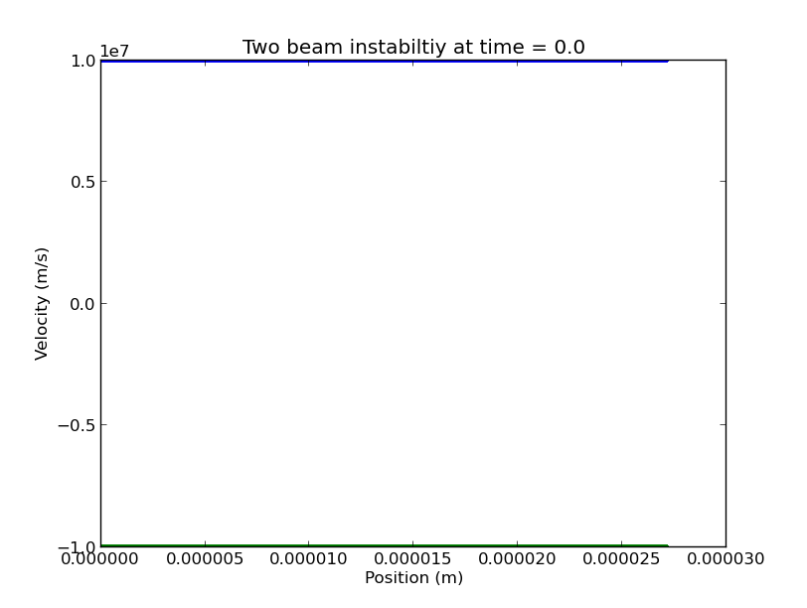

Below are phase space plots for the electrons at different times during the simulation. In these runs there were 4096 electrons in each beam over 1024 grid cells. The total length of the domain was 27.1 micrometers.

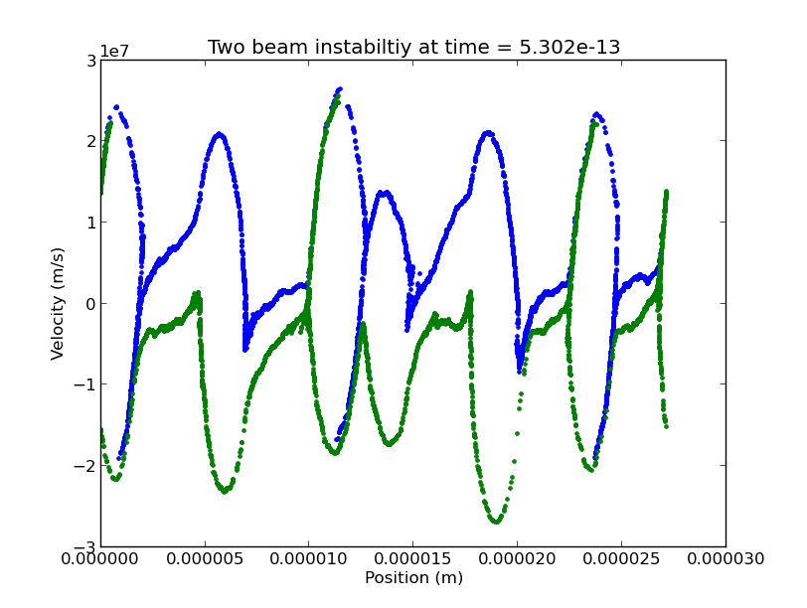
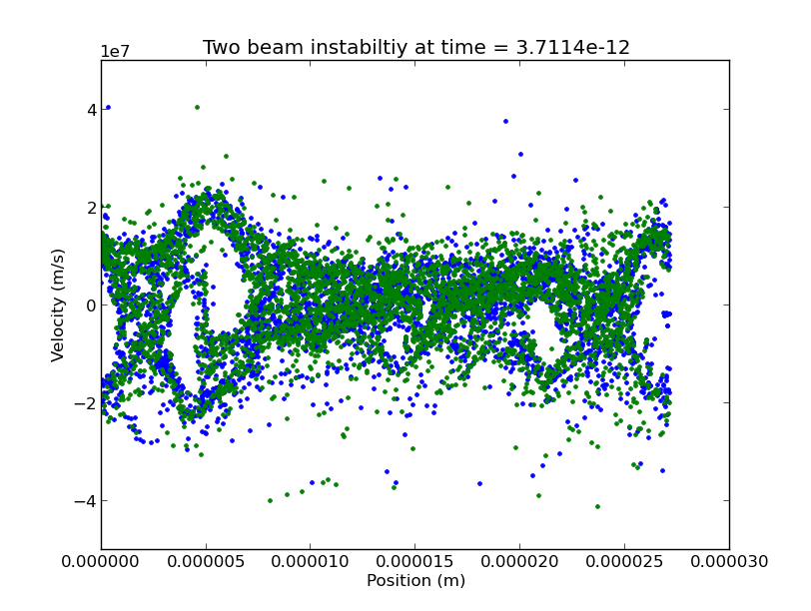

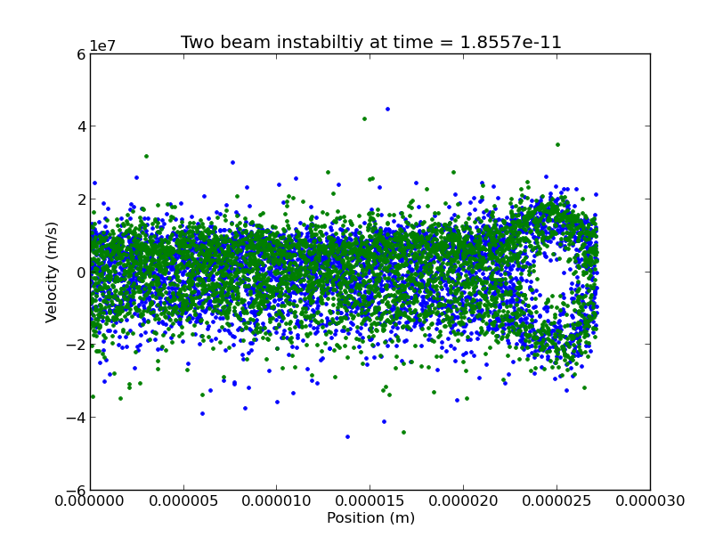

Large electric forces cause some of the particles to reverse direction forming vortices where the two beams interact with each other. Initially many phase-space vortices are observed and these eventually merge to leave one vertices. Some of the particles are accelerated to over three times their initial speed. A plot of the various energies provides more insight into what is going on .

Initially all the energy is contained in the drift energy of the particles, this is quickly converted into electric field energy which exponentially increases. As field energy increases particles are accelerated and decelerated causing the beam velocity width to increase. Field energy is quickly converted to thermal energy which then makes up the majority of the total energy in the system. The total energy in the system initially rises which is an unphysical result this may suggest the electric field energy is being over estimated. The growth is exponential so it is possible to measure the growth rate by plotting the natural log of field energy against time.

The red line shows the natural log of the electric field energy and the dashed line shows the maximum growth rate of the electric field predicted by theory. This depends on the plasma frequency. The growth of the field energy does not exceed this maximum limit.

Measured growth rate against calculated Plasma frequency, shows it is directly proportional.

Note to self
This code is stored in the two_stream folder. After running the simulation run ./peak before plotting energies.

Plasma Frequency

The code has periodic boundary conditions, equal numbers of ions and electrons are injected at the same position and the electrons are then perturbed slightly.

It is expected that the electrons will oscillate about their equilibrium position at the plasma frequency.

As a quick test injected electrons and ions at same position with no velocity. There should be no forces so nothing should move and this was observed.

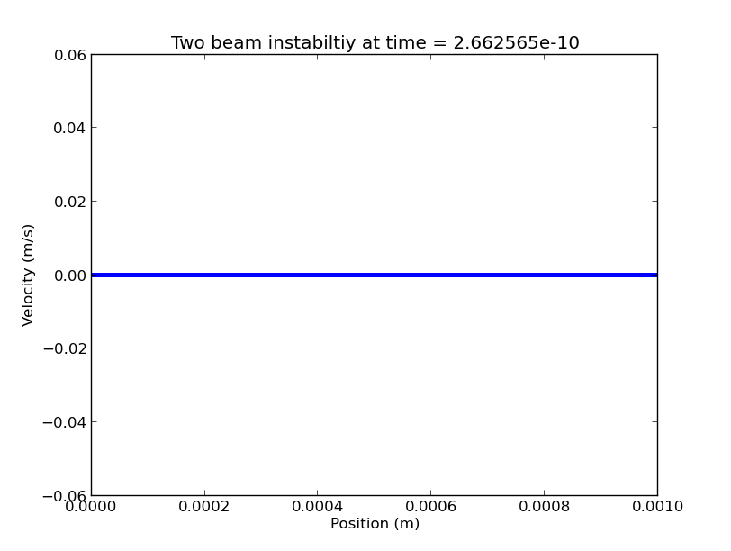

Now injecting at same position with zero velocity but will then move the electrons by 0.1 of a grid cell so all electrons are displaced from equilibrium position. I am tracking the motion of two electrons to see what happens. Time step is 1/w_p

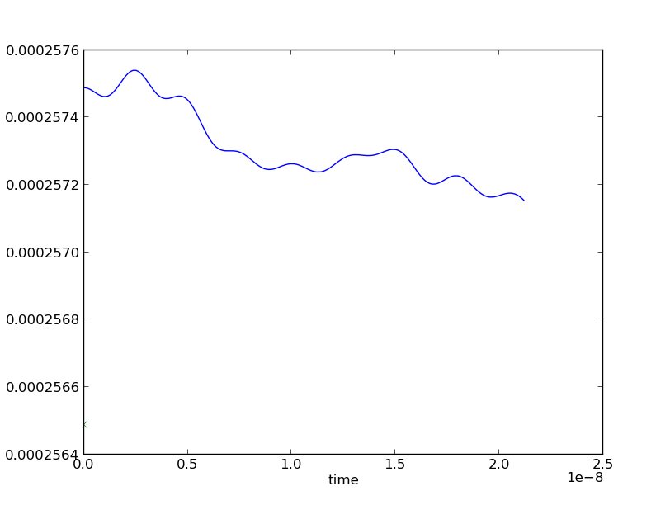
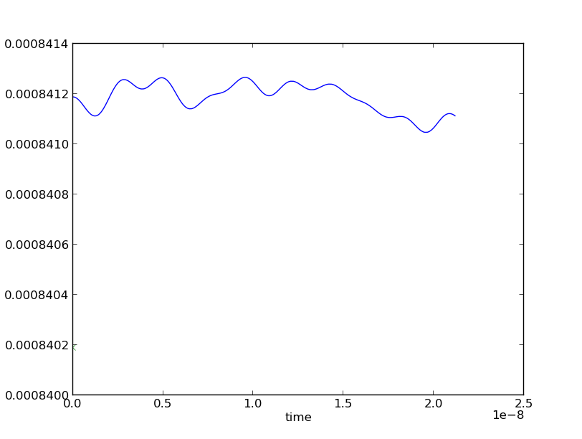

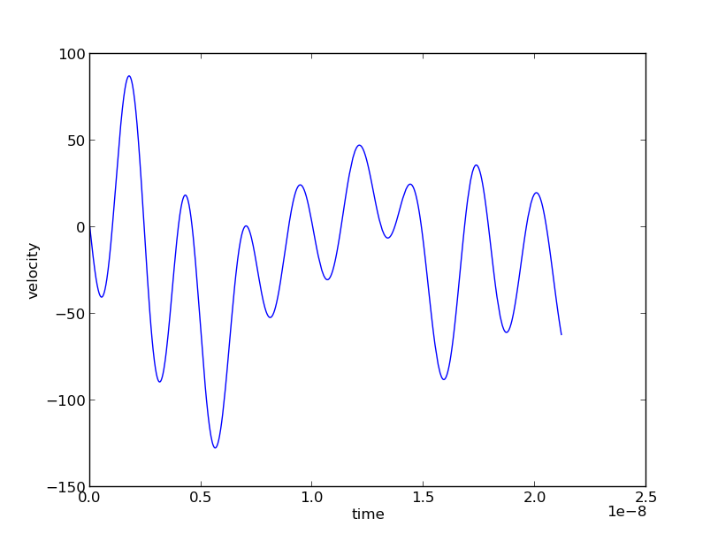

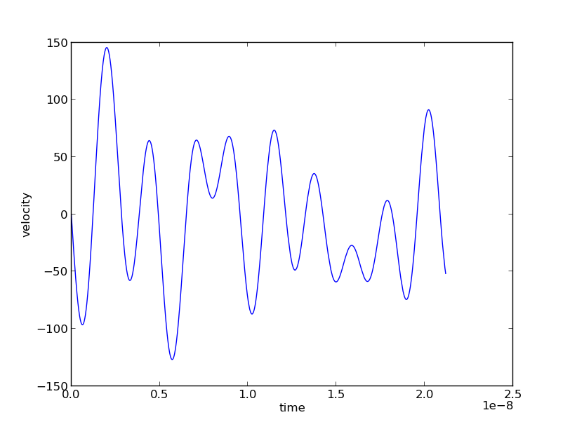

Could try just displacing one and tracking it?

Dear Sam,
Than you. Your question is correct...
I give you a simple example: let us imagine that you want to inject 1D particles from the wall and you know the flux density. Then the number of particles you inject is proportional to the wall surface area. So in that way you need the surface area in 1D too. You need it for calculation of densities, fluxes, surface charge (which I guess comes in eq. (64)) and so on. Of course you can choose it almost freely, but it has to be same for all routines in the code. Why "almost" - because this area will define the number of simulated particles. Some 1D codes simply use area = 1 and control the number of simulated particles via explicitly specifying the number of real particles per simulation particles. In my codes I use the both parameters...
Best regards,
David

Debye Length Test

Periodic boundary conditions. Start with a quasi-neutral plasma. Place a test charge in the middle. Should observe a sheath form either side of it.

Floating wall potential

