ECA5403-ELECTROMAGNETIC FILEDS AND WAVES
Hemavathi .M
192512222
CO2-9
EXPERIMENT 9
AIM:
To implement magnetic-field boundary conditions between two media and determine the relative permeability of the unknown medium.

Test case (i) Magnetic Boundary Conditions and Determination of the Relative Permeability

Program:
clc;
clear;
close all;
%% Magnetic-Field Boundary Conditions between Two Media mu0 = 4*pi*1e-7;
% H/m % Input data mur1 = input('Enter relative permeability of medium 1: ');
H1t = input('Enter tangential H-field H1t (A/m): ');
B1n = input('Enter normal flux density B1n (T): ');
H2n_meas = input('Enter measured/assigned normal H-field H2n (A/m): ');
mur2_ref = input('Enter reference relative permeability of medium 2: ');
% Permeability of the two media mu1 = mu0*mur1;
mu2_ref = mu0*mur2_ref;
% Boundary conditions for zero surface current H2t = H1t;
B2n = B1n;
% Determine relative permeability from measured H2n mur2_calc = B2n/(mu0*H2n_meas); % Theoretical normal H-field using the reference permeability H2n_theory = B2n/mu2_ref; % Percentage deviation dev = abs(mur2_calc-mur2_ref)/abs(mur2_ref)*100;
fprintf('\n--- Magnetic Boundary Condition Results ---\n');
fprintf('H2t (theoretical) = %.6f A/m\n',H2t);
fprintf('B2n (theoretical) = %.6e T\n',B2n);
fprintf('H2n (theoretical) = %.6f A/m\n',H2n_theory);
fprintf('Calculated mur2 = %.6f\n',mur2_calc);
fprintf('Reference mur2 = %.6f\n',mur2_ref);
fprintf('Percentage deviation = %.4f %%\n',dev);
% Parameter sweep: effect of relative permeability on normal H-field mur = linspace(1,10,100);
Hn = B1n./(mu0*mur);
figure;
plot(mur,Hn,'LineWidth',2);
grid on;
xlabel('Relative permeability, \mu_r');
ylabel('Normal magnetic field H_n (A/m)');
title('Normal H-field versus Relative Permeability');
% Verification of tangential H continuity and normal B continuity fprintf('\nBoundary verification for zero surface current:\n');
fprintf('H1t = %.6f A/m, H2t = %.6f A/m\n',H1t,H2t);
fprintf('B1n = %.6e T, B2n = %.6e T\n',B1n,B2n);
OUTPUT:
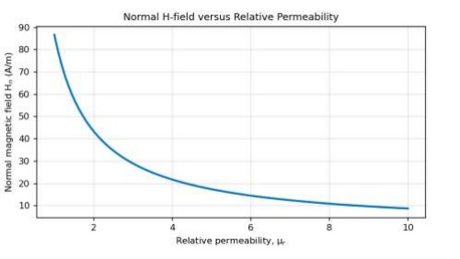

Test case (ii) Field Components and Refraction Angle at the Interface of Two Magnetic Media
program:
clc;
clear;
mu0 = 4*pi*1e-7;
H1 = input('Enter magnitude of H1 in medium 1 (A/m): ');
th1 = input('Enter angle of H1 with the normal (deg): ');
mur1 = input('Enter relative permeability of medium 1: ');
mur2 = input('Enter relative permeability of medium 2: ');
H1n = H1*cosd(th1);
% normal component in medium 1 H1t = H1*sind(th1);
% tangential component in medium 1 B1n = mu0*mur1*H1n;
% normal flux density in medium 1 H2t = H1t;
% tangential H is continuous (Ks = 0) B2n = B1n;
% normal B is continuous H2n = B2n/(mu0*mur2);
% normal H in medium 2 H2 = sqrt(H2n^2 + H2t^2);
th2 = atand(H2t/H2n);
fprintf('H1n = %.2f A/m, H1t = %.2f A/m\n', H1n, H1t);
fprintf('B1n = %.4e T\n', B1n);
fprintf('H2t = %.2f A/m, B2n = %.4e T\n', H2t, B2n);
fprintf('H2n = %.2f A/m, |H2| = %.2f A/m\n', H2n, H2);
fprintf('Refraction angle theta2 = %.2f deg\n', th2);
figure;
plot([0 0],[-80 80],'k','LineWidth',2);
hold on;
quiver(-H1n,-H1t,H1n,H1t,0,'b','LineWidth',2);
quiver(0,0,H2n,H2t,0,'r','LineWidth',2);
axis equal;
grid on;
xlabel('Normal direction (A/m)');
ylabel('Tangential direction (A/m)');
title('Magnetic field at the interface of two media');

OUTPUT:
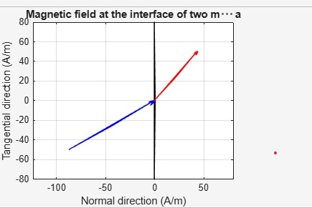
Test case (iii) Variation of the Refraction Angle with the Angle of Incidence for Different Permeabilities:
Program:
clc;
clear;
th1 = linspace(0,89,179);
mur1 = 1; mur2 = [2 5 10];
figure;
hold on;
for k = 1:3 th2 = atand((mur2(k)/mur1)*tand(th1));
% tan(th2) = (mur2/mur1)*tan(th1) plot(th1,th2,'LineWidth',2);
end plot(th1,th1,'k--');
% mur2 = mur1 (no change of direction) grid on;
xlabel('Angle in medium 1, \theta_1 (deg)');
ylabel('Angle in medium 2, \theta_2 (deg)');
legend('mur2 = 2','mur2 = 5','mur2 = 10','mur2 = 1','Location','southeast');
title('Refraction of the magnetic field at the interface');

OUTPUT:
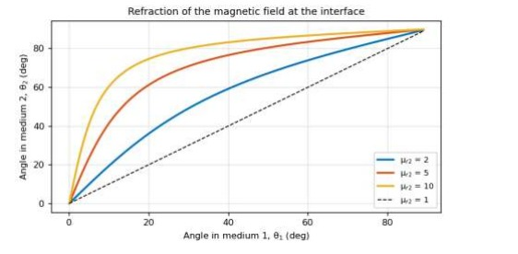

Test case (iv) Effect of the Relative Permeability on the Field Components in Medium 2:
Program:
clc;
clear;
mu0 = 4*pi*1e-7; H1 = 100;
th1 = 30;
mur1 = 1;
H1n = H1*cosd(th1);
H1t = H1*sind(th1);
B1n = mu0*mur1*H1n;
mur2 = linspace(1,10,100);
H2n = B1n./(mu0*mur2);
% normal H in medium 2 H2t = H1t*ones(size(mur2));
% tangential H (continuous) H2 = sqrt(H2n.^2 + H2t.^2);
B2n = mu0*mur2.*H2n; % normal B (continuous) subplot(1,2,1); plot(mur2,H2n,mur2,H2t,mur2,H2,'LineWidth',2);
grid on; xlabel('Relative permeability mur2');
ylabel('Magnetic field (A/m)');
legend('H2n','H2t','|H2|'); subplot(1,2,2);
plot(mur2,B2n,'LineWidth',2);
grid on;
ylim([0 2e-4]);
xlabel('Relative permeability mur2');
ylabel('B2n (T)');
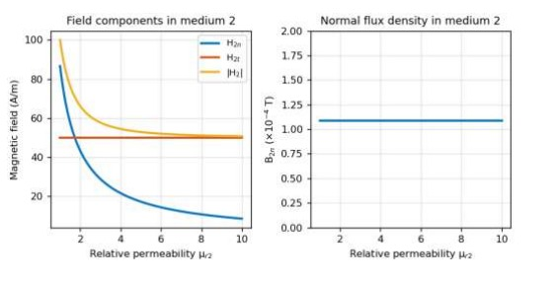

Result :
Thus the Implementation of Magnetic-Field Boundary Conditions between Two Dielectric Media and Determination of Relative Permeability using MATLAB successfully.

LABORATORY PERFORMANCE ASSESSMENT RUBRICS

Objective | Assessment Criterion | Excellent – 4 | Good – 3 | Satisfactory – 2 | Needs Improvement – 1 | Weighting | Marks given | Marks obtained
Identify magnetic media and boundary orientation | Identify magnetic media and boundary orientation | Correctly identifies isolatedsphere radius or inner/outer radii and medium permittivity | Setup is correct with minor omissio ns. | Needs help identifying components or assumptions. | Uses incorrect interface definitions | 25 | 2.5
Apply magnetic boundary relations. | Apply magnetic boundary relations | Correctly applies continuity of normal B and the tangential H relation. | Relation s are applied with minor errors. | Partly correct application requires guidance. | Boundary relations are incorrect. | 25 | 2.5
Determine permeabili ty and validate fields | Determine permeabilit y and validate fields | Calculates required quantities and verifies the boundary relations consistently. | Results are mostly correct with minor discrepa ncies. | Validation is incomplete. | Results are invalid or unverified. | 30 | 3
Explain and document findings | Explain and document findings | Explains magnetic-field behaviour and records assumptions, units and conclusion. | Docume ntation is clear with minor omissio ns. | Interpretation or documentatio n is incomplete. | Cannot explain or report results. | 20 | 2
TOTAL |  |  |  |  |  | 100 | 10

