Network Player
Design & Test Plan

Dan LaGesse & Ron Pyka

- High level design diagram and description

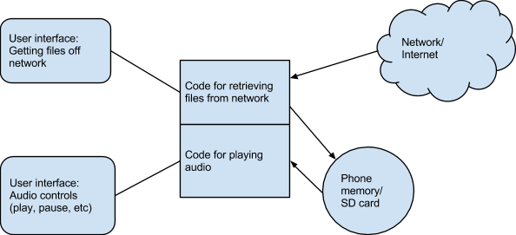

There are two main parts to the user interface- one to control the play of music, view the queue, etc. and the other to browse the network and queue files. These both connect to the main code, which handles not only retrieving and queueing the actual files, but also playing the audio.

- Dependency analysis (map service? etc)
This application depends on the WiFi manager, media service, and the jcifs library. This also requires permissions for internet, writing to external storage, as well as wake lock.

- Test cases: distinguish Must Have and Optional
Must have:
-ability to play, pause, stop, fast-forward, and rewind music
-have a queue of songs to play, go through them one at a time
-ability to skip to the next track in the queue (past tracks are dropped from queue)
-ability to browse network to find music to queue

Optional:
-browse local device for songs
-ability to save/load playlists

- Metrix table

Test Case | Requirement | Works?
-Ability to browse the network to find music to queue  -Have a queue of songs and be able to go through them one at a time | -Browsing Files  -Queuing Files | Yes
-Ability to play, pause, fast-forward and rewind music  -Ability to skip to the next track in the queue | -Playing files | Yes

