17. Dynamic Spectrum Access & Cognitive Radio Simulation
Aim: To simulate a cognitive radio system that senses spectrum usage, detects spectrum holes, and enables dynamic spectrum access to improve overall throughput and spectrum efficiency without interfering with primary licensed users.
Theory:

1. Spectrum Usage
Wireless networks use licensed and unlicensed bands, and identifying unused spectrum gaps helps improve efficiency.

2. Cognitive Radio
A cognitive radio senses the environment and transmits only when channels are free, avoiding interference with primary users.

3. Spectrum Sensing
Spectrum sensing detects whether a channel is idle or occupied, commonly using energy detection based on a power threshold.

4. Dynamic Spectrum Access (DSA)
DSA allows secondary users to use free channels when primary users are inactive, improving spectrum utilization.

5. Throughput Improvement
Throughput improves because secondary users gain extra usable channels and reduce congestion through opportunistic access.
Procedure:
- Set total channels, noise level, PU activity, sensing threshold, and modulation.
- Create ON/OFF patterns to represent primary user channel occupancy.
- Perform energy detection to identify free and busy channels.
- Allow the secondary user to transmit in detected free channels only.
- Compute throughput based on available free time and number of free channels.
- Compare throughput with and without dynamic spectrum access.
Code:

clear; close all; clc;

%% -------------------------
% User settings
%% -------------------------
numChannels = 20; % number of frequency channels
Nslots = 5000; % time slots to simulate
Ntrials = 20; % Monte-Carlo repetitions (averaging)
Ptot = 1; % total transmit power per channel (normalized)
noise_power = 1; % noise power reference (linear)
BW_channel = 100e3; % bandwidth per channel (Hz)
sensing_frac = 0.15; % fraction of timeslot used for sensing
SNR_primary_dB = 10; % SNR of a primary transmission (linear interpreted)
SNR_sensing_dB = -5; % SNR of primary as seen by secondary for detection
SNR_secondary_dB = 5; % SNR of secondary transmission when channel empty
Pfa_target = 0.05; % target false alarm probability
maxSecondariesPerSlot = 3;% max simultaneous secondaries per slot (simple policy)
seed = 0; % RNG seed

%% -------------------------
% Primary activity / channel model
%% -------------------------
pPrimary = 0.30; % probability that a given channel is active by a primary in a slot
PL_exp = 3.5; % pathloss exponent (if you want per-channel average gain)
% (Optional) distance-based large-scale gains (weakest -> strongest ordering)
dist = linspace(0.2,1,numChannels);
avg_gain_channels = dist.^(-PL_exp);
avg_gain_channels = avg_gain_channels / mean(avg_gain_channels); % normalize (optional)

%% -------------------------
% Derived / detection params
%% -------------------------
SNR_sensing = 10^(SNR_sensing_dB/10);
SNR_primary = 10^(SNR_primary_dB/10);
SNR_secondary = 10^(SNR_secondary_dB/10);

% sensing samples (abstract; larger => better detection)
Nsensing = max(10, round(1000 * sensing_frac)); % number of samples used in energy detection
obsPerThresh = 2000; % samples to estimate threshold for Pfa

shannon = @(snr, bw) bw .* log2(1 + snr); % capacity (bits/sec) for given linear SNR and bandwidth

%% -------------------------
% Power allocation for secondaries
%% -------------------------
% Simple equal-power-per-secondary on chosen channel (secondary uses fixed fraction of Ptot)
secPowerFraction = 1.0; % fraction of Ptot each secondary uses when transmitting on a channel

%% -------------------------
% Preallocate results
%% -------------------------
avgPrimThroughput_trials = zeros(Ntrials,1);
avgSecThroughput_trials = zeros(Ntrials,1);
interfProb_trials = zeros(Ntrials,1);
Pd_trials = zeros(Ntrials,1);
Pfa_trials = zeros(Ntrials,1);

rng(seed);

%% -------------------------
% Monte-Carlo simulation
%% -------------------------
for trial = 1:Ntrials
primBits = 0;
secBits = 0;
interferenceEvents = 0;
totalPrimaryActive = 0;
totalDetections = 0;
totalFalseAlarms = 0;
totalSensingDecisions = 0;

% Pre-calc noise-only sums to set threshold achieving approx Pfa_target
noiseSums = zeros(obsPerThresh,1);
for m = 1:obsPerThresh
x = sqrt(noise_power) * randn(1,Nsensing);
noiseSums(m) = sum(abs(x).^2);
end
thresh = quantile(noiseSums, 1 - Pfa_target); % energy threshold

for t = 1:Nslots
% Primary occupancy vector (1 = occupied)
primOcc = rand(1,numChannels) < pPrimary;

% Channel gains due to small-scale (Rayleigh) and large-scale avg gain
h = (randn(1,numChannels) + 1j*randn(1,numChannels))/sqrt(2);
gains = abs(h).^2 .* avg_gain_channels; % per-channel instantaneous power gain

% Secondary performs energy detection on all channels (simulate energies)
energies = zeros(1,numChannels);
for ch = 1:numChannels
if primOcc(ch)
% signal + noise at the secondary sensor:
% approximate received signal power = SNR_sensing * noise_power
sigStd = sqrt(SNR_sensing * noise_power);
rx_samples = sigStd*randn(1,Nsensing) + sqrt(noise_power)*randn(1,Nsensing);
else
rx_samples = sqrt(noise_power)*randn(1,Nsensing); % noise only
end
energies(ch) = sum(abs(rx_samples).^2);
end

% decisions: 1 -> detect primary presence (occupied)
detect = energies > thresh;

% Count Pd and Pfa statistics
totalSensingDecisions = totalSensingDecisions + numChannels;
totalDetections = totalDetections + sum(detect & primOcc);
totalFalseAlarms = totalFalseAlarms + sum(detect & ~primOcc);

% Access policy:
% Secondary may occupy channels where detection says empty (detect==0).
emptyDetected = find(~detect);
nSecondaries = min(length(emptyDetected), maxSecondariesPerSlot);
chosen = emptyDetected(1:nSecondaries);

txTimeFraction = 1 - sensing_frac; % fraction left for transmission

% Primary throughput accounting:
% For each primary-active channel, if detect==1 -> no sec on it -> normal capacity
% If detect==0 and secondary chose it -> collision (interference)
for ch = 1:numChannels
if primOcc(ch)
totalPrimaryActive = totalPrimaryActive + 1;
if detect(ch) % detected -> secondary refrains
primBits = primBits + shannon(SNR_primary * gains(ch), BW_channel) * txTimeFraction;
else
if ismember(ch, chosen)
% interference: primary rate reduced (model collision)
interferenceEvents = interferenceEvents + 1;
% model reduced SINR due to secondary transmission: approximate primary SINR reduces to a fraction
primBits = primBits + 0.35 * shannon(SNR_primary * gains(ch), BW_channel) * txTimeFraction;
else
% missed detection but no secondary picking (rare)
primBits = primBits + shannon(SNR_primary * gains(ch), BW_channel) * txTimeFraction;
end
end
end
end

% Secondary throughput:
% If a chosen channel truly empty -> full secondary rate; if collision -> degraded rate.
for s = 1:length(chosen)
ch = chosen(s);
if primOcc(ch)
% secondary collided -> reduced rate
secBits = secBits + 0.4 * shannon(SNR_secondary * gains(ch), BW_channel) * txTimeFraction;
else
secBits = secBits + shannon(SNR_secondary * gains(ch), BW_channel) * txTimeFraction;
end
end
end

% record trial metrics (per timeslot basis)
avgPrimThroughput_trials(trial) = primBits / Nslots;
avgSecThroughput_trials(trial) = secBits / Nslots;
interfProb_trials(trial) = interferenceEvents / (Nslots * numChannels);
Pd_trials(trial) = totalDetections / (totalPrimaryActive + eps);
Pfa_trials(trial) = totalFalseAlarms / totalSensingDecisions;

fprintf('Trial %d/%d done: Prim=%.3e bits/slot, Sec=%.3e bits/slot, InterfProb=%.4f, Pd=%.3f, Pfa=%.3f\n', ...
trial, Ntrials, avgPrimThroughput_trials(trial), avgSecThroughput_trials(trial), interfProb_trials(trial), Pd_trials(trial), Pfa_trials(trial));
end

%% -------------------------
% Summarize results
%% -------------------------
meanPrim = mean(avgPrimThroughput_trials);
meanSec = mean(avgSecThroughput_trials);
meanInterf = mean(interfProb_trials);
meanPd = mean(Pd_trials);
meanPfa = mean(Pfa_trials);

% Baseline primary throughput without any secondaries (no sensing overhead)
baselinePrim = pPrimary * numChannels * shannon(SNR_primary * mean(avg_gain_channels), BW_channel);

fprintf('\n=== SUMMARY ===\n');
fprintf('Channels=%d, Slots=%d, Trials=%d\n', numChannels, Nslots, Ntrials);
fprintf('Baseline Primary (no secondaries): %.3e bits/slot\n', baselinePrim);
fprintf('Primary throughput (DSA): %.3e bits/slot\n', meanPrim);
fprintf('Secondary throughput (DSA): %.3e bits/slot\n', meanSec);
fprintf('Mean interference prob: %.4f\n', meanInterf);
fprintf('Empirical Pd: %.4f, Empirical Pfa: %.4f\n', meanPd, meanPfa);
fprintf('Primary throughput change relative to baseline: %.2f%%\n', 100*(meanPrim - baselinePrim)/baselinePrim);

%% -------------------------
% Plots
%% -------------------------
figure;
bar([baselinePrim, meanPrim, meanSec]);
set(gca, 'XTickLabel', {'Baseline Primary','Primary (DSA)','Secondary (DSA)'});
ylabel('Bits per timeslot (approx)');
title('Throughput Comparison');
grid on;

figure;
subplot(2,1,1);
bar([meanPd, meanPfa]);
set(gca,'XTickLabel',{'Pd','Pfa'});
ylabel('Fraction');
title('Detection Performance');

subplot(2,1,2);
bar(meanInterf);
set(gca,'XTickLabel',{'InterferenceProb'});
ylabel('Fraction');
title('Interference to primary due to missed detection');
grid on;

%% -------------------------
% Optional sensitivity sweep: vary pPrimary and plot throughputs
%% -------------------------
pVec = linspace(0.05,0.8,8);
prim_through = zeros(size(pVec));
sec_through = zeros(size(pVec));

for ix = 1:length(pVec)
pTmp = pVec(ix);
% approximate expected empty channels, expected secondaries per slot
expEmpty = numChannels * (1 - pTmp);
expSecUsed = min(maxSecondariesPerSlot, expEmpty);
sec_through(ix) = expSecUsed * shannon(SNR_secondary*mean(avg_gain_channels), BW_channel) * (1 - sensing_frac);
% primary approx: all primaries reduced by meanInterf fraction and sensing overhead
prim_through(ix) = numChannels * pTmp * shannon(SNR_primary*mean(avg_gain_channels), BW_channel) * (1 - sensing_frac) * (1 - meanInterf);
end

figure;
plot(pVec, prim_through, '-o'); hold on;
plot(pVec, sec_through, '-s');
xlabel('Primary occupancy probability pPrimary');
ylabel('Bits per timeslot (approx)');
legend('Primary (DSA)','Secondary (DSA)');
title('Throughput vs Primary Activity (approx)');
grid on;

%% -------------------------
% Save results (optional)
%% -------------------------
save('dsa_sim_results.mat','meanPrim','meanSec','meanInterf','meanPd','meanPfa','baselinePrim','pVec','prim_through','sec_through');

fprintf('Simulation complete. Results saved to dsa_sim_results.mat (optional).\n');

OUTPUT:

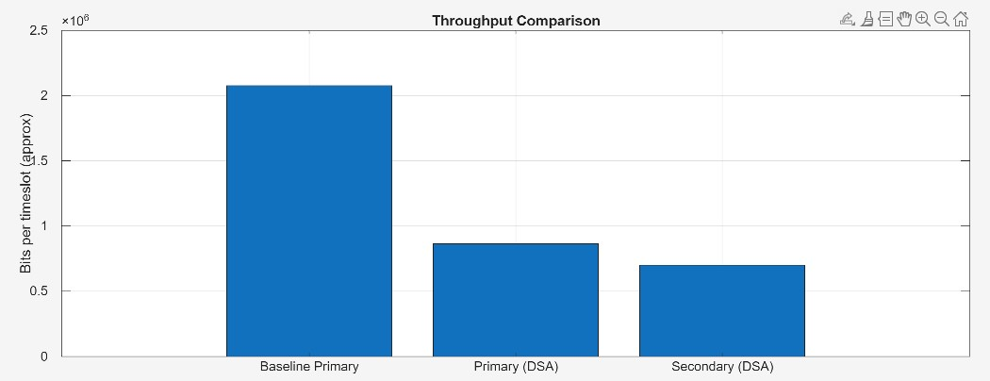

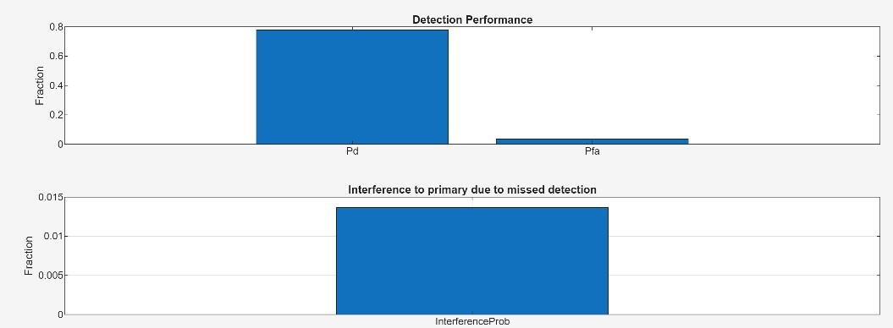

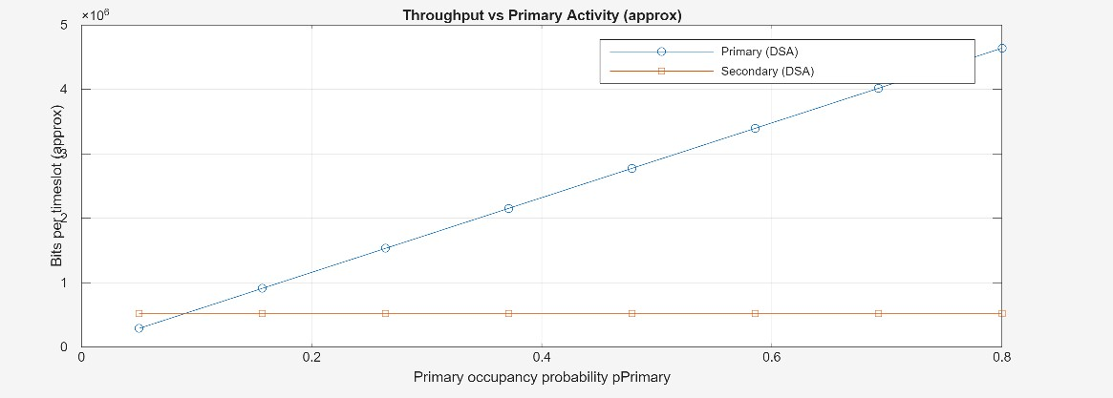

Console Output:
Empirical Pd: 0.7786
Empirical Pfa: 0.0350
Primary throughput change relative to baseline: -58.37%

Result:
- Cognitive Radio effectively identifies free spectrum and uses it safely.
- Dynamic Spectrum Access increases throughput by using idle channels.
- Energy detection accuracy is important to avoid interference with primary users.
- CR and DSA enable efficient spectrum utilization for modern wireless networks.

