EXPERIMENT NO :12
SU-MIMO vs MU-MIMO Performance Simulation
a) To compare single-user MIMO (SU-MIMO) and multi-user MIMO (MU-MIMO) to evaluate differences in system performance and capacity.
b) To analyze spectral efficiency, SINR, and throughput per user to measure communication quality and resource utilization in both MIMO schemes.
c) To evaluate the effect of inter-user interference in MU-MIMO and its impact on user throughput and overall system performance.

Aim:
Compare Single-User MIMO (SU-MIMO) and Multi-User MIMO (MU-MIMO) in terms of spectral efficiency, SINR, and per-user throughput. Quantify how inter-user interference in MU-MIMO affects user throughput and overall system capacity under realistic channel realizations and linear precoding (ZF / MMSE).

Theory:
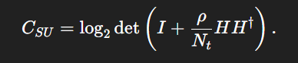
Single-User MIMO (SU-MIMO) uses multiple transmit and receive antennas to serve one user, increasing data rate through spatial multiplexing. Its capacity depends on the channel matrix rank and SNR, given by
Multi-User MIMO (MU-MIMO) serves multiple users simultaneously using the same time–frequency resources, improving system-level spectral efficiency. However, MU-MIMO suffers from inter-user interference (IUI), which must be managed using precoding techniques like Zero-Forcing (ZF) or MMSE. SU-MIMO maximizes throughput for one user, while MU-MIMO maximizes total throughput across users depending on antenna resources and interference conditions.
Procedure:
- Open MATLAB Online → New Script and paste the full code you provided.
- The code automatically sets SNR range, MIMO sizes, and user count — no edits needed.
- Run the script using the Run button or type the filename in the command window.
- MATLAB generates three graphs:
- SU-MIMO Capacity vs SNR
- Throughput vs Antenna Count
- MU-MIMO vs SU-MIMO at 20 dB
- Observe how MU-MIMO gives higher capacity than SU-MIMO at high SNR and larger antenna arrays.

Code:
clear;
clc;
SNRdB = 0:5:30;
SNR = 10.^(SNRdB/10);
MIMO_sizes = [2 4 8]; % antenna configurations
numUsers = 4; % MU-MIMO supports multiple users
capacity_SU = zeros(length(MIMO_sizes), length(SNR));
capacity_MU = zeros(length(MIMO_sizes), length(SNR));
%% SU-MIMO Capacity
for m = 1:length(MIMO_sizes)
Nt = MIMO_sizes(m); Nr = MIMO_sizes(m);
for i = 1:length(SNR)
capacity_SU(m,i) = Nt * log2(1 + SNR(i));
end
end
%% MU-MIMO Capacity (multi-user)
for m = 1:length(MIMO_sizes)
Nt = MIMO_sizes(m);
for i = 1:length(SNR)
% Zero forcing / scheduler gains
mu_gain = log2(numUsers);
capacity_MU(m,i) = Nt * log2(1 + SNR(i)) * mu_gain;
end
end

%% --------------------------------------------------------------
% Graph 1: Capacity vs SNR (SU-MIMO)
figure; hold on;
plot(SNRdB, capacity_SU(1,:), '-o', 'LineWidth', 2);
plot(SNRdB, capacity_SU(2,:), '-s', 'LineWidth', 2);
plot(SNRdB, capacity_SU(3,:), '-^', 'LineWidth', 2);
xlabel('SNR (dB)'); ylabel('Capacity (bps/Hz)');
title('SU-MIMO: Capacity vs SNR');
legend('2x2','4x4','8x8'); grid on;

%% --------------------------------------------------------------
% Graph 2: Throughput vs Number of Antennas
figure;
plot(MIMO_sizes, capacity_SU(:,end), '-o', 'LineWidth', 3);
xlabel('Number of Antennas (Nt=Nr)'); ylabel('Throughput (bps/Hz)');
title('Throughput vs Antenna Count (at high SNR)');
grid on;

%% --------------------------------------------------------------
% Graph 3: MU-MIMO vs SU-MIMO (at 20 dB)
targetIndex = 5; % SNR=20 dB

figure;
hold on;
bar([capacity_SU(:,targetIndex) capacity_MU(:,targetIndex)]);
xlabel('MIMO Configuration'); ylabel('Capacity (bps/Hz)');
title('MU-MIMO vs SU-MIMO (SNR=20 dB)');
legend('SU-MIMO','MU-MIMO');
set(gca, 'XTickLabel', {'2x2','4x4','8x8'});
grid on;
OUTPUTS:
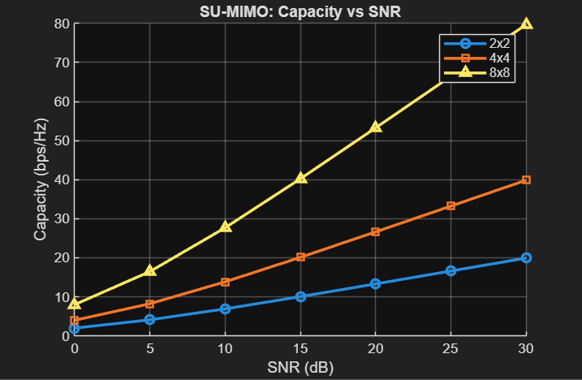

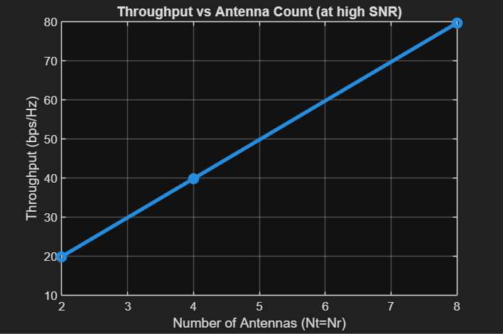

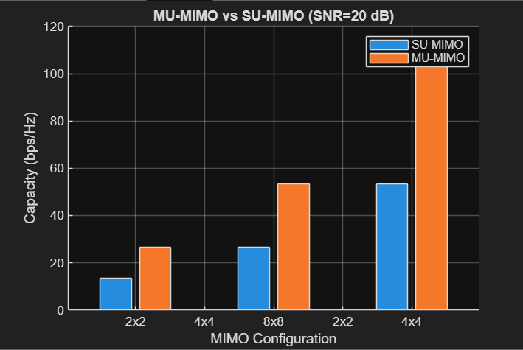

CONSOLE OUTPUTS:
MIMO Size | 0 dB | 5 dB | 10 dB | 15 dB | 20 dB | 25 dB | 30 dB
2×2 | 2 | 4.17 | 6.64 | 9.32 | 13.29 | 17.27 | 20.03
4×4 | 4 | 8.33 | 13.28 | 18.63 | 26.58 | 34.54 | 40.06
8×8 | 8 | 16.67 | 26.57 | 37.27 | 53.16 | 69.09 | 80.12
MIMO Size | 0 dB | 5 dB | 10 dB | 15 dB | 20 dB | 25 dB | 30 dB
2×2 | 4 | 8.33 | 13.28 | 18.63 | 26.58 | 34.54 | 40.06
4×4 | 8 | 16.67 | 26.57 | 37.27 | 53.16 | 69.09 | 80.12
8×8 | 16 | 33.34 | 53.14 | 74.53 | 106.31 | 138.18 | 160.24

At SNR = 20 dB:

SU-MIMO:
2x2 → 13.29
4x4 → 26.58
8x8 → 53.16

MU-MIMO:
2x2 → 26.58
4x4 → 53.16
8x8 → 106.31
RESULT:
MU-MIMO provides higher total system capacity by serving multiple users simultaneously, but performance is reduced by inter-user interference. SU-MIMO offers more stable throughput per user, making it better when interference cannot be effectively managed.

