**SOP for Configuring Google Cloud Identity LDAP on Linux**

This article represents how to configure GoogleCloud Identity Logins on the Linux Device

with connecting to Google’s Secure LDAP.

**Pre-requisites:**

Linux Ubuntu Machines/Workstations

**Minimum system requirements:**

8GB RAM

256 GB Storage

Linux Ubuntu 16.4

Windowing System – Wayland

A Shell script has been prepared for this task execution. Same can be run with **root** user.

Please copy the **Linux** folder on the Desktop **of the administrator**. Open the terminal & run the command below

sudo -i

(It will ask for administrator password. Type the administrator password & hit enter)

Now go to the path & then run the script with below 2 commands

chmod 777 /home/Delhivery/Downloads/Linux/

sh -x linux_cip_new.sh

Once completed, exit from **root** user. Now check the service status with the command below.

sudo service sssd status | grep Active:

It should be active & should be displayed as Active: active (running) since. Then run the below command with administrator user to enable for all users.

pam-auth-update

A pop-up will appear there. Press the down arrow & select “[*] Create home directory on login”. Update the value from blank to * by pressing the space button & then hit Enter. Pop-up will be closed. Then reboot the machine.

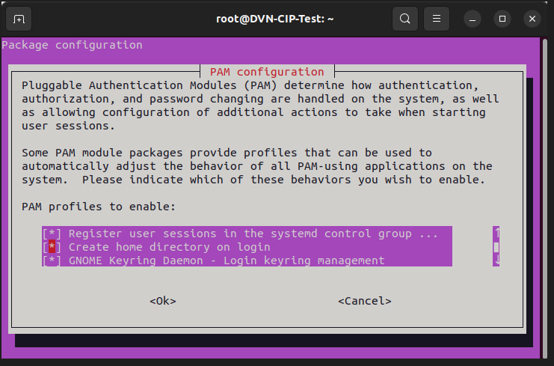

getent passwd

Restart the system after all of the above has been completed. Now try to login using only

username (ex.test.user) with Google Identity Password, and it will create the login accounts.

**Note : It might take 3 to 4 failed attempt.**

**Note : If it fails login, then you can do the installation & enable process manually with below steps.**

Once you’re connected to the instance the first thing you’ll need to do is update the packages.

That is done with the following command:

sudo apt update -y

After that’s done, run the following command to install the SSSD package:

sudo apt install -y sssd sssd-tools

Creating the sssd.conf file

After the packages are done installing, you will need to create a new file in /etc/sssd/ called

sssd.conf. You can do that with the following command:

sudo gedit /etc/sssd/sssd.conf

Your sssd.conf file should include the following:

[sssd]

services = nss, pam

domains = delhivery.com

[domain/delhivery.com]

cache_credentials = true

ldap_tls_cert = /var/Google_2026_05_22_46666.crt

ldap_tls_key = /var/Google_2026_05_22_46666.key

ldap_uri = ldaps://ldap.google.com:636

ldap_search_base = dc=delhivery,dc=com

id_provider = ldap

auth_provider = ldap

ldap_schema = rfc2307bis

ldap_user_uuid = entryUUID

ldap_groups_use_matching_rule_in_chain = true

ldap_initgroups_use_matching_rule_in_chain = true

enumerate = false

Copying Google SSL certificates to the Server

When you created the LDAP client in the G Suite admin portal, an SSL certificate and key were

generated for you. This certificate is used to authenticate the LDAP client and the service trying to

connect to it. You will need to make the crt and key files available on the server. By default, Google linux instances disable password authentication so trying to use a client like winscp to upload the file

will fail when trying to authenticate.

Once the certificates have been saved on the server and placed any location you deem fit, modify

the sssd.conf file to update the location and cert and key names for ldap_tls_cert and ldap_tls_key.

Now that both the cert and key are in place and the sssd.conf file is ready, you will need to

modify the permissions of the sssd.conf file in order to let the service run. Run the following

commands to modify the permissions:

sudo chown root:root /etc/sssd/sssd.conf

sudo chmod 600 /etc/sssd/sssd.conf

**Restart the SSSD service:**

If everything is set correctly you shouldn’t see any messages and the service should start

running. To verify that SSSD is running and connecting to the LDAP server you can run the

following command with any of the users in your G Suite account:

sudo service sssd restart

Now change the configuration file to enable wayland by default by using the below command. A pop-up will be opened. Now replace the highlighted entry

gedit /etc/gdm3/custom.conf

A pop-up will be opened. Now replace the highlighted entry

# GDM configuration storage

#

# See /usr/share/gdm/gdm.schemas for a list of available options.

[daemon]

# Uncomment the line below to force the login screen to use Xorg

WaylandEnable=true

# Enabling automatic login

# AutomaticLoginEnable = true

# AutomaticLogin = user1

# Enabling timed login

# TimedLoginEnable = true

# TimedLogin = user1

# TimedLoginDelay = 10

[security]

[xdmcp]

[chooser]

[debug]

# Uncomment the line below to turn on debugging

# More verbose logs

# Additionally lets the X server dump core if it crashes

#Enable=true

Now save & close the popup.

Now to enable the the home directory creation for each user, we need to make changes in kernel. Execute the below command & follow the steps below.

pam-auth-update

A pop-up will appear there. Press the down arrow & select “[*] Create home directory on login”. Update the value from blank to * by pressing the space button & then hit Enter. Pop-up will be closed. Then reboot the machine.



Now run the below command to update the Google users with their passwords for authentication during login.

gedit /etc/gdm3/cusotm.conf

A text file will be opened. Then replace

getent passwd

Restart the machine after all of the above has been completed. Now try to login using only

username (ex.test.user) with Google Identity Password, and it will create the login accounts.

**End of the Document**