**Contents of the Report :**

|  |  |
| --- | --- |
| **Topic** | **Page Numbers** |
| 1. **Problem Statement** | **2** |
| 1. **Applications** | **3** |
| 1. **Commands used** | **5** |
| 1. **Code** | **8** |
| 1. **Flowchart** | **13** |
| 1. **Output** | **14** |
| 1. **Conclusion** | **18** |

**PROBLEM STATEMENT :**

**To write a C program for Student attendance management using Concepts of Data Structure.**

**APPLICATIONS OF STUDENT ATTENDENCE MANAGEMENT SYSTEM :**

Working of Present System:

In the present system all work is done on paper. The

whole session attendance is stored in register and at the end of the session the reports are generated. We are not interested in generating report in the middle of the session or as per the requirement because it takes more time in calculation. At the end of session the students who

don’t have 75% attendance gets a notice. So to overcome this time consuming job we can develop a program which can further be developed into a software to maintain the attendance of the students.

Attendance Management System is a Program developed for daily student attendance in schools, collages and institutes. If facilitates to access the attendance information of a particular student in a particular class, the information is sorted by the operators, which will be provided by the teacher for a particular class.

The purpose of developing attendance management system is to computerized the tradition way of taking attendance. Another purpose for developing this program is to generate the report automatically at the end of the session or in the between of the session if needed.

**ADVANTAGES OF THIS SYSTEM :**

**User Friendly :**

The proposed system is user friendly because the retrieval and storing of data is fast and data is

maintained efficiently.

**Reports can be easily generated :**

In the proposed system so user can generate the report as per the requirement or in the middle ofthe session. User can give the notice to the students so he/she become regular.

**Very less paper work :**

The proposed system requires very less paper work. All the data is feted into the computer immediately and reports can be

generated through computers. Moreover work becomes very easy because there is no need to keep data on papers.

**Computer operator control :**

Computer operator control will be there so no chance of errors.

Moreover storing and retrieving of information is easy. So work can be done speedily and in time.

**COMMANDS USED :**

|  |  |
| --- | --- |
| **C Basic commands** | **Explanation** |
| #include <stdio.h> | This is a preprocessor command that includes standard input output header file(stdio.h) from the C library before compiling a C program |
| int main() | This is the main function from where execution of any C program begins. |
| { | This indicates the beginning of the main function. |
| /*_some_comments_*/ | whatever is given inside the command “/*   */” in any C program, won’t be considered for compilation and execution. |
| printf( ); | printf command prints the output onto the screen. |
| getch(); | This command waits for any character input from keyboard. |
| return 0; | This command terminates C program (main function) and returns 0. |
| } | This indicates the end of the main function. |
| while | while(condition) { statements; } |

|  |  |
| --- | --- |
| **C functions aspects** | **Syntax** |
| **function definition** | **Return_typefunction_name (arguments list) { Body of function; }** |
| **function call** | **function_name (arguments list);** |
| **function declaration** | **return_typefunction_name (argument list);** |
| **Decision control statements** | **Syntax/Description** |
| **If** | if (condition)  { Statements; }  Description: In these type of statements, if condition is true, then respective block of code is executed. |

**SOME OF THE USER-DEFINED FUNCTIONS USED IN THE CODE :**

void inpu**t_**data() – This function is used to put the details of the Students.

void Feed_attendence() – This function updates the attendance of the

Students .

void display()- This function is used to display the details of the Students.

**CODE :**

**#include<stdio.h>**

**#include<conio.h>**

**#include<process.h>**

**#include<string.h>**

**void display();**

**void input_data();**

**void Feed_attendence();**

**int n;**

**int at[100];**

**/*struct attendence**

**{**

**int at[100];**

**char date;**

**}a[5];*/**

**struct student**

**{**

**char name[20];**

**int rollno;**

**char attend;**

**}s[100];**

**void Input_data()**

**{**

**int i,j,temp;**

**char temp1[20];**

**printf("\n\nEnter the student details here\n");**

**printf("\nEnter the class strength");**

**scanf("%d",&n);**

**for(i=0;i<n;i++)**

**{**

**printf("student name:");**

**scanf("%s",&s[i].name);**

**printf("Roll no\n");**

**scanf("%d",&s[i].rollno);**

**}**

**for(i=0;i<n;i++){**

**for(j=0;j<n-i-1;j++){**

**if(s[j].rollno>s[j+1].rollno){**

**temp=s[j].rollno;**

**strcpy(temp1,s[j].name);**

**s[j].rollno=s[j+1].rollno;**

**strcpy(s[j].name,s[j+1].name);**

**s[j+1].rollno=temp;**

**strcpy(s[j+1].name,temp1);**

**}**

**}**

**}**

**/*for(i=1;i<n;i++)**

**{**

**fprintf(f,"%d\t\t%s\t",s[i].rollno,s[i].name);**

**}**

**fclose(f);**

**}*/**

**}**

**void Feed_attendence(){**

**int j;**

**printf("Press 1 if present and 0 if absent\n");**

**for(j=0;j<n;j++){**

**printf("%s",s[j].name);**

**scanf("%d",&at[j]);**

**}**

**}**

**void display(){**

**int i,j;**

**printf("Roll no\tname\tAttendence\n");**

**for(i=0;i<n;i++){**

**printf("\n%d\t%s\t%d\t",s[i].rollno,s[i].name,at[i]);**

**}**

**}**

**main(){**

**int i,a,b,m,j;**

**char c;**

**do{ printf("\n____________\n");**

**printf("\n\n\n Attendance System \n\n");**

**printf("____________\n");**

**printf("1)Enter student details\n2)Take Attendance\n3)View Attendance\n4)Exit\n");**

**printf("\n\n\n:");**

**printf("Choose the option\n");**

**scanf("%d",&m);**

**switch(m){**

**case 1:Input_data();**

**break;**

**case 2:Feed_attendence();**

**break;**

**case 3:display();**

**break;**

**case 4:printf("");**

**break;}}while(m!=4);**

**getch();**

**return 0;**

**}**

**FLOW CHART :**

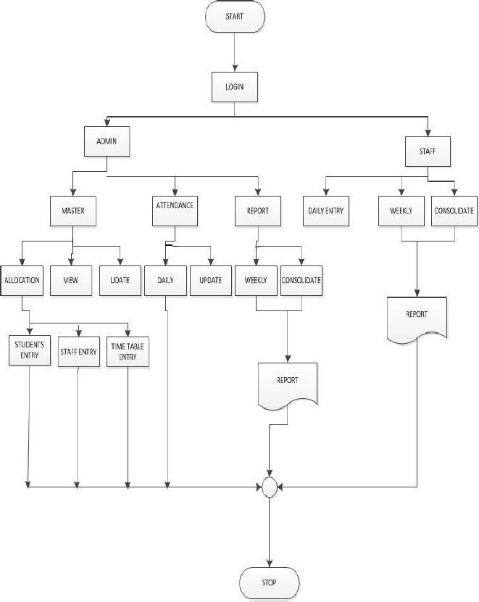

**OUTPUT :**

**MAIN MENU :**

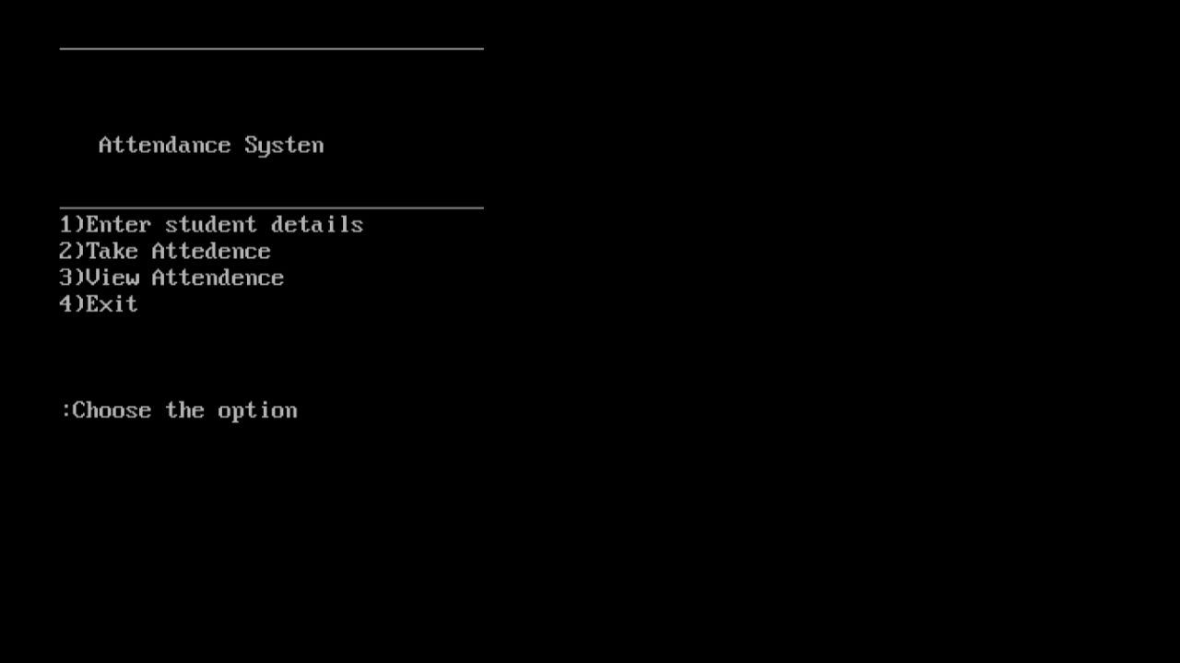

**CASE 1 :** To enter student details

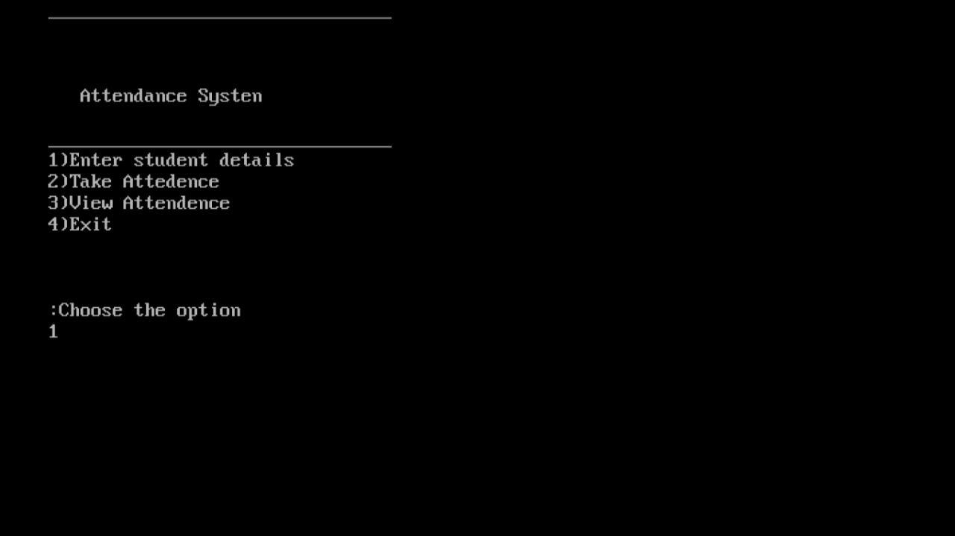

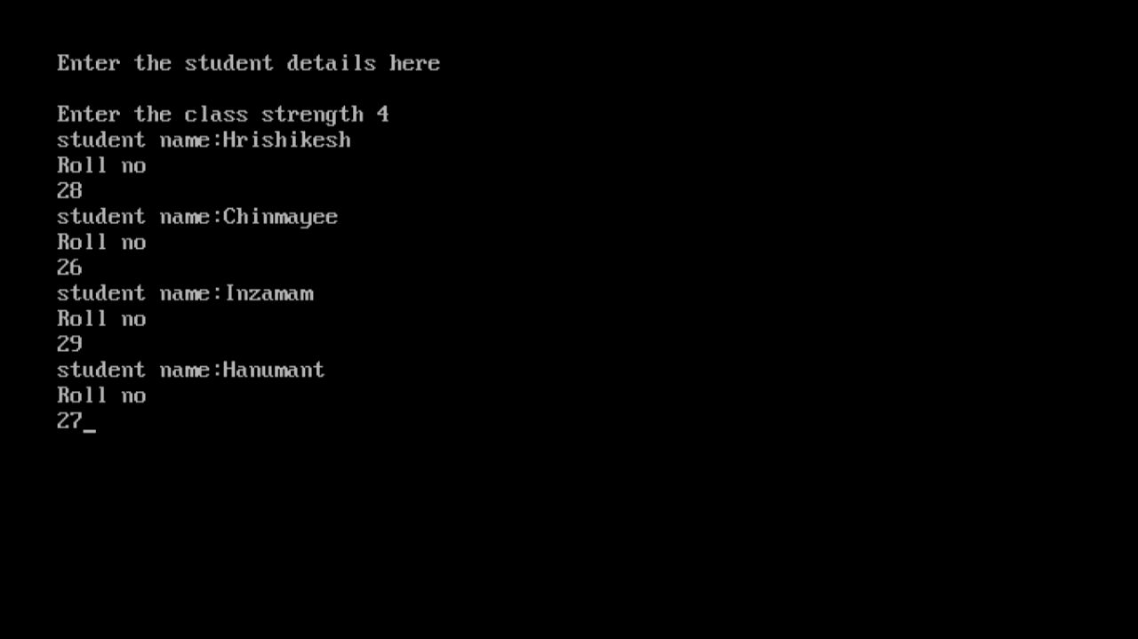

**CASE 2 :** Taking the attendance of the Students.

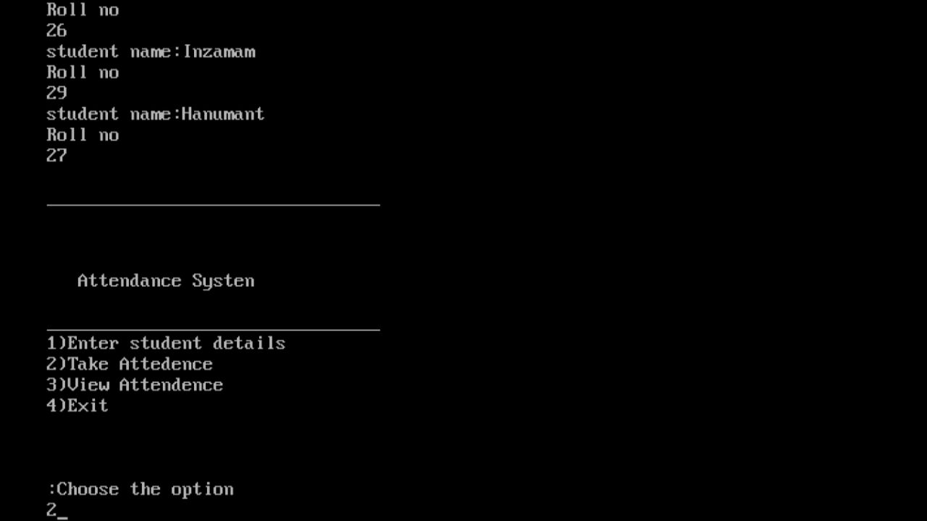

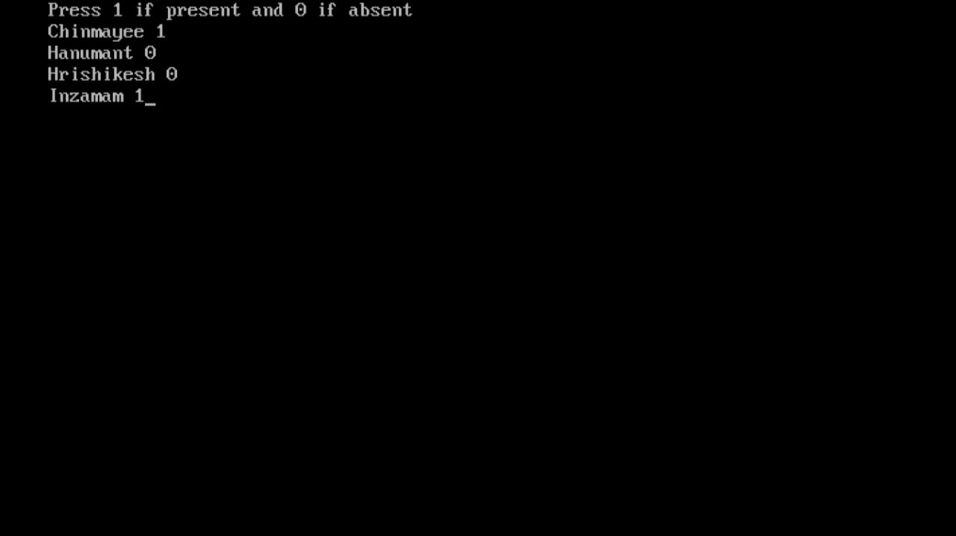

**CASE 3 :** View the Attendance.

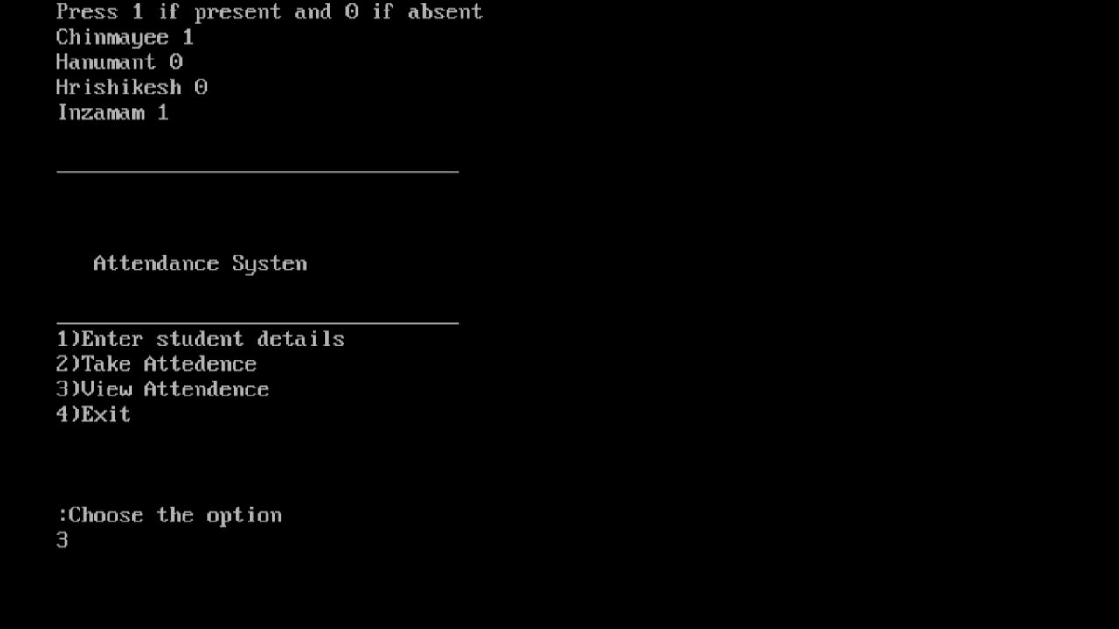

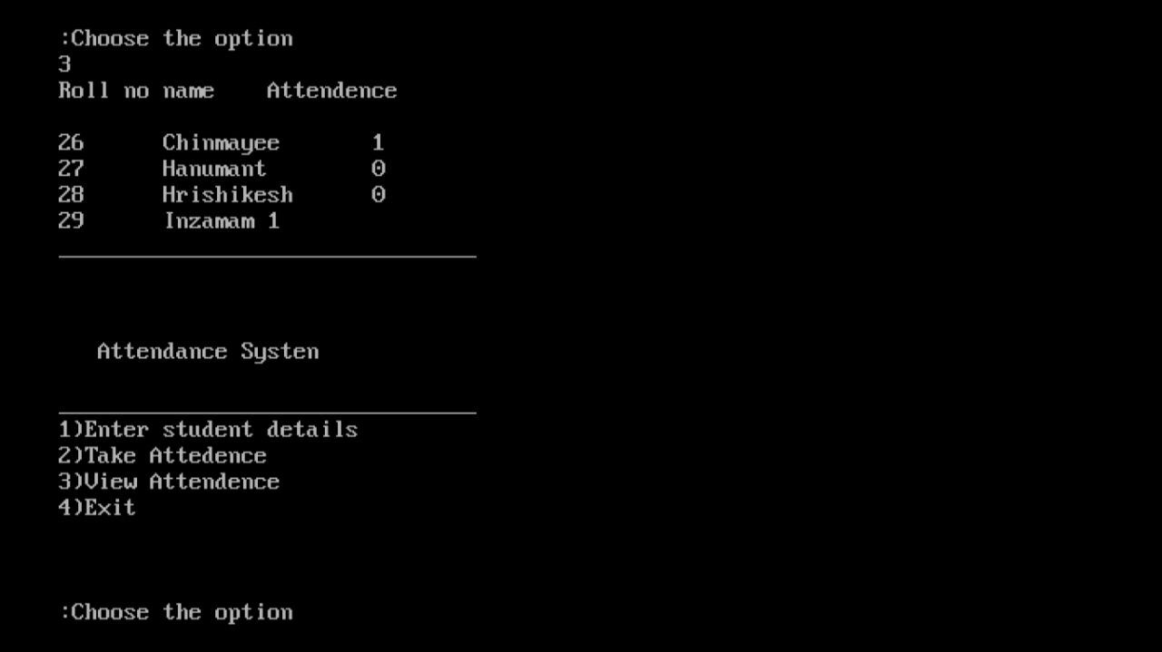

**CONCLUSION :**