**Data Management**

**A Project Report On topic**

**HOTEL BOOKINGS**

Submitted in partial fulfilment of the requirements for the award of degree of

**Bachelor of Technology**

**(Computer Science & Engineering)**

**Submitted to**

**LOVELY PROFESSIONAL UNIVERSITY**

**PHAGWARA, PUNJAB**



**SUBMITTED BY**

Name of student: Sneha Singh

Registration Number: 11808742

**Student Declaration**

I, **Sneha Singh** student of **Data Management** under CSE/IT Discipline at, Lovely Professional University, Punjab, hereby declare that all the information furnished in this project report is based on my own intensive work and is genuine.

Date: 17/12/2020 Signature: Sneha

Registration:11808742 Name: Sneha Singh

**ACKNOWLEDGEMENT**

The satisfaction that accompanies the successful completion of this project would be incomplete without the mention of the people who made it possible, without whose constant guidance and encouragement would have made efforts go in vain. I consider myself privileged to express gratitude and respect towards all those who guided me through the completion of this project.

I convey thanks to my project guide **Ms. Savleen Kaur** of Computer Science and Engineering Department for providing encouragement, constant support and guidance which was of a great help to complete this project successfully.

**CERTIFICATE**

This is to certify that **Sneha Singh** bearing Registration Number **11808742** has completed INT217 (Data Management) project titled, “**Hotel Bookings**” under my guidance and supervision. To the best of my knowledge, the present work is the result of his original development, effort and study.

**Savleen Kaur**

**School of Computer Science &**

**Engineering Lovely Professional**

**University**

**Phagwara, Punjab**

**Table of Content**

|  |  |  |
| --- | --- | --- |
| S No | Title | Pages |
| 1. | Introduction | 6 |
| 2. | Objectives | 7 |
| 3. | Source of data | 8 |
| 4. | ETL process | 9-10 |
| 5. | Analysis of data | 11-12 |
| 6. | List of analysis with answers | 13-25 |
| 7. | Visualization | 26 |
| 8.    9. | References  Conclusion | 27    28 |

**INTRODUCTION**

This report covers the **Hotel Bookings Project** which is our project for the final end term practical exam of course code INT217.

This project covers the analysis part of Booking Details for the year 2015-17 based on some Type of hotel. This dataset consists of various data fields like – Hotel Type,Booking year,special requirement, etc.

Analysis is done using the different tools of Microsoft Excel like – pivot table, pivot chart, slicers etc. To perform analysis on dataset to analysis of bookings yearwise,total cancelletion,special requirements etc.





**Objectives**

1. Analysis of the different types of hotel booked evey year.
2. Analysis of the Reservation Status every year.
3. Analysis of the Hotel Reserved every year according to different types.
4. Analysis of Changes occurred in Booking per year .
5. Analysis of Top 10 Countries Booked Hotel every year.
6. Analysis of Marketing Segement of different hotel.
7. Analysis of Total Special Requests made by Customers .
8. Analysis of Different Type of Customers Booked the hotel.
9. Analysis of Total no. of Adults,Children and babies booked hotel every year.
10. Analysis of Reservation In hotel Monthly.
11. Analysis of Channel Distribution.





**SOURCE OF DATA**

* Kaggle

Link: <https://www.kaggle.com/jessemostipak/hotel-booking-demand/activity>

**Data Set:**

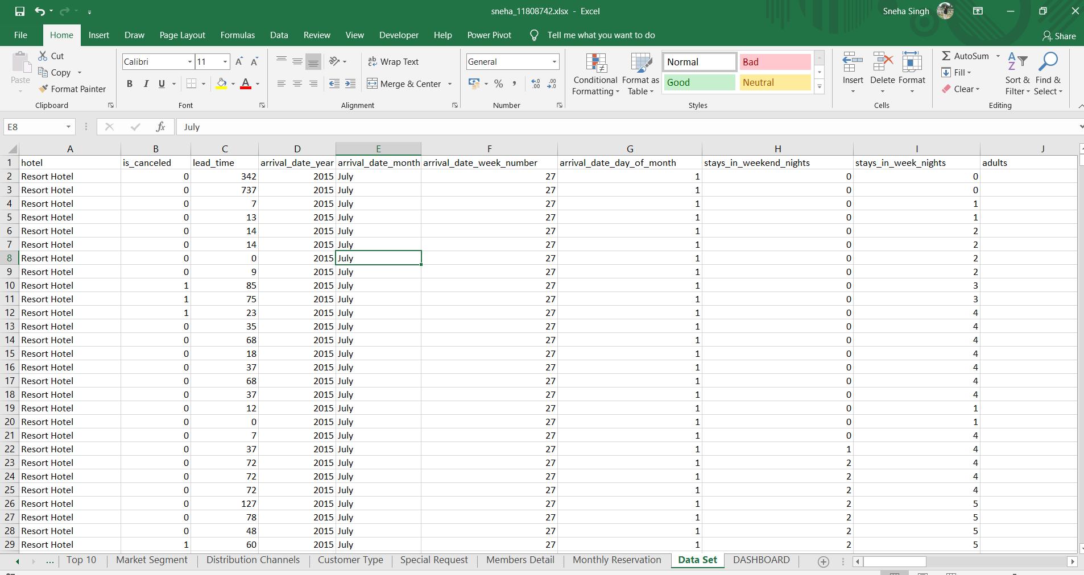

**ETL process**

## **What is ETL?**

**ETL**is a process that extracts the data from different source systems, then transforms the data (like applying calculations, concatenations, etc.) and finally loads the data into the Data Warehouse system. Full form of ETL is Extract, Transform and Load.

## **Why do you need ETL?**

There are many reasons for adopting ETL in the organization:

* It helps companies to analyze their business data for taking critical business decisions.
* Transactional databases cannot answer complex business questions that can be answered by ETL example.
* A Data Warehouse provides a common data repository
* ETL provides a method of moving the data from various sources into a data warehouse.
* As data sources change, the Data Warehouse will automatically update.
* Well-designed and documented ETL system is almost essential to the success of a Data Warehouse project.

## **ETL Process in Data Warehouses**

ETL is a 3-step process

## Step 1) Extraction

## Step 2) Transformation

## Step 3) Loading

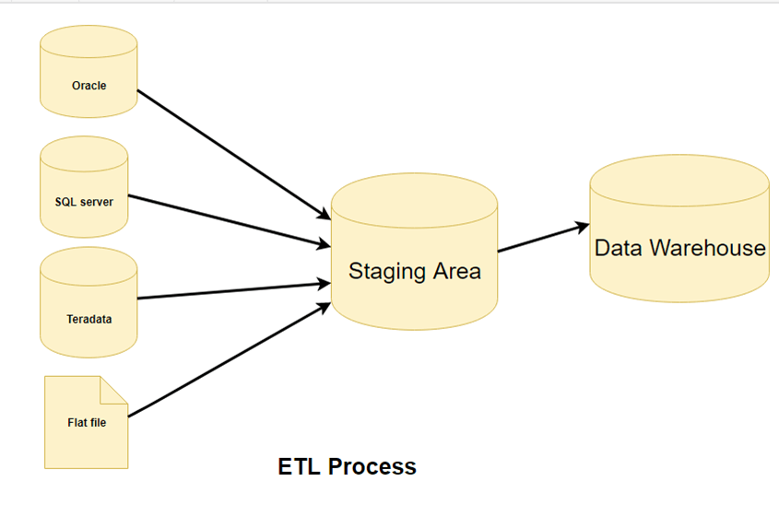

**Analysis on dataset**

* **Introduction**

This project covers the analysis part of Booking Details for the year 2015-17 based on some Type of hotel. This dataset consists of various data fields like – Hotel Type,Booking year,special requirement, etc.

Analysis is done using the different tools of Microsoft Excel like – pivot table, pivot chart, slicers etc. To perform analysis on dataset to analysis of bookings yearwise,total cancelletion,special requirements etc.

* **General Description**

This dataset consists of numerical values and categorial values. Among them 15 columns consists of numerical values and 9 columns consists of categorial values.

Numerical columns – Canceled , No. of stays_months , No. of stays_weekday, No. of stays_weeknights,year, special requests, adults, Children, Babies,etc

Categorical columns – Country, Hotel , Arrive Month, Distribution Channels , Market_Segment, Meal , Deposite_type, Customer_type,Reservation_Status.

On these numerical and categorical values the analysis is being performed to find out the reservation Status,No. of adults,children,babies,etc.

* **Specific Requirement, formulas and functions**

We are performing the analysis using different tools of Ms Excel for example - pivot table, pivot chart, slicers, filters etc.

For the analysis purpose many functions had been used in this project.

**Pivot table** – A [Pivot Table](https://en.wikipedia.org/wiki/Pivot_table) is one of the basic data analysis tools. Pivot Tables can quickly answer many important business questions.

One of the reasons we build Pivot Tables is to pass information. We would like to support our story with data that is easy to understand, easy to see.

**Pivot chart** - A **pivot chart** is the visual representation of a pivot table in **Excel**. Pivot charts and pivot tables are connected with each other.

**Slicers -** Slicers provide buttons that you can click to filter [tables](https://support.microsoft.com/en-us/office/create-and-format-tables-e81aa349-b006-4f8a-9806-5af9df0ac664), or [PivotTables](https://support.microsoft.com/en-us/office/create-a-pivottable-to-analyze-worksheet-data-a9a84538-bfe9-40a9-a8e9-f99134456576). In addition to quick filtering, slicers also indicate the current filtering state, which makes it easy to understand what exactly is currently displayed.

**Filters** - The basic Excel filter (also known as the Excel Autofilter) allows you to view specific rows in an Excel spreadsheet, while hiding the other rows.

When the Excel autofilter is added to the header row of a spreadsheet, a drop-down menu appears in each cell of the header row. This provides you with a number of filter options that can be used to specify which rows of the spreadsheet are to be displayed.

* **Analysis Results**
* **Analysis of the Total No. Of different types of hotel booked every year**
* Total Number of Hotel Booked in year 2015 i.e

Resort Hotel=8314

City Hotel = 13682

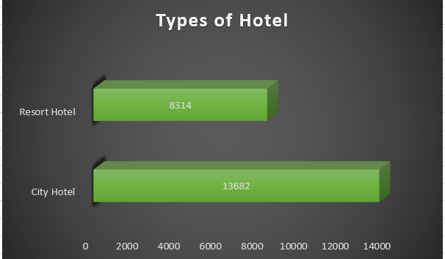

* Total Number of Hotel Booked in year 2016 i.e

Resort Hotel=18567

City Hotel = 38140

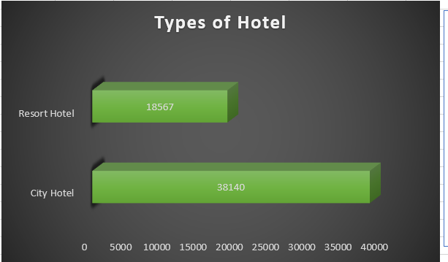

* Total Number of Hotel Booked in year 2017 i.e

Resort Hotel=13179

City Hotel = 27508

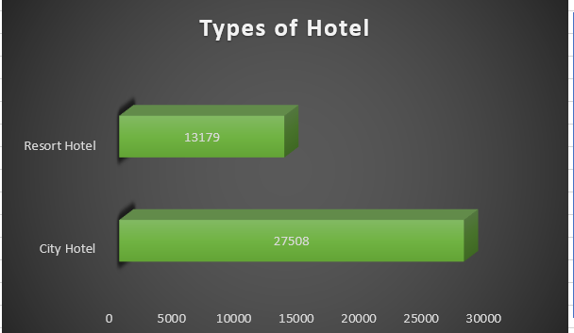

* **Analysis of the Reservation Status every year.**
* Total no. of Canceled,check-out,No-show done in year 2015.i.e.

City Hotel:

Canceled=2069

Check-out=6176

No-show=122

Resort Hotel:

Canceled=5882

Check-out=7678

No-show=139

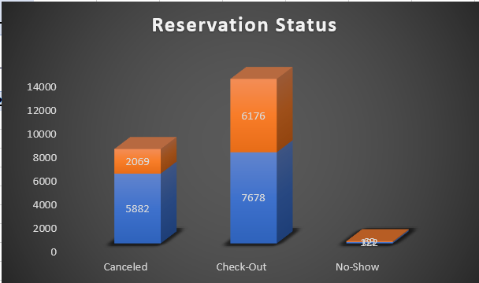

* Total no. of Canceled,check-out,No-show done in year 2016.i.e.

City Hotel:

Canceled=4817

Check-out=13637

No-show=555

Resort Hotel:

Canceled=5882

Check-out=7678

No-show=133

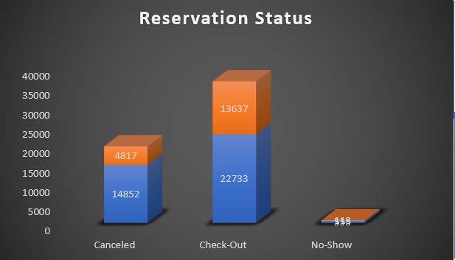

* Total no. of Canceled,check-out,No-show done in year 2017.i.e.

City Hotel:

Canceled=3945

Check-out=9125

No-show=239

Resort Hotel:

Canceled=11452

Check-out=15817

No-show=109

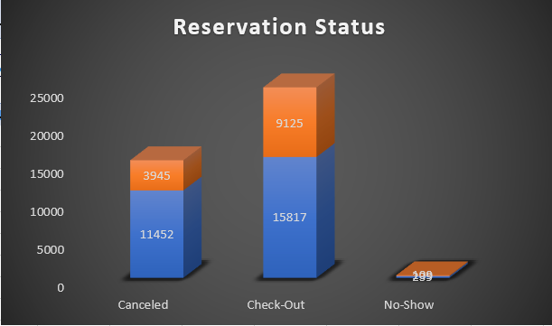

* **Analysis of the Hotel Reserved every year according to different types**
* Type of Hotel reserved in year 2015.i.e.

City Hotel=74%

Resort Hotel=26%

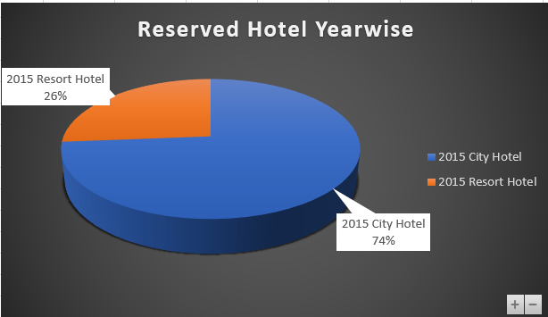

* Type of Hotel reserved in year 2016.i.e.

City Hotel=76%

Resort Hotel=24%

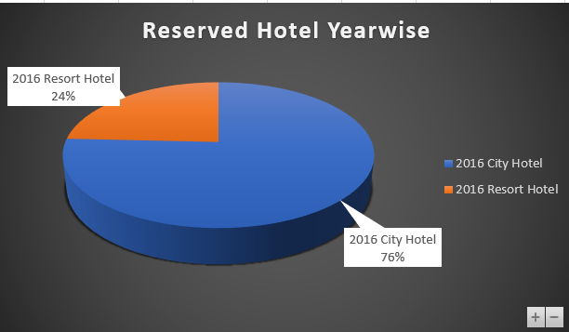

* Type of Hotel reserved in year 2017.i.e.

City Hotel=74%

Resort Hotel=26%

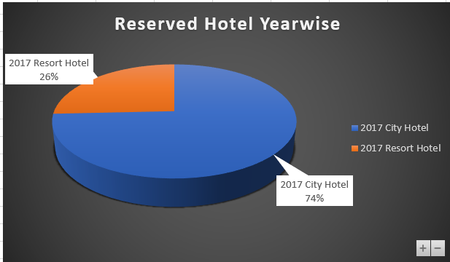

* **Analysis of Changes occurred in Booking per year .**
* Booking changes done in year 2015.i.e.

City Hotel:

No Deposite=10533

Not Refundable=3146

Refundable=3

Resort Hotel:

No Deposite=7792

Not Refundable=521

Refundable=1

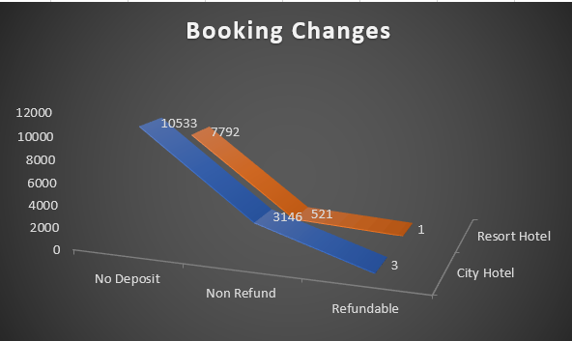

* Booking changes done in year 2016.i.e.

City Hotel:

No Deposite=32227

Not Refundable=5910

Refundable=3

Resort Hotel:

No Deposite=17555

Not Refundable=824

Refundable=128

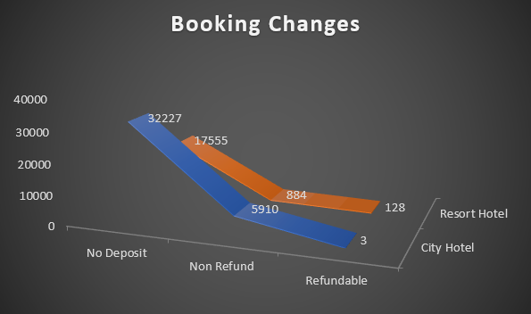

* Booking changes done in year 2017.i.e.

City Hotel:

No Deposite=23682

Not Refundable=3812

Refundable=14

Resort Hotel:

No Deposite=12852

Not Refundable=314

Refundable=13

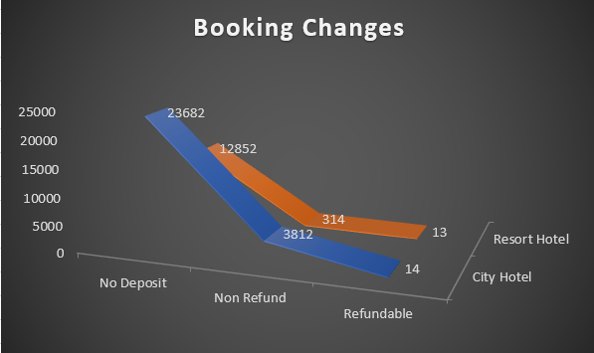

* **Analysis of Top 10 Countries Booked Hotel every year.**

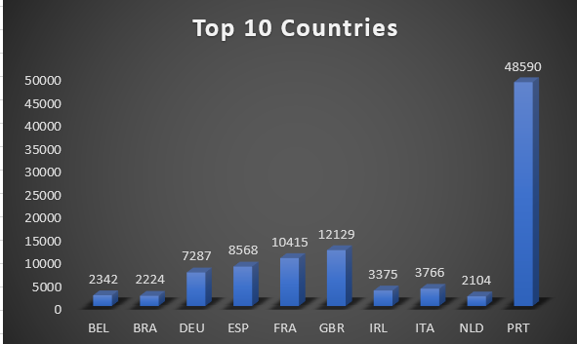

* **Analysis of Marketing Segement of different hotel.**

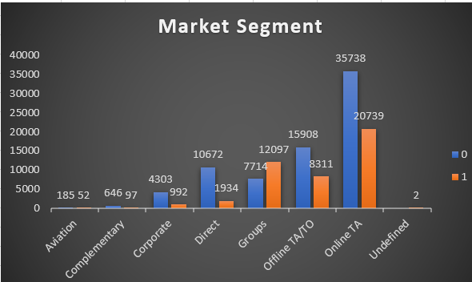

* **Analysis of Total Special Requests made by Customers .**

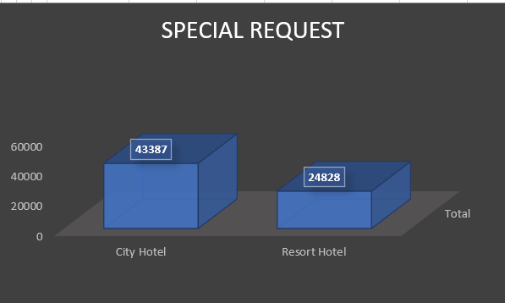

* **Analysis of Different Type of Customers Booked the hotel.**
* Total No. Of Different type of Customer:

Contract Type Customer=4076

Group Type Customer=577

Transient Type Customer=89613

Transient-Party Type Customer=25124

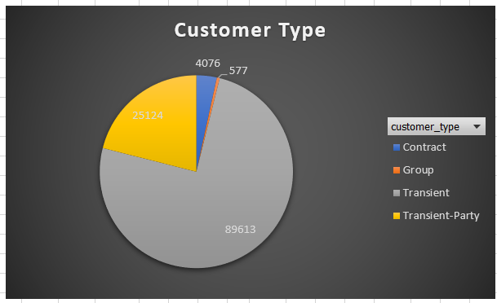

* **Analysis of Total no. of Adults,Children and babies booked hotel every year.**
* Total no. of Adults,Children,Babies in Different Hotel.i.e.

City Hotel:

Children=79330

Adult=146838

Babies=392

Resort Hotel:

Children=40060

Adult=74798

Babies=557

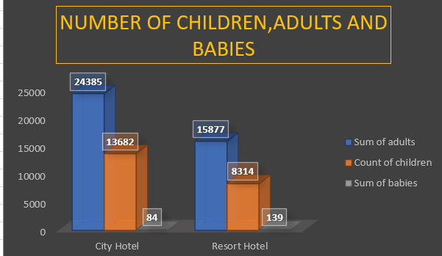

* **Analysis of Reservation In hotel Monthly.**
* Monthly Reservation in year 2015.

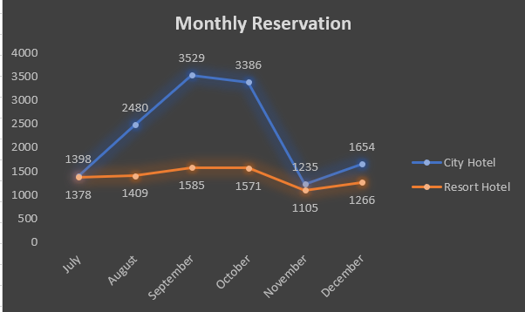

* Monthly Reservation in year 2016.

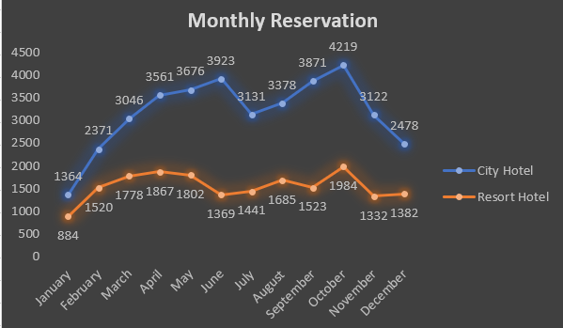

* Monthly Reservation in year 2016.

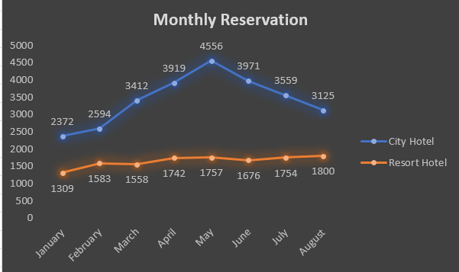

* **Analysis of Channel Distribution.**

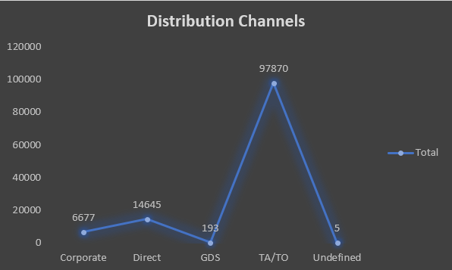

* **Visualization:**

This is dashboard of Hotel Booking Data Set**.**

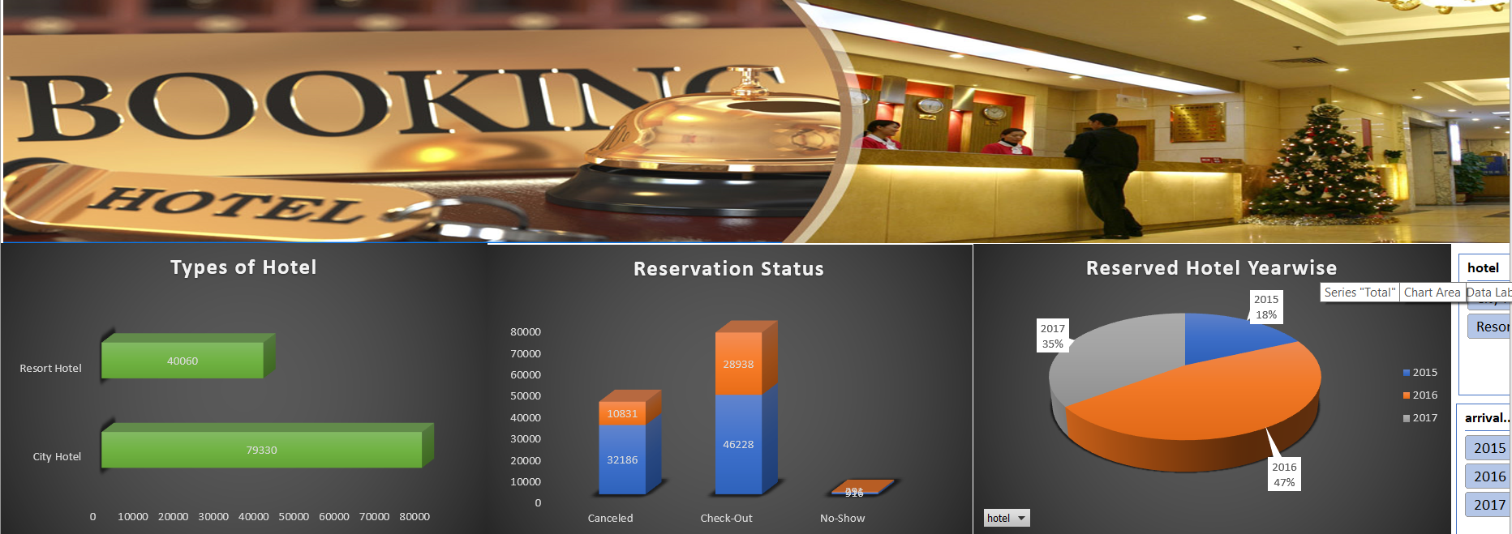

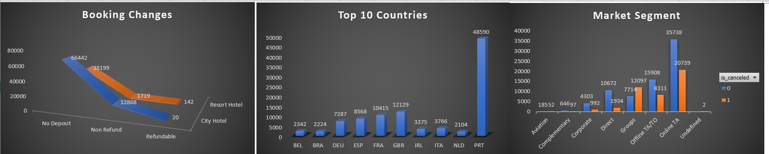

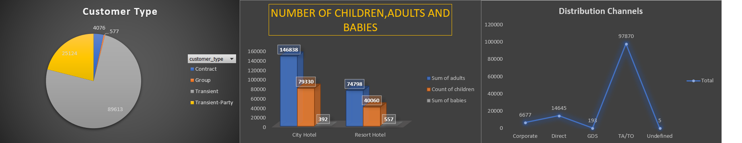

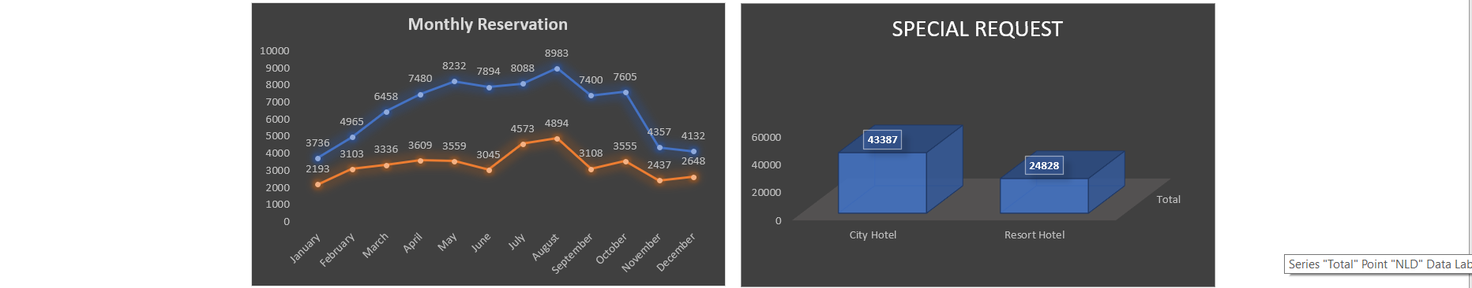

**Reference**

This dataset was taken from Kaggle account:

Link –

<https://www.kaggle.com/jessemostipak/hotel-booking-demand/activity>

Project reference link:

<https://en.wikipedia.org/wiki/Microsoft_Excel>

https://www.excel-easy.com/examples/pivot-chart.html

**Conclusion**

In conclusion, MS-Excel is a great tool for data analysis to computer science and the professionals who utilize them. Data analysis have their advantages and disadvantages like everything in our lives. Only advance users can make use of data analysis, and any problem involving data analysis will need a professional to use it. Luckily, there are more advantages than there are disadvantages. Data analysis allow information to analysis the data and retrieve useful information, it provides the means for management of large data like databases, work together and are necessary for efficient analysis, safe storage of data, allows easier processing of data, and the use of the internet to access data anytime. With those odds, this makes it easy to accept that without these kinds of applications in our lives, life would be that much harder when dealing with computer science and even our day to day tasks.