📜 Chapter 4 – Signs, Staff, and Obedience

שמות ד׳ – אוֹתוֹת, מַטֶּה וּצִוּוּי אֱלֹהִי

🧵 THREAD (1/4): Yahweh Calls, and Mosheh Hesitates

* “But behold, they will not believe me or listen to my voice…”

4:1

Then מֹשֶׁה (Mosheh) answered, “But behold, they will not believe me or listen to my voice, for they will say, ‘Yahweh did not appear to you.’”

4:2

Yahweh said to him, “What is that in your hand?” He said, “A staff.”

4:3

And he said, “Throw it on the ground.”

So he threw it on the ground, and it became a serpent — and מֹשֶׁה fled from it.

→ Hebrew: נָחָשׁ (Nachash) → Serpent

→ 🕊️ Prophetic Insight: Yahweh reveals power through the ordinary.

→ ⚖️ Remnant Lesson: What seems simple in your hand can become mighty under Yahweh’s command.

4:4

But Yahweh said to Mosheh, “Reach out your hand and take it by the tail.”

So he reached out his hand and caught it—

And it became a staff in his hand again.

4:5

“That they may believe that Yahweh, the Elohim of their fathers, the Elohim of Abraham, Yitzchak, and Ya’akov, has appeared to you.”

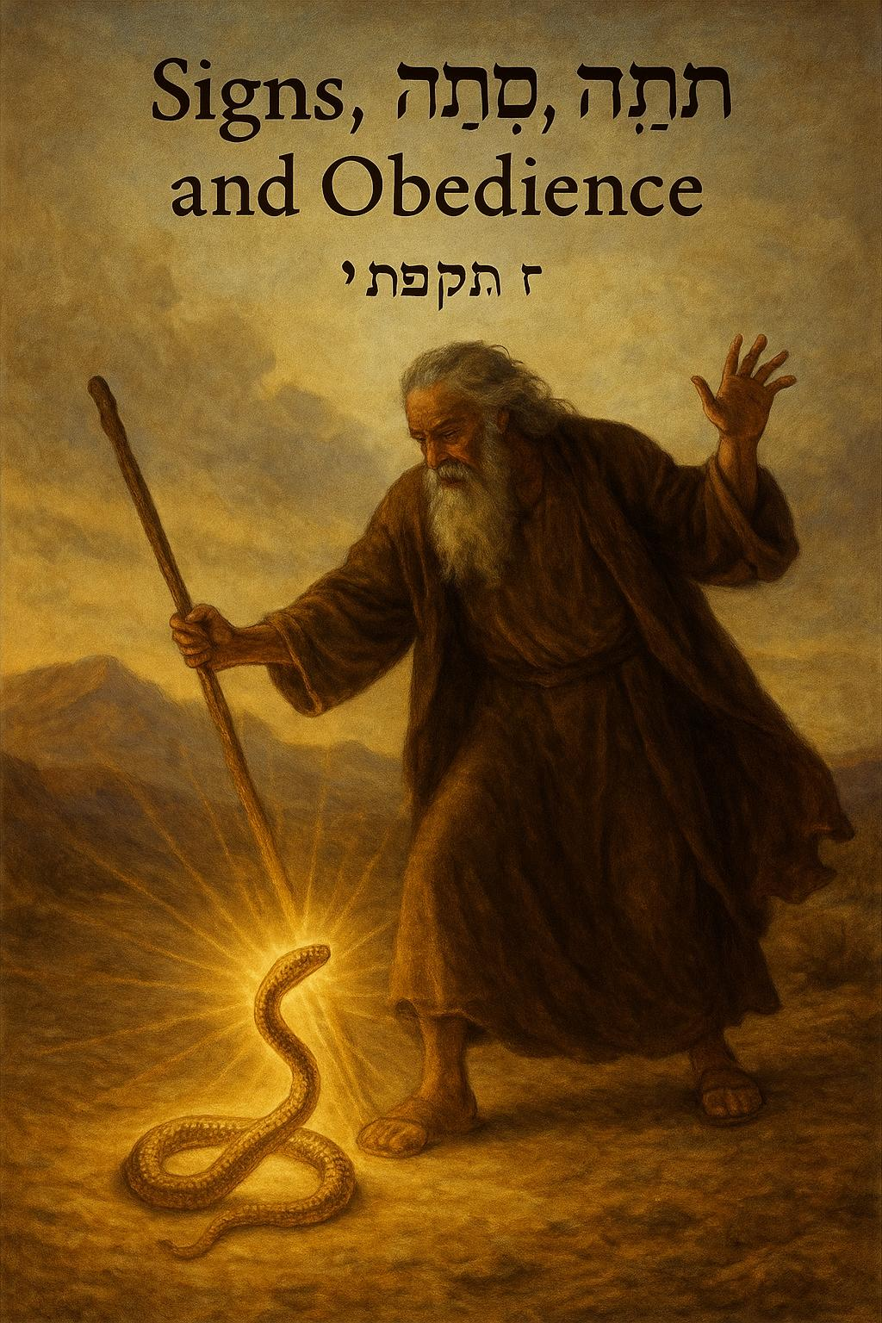

📜 Part 2 – Reluctance, Covenant, and Divine Justice  
שמות ד׳ – הִסְסוּת, בְּרִית, וּצְדָקָה אֱלֹהִית

📖 Exodus 4:10–13  
Moses doubts himself.  
He tells יהוה, “I am not eloquent... I am slow of speech.”  
But Yahweh responds:  
🗣️ “Who made man’s mouth? I will be with your mouth.”  
Yet Moses still pleads for someone else to be sent.

→ Prophetic Insight: Yahweh’s call is not based on our confidence, but His covenant.  
→ Remnant Lesson: Even reluctance cannot cancel the commission if Yahweh is behind it.

📖 Exodus 4:14–17  
Yahweh, angered but merciful, appoints Aaron to speak for Moses.  
Moses will be “as God” to Aaron — a divine chain of command.  
And the staff — now transformed — is the chosen tool of miracles.

→ Hebrew: מַטֶּה (Matteh) → Staff  
→ Remnant Lesson: The staff in your hand is enough when Yahweh is with you ⚖️.

📖 Exodus 4:18–23  
Moses departs for Egypt with his family.  
Yahweh warns: Pharaoh’s heart will be hardened.  
He gives Moses this chilling message for Pharaoh:  
🩸 “Let My son go... If you refuse, I will kill your firstborn son.”

→ Hebrew: בְּכוֹר (Bechor) → Firstborn  
→ Prophetic Insight: Yahweh defends His covenant children with fierce love.  
→ Remnant Lesson: What is withheld unjustly will be reclaimed by divine force.

📖 Exodus 4:24–26  
A mysterious moment: Yahweh seeks to kill Moses.  
Zipporah, discerning the breach in covenant, circumcises their son.  
🩸 She touches Moses’ feet with the foreskin, declaring:  
“You are a bridegroom of blood to me!”

→ Hebrew: חֲתַן דָּמִים (Chatan Damim) → Bridegroom of Blood  
→ Prophetic Insight: Obedience to ancient covenant signs is life-saving.  
→ Remnant Lesson: Don’t neglect the marks of divine identity ✡️.

📖 Exodus 4:27–31  
Aaron meets Moses at the Mountain 🔥 of God.  
Together, they share Yahweh’s message with Israel’s elders.  
The people hear. They believe. They bow in worship.

→ Hebrew: וַיַּאֲמֵן (Vaya’amen) → They Believed  
→ Prophetic Insight: Belief awakens when Yahweh’s word is heard clearly.  
→ Remnant Lesson: The response to revelation must always be worship 🙏.

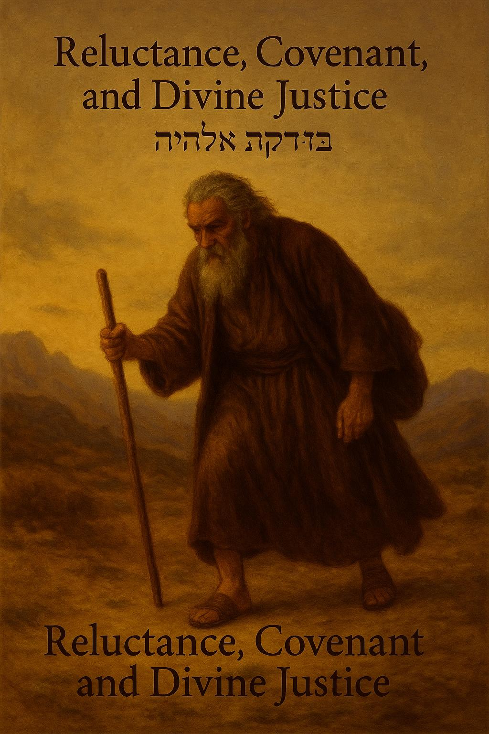

## 📜 Part 3 – Return, Warning, and Worship

**שמות ד׳ – שׁוּב, אַזהָרָה, וְהִשְׁתַּחֲוָיָה**

📖 **Exodus 4:27–28**  
Yahweh speaks to Aaron:

“Go into the wilderness to meet Moses.”  
Aaron obeys.  
They meet at **the Mountain 🔥 of God** — a place of encounter.  
Moses shares everything Yahweh had commanded.

→ **Remnant Lesson:** Divine reunion always begins in sacred places.  
→ **Prophetic Insight:** Yahweh equips the mission with unity and confirmation.

📖 **Exodus 4:29–30**  
The brothers gather the elders of Israel.  
Aaron speaks the words of Yahweh.  
He performs the signs in front of the people.

→ **Remnant Lesson:** Obedience to the message carries weight when it’s backed by evidence.  
→ **Hebrew:** אוֹתוֹת (Otot) → Signs

📖 **Exodus 4:31**  
**And the people believed.**  
When they heard that Yahweh had seen their affliction and visited them…  
**They bowed their heads and worshiped.**

→ **Hebrew:** וַיַּאֲמֵן (Vaya’amen) → They believed  
→ **Prophetic Insight:** True belief rises when Yahweh’s compassion is revealed.  
→ **Remnant Lesson:** Every movement of Yahweh begins in reverent worship 🙇‍♂️🙇‍♀️

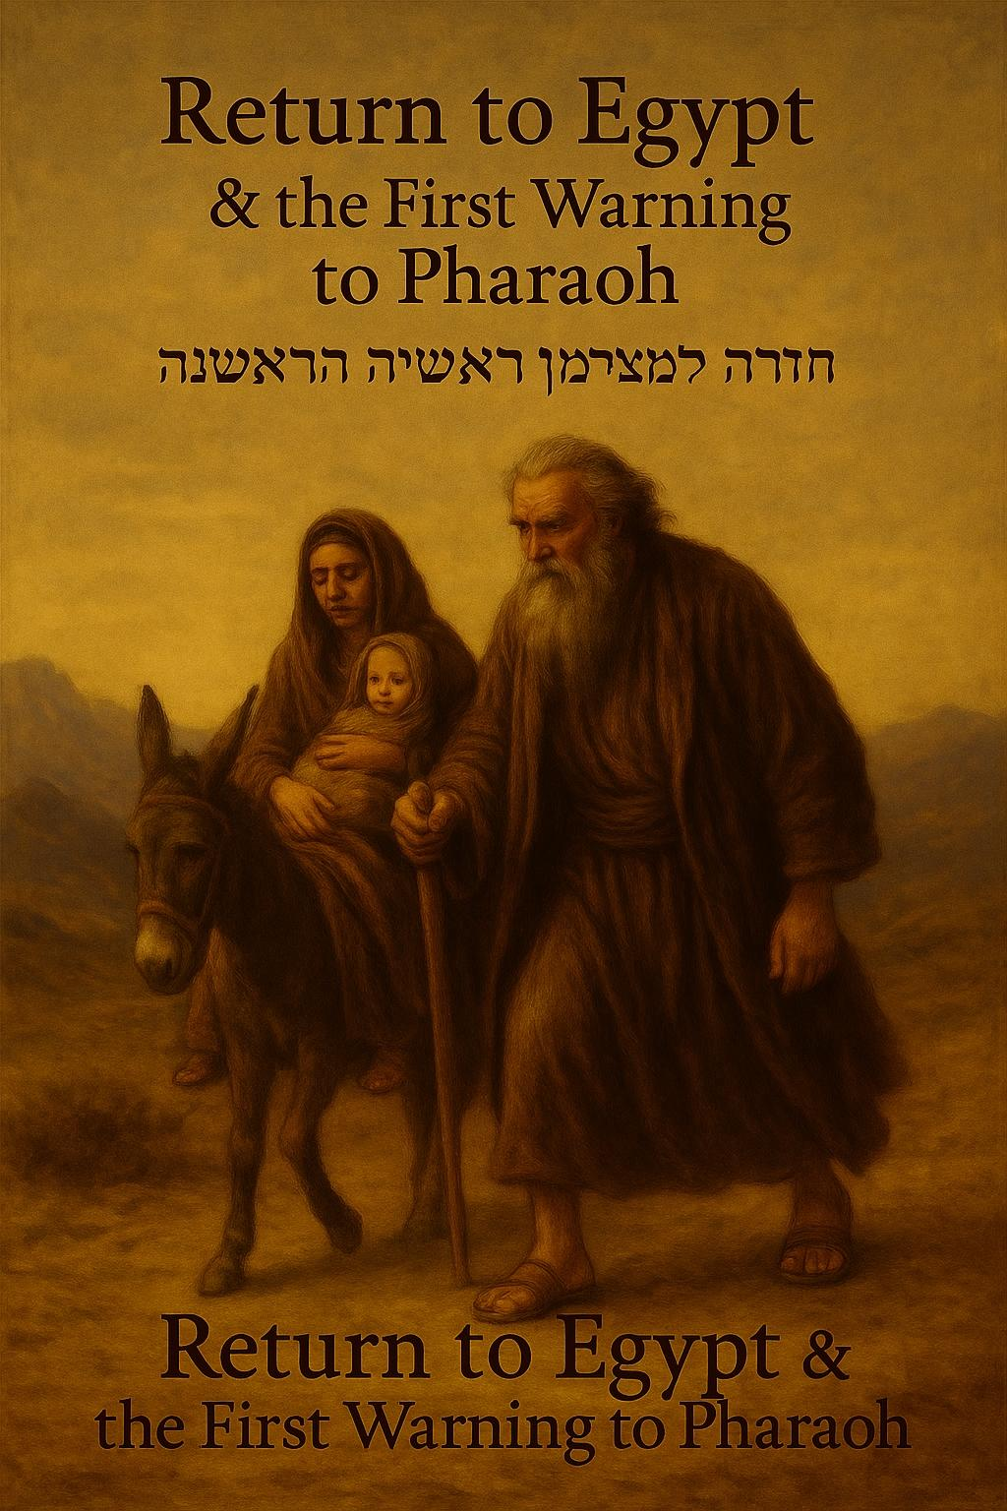

📜 **Part 4 – Obedience and Awakening**  
**שמות ד׳ – שְׁלִיחוּת וְהִתְעוֹרְרוּת הָעָם**

📖 **Exodus 4:27–28**  
Yahweh speaks to Aaron:  
“Go into the wilderness to meet Moses.”  
Aaron obeys, and they reunite at the mountain 🔥 of God with a kiss of brotherhood.  
Moses recounts all of Yahweh’s words and the signs he was commanded to perform.

→ Prophetic Insight: Brotherhood is rekindled in obedience.  
→ Remnant Lesson: When Yahweh unites His servants, the message carries fire and clarity 🔥.

📖 **Exodus 4:29–31**  
Together, Moses and Aaron gather the elders of Israel.  
Aaron speaks the divine words; Moses performs the signs.  
The people listen.  
They believe.  
They worship.

→ Hebrew: **וַיַּאֲמֵן (Vaya’amen)** → They Believed  
→ Prophetic Insight: Belief arises when divine truth is proclaimed with authority.  
→ Remnant Lesson: When Yahweh’s voice is heard, faith awakens — and worship follows 🙏.

