

SRI LANKA INSTITUTE OF INFORMATION TECHNOLOGY 2015

IT 501 - Information and Network Security

Assignment 01 – Year 1 Semester 2

Lecturer: Mr.Lakmal Rupasighe

**War Games**

S.S.Niranga - MS14901836

# Acknowledgement

I would like to express my special thanks of gratitude to Dr. Samantha Thelijjagoda for providing me with the opportunity to study at SLIIT as well as my Mr.Lakmal Rupasinghe who gave me this golden opportunity to do this assignment on the topic "Security and penetration testing", which also helped me in doing a lot of research and I came to know about so many new things and I am really thankful to them. Secondly, I would also like to thank wife and friends who helped me a lot in finishing this project within the limited time.

I am making this assignment not only for marks, but to also increase my knowledge.

Thanks again to all who helped me.

Table of Contents

Acknowledgement 2

Bandit Level 0 4

Bandit Level 0 → Level 1 5

Bandit Level 1 → Level 2 5

Bandit Level 2 → Level 3 6

Bandit Level 3 → Level 4 7

Bandit Level 4 → Level 5 8

Bandit Level 5 → Level 6 8

Bandit Level 6 → Level 7 8

Bandit Level 7 → Level 8 8

Bandit Level 8 → Level 9 8

Bandit Level 9 → Level 10 9

Bandit Level 10 → Level 11 9

Bandit Level 11 → Level 12 9

Bandit Level 12 → Level 13 9

References 10

# Bandit Level 0

Download and Run the putty.exe

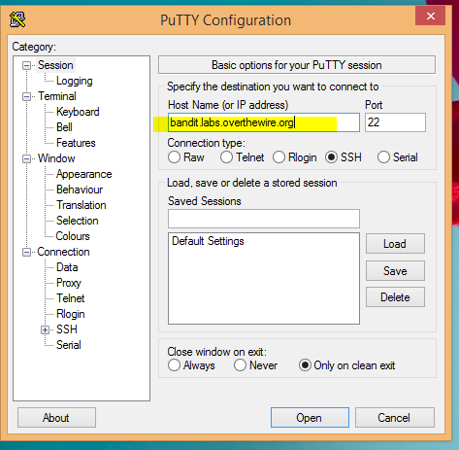

Login As

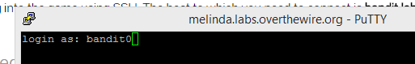

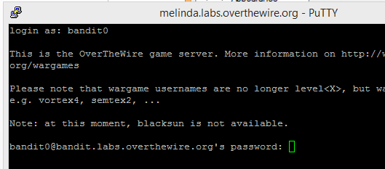

# Bandit Level 0 → Level 1

Enter ls command

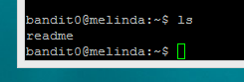

Enter cat readme command

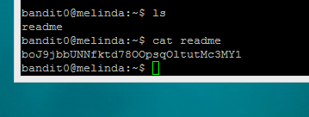

Password: - boJ9jbbUNNfktd78OOpsqOltutMc3MY1

# Bandit Level 1 → Level 2

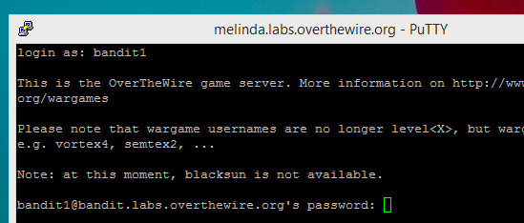

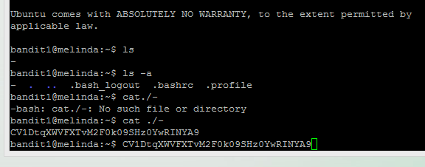

Password - CV1DtqXWVFXTvM2F0k09SHz0YwRINYA9

# Bandit Level 2 → Level 3

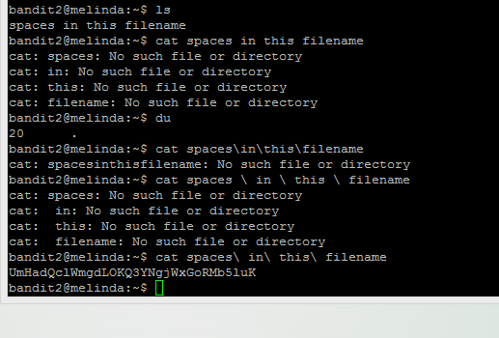

Password - UmHadQclWmgdLOKQ3YNgjWxGoRMb5luK

# Bandit Level 3 → Level 4

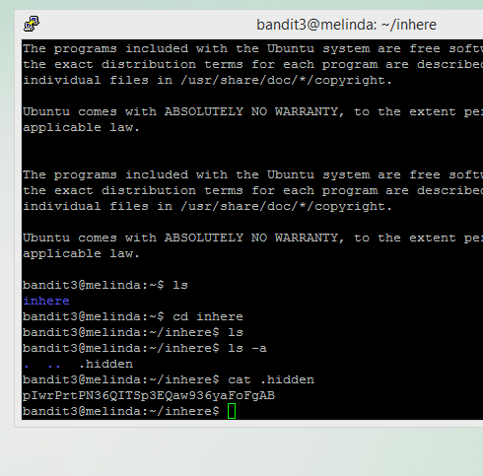

Password - pIwrPrtPN36QITSp3EQaw936yaFoFgAB

# Bandit Level 4 → Level 5

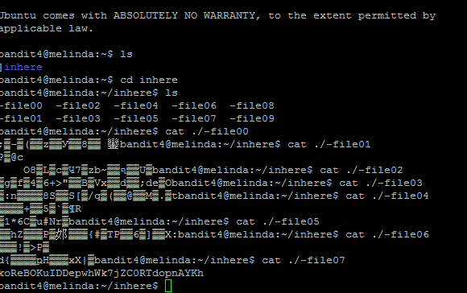

Password - koReBOKuIDDepwhWk7jZC0RTdopnAYKh

# Bandit Level 5 → Level 6

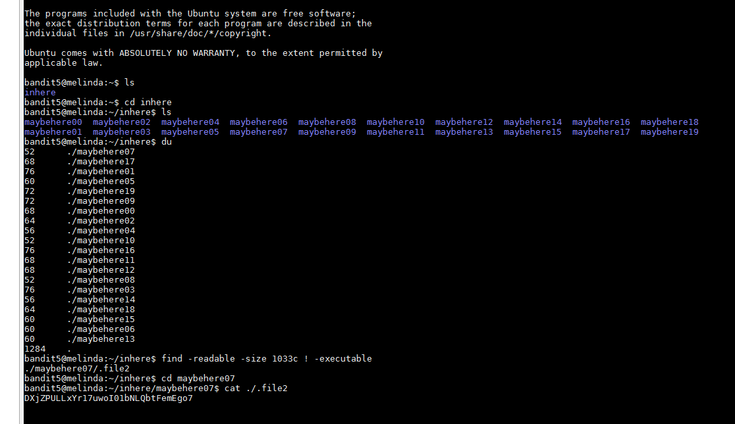

Password - DXjZPULLxYr17uwoI01bNLQbtFemEgo7

# Bandit Level 6 → Level 7

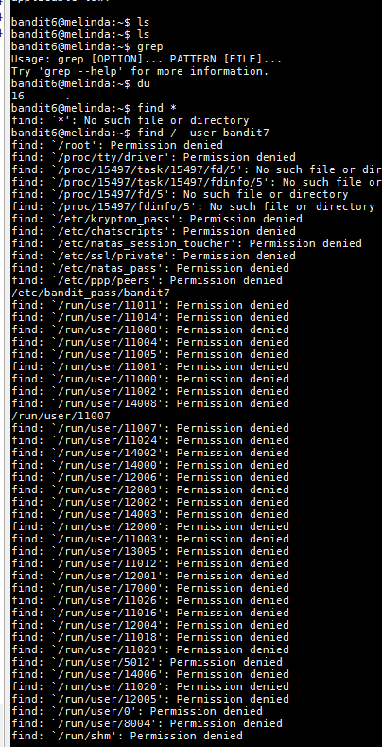

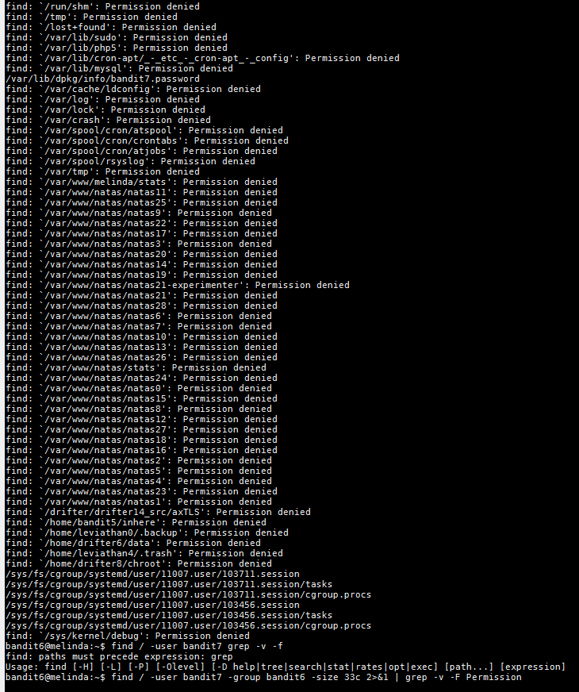

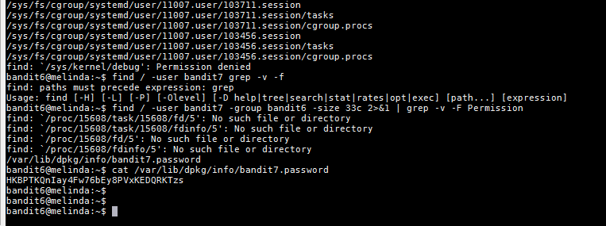

Password - HKBPTKQnIay4Fw76bEy8PVxKEDQRKTzs

# Bandit Level 7 → Level 8

<http://linux.die.net/Linux-CLI/finding-text-within-files.html>

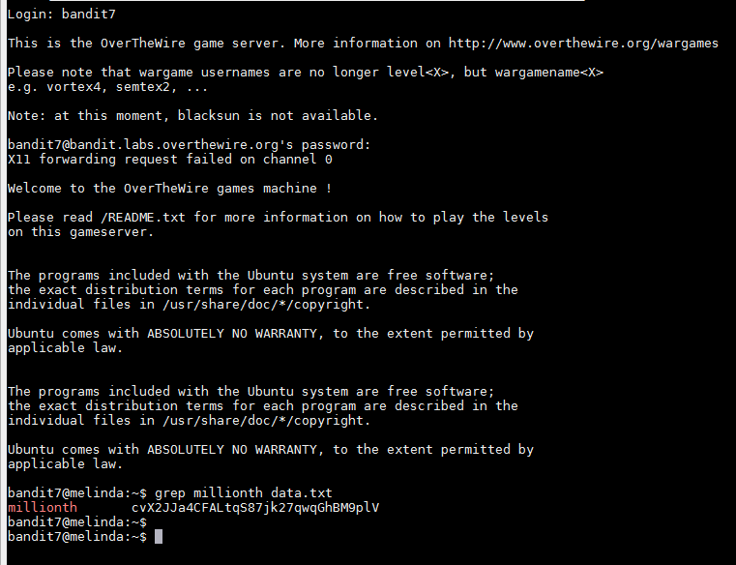

Password - cvX2JJa4CFALtqS87jk27qwqGhBM9plV

# Bandit Level 8 → Level 9

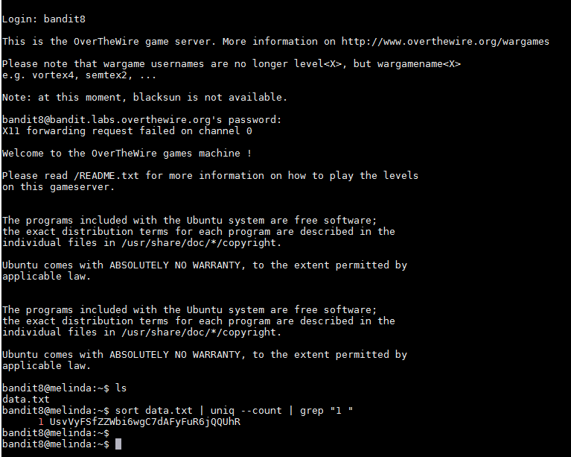

Password - UsvVyFSfZZWbi6wgC7dAFyFuR6jQQUhR

# Bandit Level 9 → Level 10

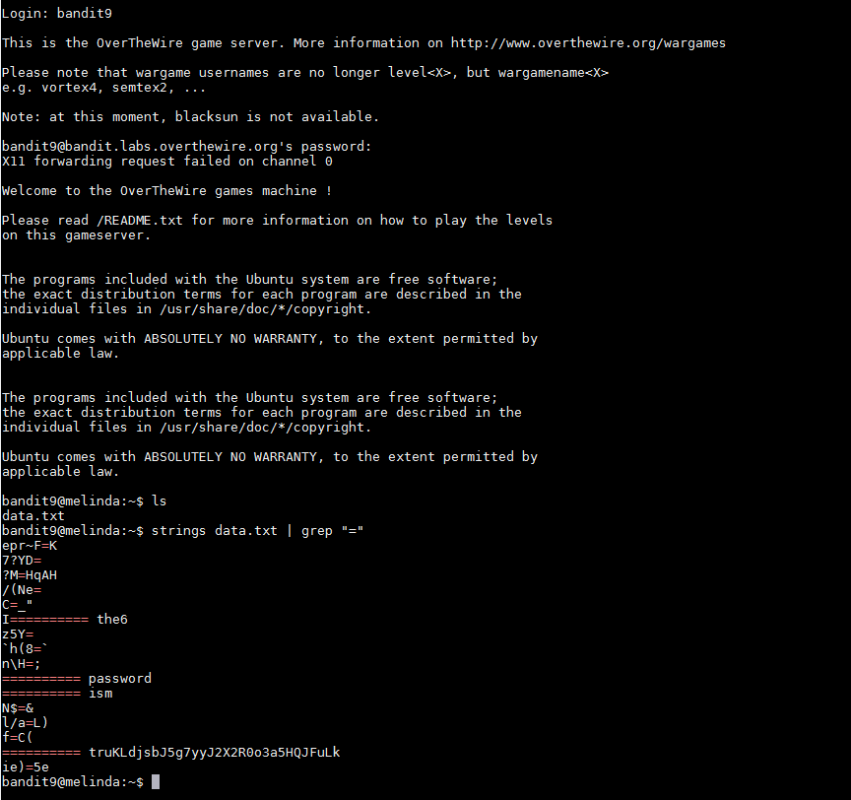

Password- truKLdjsbJ5g7yyJ2X2R0o3a5HQJFuLk

# Bandit Level 10 → Level 11

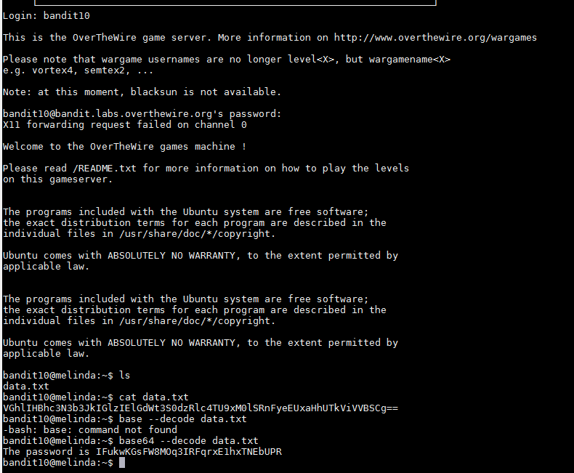

Password - IFukwKGsFW8MOq3IRFqrxE1hxTNEbUPR

# Bandit Level 11 → Level 12

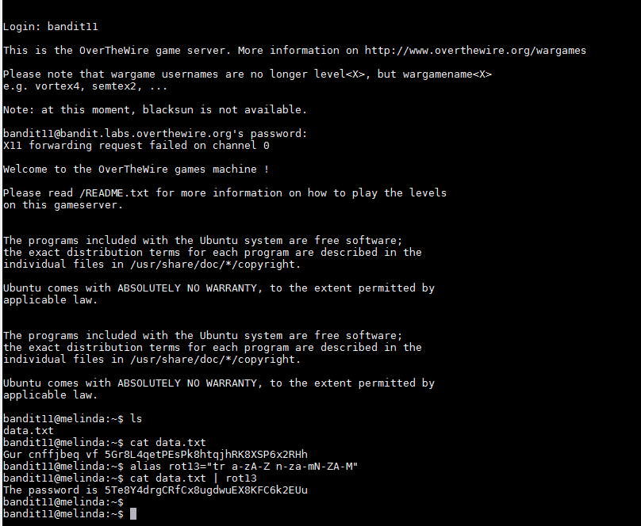

Password - 5Te8Y4drgCRfCx8ugdwuEX8KFC6k2EUu

# Bandit Level 12 → Level 13

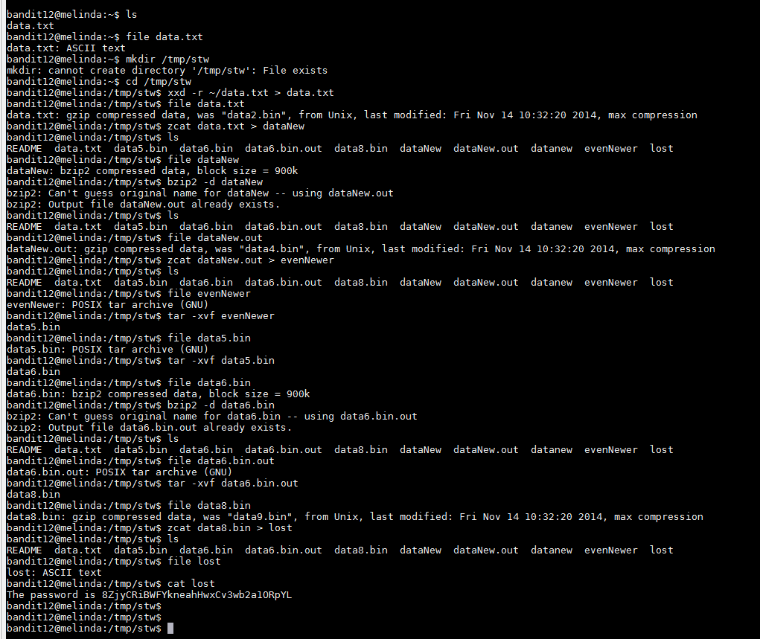

Password - 8ZjyCRiBWFYkneahHwxCv3wb2a1ORpYL

# Bandit Level 13 → Level 14

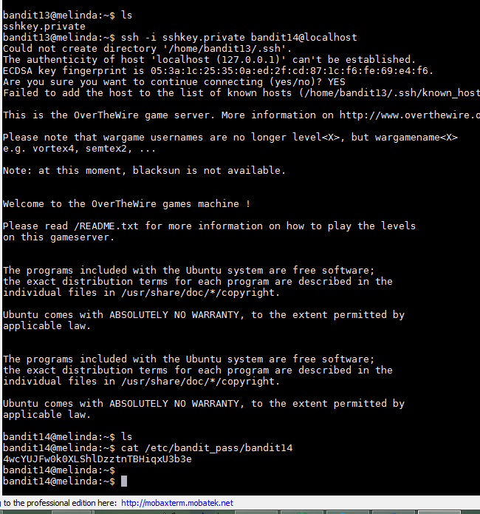

Password - 4wcYUJFw0k0XLShlDzztnTBHiqxU3b3e

# Bandit Level 14 → Level 15

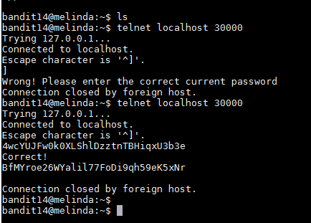

Password - BfMYroe26WYalil77FoDi9qh59eK5xNr

# Bandit Level 15 → Level 16

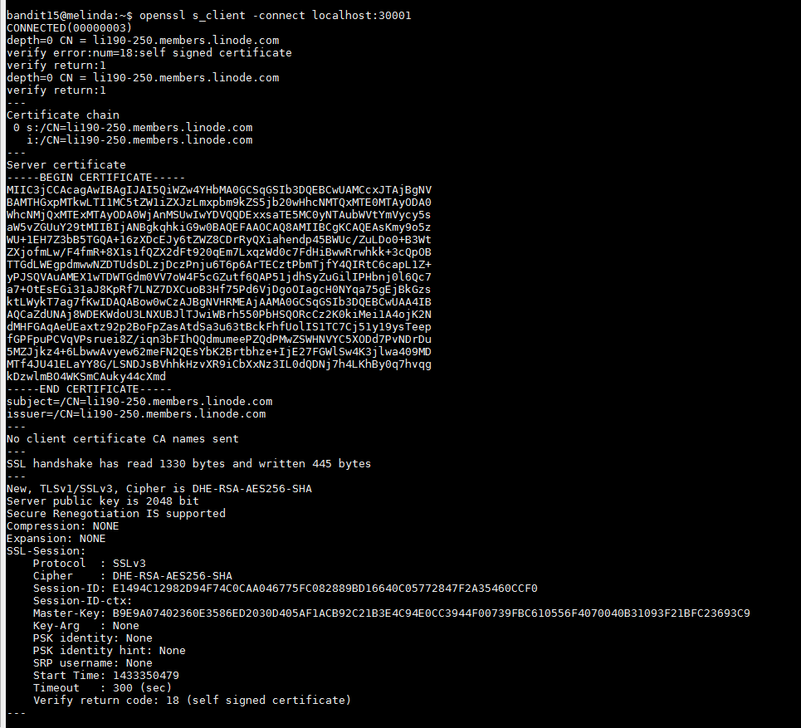

Password - cluFn7wTiGryunymYOu4RcffSxQluehd

# Bandit Level 16 → Level 17

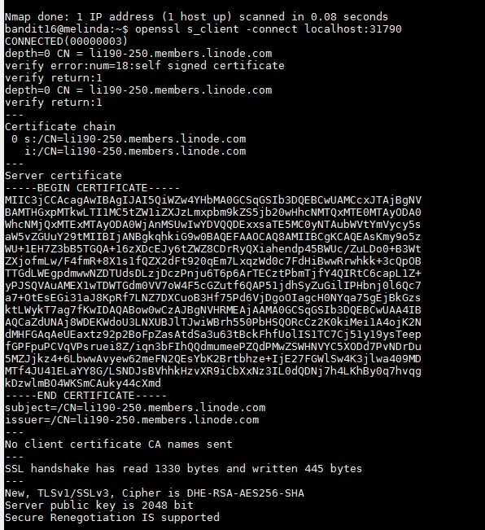

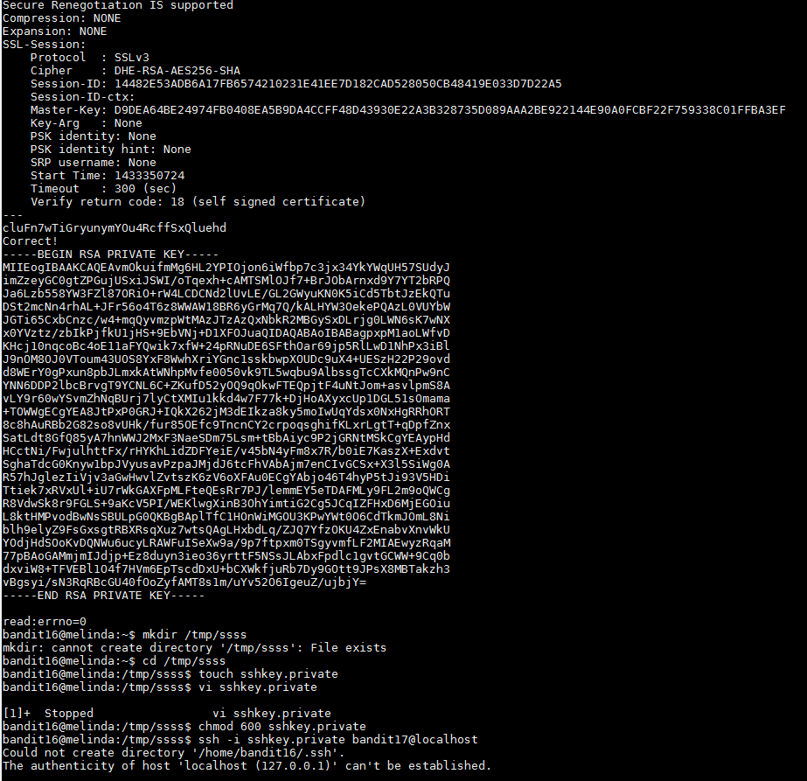

# 

# Bandit Level 17 → Level 18

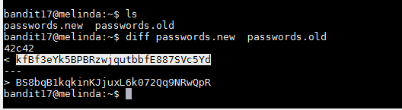

Password - kfBf3eYk5BPBRzwjqutbbfE887SVc5Yd