PRESENTATION ON:
CLIMATE CHANGE AND
ENGINEERING SOLUTIONS

Presented By:
S.S.Nishanth
I B.E.ECE
25012293

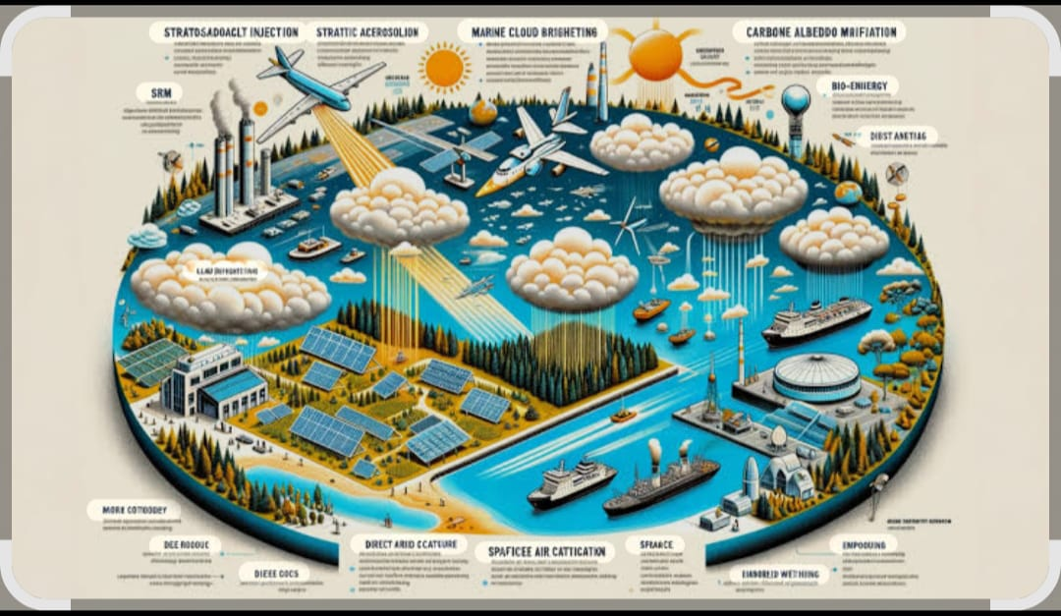

Climate Change and Engineering Solutions

Introduction
Climate change is one of the most significant global challenges of the 21st century. It is primarily driven by human activities such as burning fossil fuels, industrial processes, deforestation, and unsustainable land use. The impacts of climate change include rising global temperatures, extreme weather events, sea-level rise, and threats to biodiversity, agriculture, and water resources.

Causes of Climate Change
1. Greenhouse gas emissions from fossil fuel combustion
2. Deforestation and land degradation
3. Industrial and agricultural emissions
4. Waste generation and improper waste management

Effects of Climate Change
1. Increased frequency of droughts, floods, and cyclones
2. Rising sea levels and coastal erosion
3. Disruption of ecosystems and loss of species
4. Threats to food security and human health

Engineering Solutions to Combat Climate Change

Engineering plays a vital role in addressing climate change by developing sustainable technologies and systems that reduce emissions and enhance resilience. Key engineering solutions include:
• Renewable Energy Technologies: Solar, wind, hydro, geothermal, and biomass energy systems reduce dependence on fossil fuels.
• Green Building and Sustainable Architecture: Energy-efficient buildings, smart HVAC systems, and low-carbon materials.
• Carbon Capture and Storage (CCS): Technologies that trap and store carbon dioxide from industrial sources.
• Electric and Hybrid Transportation: Reduces emissions from the transport sector.
• Smart Grids and Energy Storage: Improves efficiency and stability of power systems.
• Waste-to-Energy Systems: Converts waste materials into usable energy.
• Water and Environmental Engineering: Flood control, coastal protection, and sustainable water management.

Conclusion
In conclusion, climate change is one of the most critical challenges facing the world today, affecting natural ecosystems, human life, and global development. Rising temperatures, extreme weather events, and environmental degradation highlight the urgent need for effective action. Addressing climate change is essential not only for protecting the environment but also for ensuring sustainable growth and a safe future for upcoming generations.
Engineering solutions play a vital role in combating climate change by offering practical and innovative approaches to reduce environmental impact. Through the development of renewable energy technologies, energy-efficient systems, sustainable infrastructure, and eco-friendly industrial processes, engineers contribute significantly to lowering greenhouse gas emissions. These solutions help balance technological progress with environmental responsibility.
Furthermore, engineering supports climate adaptation by strengthening resilience against climate-related risks. Climate-resilient infrastructure, smart resource management, and advanced monitoring systems help communities adapt to changing conditions. By integrating sustainability into engineering practices, engineers can lead the transition toward a greener, more resilient, and sustainable future for the planet 🌍💪

