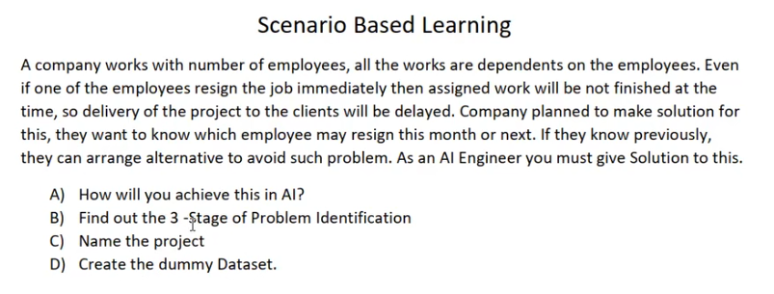
Scenario :
Exact Requirement : if one of the employees resign the job immediately, then assigned work be not finished at the time.so project delayed.
Solution : They want to know which employee may resign this month or next. If we know previously , they can arrange alternative to avoid such problem.
As an AI Engineer must given solution to this.
Analysis :
Employees still not resigned. But we need to identify which employee will be resign.
Output will be resign this month or next month.

Machine Learning : From Analysis, input employee will Active or WillResign Category (input 1/2 )
Supervised : Clear input details and We have to find specific output Current Month / Next Month.
Classification : we need to predict the resigning month is Current Month or Next Month (Not Date)

Predictions from following input : we need to take this attribute and provide some rank employee and decide the category is 1 is Active or 2 is willResign.
Resigned/Left: we use historical data where this is already known to train the model so it can predict this value for current employees.

Monthly internal Surveys : (0.0 to 1.0) Usually from internal surveys.
Employee Salary vs Market Employee Salary
Salary Increment - If an employee hasn't been increased salary in 3+ years, their resignation risk spikes.
Last promotion - If an employee hasn't been promoted in 5+ years, their resignation risk spikes.
Average monthly hours : High hours suggest burnout; very low hours suggest "quiet quitting."
High Over Time: (Yes/No) A strong predictor of burnout.
Number of project handling
Complaints / Sick Leave
Distance from Home
Exist data – will train and find from resign data
Emp_ID | Designation | Survey_Score (1-10) | Salary_Ratio (Internal/Market) | No_Inc_3yrs | No_Promo_5yrs | Avg_Monthly_Hours | Projects | Sick_Leave (Days) | Dist_From_Office (km) | Status (Target)
101 | Sr. Developer | 4.2 | 0.85 | Yes | Yes | 240 | 6 | 12 | 45 | Resigned
102 | HR Manager | 8.5 | 1.1 | No | No | 165 | 3 | 2 | 5 | Active
103 | Data Analyst | 3.1 | 0.75 | Yes | No | 265 | 7 | 15 | 30 | Resigned
104 | Tech Lead | 7.9 | 1.05 | No | No | 180 | 4 | 4 | 12 | Active
105 | Designer | 5.5 | 0.9 | Yes | Yes | 195 | 5 | 8 | 50 | Resigned
106 | Jr. Developer | 9 | 0.95 | No | No | 170 | 2 | 1 | 8 | Active

Resigned – will resigin 2 / Active 1

