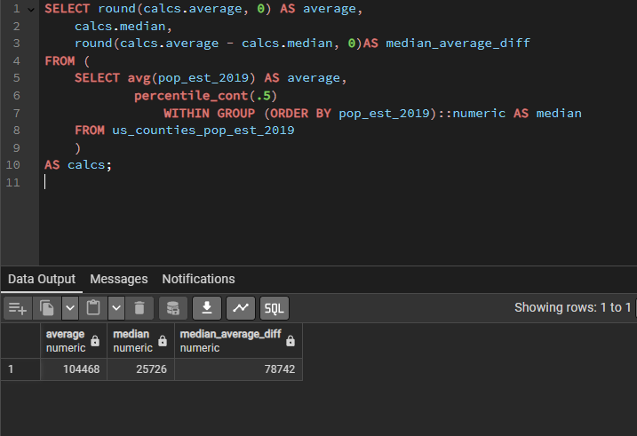

N.B.: The difference between the median and average is 78,742, which is nearly 3 times
the size of the median. This indicates that some high-population counties are inflating the average.

