Window Functions – perform calculations across a set of rows relative to the current row.

Ranking Functions:
RANK()
DENSE RANK()
ROW_NUMBER()

Aggregate Functions
SUM(), AVG, MIN(),MAX( ), COUNT()

Lead and Lag Functions
LEAD () - accesses data from subsequent rows
LAG() – accesses data from preceding rows

Percentile Functions
PERCENT RANK() -relative rank within a group of values
CUME_DIST() – cumulative distribution of a value within a group of values

---------------------------------------------------------------------------------------------------------------
A simple Rank and Dense Rank example. 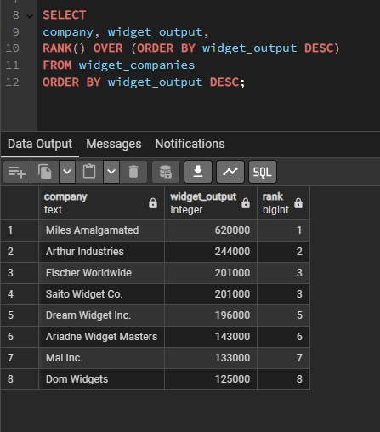

This example creates ranks within groups of rows .
(In this example ordering food categories for each store)

Each row here includes a store’s product category and sales for that category.
The SELECT statement creates a result showing how each store’s sales ranks within each category. – The PARTITION BY OVER clause tells the in the first window (line 2) creates rankings one category at a time, using the store’s unit sales in descending order.
The final ORDER BY clause includes the category column and the same RANK() function syntax.
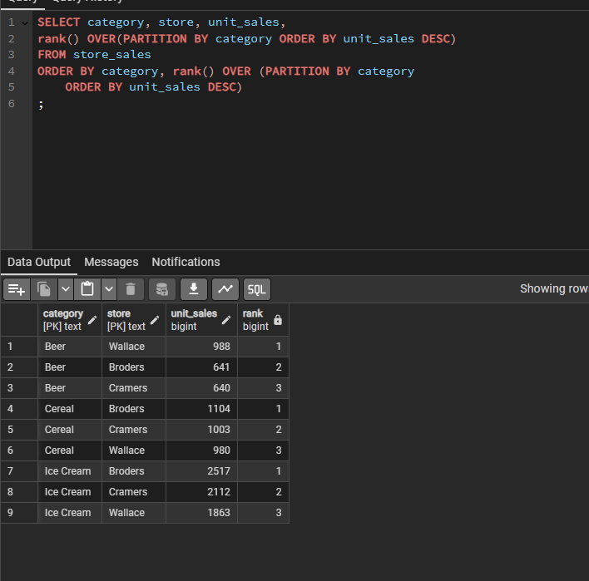

For reference here is the entire table without any filters:
