Global information tracker
So for application we need multiple developers
Developers use their local computers so to have all the source code we use git
Developers use git to commit the information and save their repository in github or gitlab
Git is version control system
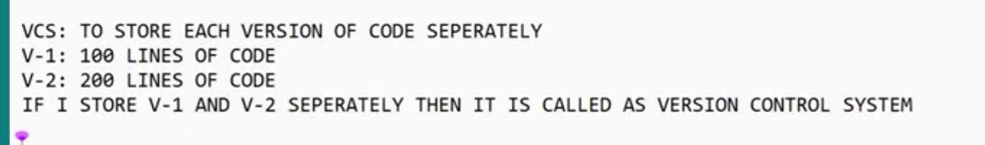
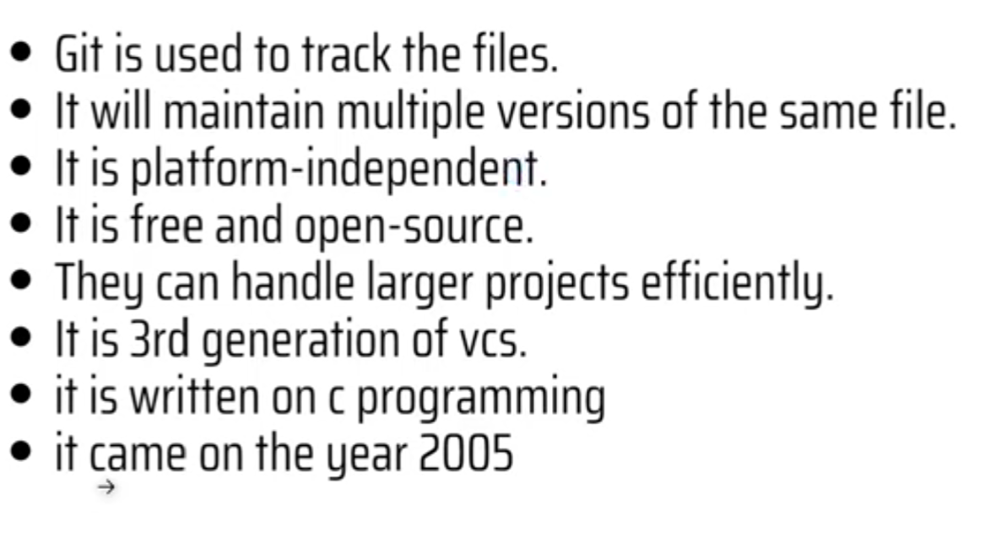
Git is distributed control system as it can store multiple repositories
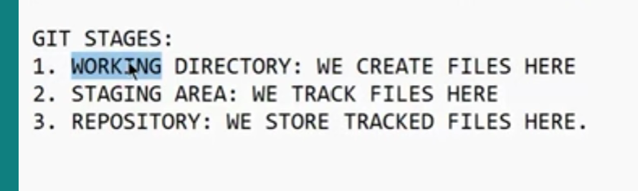
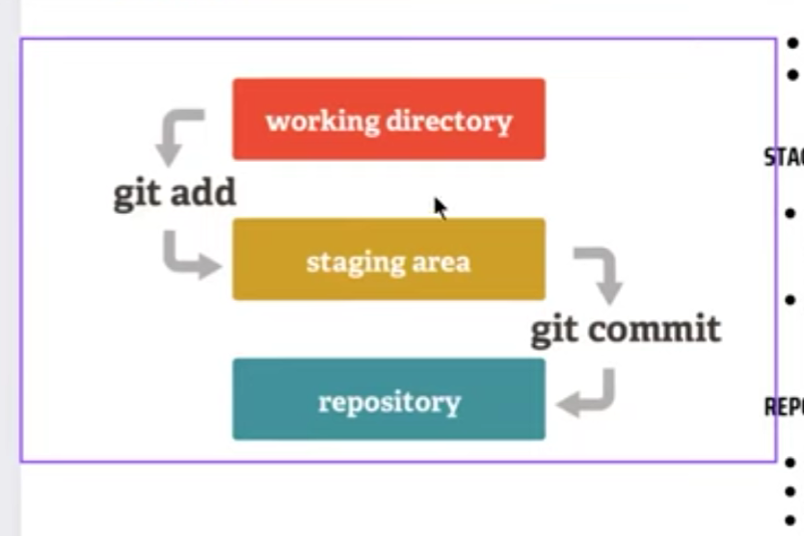
Working directory is the directory in which we work
Staging area is the we store the files and get tracked
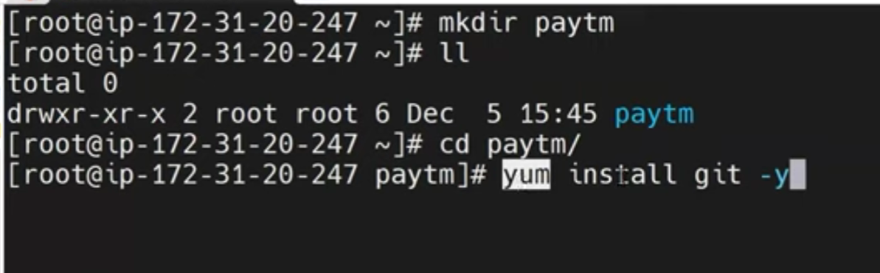
Mkdir is used to create the folder
Yum is the package manager and it gets installed on the server
Git init is used to go into the git [you have to use it every time when you go into new folder]
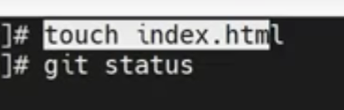
It is used to create the index.html and status will give in which status it is either tracked or untracked if it is tracked then it is in green color if it is in red color then it is untracked
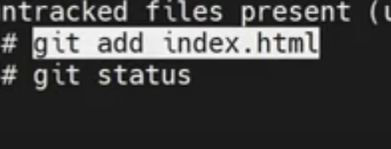
Add will helps to get tracked
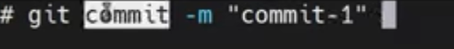
See we are giving message while committing and its compulsory
It commits and save it into the repository
And if you give the status it doesnot appear as it is saved in the repository
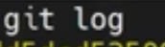
It gives all the commits done by the user
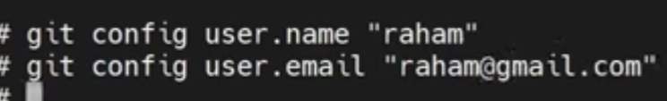
If you want to know which user has commited then better change your email and name
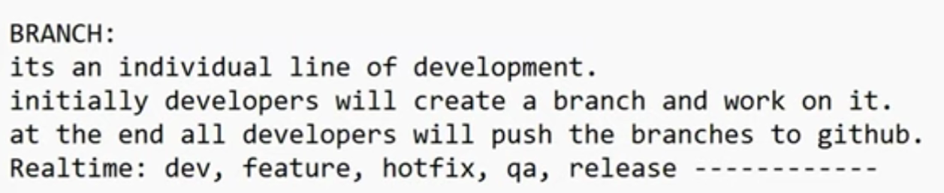
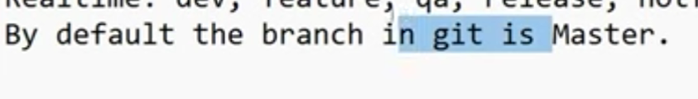
You can see the branch when initial commit is done
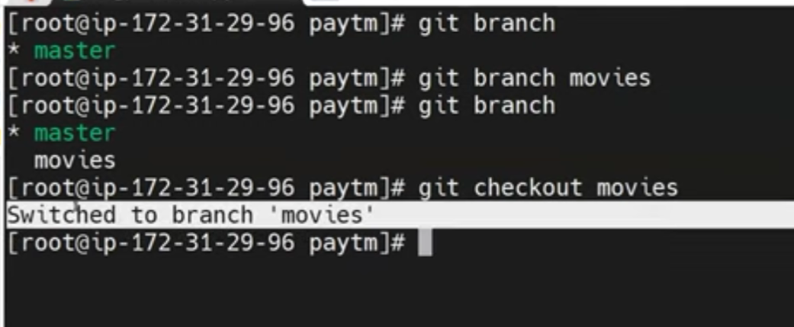
Git branch movies create new branch
No developer works on main branch they work on their designated branch
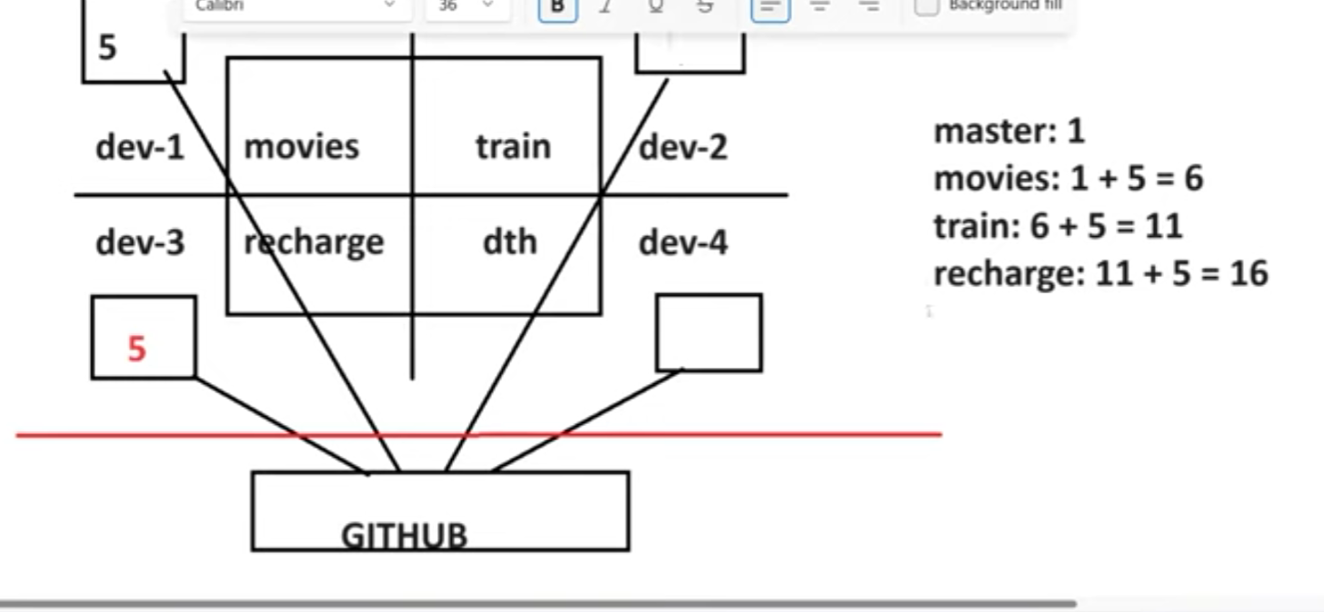
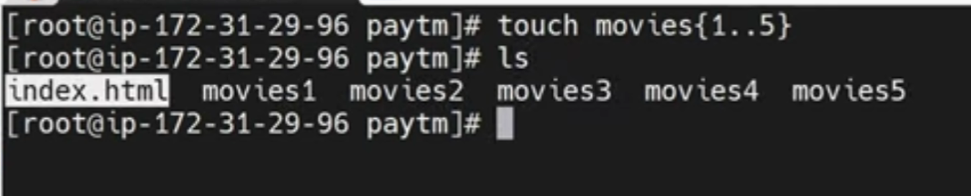
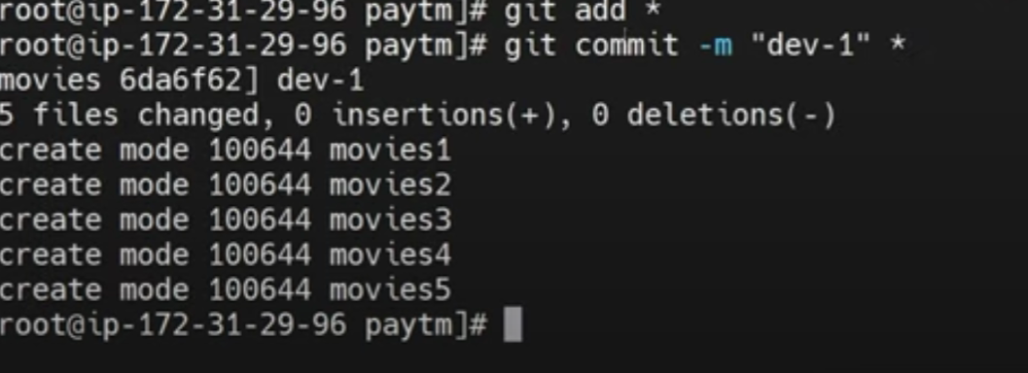
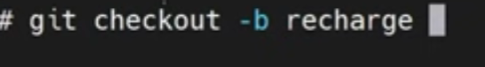
With the help of this branch we can create and checkout to that branch

