UIUC Lithography

Micro-stencil

- Suhas Somnath

somnath2@illinois.edu

University of Illinois Urbana-Champaign

1206 W. Green Street, Room 64

Mechanical Engineering Building

Urbana 61801

Last Updated: 2/13/2011

UIUC – Micro-Stencil

## Overview

Asylum Research provides a “bitmap” tool that reads a user specified image file and generates sets of patterns that mimic the original image. It becomes the user’s responsibility to remove any unwanted features from the images such as the background, etc. as the software package is not able to differentiate such features for the user. This UIUC-Micro Stencil package complements the Smart Litho package by providing the user the ability to conveniently generate a customized line-image and import it into Igor PRO using Smart Litho.

## Installing & starting Micro-stencil

Once the current directory in Matlab is directed towards the folder containing the two MicroStencil files, MicroStencil can be executed by typing “MicroStencil” in the command prompt. Note – This application requires the ‘Image Processing’ package on Matlab.

## Using Micro-Stencil

Once the suite is started up, the Micro-Stencil window is presented and following steps are followed to generate the custom line image:

1. The background image that is to be used as a guide or a stencil is loaded by clicking on the **Load Image** button.
2. Once the **Start Chain** button is clicked, the user clicks on points in the image to create a chain of connected line segments between these points as shown in Fig. 1 a. On hitting the return or **Enter** key on the keyboard, the user can complete the current series of connected line segments. At this point, red stars connected via line segments are presented delineating the completed chain of line segments
3. Step 2 is repeated if required to make other connected segments.
4. Once the desired line image is formed, the user may click on the **Generate Output** button to generate a preview of the formed line-image as shown in Fig. 1 b. A separate window is also presented to save the acquired data to a *.txt file.
5. The **Load from Disk** option is used in the **UIUC Smart Litho** software to load this pattern into Igor Pro as shown in Fig 1 c.

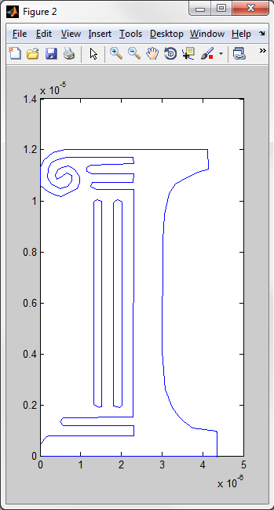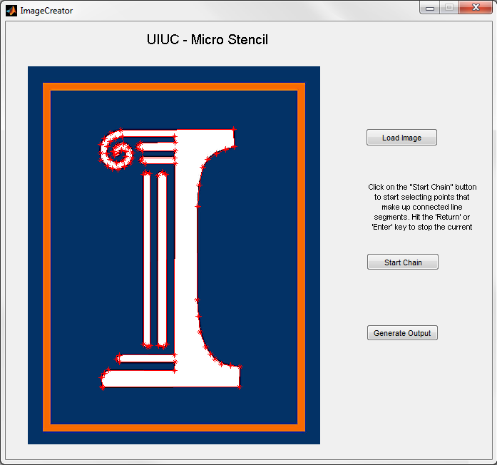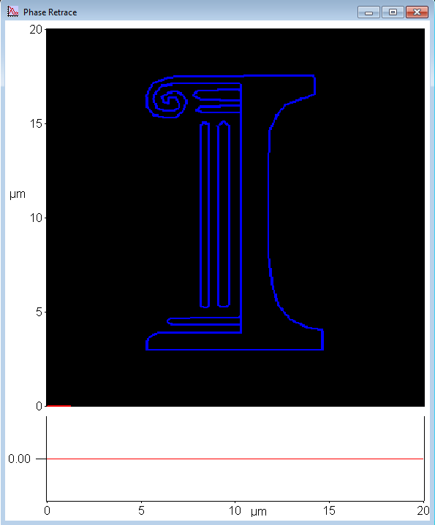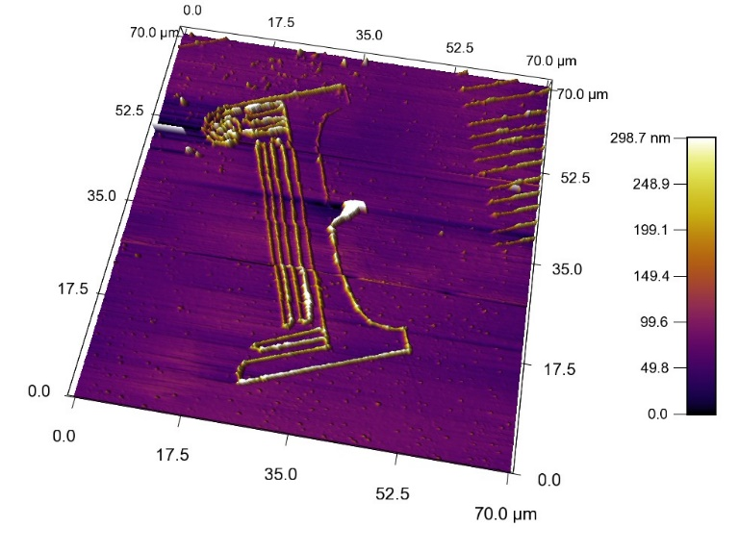

**(a)**

**(b)**

**(c)**

**(d)**

**Fig. 1:** Complete cycle of events that show the interaction between Smart Litho and Micro Stencil. (a) & (b) The creation of a line-image using Micro Stencil. (c) Line image imported into IGOR Pro via Smart Litho. (d) The University of Illinois logo written in poly methyl methacrylate on a ZnSe substrate at 120oC