EXP-3

1. Write a shell script that takes a command line argument and reports on whether it is a directory or a file.

B)Write a shell script that takes file names as arguments and convert all of them to uppercase.

Exp A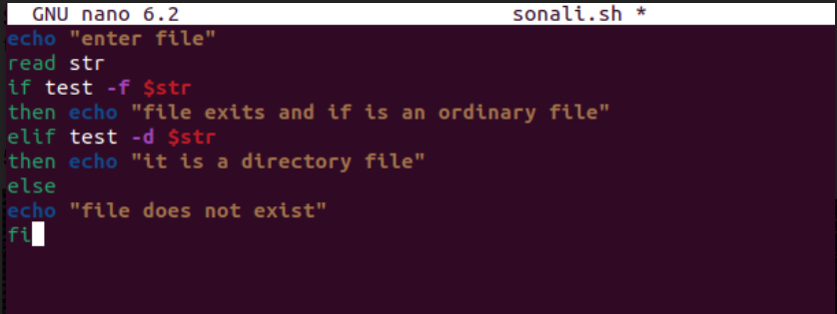

Exp B

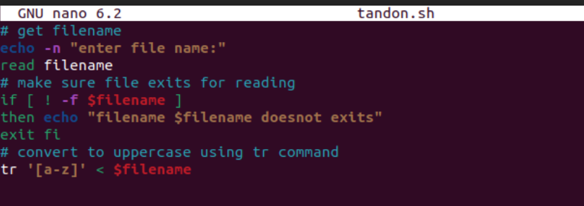

RESULT FOR EXP-3 A&B