EXP -8

Observe and understand the process map of the previous two lab programs (Experiment 6 and Experiment 7)  using pmap command.

Experiment-6

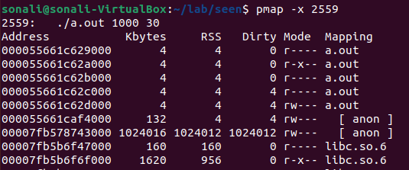

CPU bound

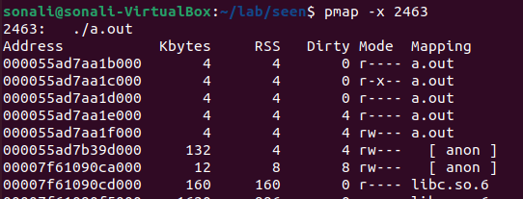

I/O Bound

