Introduction

With over 32 percent of the entire world’s public cloud share, it’s no surprise that [AWS](https://www.simplilearn.com/tutorials/aws-tutorial/what-is-aws) serves more than 190 countries with scalable, reliable, and low-cost infrastructure. One of its most powerful and commonly used services are Amazon EC2 (Elastic Cloud Compute).

Amazon EC2 provides scalable computing capacity in the AWS cloud. Leveraging it enables organizations to develop and deploy applications faster, without needing to invest in hardware upfront. Users can launch virtual servers, configure security and networking, and manage cookies from an intuitive dashboard.

What is Amazon EC2?

Amazon Elastic Compute Cloud (Amazon EC2) provides scalable computing capacity in the Amazon Web Services (AWS) Cloud. Using Amazon EC2 eliminates your need to invest in hardware up front, so you can develop and deploy applications faster. You can use Amazon EC2 to launch as many or as few virtual servers as you need, configure security and networking, and manage storage. Amazon EC2 enables you to scale up or down to handle changes in requirements or spikes in popularity, reducing your need to forecast traffic.

## Features of Amazon EC2

Amazon EC2 provides the following features:

* Virtual computing environments, known as instances
* Preconfigured templates for your instances, known as Amazon Machine Images (AMIs), that package the bits you need for your server (including the operating system and additional software)
* Various configurations of CPU, memory, storage, and networking capacity for your instances, known as instance types
* Secure login information for your instances using key pairs (AWS stores the public key, and you store the private key in a secure place)
* Storage volumes for temporary data that's deleted when you stop, hibernate, or terminate your instance, known as instance store volumes
* Persistent storage volumes for your data using Amazon Elastic Block Store (Amazon EBS), known as Amazon EBS volumes
* Multiple physical locations for your resources, such as instances and Amazon EBS volumes, known as Regions and Availability Zones
* A firewall that enables you to specify the protocols, ports, and source IP ranges that can reach your instances using security groups
* Static IPv4 addresses for dynamic cloud computing, known as Elastic IP addresses
* Metadata, known as tags, that you can create and assign to your Amazon EC2 resources
* Virtual networks you can create that are logically isolated from the rest of the AWS Cloud, and that you can optionally connect to your own network, known as virtual private clouds (VPCs)

## **Why is AWS EC2 important?**

1. You don’t require any hardware units
2. Easily scalable (up or down)
3. You only pay for what you use
4. You have complete control
5. Highly secure
6. You can access your assets from anywhere in the world

## **AWS EC2 Instance Types**

[AWS EC2 instance types](https://intellipaat.com/blog/aws-ec2-instance-types/) determine the underlying hardware of the instances which are launched.

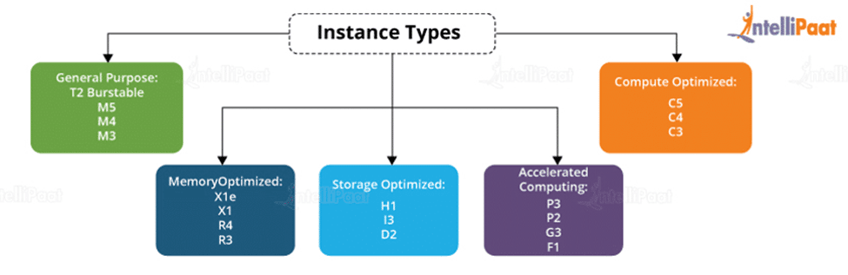

**There are several types of AWS instances with different configurations and benefits.**

* General purpose
* Compute optimized
* Memory-optimized
* Accelerated Computing
* Storage optimized