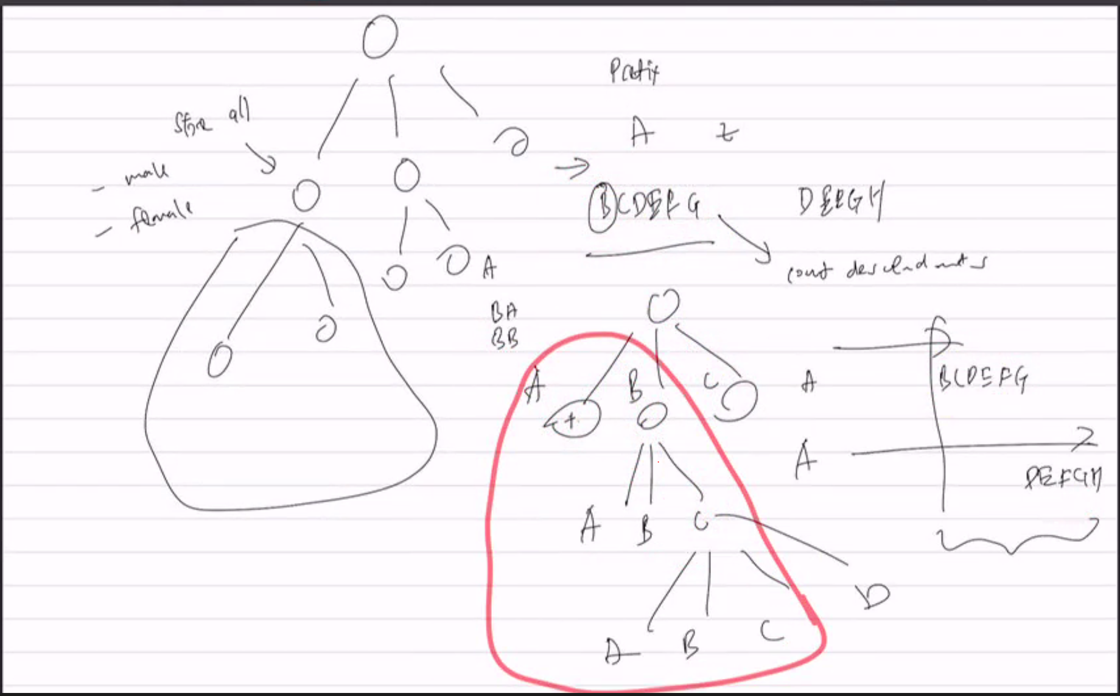

Store decendant number of males and females in each parent node

Finding one word:
Compute from A to starting prefix
Compute from A to ending prefix
Ending prefix total - statrting prefix total (Recursion from the top)
