# Team-plan

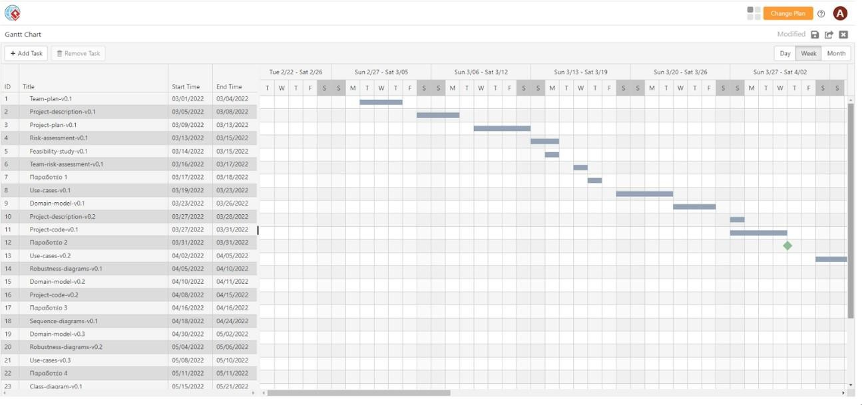

Εικόνα 1: Διάγραμμα Gantt Chart (1ο μέρος)

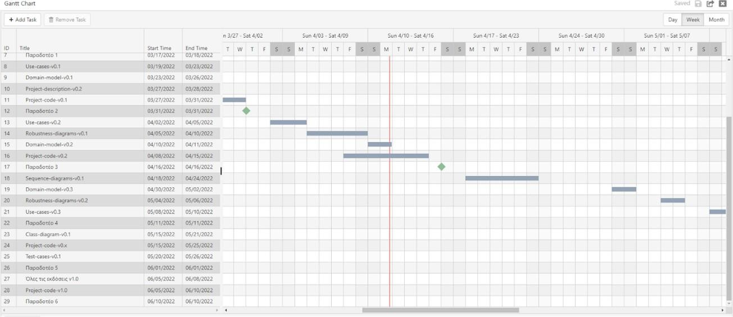

Εικόνα 2: Διάγραμμα Gantt Chart (2ο μέρος)

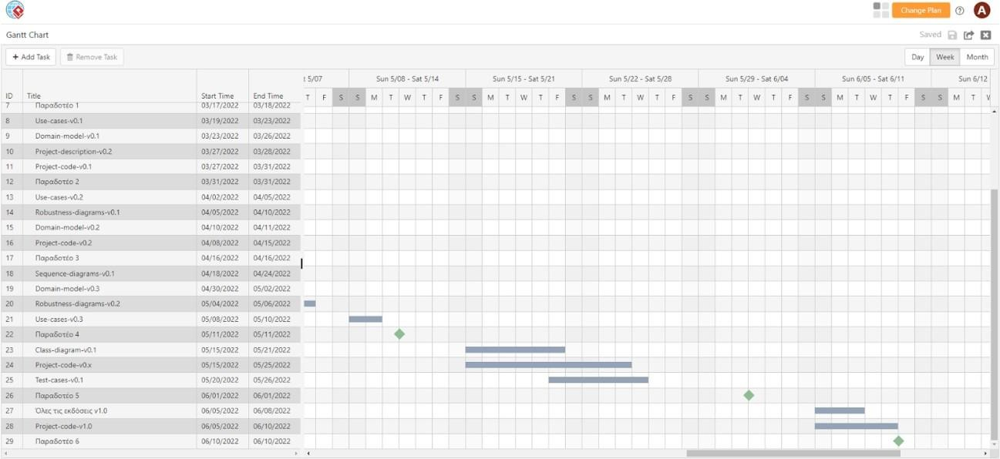

Εικόνα 3: Διάγραμμα Gantt Chart (3ο μέρος)

## 

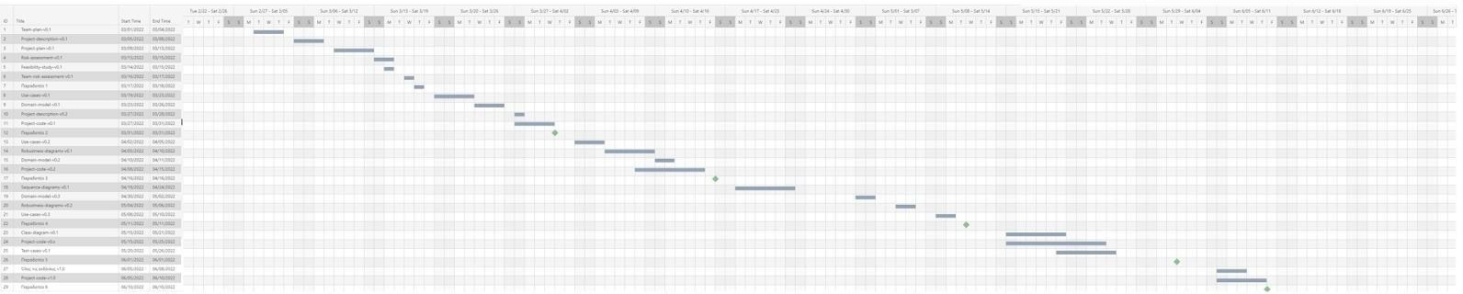

Εικόνα 4: Διάγραμμα Gantt Chart (ολοκληρωμένο)

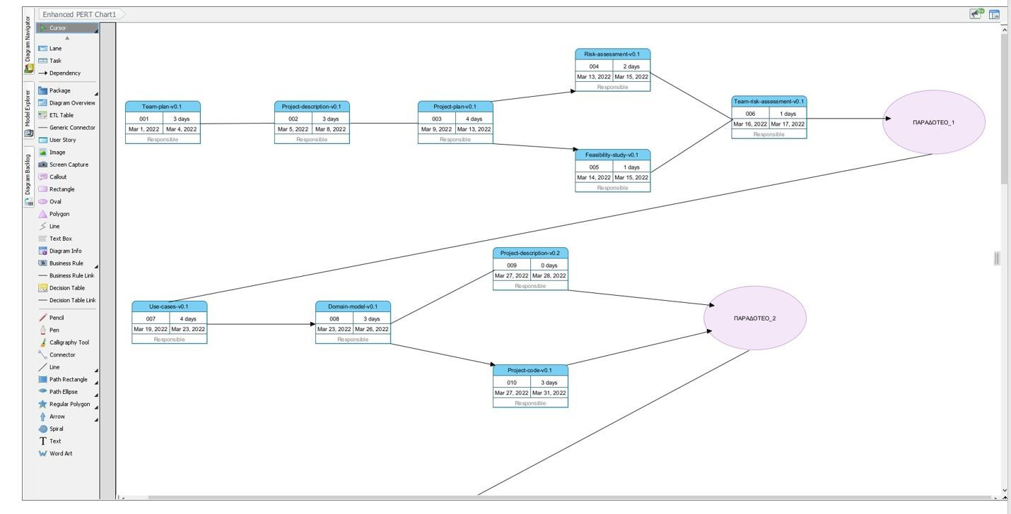

Εικόνα 5: Διάγραμμα Pert Chart (1ο μέρος)

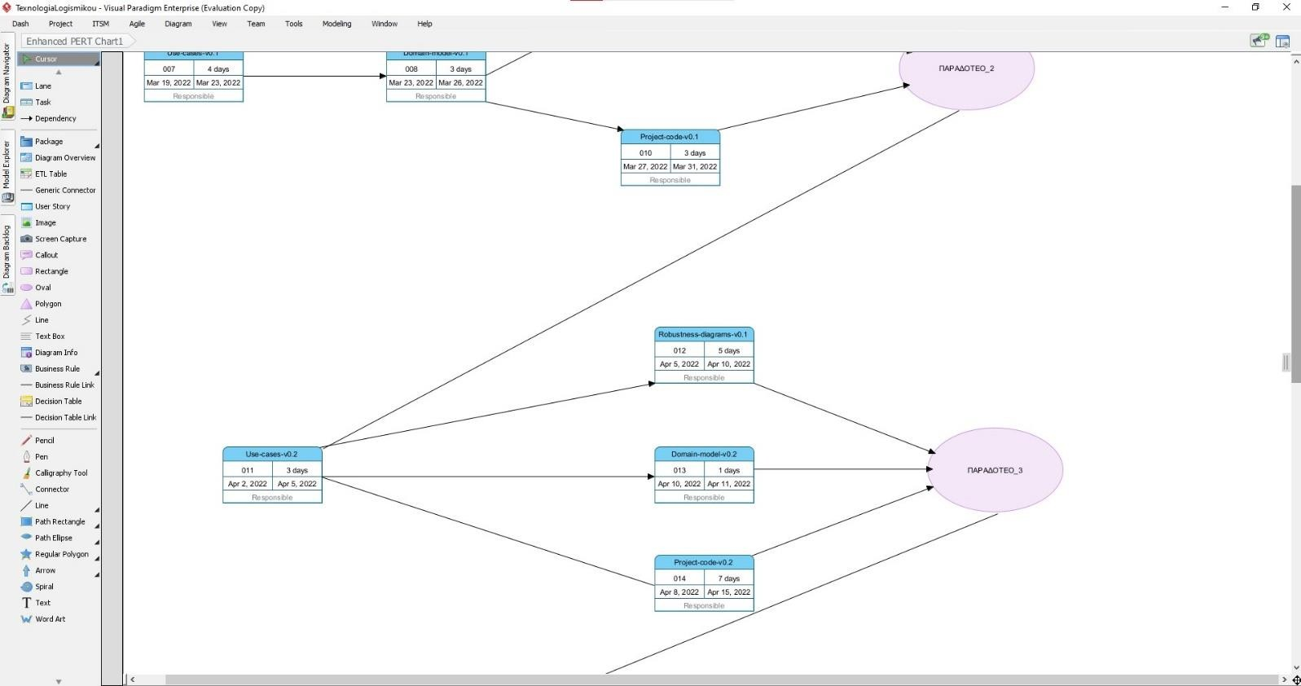

## 

Εικόνα 6: Διάγραμμα Pert Chart (2ο μέρος)

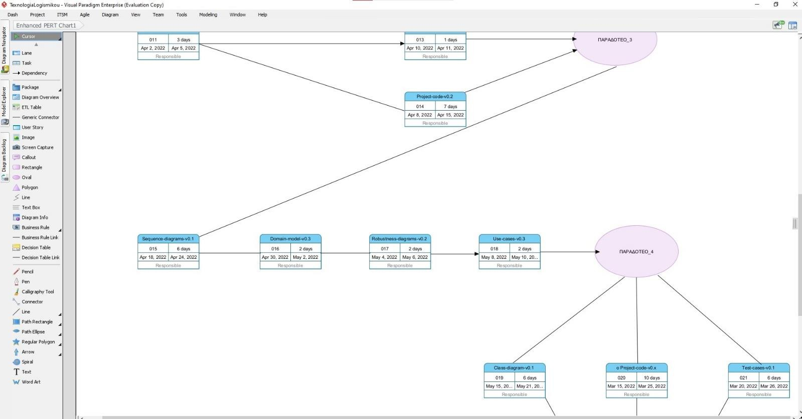

Εικόνα 7: Διάγραμμα Pert Chart (3ο μέρος)

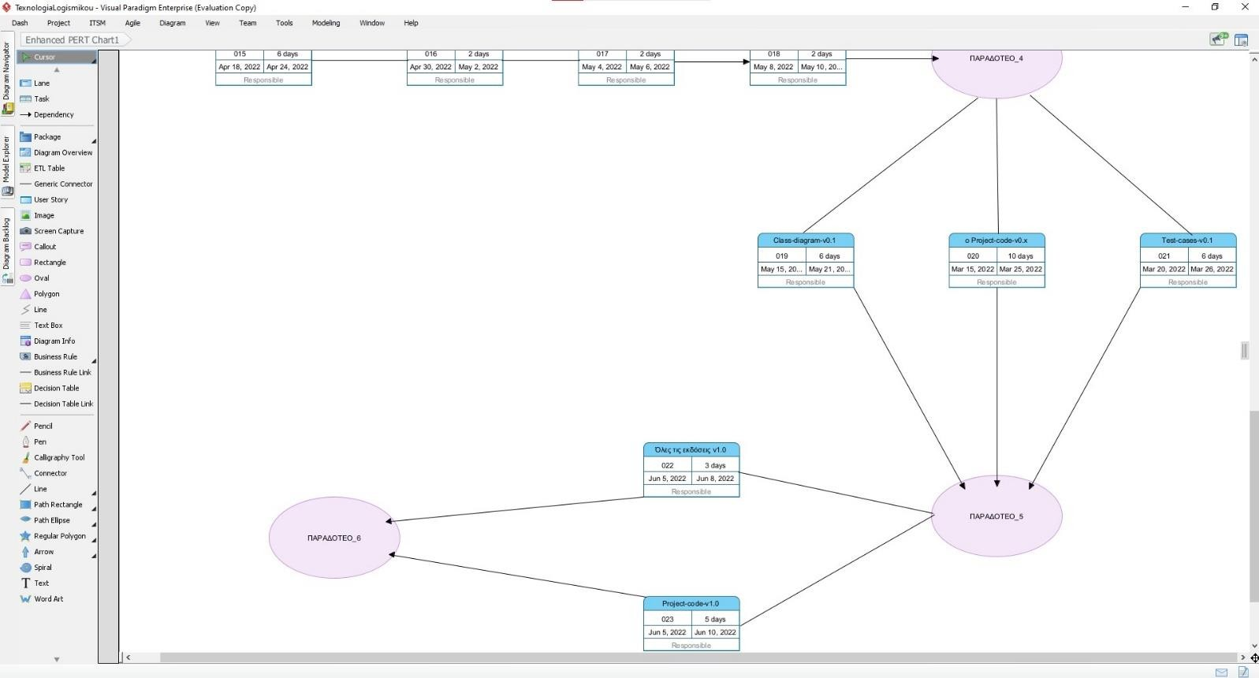

Εικόνα 8: Διάγραμμα Pert Chart (4ο μέρος)

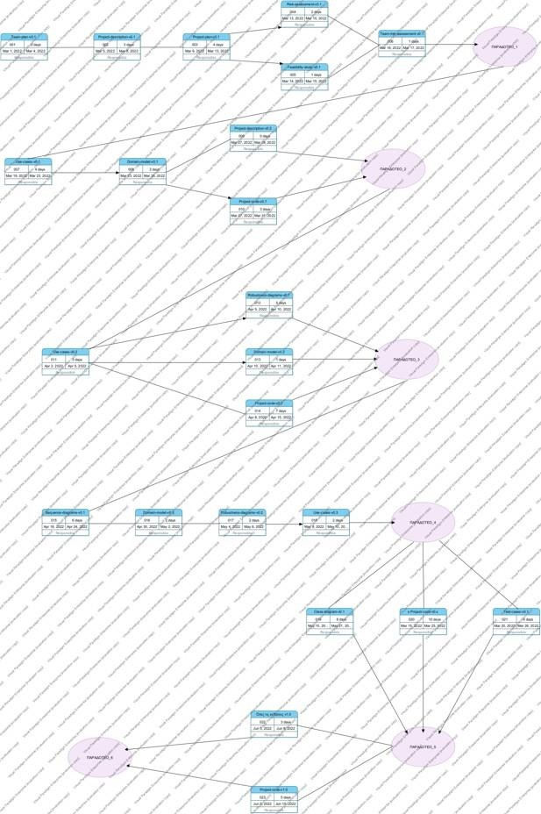

Εικόνα 9: Διάγραμμα Pert Chart (ολοκληρωμένο)

**Method description**

We decided as a team to use the SCRUM method. The SCRUM method-structure aims to create and maintain complex products such as the software that we will build as a team. In order to implement our software, we had to create a team called the SCRUM TEAM. In this group there are the following members: The Scrum master and the developers. There are no hierarchies and our goal is to achieve one goal per sprint. In each sprint, the ideas become a reality, that is, it is the period where our team creates and gets one step closer to the final software we want to produce. Sprints consist of Sprint Planning, Daily Scrums, Sprint Reviews and finally the Sprint Retrospective. So, as a team and depending on the obligations we have, we work as follows: First, we create Planning, that is, we gather the work for the current Sprint and distribute it in order to make an effective plan. Then we use Daily scrums to be informed about our progress. At the end of the sprint we do the Review where we discuss and analyze how effective our work was. In the retrospective we discuss changes that can be made to be more efficient, with analyzes of the tools we use and various other important topics. Our Scrum master is the person in the team who confirms that our method follows the rules of SCRUM. Each member of our team is a developer and contributes equally to the completion of the project.

We consider as a group that the method used worked and that we have a satisfactory result.

**Basic Tools**

The main tools we use are the following:

For IDE, Visual Studio.

For technical texts we use Word.

For the shared repository we use Google Docs and Git-hub.

For object oriented programming language we use C#

Description :

We have made a change in the programming language we will use due to the convenience of our members. The rest of the tools remain the same.