**Moch-up screens**

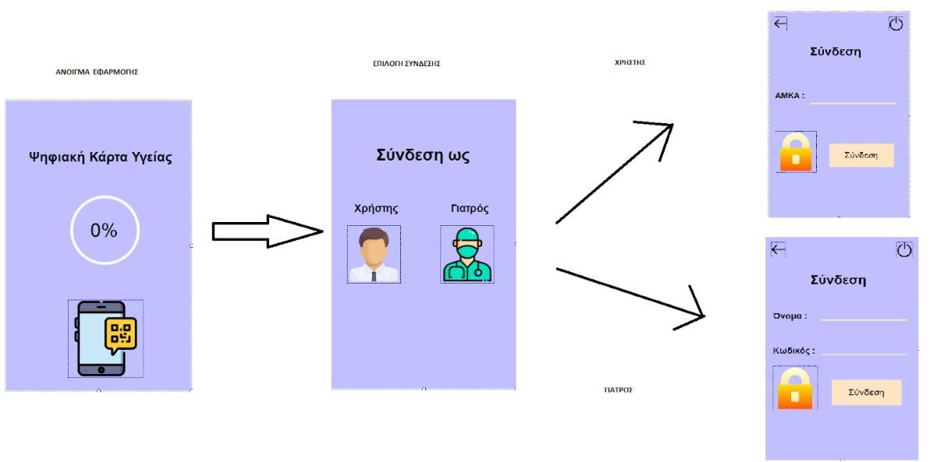

**Mock-ups User**

**:** **Change personal information**

**:** **User History/Diagnoses**

**:** **Appointment with a doctor :** **Vaccination**

**: Prescription :** **Evaluation**

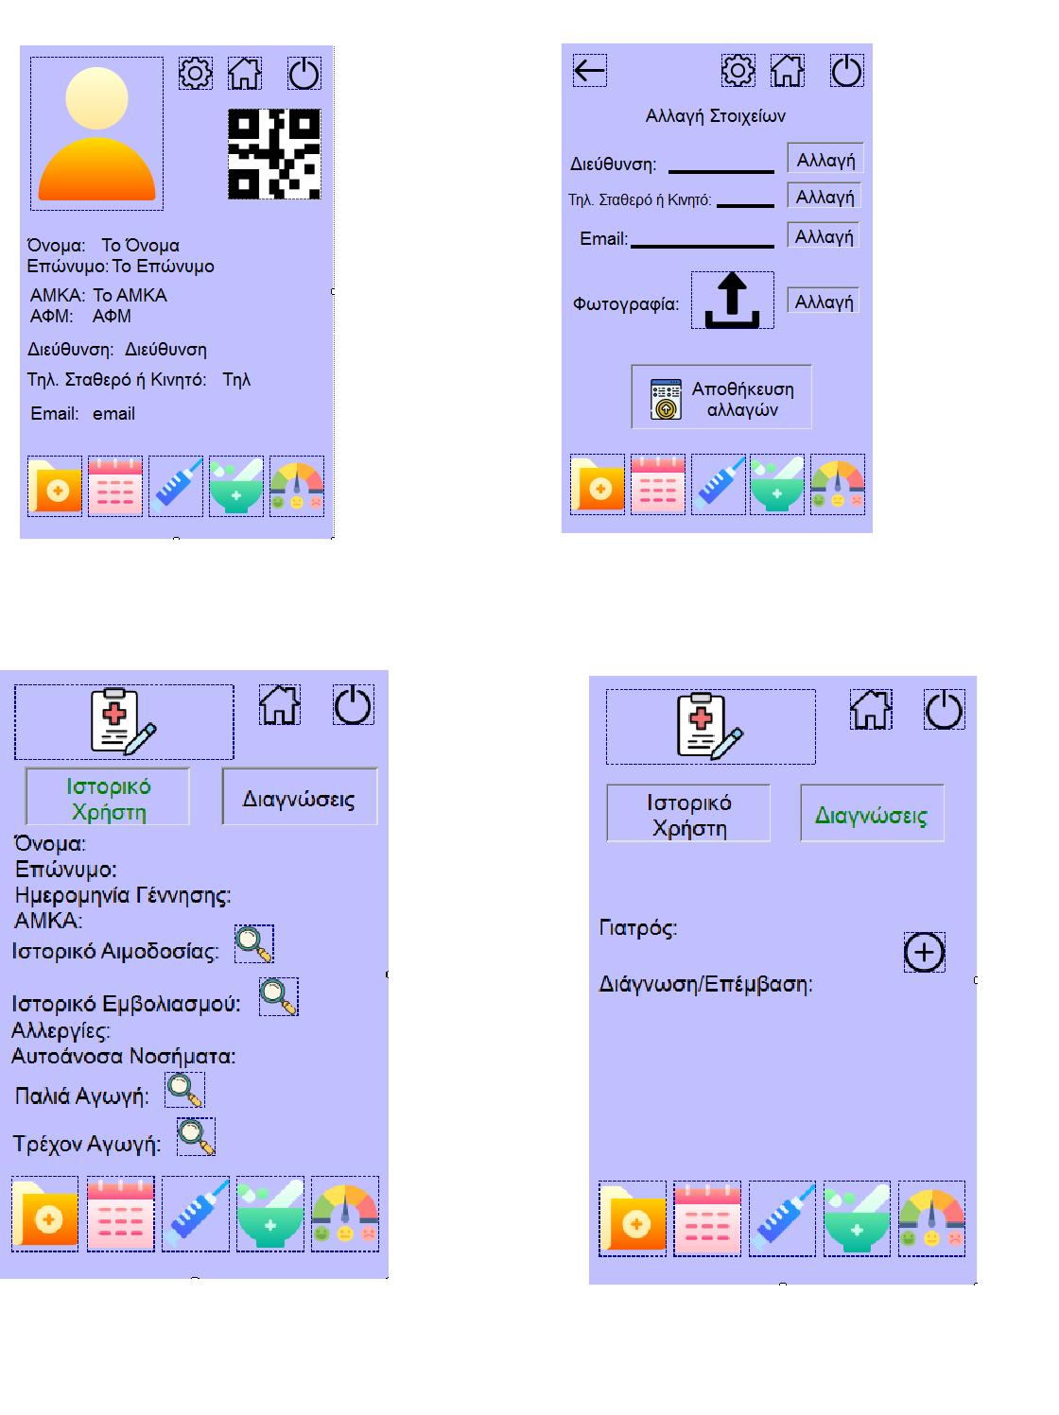

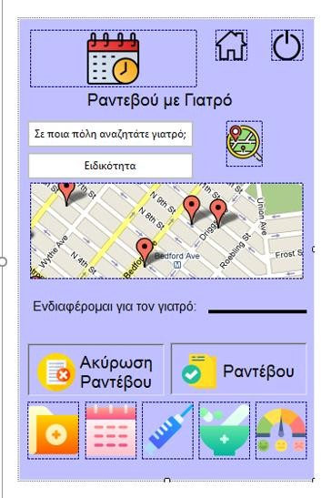

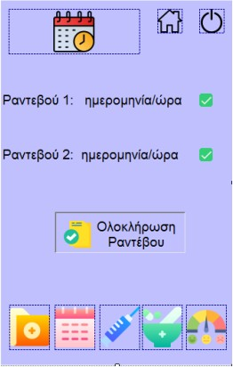

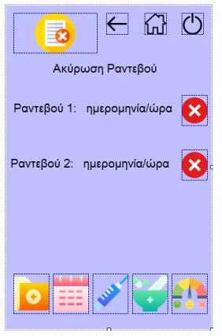

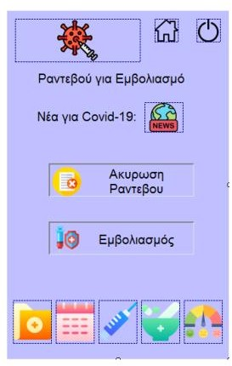

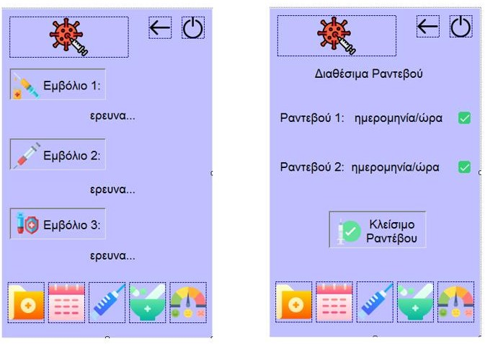

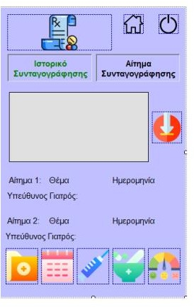

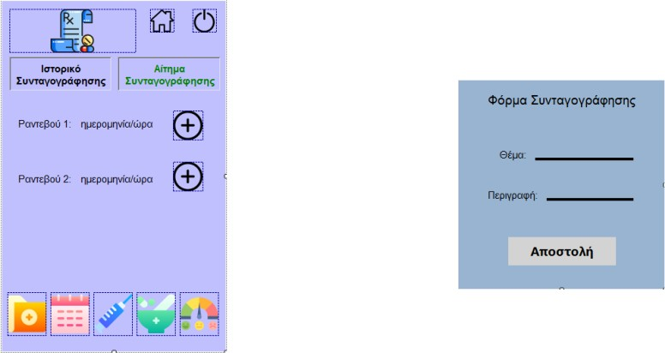

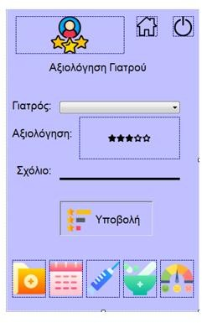

**Mock-ups Γιατρού**

**:** **Change personal information**

**:** **Scanning**

**:** **Declaration of availability for an appointment**

**:** **Declaration of availability for vaccination**

**:** **Prescription drugs**

**:** **Diagnosis**

**: Show rating**

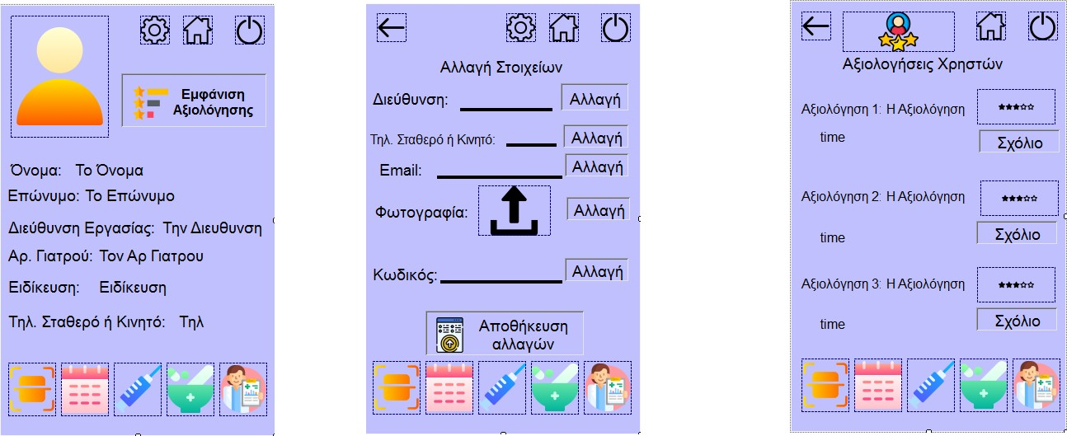

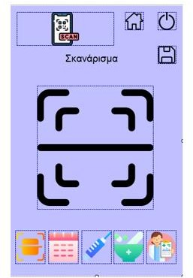

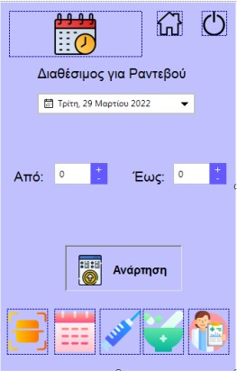

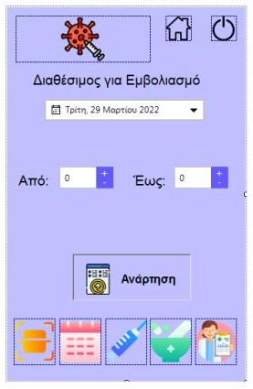

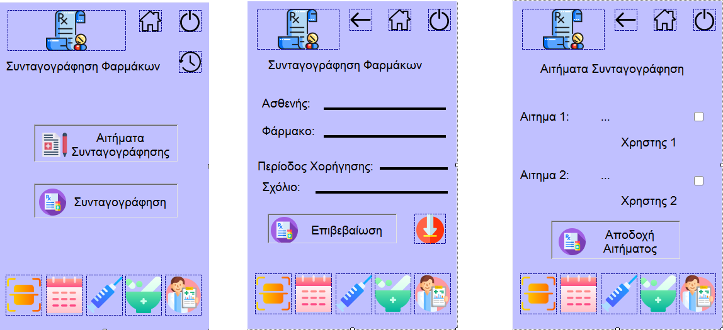

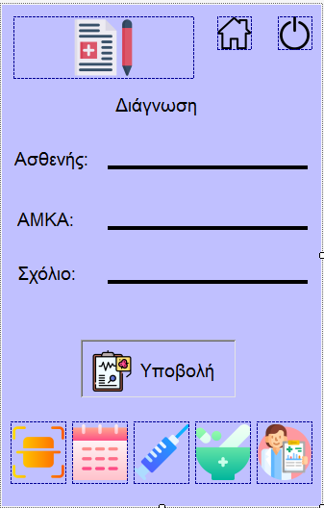

**Project-description**

**DIGITAL HEALTH CARD**

Based on the pandemic and the various problems it caused in the health sector, it is proven that the health system is not able to deal effectively with the epidemics. .With this given, we decided to strengthen the health units by making the following application, in order to limit unnecessary contacts and automate the health procedures. What we thought of is to create an application that will create for each person a digital card with which they can enter health units, universities, etc., after first scanning the QR code that will be on the card in question. The specific idea can, in the way we will implement it (object-oriented), be used in various other areas such as e.g. as a card for entry to shops, universities, gyms and more. But we focused on the health sector by creating a digital health card with many functions. Initially, our software, after receiving the command to run from the user, displays the loading screen which consists of the logo of our application and the progress by 100 which will show when the application is ready.Then, once it loads, it redirects us to the point of connection where we are given two options, the option to connect as a normal user and the option to connect as a doctor (medical). To register the user we use the AMKA with which through the database that we have made, we pull all the user's details. For the doctor's registration, we use a specially configured database that has all the doctors who are in Greece and work in the private or public sector, that is, their registration is done automatically and we send them their code by written sms for their connection. If the connection as a user is selected and after the connection is made via AMKA the application redirects us to the home screen of the user's menu. There appears the initial menu which consists of the photo, a box with the QR-code (unique for each user) and the basic personal information of the user. In the upper right part there are: a button to go to the settings (gear), next to it a button to go to the home screen (home) and a button to close the application (quit). At the bottom of the menu are the various functions of the application in appropriately shaped icons. Our software functions address a wide range of needs in hospitals and clinics. Specifically for the user we have functions such as: 1) The change of personal information with which the user can change address,

contact phone photo and e-mail. 2) The display of his medical history in which he can see his history of blood donation, vaccination, his allergies, the treatments he has received as well as the diagnoses and surgeries he has had. In diagnoses and surgeries, he has the possibility to write down the symptoms that led him to contact a doctor, which will help in his future medical visits 3) The immediate and planned appointment with a doctor of his preference as well as the specialty he desires. In this function, he also has the convenience of finding a doctor through a map. 4) Vaccination, through which he will be able to schedule his vaccination whenever he wants and also choose the preparation he prefers. 5) Appointment cancellation, mutual exchange of time through which he will be able to cancel (within a certain period) an appointment booked by our application as well as exchange his scheduled appointment with another user. 6) The prescription, through this function the user will be able to find all the prescriptions that have been suggested to him and also make a request for new ones. 7) Finally, the evaluation with which he will be able to evaluate a doctor who has certainly been proven (through the application-diagnosis) that he has visited. Then if login as a doctor is selected and after logging in through name and password, the application redirects us to the home screen of the doctor's menu. This consists of the photo, a box with the ability to display the evaluations as well as the basic personal information of the respective doctor. In addition, in the upper right part there is a button to go to the settings (gear), next to it a button to go to the home screen and a button to close the application. Finally at the bottom of the menu there are the buttons for the various functions of the application regarding the doctor, with appropriately designed icons. Specifically, we have functions such as: 1) The change of personal information with which the doctor can change the address, contact phone number, photo, e-mail and password. 2) The evaluation display in which each doctor sees his evaluations but also has the possibility to comment. 3) The ability to scan a QR-code with which the doctor can see if the user is vaccinated and then his health history. 4) The doctor's availability statement with which the doctor states when he wants to serve users for appointments and when for vaccinations (as well as the address that accepts appointments and vaccinates - hospitals). 5) The drug prescription with which the doctor writes drugs, dosages and comments to the desired user. 6) The diagnosis in which the doctor writes what he thinks the user is suffering from, while he can also note the chances of having other diseases. In conclusion, we want to believe that the software we will implement will be suitable to cope with the modern demands of customers and facilitate hospitals and healthcare workers in their work.