Project-plan

# α)

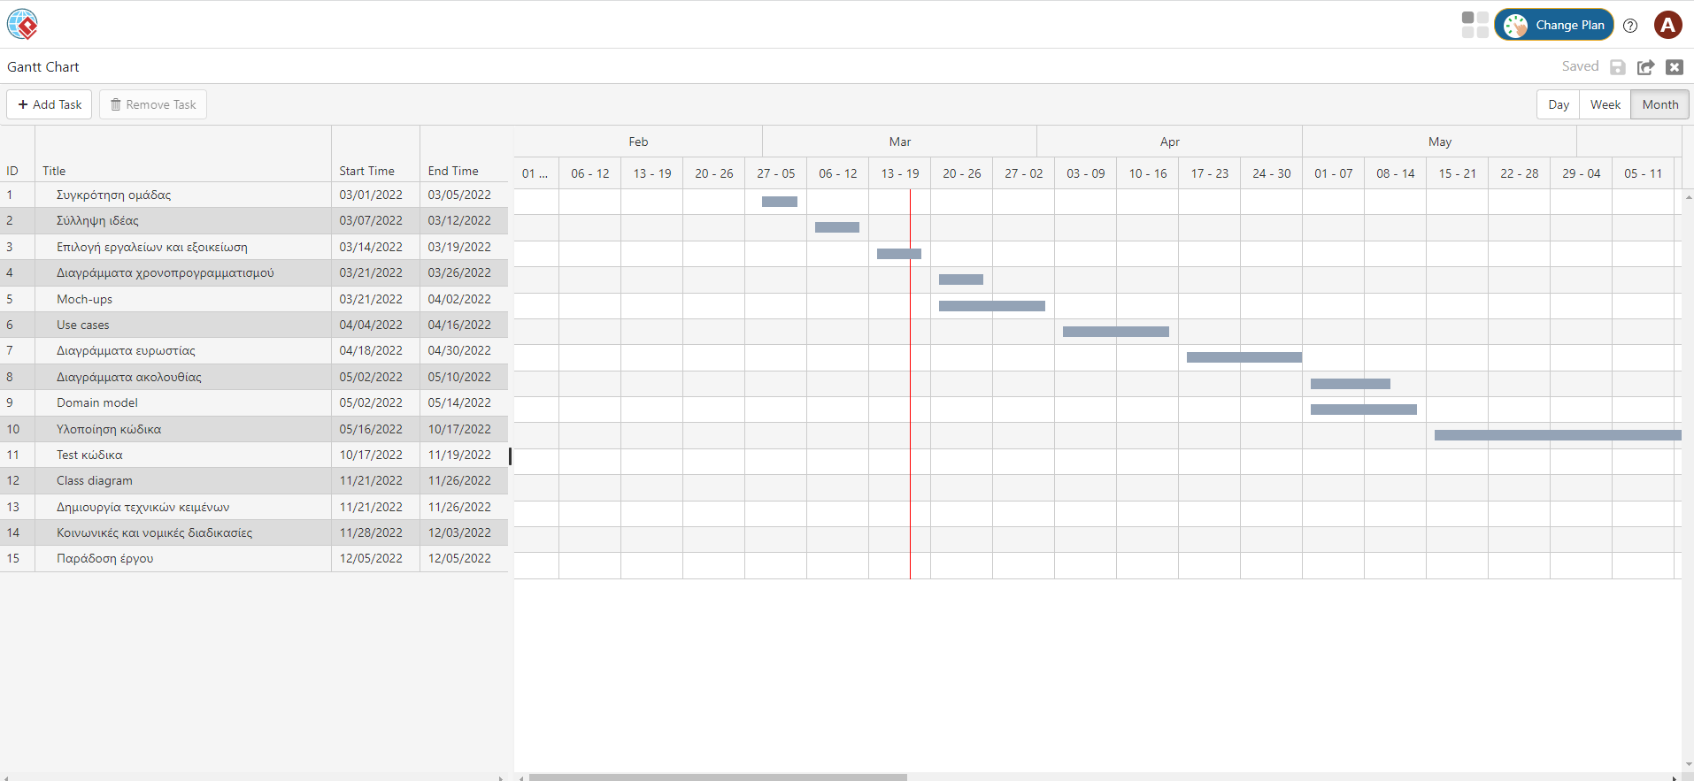

Εικόνα 1: Διάγραμμα Gantt Chart(1ο μέρος)

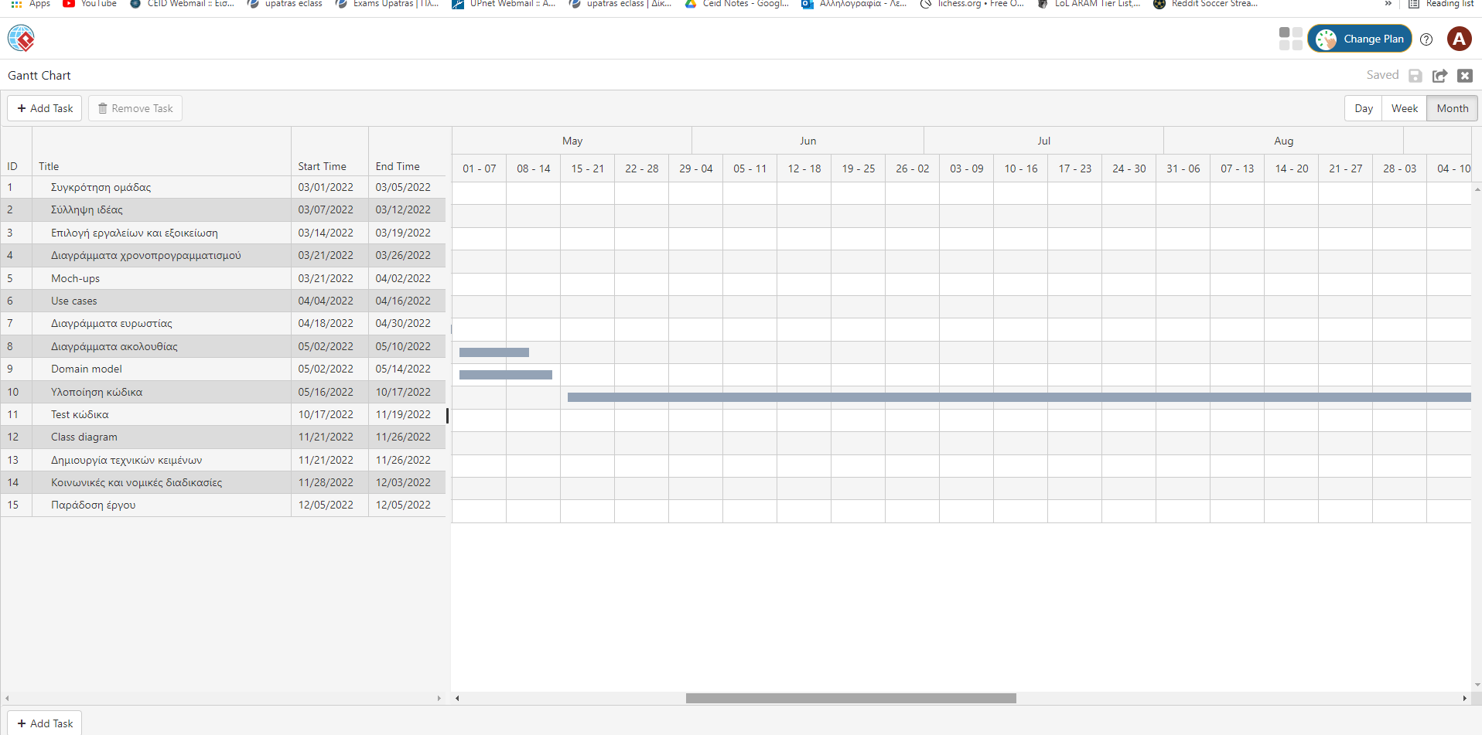

Εικόνα 2: Διάγραμμα Gantt Chart(2ο μέρος)

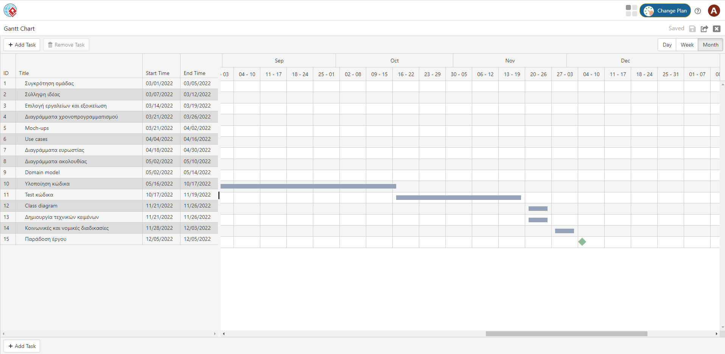

Εικόνα 3: Διάγραμμα Gantt Chart(3ο μέρος)

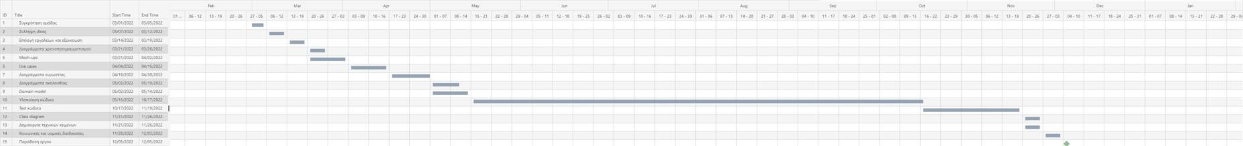

Εικόνα 4: Διάγραμμα Gantt Chart(Ολοκληρωμένο)

# β)

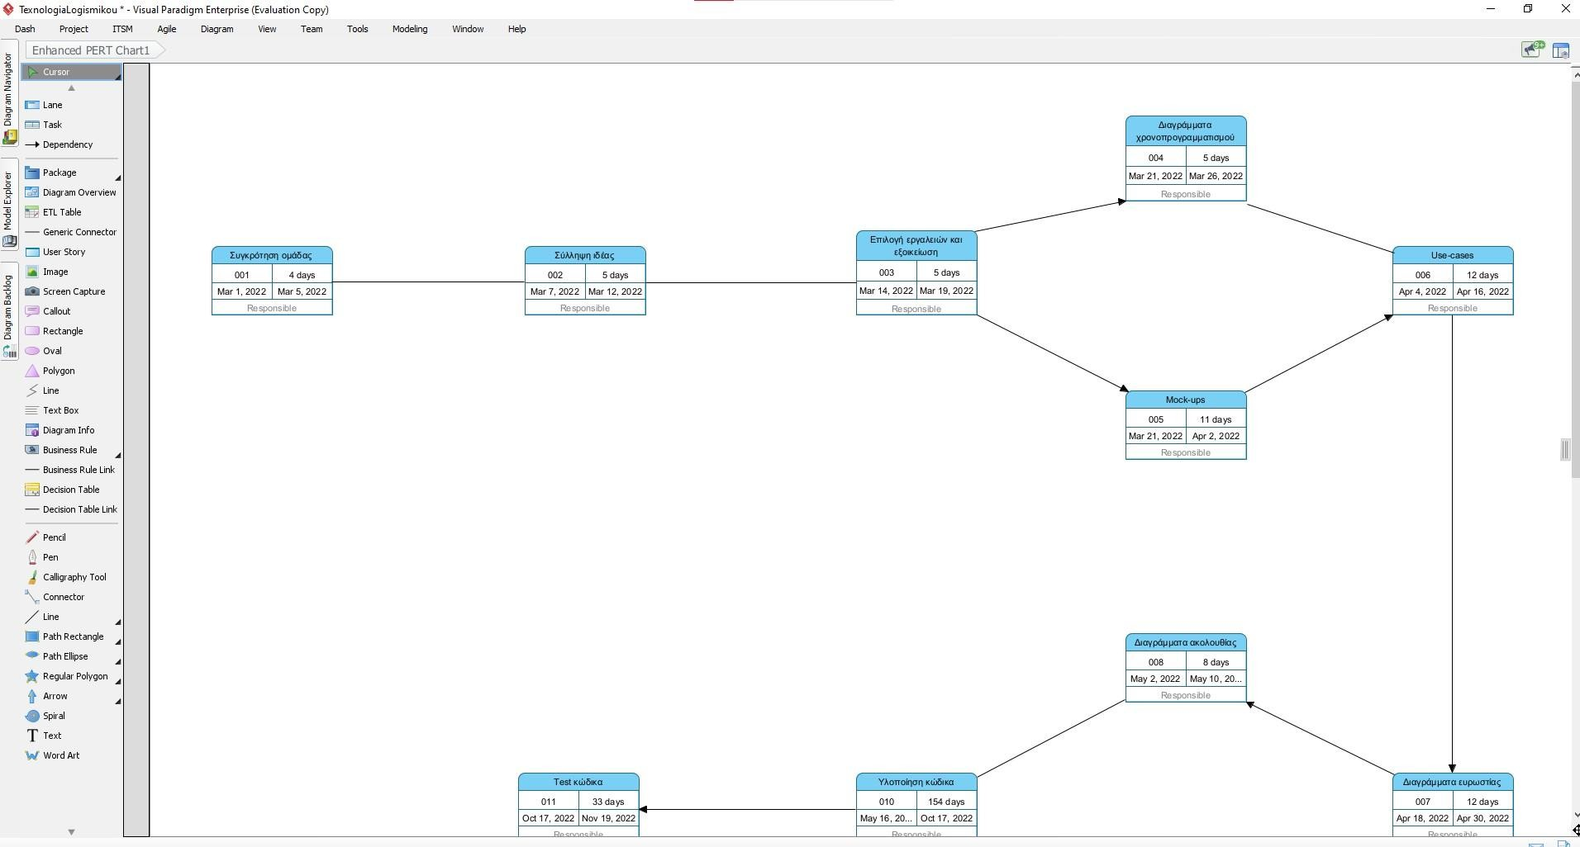

Εικόνα 5: Διάγραμμα Pert Chart(1ο μέρος)

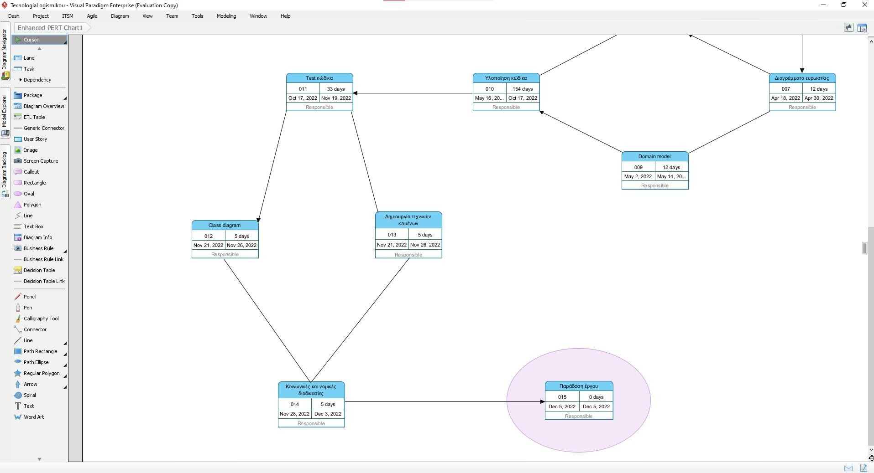

Εικόνα 6: Διάγραμμα Pert Chart(2ο μέρος)

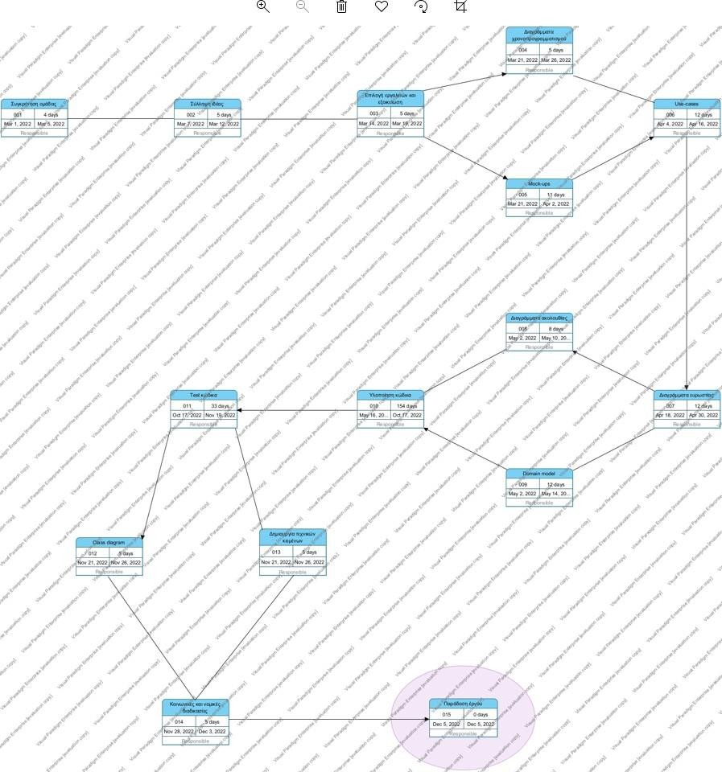

Εικόνα 7: Διάγραμμα Pert Chart(Ολοκληρωμένο)

γ)

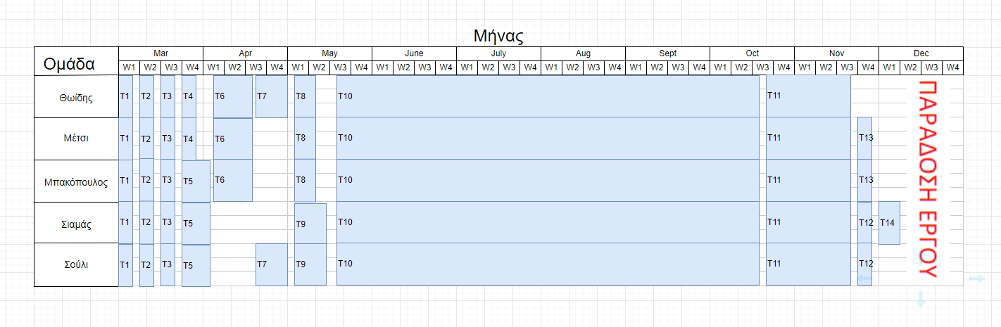Eικόνα 8: Διάγραμμα ανάθεσης έργου μελών

*T1: Team Formation T2: Team Conception*

*T3: Tool selection and familiarization T4: Scheduling diagrams T5: Mock-ups*

*T6: Use cases*

*T7: Robustness diagrams T8: Sequence diagrams T9: Domain model*

*T10: Code Implementation T11: Code Test*

*T12: Class diagram*

*T13: Creation of technical texts*

*T14: Social and legal procedures T15: Project delivery*

# δ)

**COST ESTIMATION**

Our team will work approximately 9 months for the specific Project, so the direct costs are calculated as follows:

1. Workforce wages = 1,000 euros per person X 9 months = 9,000 euros we are 5 people so 45,000 euros in total
2. We will need at least 2 desktop computers with their peripherals for shared use in our space. We will mainly use our own machines so = 1,000 euros per computer X 2 =

2,000 euros in total

1. We will need a server to be able to work remotely and connect from our own machines but also to support our application = 5,000 euros X 1 = 5,000 euros in total
2. For the infrastructure we need 2 tables and 5 chairs so that we have space to work and hold our meetings = 2 tables X 500 euros = 1,000 euros, 5 chairs X 50 euros = 250 euros so 1,000+250 = 1,250 euros in total.
3. *We will need a mobile phone as testing hardware for our application = 200 euros in total*
4. *The expenses for sanitary items and various other accessories such as a table = 100 euros in total.*

## As for indirect costs, we calculate as follows:

## Studio/studio/garage rent based in Patras = 200 euros per month X 9 months

## = 1,800 euros in total

## Electricity, water and taxes = 60 euros per month X 9 months = 540 euros in total

## So we estimate that we will need a total of 55,890 euros