TITLE: School Bus Tracking & Management System(Blue Horizon)
ABSTRACT

The design patent titled “School Bus Tracking & Management System” features an innovative and intelligent transportation management solution designed for schools to ensure student safety and efficient school bus operations. The system integrates real-time GPS tracking, student attendance monitoring, route optimization, and instant notification alerts for parents and school administrators. The platform provides live bus location updates, estimated arrival times, student check-in/check-out monitoring, and emergency communication features. The system includes a user-friendly interface for parents, drivers, and school management with secure cloud-based data handling. This combination of smart tracking, automation, and communication technology improves operational efficiency, student safety, and convenience for educational institutions.

Ms. Soumya . S Dr. S . Kalaiarasi
THE FIELD OF INVENTION
The field of invention pertains to smart transportation systems and school safety technologies, specifically focusing on GPS-enabled school bus tracking, student attendance management, and real-time communication systems for educational institutions.

BACKGROUND OF THE INVENTION
The present invention relates to transportation monitoring systems and, more specifically, to a smart school bus tracking and management system. Traditionally, school transportation systems rely on manual monitoring methods, making it difficult for parents and school administrators to track buses in real time and ensure student safety. Parents often face uncertainty regarding bus arrival times, delays, and student attendance during transportation.

Recent technological advancements have enabled GPS-based tracking systems and digital attendance management solutions. However, many existing systems lack integrated features such as real-time notifications, attendance tracking, route optimization, and centralized management. The “School Bus Tracking & Management System” solves these issues by combining GPS tracking, automated attendance monitoring, notification alerts, and route management into a single intelligent platform. The system provides real-time updates to parents and administrators while improving transportation efficiency and safety.

Ms. Soumya . S Dr. S . Kalaiarasi

SUMMARY OF THE INVENTION
The invention is a smart School Bus Tracking & Management System featuring real-time GPS tracking, student attendance monitoring, route optimization, and instant parent notifications. The system improves student safety, transportation efficiency, and communication between schools and parents.

Ms. Soumya . S Dr. S . Kalaiarasi
SPECIFICATION
The system provides real-time GPS tracking of school buses.
• Student attendance is automatically monitored during check-in and check-out.
• Parents receive instant notifications regarding bus arrival, delays, and attendance.
• Route optimization improves travel efficiency and reduces delays.
• The system includes an admin dashboard for monitoring buses, routes, and students.
• Secure cloud-based storage ensures reliable data management and accessibility.
• The platform includes driver, parent, and administrator interfaces for seamless communication.

Ms. Soumya . S Dr. S . Kalaiarasi

DESCRIPTION
The “School Bus Tracking & Management System” is an intelligent transportation solution designed to improve student safety and transportation management for schools. The system integrates GPS tracking technology, cloud-based monitoring, and automated attendance recording to provide real-time updates regarding school buses and students. Parents can monitor live bus locations, receive arrival alerts, and track student attendance through a mobile or web application. Administrators can manage routes, monitor buses, and analyze transportation performance through a centralized dashboard. The system enhances communication, reduces transportation delays, and improves operational efficiency while ensuring student security during travel.
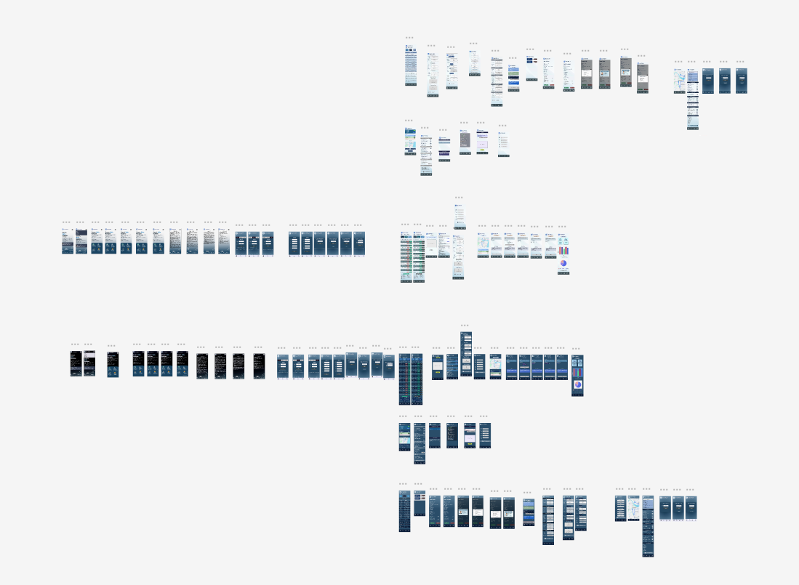
Figure 1: School Bus Tracking & Management System Design and Prototype(Figma)

Ms.Soumya S Dr.S . Kalaiarasi
WE CLAIM
1. Claim: A smart school bus tracking system comprising GPS-based real-time tracking, student attendance monitoring, and cloud-based data management.
2. Claim: The system of claim 1, wherein parents receive instant notifications regarding bus arrival, delays, and student attendance.
3. Claim: The system of claim 1, wherein the platform includes an administrator dashboard for route management and monitoring.
4. Claim: The system of claim 1, wherein GPS tracking provides live bus location updates and estimated arrival timings.
5. Claim: The system of claim 1, wherein automated attendance management records student check-in and check-out details.
6. Claim: The system of claim 1, wherein the platform supports communication between drivers, parents, and school administrators.
7. Claim: The system of claim 1, wherein the system improves transportation efficiency, student safety, and operational management.

Ms. Soumya S Dr. S. Kalaiarasi

