1. Experiment number 1 – basic pc communication

Configuration of network devices using packet tracer tools (Hub, switch, ethernet, broadcast)

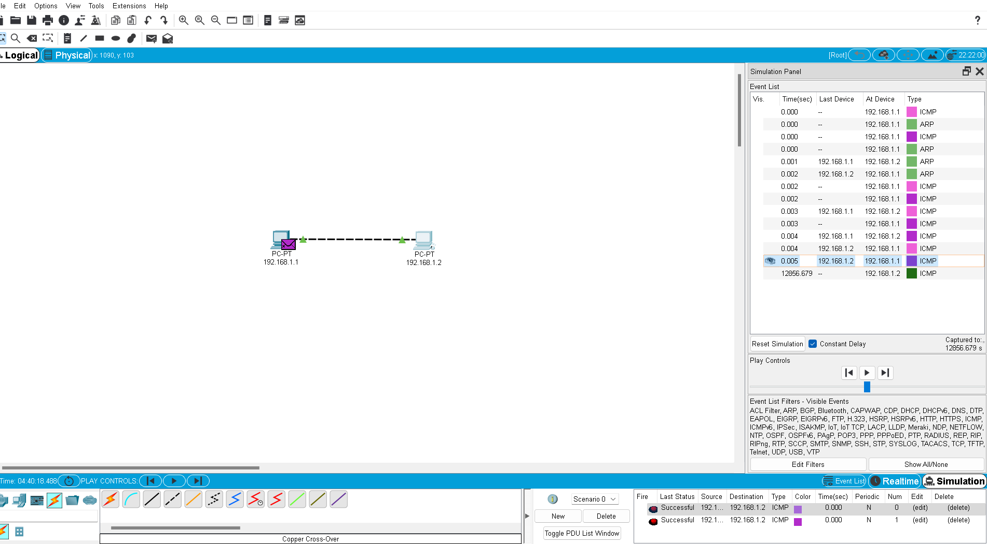

The results are obtained.

Experiment 2:

IMPLEMENTATION OF STAR TOPOLOGY USING PACKET TRACER

AIM:

To implement a star topology using packet tracer and hence to transmit data between the devices connected using star topology

APPARATUS REQUIRED :  
packet tracer / end devices ,bridge ,connectors.

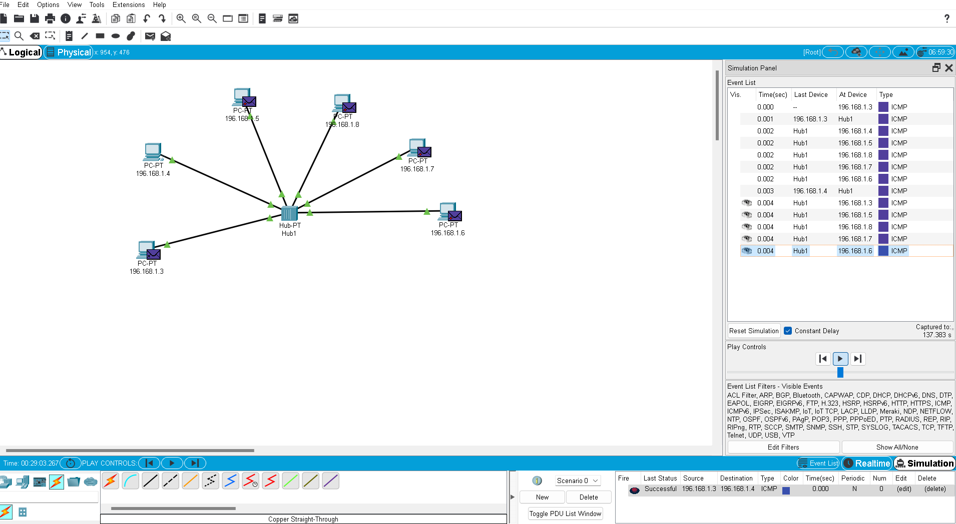

Result :

Thus the star topology is implemented with packer stimulation tool

Ex 3

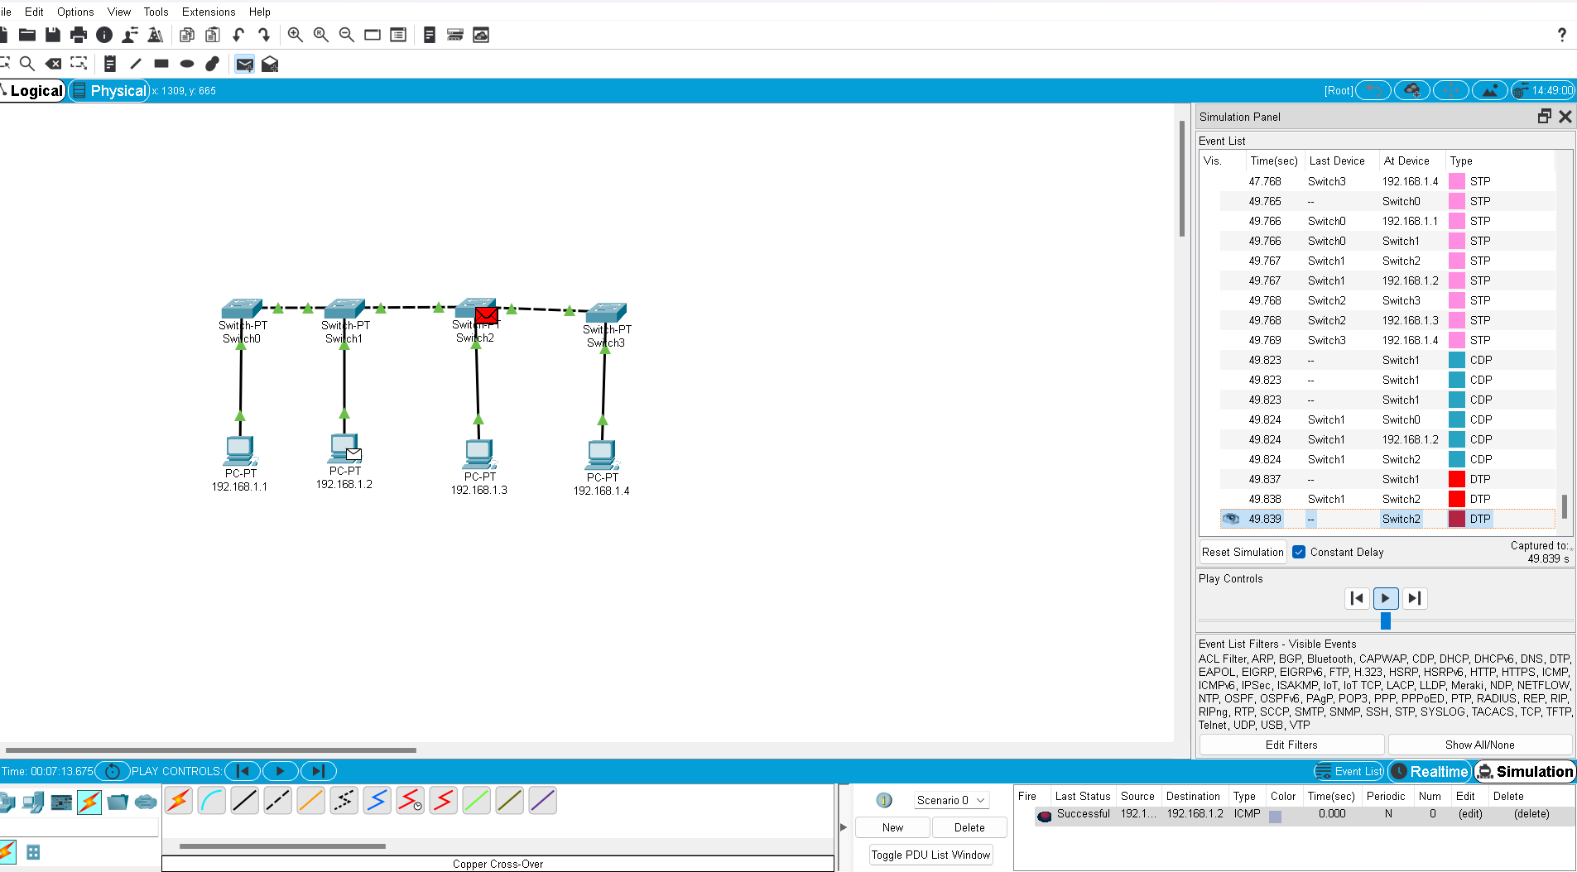SMTP;

Switch on the wire shark or

Select wifi , open one website press windows R and u will get command like smtp and

type telnet gmail-smtp-in.l.google.com 25

then enter and you will get gmail terminal ,

and hello how r you ,some messages ,

then go to wireshark type smtp u will get some messages and you will get response’

29) windows r >> ipconfig 8.8.8.8

Or ping 123.83498 some ip address

Or window r >> cmd>>

tracert scopus.com.

and then take some ip add from previous and

put ping xxxxxxxx ip address

