Comparative Visual Analytics and Explainable AI for Bi-Temporal Satellite Image Change Detection
P. Sai Sarvesh
D. S. Sanjay
Vellore Institute of Technology
Chennai, India
Reg. No. 24MIA1147
Reg. No. 24MIA1099
Abstract—Bi-temporal satellite image change detection detects changes between two satellite images taken before and after the change. This paper evaluates change detection using four architectures: Siamese convolutional neural network (CNN), U-Net, Swin Transformer, and ChangeFormer. These models are trained to predict pixel-level change in paired images from the LEVIR-CD dataset. Each model is evaluated using six metrics: accuracy, precision, recall, F1-score, intersection over union (IoU), and the Dice coefficient. This paper stands out because it compares four models and points out where each model went wrong. The results are displayed in a Streamlit dashboard. All the models predicted more changed area than the ground truth. Swin Transformer achieved the best F1-score (0.328), and ChangeFormer achieved the best recall (0.894). The models were trained for five epochs and tested on five image pairs, so the results are preliminary.
Index Terms—Change detection, explainable artificial intelligence (XAI), LEVIR-CD, remote sensing, Siamese networks, Swin Transformer, visual analytics.
I. Introduction
Satellite images provide continuous observation of changes in the same geographical area, and these images give us information about new buildings, demolished structures, and other changes that occurred in the surrounding area. Supervised change detection models are given two images, i.e., before- and after-change images, and are used to predict a binary mask that labels each pixel as changed or unchanged. This task is difficult for this reason: true changes often occur only in a small fraction of the image, which results in heavy class imbalance [1]. The results created by the model are often different from the real image due to this.
Convolutional neural networks (CNNs) are used for performing pixel-level prediction since they learn local patterns such as edges and shapes [2], [3]. Siamese networks pass the paired images through the same network, then compare the two outputs to find changes [2]. U-Net is an encoder-decoder with skip connections that retain fine details [3]. Transformers look for relationships across the whole image not just the closer pixels [4]. Swin Transformer applies attention within a small window that shifts position between layers, which keeps it efficient [4]. Transformers built for change detection include BIT [5] and ChangeFormer [6]. So testing all four models on the same dataset shows how the choice of models affects each result.
However, a single score such as F1 or IoU cannot decide the best model. Models might have similar values but make different errors. Therefore, we built a dashboard to display each model’s prediction on the actual image. The dashboard covers error maps that separate false alarms from missed changes, overlays on the satellite images, and predicted versus actual areas of change. We found that all the models predicted more changed area than the ground truth. Grad-CAM [7] and attention rollout [8] show which region each model focused on.
II. Related Work
A. Change-Detection Datasets and Models
Chen and Shi introduced the LEVIR-CD dataset with STANet, which is a method of change detection based on spatial–temporal attention [1]. The dataset consists of pairs of images that have high resolution and pixel-level labels showing the changes of buildings [1]. This research acknowledges that a temporal model needs to be created instead of treating each image as a separate one [1]. Daudt et al. [2] developed three types of fully convolutional architectures for change detection, which are Siamese systems that use feature concatenation or feature subtraction, which allowed making the Siamese encoder with shared weights the basic baseline.
Swin Transformer is a type of vision transformer that uses self-attention only within local windows in a hierarchical sense [4]. The windows can be moved between subsequent layers of the architecture [4]. At each stage, the Swin Transformer produces helpful representations that can serve as a backbone for dense prediction [4]. BIT shows that a small transformer, which works on semantic tokens, is able to analyze spatio-temporal context for the purposes of change detection [5]. ChangeFormer is based on the idea of combining a Siamese hierarchical transformer encoder and a simple multilayer perceptron (MLP) decoder to combine the feature differences at different scales of the data produced [6].
B. Explainability and Visual Analytics
The Grad-CAM technique creates a rough localization map for a certain prediction by employing gradient information that reaches a certain convolution layer [7]. The approach of attention rollout determines how data flows from the given token input to the output by means of accumulating attention matrices related to residual paths [8]. In spite of the fact that both techniques could be useful for diagnostics, neither of them can actually prove that the highlighted areas somehow impact the prediction. In information visualization, Shneiderman’s classification of tasks describes a sequence of first presenting an overview of the data, then filtering, and then analyzing details upon request [9]. The dashboard presented above works in a similar way. It is not meant to be a different method of change detection; rather, it could be seen as an analysis and comparison layer for models that shows where the overall score is not accurately related to errors.
III. Dataset and Experimental Protocol
The performed experiments use the LEVIR-CD dataset [1], [10]. The full dataset has 637 pairs of high-resolution (1024 × 1024) Google Earth images taken in different times separated by 5–14 years, which were randomly subdivided into the dataset consisting of 70% training, 10% validation and 20% testing samples [1]. Each sample includes a pair of pictures: one earlier one (T1) and one later (T2); a binary mask indicating changed pixels is also provided [10]. The data loading logic retrieves sample elements from A (T1), B (T2), and label directories to create a triplet of images. Due to computational limitations, this research starts off with a much smaller dataset compared to the original one (see Table I). The size of the images is reduced to 224 × 224 pixels, while 20, 5 and 5 samples (in pairs) are used for training, validation and testing purposes, correspondingly. The test suite includes 5 masks with no more than 250 880 pixels where 20 437 pixels (8.15%) were identified as changed. Although this subset seems to be enough for validating the pipeline and the user interface, it might not be sufficient to evaluate the generalization ability of LEVIR-CD model.
TABLE I
Experimental Subset of LEVIR-CD
Element | Value in this study
Input | Co-registered image pair (T1, T2)
Target | Binary pixel-level change mask
Input size | 224 × 224 pixels (resized)
Training / validation / test | 20 / 5 / 5 image pairs
Evaluated test pixels | 250 880 (5 × 224 × 224)
Changed test pixels | 20 437 (8.15%)

IV. Models and Evaluation Method
A. Preprocessing
The sequence opens T1, T2 and the designated mask as a corresponding triplet. Random horizontal and vertical flips and changes of orientation in multiples of 90° are applied masterfully to all three objects so that the spatial relationship is kept. The input images are subjected to an adjustment on the basis of the ImageNet [11] channel mean and variance, and the target mask is binary.
B. Investigated Architectures
All four architectures process the two inputs and deliver a pixel-level probability of change map. They employ the shared-weight Siamese encoder and map the two images to the same feature space, thesaurus employed to derive changes through the feature space difference. Table II presents a summary of the designs. The ChangeFormer follows the original structure as described in [6]; however, the verification between it and the original drafting of [12] has not been conducted yet.
TABLE II
Evaluated Architectures
Model | Design | Role
Siamese CNN | Four-stage shared convolutional encoder; absolute difference at the bottleneck; upsampling decoder. | Baseline for paired CNN features.
Siamese U-Net | Shared CNN encoder; multi-scale feature fusion with U-Net-style skip connections [3]. | Tests multi-scale localization.
Swin Transformer | Pretrained Swin-Tiny backbone [4]; multi-scale feature differences; convolutional decoder. | Hierarchical transformer model.
ChangeFormer | Hierarchical transformer stages with spatial-reduction attention and depthwise-convolution feed-forward blocks; MLP fusion head [6]. | Transformer designed for change detection.

C. Objective of Training
The four models in question are trained with a loss function that consists of 50% binary cross-entropy loss and 50% Dice loss [13]. The binary cross-entropy loss calculates the error of each pixel independently and punishes erroneous predictions. On the other hand, the Dice loss indicates the degree of overlap between the predicted area of change and the ground truth area of change, which is particularly useful when changes occur in only a small number of pixels [13]. All four models are trained for five epochs with the AdamW optimizer [14] with a learning rate of 1 × 10⁻⁴, a weight decay of 1 × 10⁻⁴, and cosine learning rate schedule [15]. Since training was short, the results should be perceived as a preliminary comparison rather than an ultimate performance.
D. Evaluation Metrics
The metrics are summarized in Table III, which defines the parameters in terms of true positive (TP), true negative (TN), false positive (FP) and false negative (FN) pixel counts. The metrics are computed using a micro-averaging method where counts are pooled over all pixels of the five images. Accuracy may be misleading when most pixels remain unchanged; hence with only 8.15% pixels changing, a model that predicts no change everywhere will achieve a score of 0.9185. In the case of binary masks, the F1-score and the Dice coefficient will be equal when calculated with the same counts as they are equivalent from the mathematical point of view.
TABLE III
Pixel-Level Evaluation Metrics
Metric | Definition
Accuracy | (TP + TN) / (TP + TN + FP + FN)
Precision | TP / (TP + FP)
Recall | TP / (TP + FN)
F1-score | 2 · Precision · Recall / (Precision + Recall)
IoU | TP / (TP + FP + FN)
Dice | 2TP / (2TP + FP + FN)

V. Explainable AI Analysis
Post-hoc explanation approaches identify the regions in space related to model predictions of changes. In the case of a Swin Transformer, attention rollout forms a transmission of attention of different stages including a residual layer to display the image [8]. For a convolutional neural network layer, Grad-CAM utilizes the gradients of the prediction of changes to derive a generalized saliency map [7].
The map is assessed via two diagnostics that provide information on overlap and stability of the explanation map itself. Overlap indicates the level of agreement between the regions with high attribution and a change mask, and stability indicates the degree of similarity between the explanation map obtained using the original input and the one received after adding Gaussian noise with 0.02 standard deviation. Both values are presented in Table IV for the test sample test_17.
TABLE IV
Explanation Diagnostics for Sample test_17
Model | Overlap | Stability
Siamese CNN | 0.0005 | 0.9807
Siamese U-Net | 0.0060 | 0.9596
Swin Transformer | 0.1114 | 0.9931
ChangeFormer | 0.1172 | 0.9999

Every model’s maps maintain stability during small input changes, yet maps have low overlap with labeled buildings (stability > 0.96). Thus, most attributions occur outside of the areas of interest, confirming the previously discussed false-positive pattern in Section VII, and indicating that the models do not use labeled buildings.
VI. Interactive Visual Analysis Dashboard
The dashboard created through Streamlit allows users to link the assessment of aggregated results with the checking of separate predictions. It follows a bottom-up order of seeing things [9]: first, the user sees the summary metrics (Fig. 1), then picks a model or a sample, and lastly sees the images, errors, etc. (Fig. 2). The information about the nine views is provided in Table V with the respective analytical questions being answered.
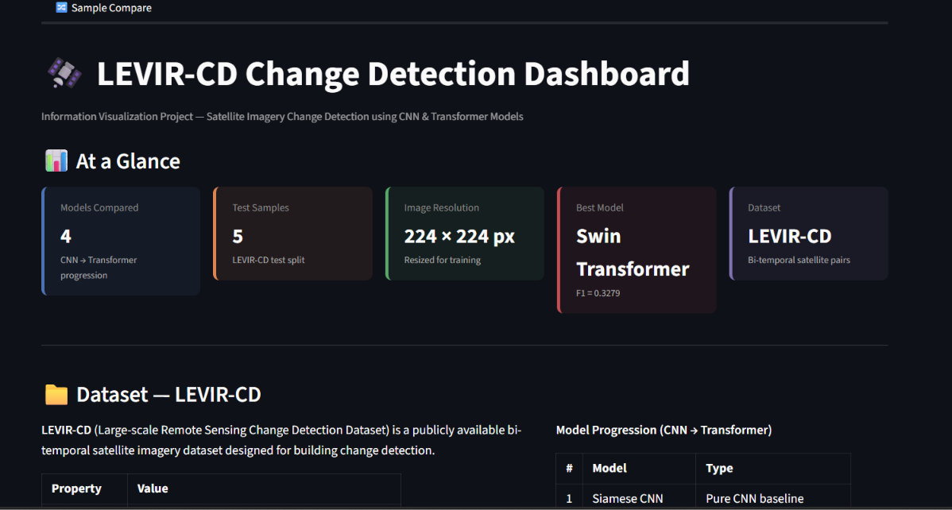
Fig. 1. Dashboard overview showing the four evaluated models, test-set size, input resolution and dataset summary.
TABLE V
Dashboard Views
View | Visualizations | Analytical question
1. Overview | KPI cards, radar plot, metric bars, runtime cards | What is the overall state of the experiment?
2. Model comparison | Metric bars, grouped precision–recall–F1 chart, sample × model heatmap, epoch curves | Which model performs best, and how does performance vary?
3. Change explorer | T1, T2, reference and prediction grid; sample and model selectors | What does a selected prediction look like?
4. Spatial analysis | Adjustable-opacity overlays; area-difference bars | Where is change predicted, and does it align with labels?
5. Error analysis | TP/TN/FP/FN map, pixel-composition chart, FP/FN comparison | Where does the model miss changes or raise false alarms?
6. Confusion matrix | Annotated 2 × 2 heatmaps with per-sample drill-down | Which pixel-level errors dominate?
7. XAI | Attention-rollout and Grad-CAM views; diagnostic table | Which regions does the explanation highlight?
8. Area analysis | Reference-versus-predicted area scatter, error histogram, bubble chart | Does the model over- or underestimate changed area?
9. Sample comparison | T1, T2, reference and all four predictions; error strip | How do models differ on the same scene?

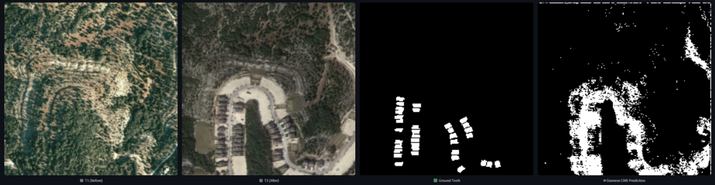
Fig. 2. Change-detection explorer for sample test_17: (left to right) T1, T2, reference mask and Siamese CNN prediction.
The views employ various visual encoding techniques. Bar graphs allow for straightforward comparison of magnitude values, heat maps show tendencies seen in samples and models, overlays maintain spatial orientation, categorical error maps show where the errors belong to, and scatter plots depict references compared against predicted areas of change.
VII. Experimental Results
A. Quantitative Comparison
The metrics for the test set are published in Table VI. The pooled confusion counts as well as the changed area statistics are shown in Table VII, which are corresponding to the metrics mentioned in Table VI. The confusion matrices corresponding to those are shown in Fig. 3.
TABLE VI
Test-Set Performance on the LEVIR-CD Subset
Model | Acc. | Prec. | Rec. | F1 | IoU
Siamese CNN | 0.8354 | 0.1812 | 0.2901 | 0.2231 | 0.1255
Siamese U-Net | 0.6594 | 0.1435 | 0.6405 | 0.2345 | 0.1328
Swin Transformer | 0.7352 | 0.2067 | 0.7930 | 0.3279 | 0.1961
ChangeFormer | 0.5414 | 0.1393 | 0.8938 | 0.2410 | 0.1370
Best value in each column in bold. F1 equals Dice for binary masks, so Dice is not listed separately. All metrics are pooled over the five test samples.
TABLE VII
Pooled Confusion Counts and Changed Area
Model | TP | FP | FN | Area | Ratio
Siamese CNN | 5 929 | 26 792 | 14 508 | 13.0% | 1.6×
Siamese U-Net | 13 090 | 78 107 | 7 347 | 36.4% | 4.5×
Swin Transformer | 16 206 | 62 208 | 4 231 | 31.3% | 3.8×
ChangeFormer | 18 266 | 112 872 | 2 171 | 52.3% | 6.4×
Counts from the aggregate confusion matrices in Fig. 3, pooled over all five test samples (250 880 pixels); reference changed area is 8.15% (20 437 pixels). Area = predicted changed area, (TP + FP) / all pixels; Ratio = predicted / reference changed area.
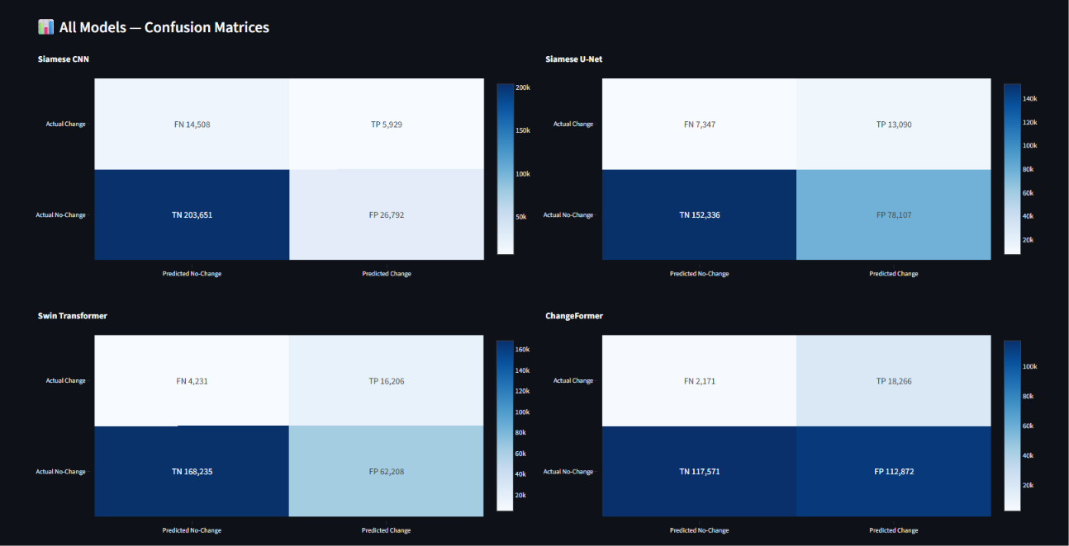
Fig. 3. Aggregate confusion matrices for the four models, pooled over all five test samples (250 880 pixels per model). Per-sample matrices are shown separately in Fig. 12.
B. Discussion
The Swin Transformer is responsible for getting the top score for the metric F1 (0.3279) as well as the metric IoU (0.1961). The Swin Transformer has also achieved the greatest precision. Its recall number is equal to 0.7930, meaning that the method identifies plenty of pixels that have changed. Meanwhile, according to this method, about four out of five pixels that have been identified are unchanged. The highest recall level is achieved by ChangeFormer (0.8938), which fails to identify only 2,171 changed pixels, but marks approximately 52.3% of all tested area as changed. That is 6.4 times higher than the usual area that could be marked as changed; therefore, the accuracy of this approach equals 0.5414.
Siamese CNN has proved to have the highest accuracy percentage (0.8354), while it only identifies 29% of changed pixels. No method under consideration is better than a trivial predictor that gives 91.85% accuracy (in other words, it predicts that no pixels have changed at all). It can be worthy of consideration that the step from the Siamese CNN to the Siamese U-Net results in raising the recall level from 0.2901 to 0.6405, while the F1 metric rises from 0.2231 to 0.2345 at the same time, which can be explained this way: the number of false alarms.
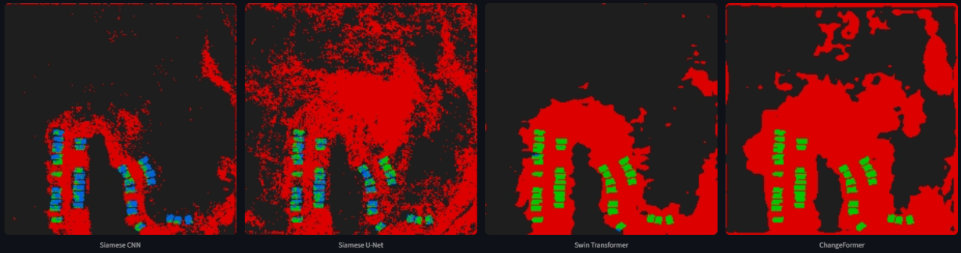
Fig. 4. Error maps for the four models on sample test_17 (green: TP; red: FP; blue: FN; dark: TN). From left: Siamese CNN, Siamese U-Net, Swin Transformer, ChangeFormer.
The spatial images reveal the locations of errors. In the error maps for test sample 17 (Fig. 4), both the Swin Transformer and ChangeFormer accurately identify almost all buildings but erroneously classify much sizable area near buildings, comprising ground cleared from any vegetation and roads that can be observed in the T2 image (Fig. 2), as this area has changed. The CNN and U-Net on the contrary fail to speedily identify a large number of building pixels (in blue), while they still produce many false alarms. Given that LEVIR-CD labels only the changes that occurred to buildings, any other change identified in the scene will be classified as a false positive. It is impossible to say if this picture is true for the rest of the dataset based on the results of just five samples. The precision does not exceed 0.21 for any of the models and false positives are the most common error.
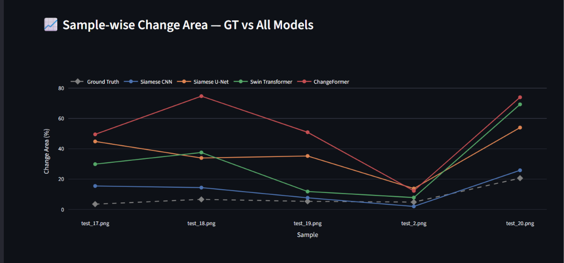
Fig. 5. Changed-area percentage per test sample for the reference masks and all four models.
The area analysis (Fig. 5) indicates that this over-prediction is a consistent finding, as U-Net, Swin Transformer and ChangeFormer have over-predicted changed area compared to the reference in all examples considered, and CNN provides the closest outcome to the reference in just one case of under-prediction. The level of performance depends on the amount of change in the examined scene (Fig. 6): the four samples with area change of about 7% have the F1 score lower in all models compared to the four samples with changed area about 20%.
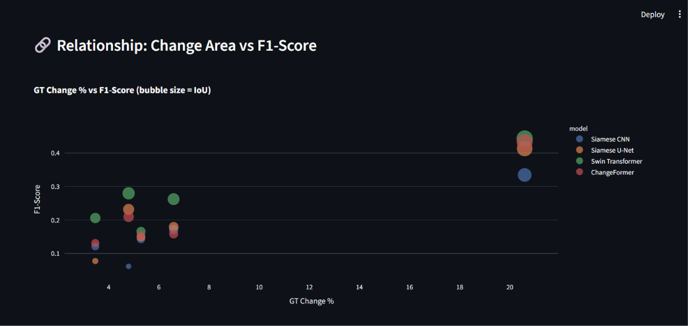
Fig. 6. Reference changed-area percentage versus F1-score per sample and model; bubble size encodes IoU.
The interpretation needs to be done carefully while performing these comparisons. In fact, the models were trained for five epochs and experienced five pairs of images, which does not allow for a robust generalization or a strong claim regarding the advantages of using CNNs and transformers. Thus, results can be regarded as a preliminary comparison and the demonstration.
VIII. Limitations and Threats to Validity
- Small test set: The minimal test size of five samples cannot capture all possible discrepancies in scenes of the LEVIR-CD and one sample can change calculations significantly.
- Short training: Five epochs might not produce enough training time, meaning that results can vary based on initialization and checkpoint selection.
- Subset protocol: The selected 20/5/5 ratio is based on small local subsets of data at 224 × 224 resolution instead of the regular 70/10/20 proportion from the first paper [1].
- Decision threshold: As each metric is dependent on the threshold used for binarization, the threshold sensitivity is not considered in this research work.
- Architecture fidelity: The model named ChangeFormer follows the design described in [6] and it is not a reproduction of the reference implementation mentioned in [12].
- Explanation validity: Attention rollouts and Grad-CAMs are tools for visual diagnostics rather than causation explanations [7], [8] and those presented in Table IV are a diagnostic of only one sample.
- External validity: The LEVIR-CD is only for building changes in one image and the results are not applicable to other sensors, areas, or types of changes.
IX. Conclusion
A comparative bi-temporal change-detection pipeline was incorporated into a Streamlit visual-analytics dashboard in this article. Four different Siamese architectures have been proposed to investigate the similarities and differences between convolutional and transformer-based approaches. All the performance metrics attained by the corresponding models have been presented in the dashboard in combination with the spatial proof that supports the scores. It was observed that in the conducted preliminary experiment Swin Transformer produced best results in terms of F1 score and IoU, ChangeFormer was the most efficient in terms of recall, while the Siamese CNN model, despite yielding the best accuracy, failed to detect most of the changed pixels.
The dashboard enabled monitoring of the performance of the models in ways that their metric grid could not. For instance, it revealed that all four models overestimate the changed area by a factor of 1.6 to 6.4 times; it also showed that most of the false-positive area for the scene under study is located any number of miles away from the labeled constructions, and lastly, that the explanation maps bear little relevance to the changes indicated. Future actions would consist in efficient testing of models on all splits of the LEVIR-CD official test set along with training them for a longer time, performing model-specific threshold selection, and testing their explanation reliability through perturbation analysis.
Appendix: Additional Dashboard Views
Figs. 7–15 show additional views from the dashboard.
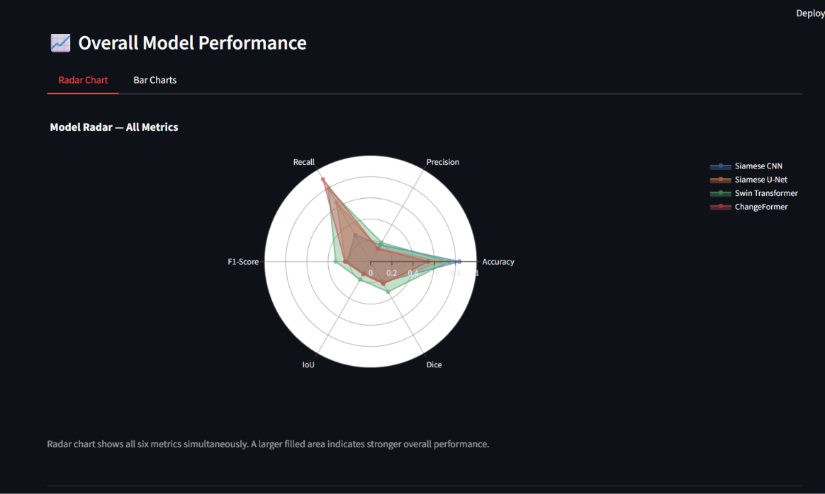
Fig. 7. Radar chart of accuracy, precision, recall, F1-score, IoU and Dice for the four models.
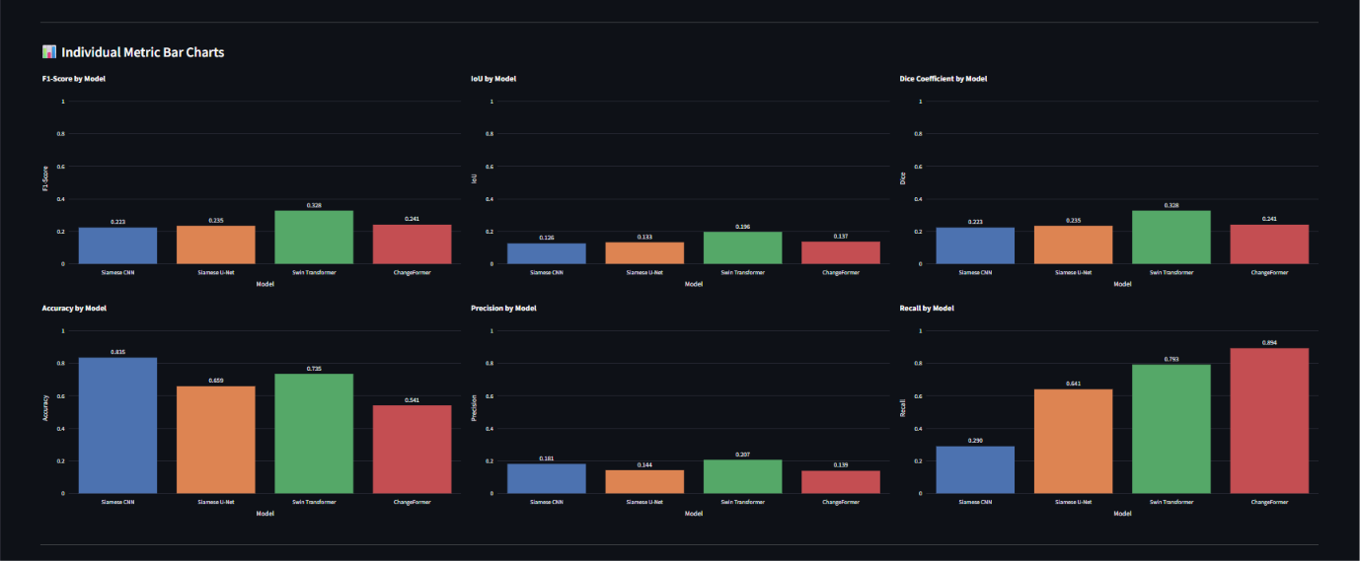
Fig. 8. Individual bar charts comparing the models on each of the six metrics.
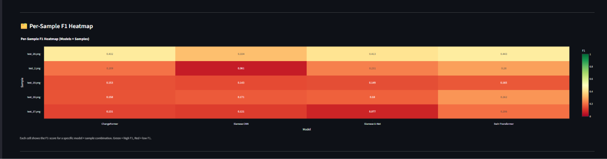
Fig. 9. Per-sample F1-score heatmap across the five test images and four models.
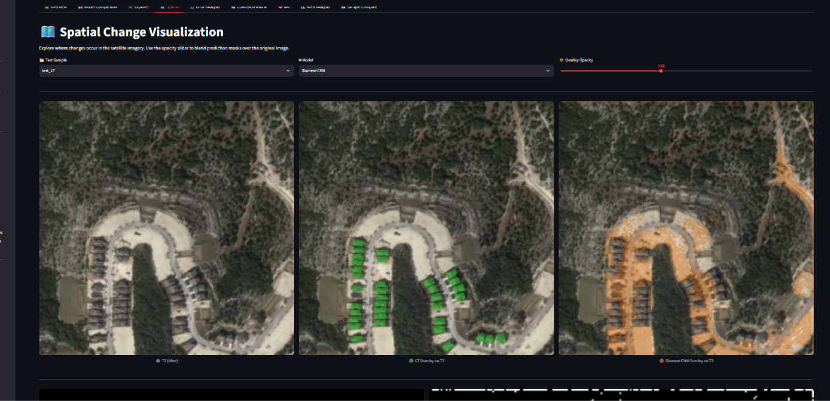
Fig. 10. Spatial view with reference and prediction overlays on the T2 image.
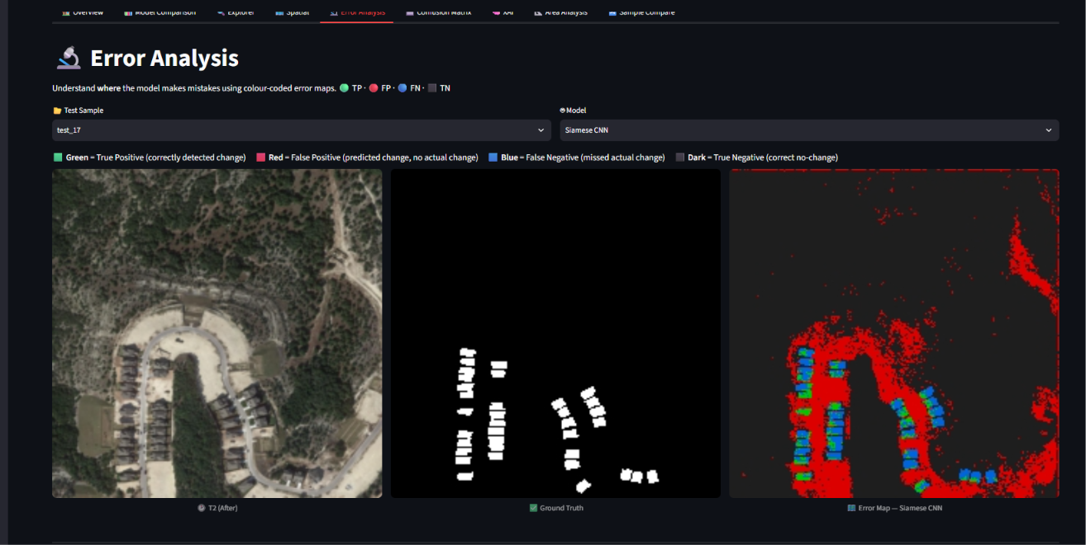
Fig. 11. Error-analysis view: T2 image, reference mask and color-coded pixel-level error map for a selected model.
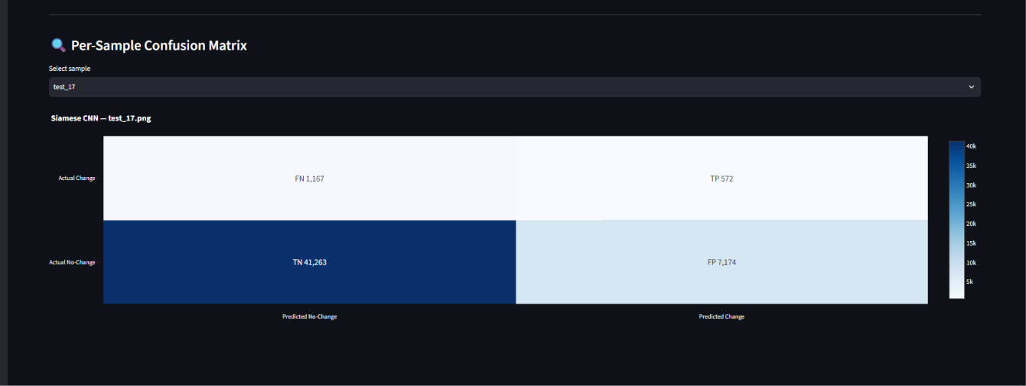
Fig. 12. Single-sample confusion matrix for the Siamese CNN on test_17 (50 176 pixels). These per-sample counts are not used in Tables VI and VII, which report results pooled over all five samples.
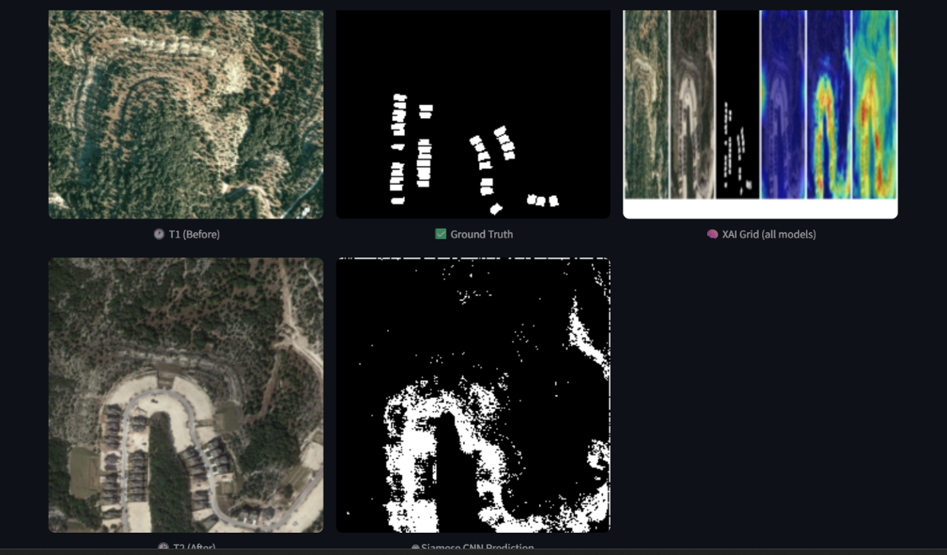
Fig. 13. XAI comparison view combining the input images, reference mask, explanation grid and predicted mask.
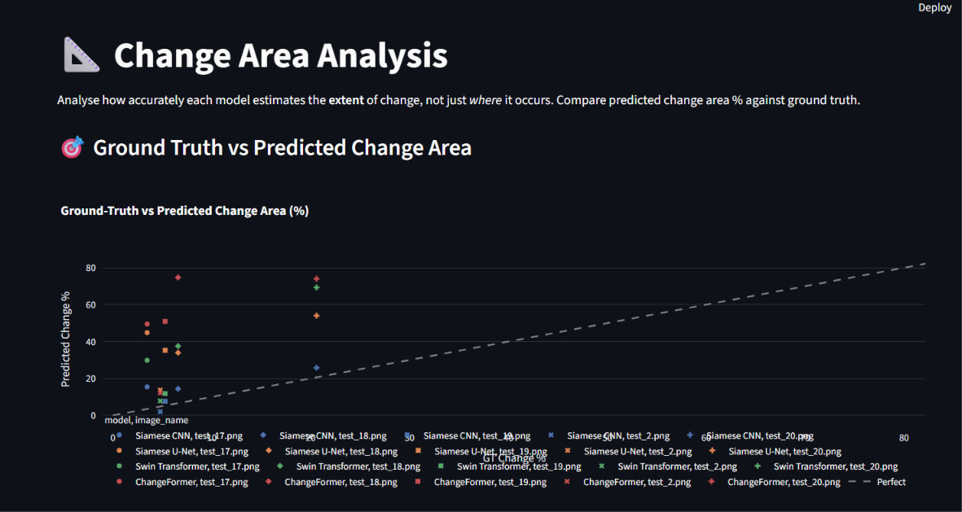
Fig. 14. Reference versus predicted changed-area percentage across models and samples; the dashed diagonal denotes perfect agreement.
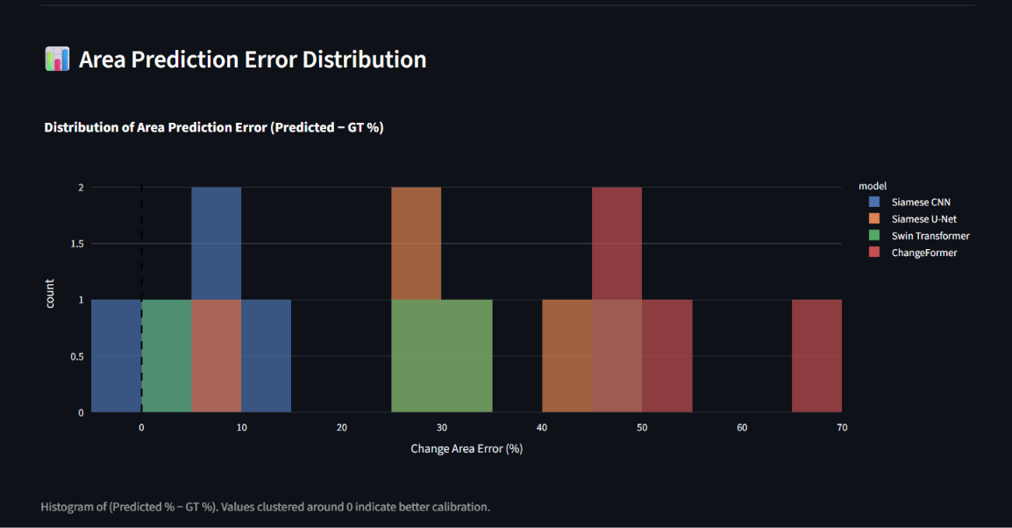
Fig. 15. Distribution of changed-area error (predicted minus reference percentage) for each model.
References
[1] H. Chen and Z. Shi, “A spatial-temporal attention-based method and a new dataset for remote sensing image change detection,” Remote Sens., vol. 12, no. 10, Art. no. 1662, May 2020, doi: 10.3390/rs12101662.
[2] R. C. Daudt, B. Le Saux, and A. Boulch, “Fully convolutional Siamese networks for change detection,” in Proc. 25th IEEE Int. Conf. Image Process. (ICIP), Athens, Greece, 2018, pp. 4063–4067, doi: 10.1109/ICIP.2018.8451652.
[3] O. Ronneberger, P. Fischer, and T. Brox, “U-Net: Convolutional networks for biomedical image segmentation,” in Proc. Med. Image Comput. Comput.-Assist. Interv. (MICCAI), 2015, pp. 234–241, doi: 10.1007/978-3-319-24574-4_28.
[4] Z. Liu et al., “Swin Transformer: Hierarchical vision transformer using shifted windows,” in Proc. IEEE/CVF Int. Conf. Comput. Vis. (ICCV), 2021, pp. 9992–10002, doi: 10.1109/ICCV48922.2021.00986.
[5] H. Chen, Z. Qi, and Z. Shi, “Remote sensing image change detection with transformers,” IEEE Trans. Geosci. Remote Sens., vol. 60, pp. 1–14, 2022, doi: 10.1109/TGRS.2021.3095166.
[6] W. G. C. Bandara and V. M. Patel, “A transformer-based Siamese network for change detection,” in Proc. IEEE Int. Geosci. Remote Sens. Symp. (IGARSS), 2022, pp. 207–210, doi: 10.1109/IGARSS46834.2022.9883686.
[7] R. R. Selvaraju, M. Cogswell, A. Das, R. Vedantam, D. Parikh, and D. Batra, “Grad-CAM: Visual explanations from deep networks via gradient-based localization,” in Proc. IEEE Int. Conf. Comput. Vis. (ICCV), 2017, pp. 618–626, doi: 10.1109/ICCV.2017.74.
[8] S. Abnar and W. Zuidema, “Quantifying attention flow in transformers,” in Proc. 58th Annu. Meeting Assoc. Comput. Linguistics (ACL), 2020, pp. 4190–4197, doi: 10.18653/v1/2020.acl-main.385.
[9] B. Shneiderman, “The eyes have it: A task by data type taxonomy for information visualizations,” in Proc. IEEE Symp. Visual Lang., 1996, pp. 336–343, doi: 10.1109/VL.1996.545307.
[10] LEVIR Lab, “LEVIR-CD: A large-scale remote sensing change detection dataset.” [Online]. Available: https://justchenhao.github.io/LEVIR/
[11] J. Deng, W. Dong, R. Socher, L.-J. Li, K. Li, and L. Fei-Fei, “ImageNet: A large-scale hierarchical image database,” in Proc. IEEE Conf. Comput. Vis. Pattern Recognit. (CVPR), 2009, pp. 248–255, doi: 10.1109/CVPR.2009.5206848.
[12] W. G. C. Bandara and V. M. Patel, “ChangeFormer: A transformer-based Siamese network for change detection,” GitHub repository. [Online]. Available: https://github.com/wgcban/ChangeFormer
[13] F. Milletari, N. Navab, and S.-A. Ahmadi, “V-Net: Fully convolutional neural networks for volumetric medical image segmentation,” in Proc. 4th Int. Conf. 3D Vis. (3DV), 2016, pp. 565–571, doi: 10.1109/3DV.2016.79.
[14] I. Loshchilov and F. Hutter, “Decoupled weight decay regularization,” in Proc. Int. Conf. Learn. Represent. (ICLR), 2019.
[15] I. Loshchilov and F. Hutter, “SGDR: Stochastic gradient descent with warm restarts,” in Proc. Int. Conf. Learn. Represent. (ICLR), 2017.

