OSSP – EXPERIMENT 2
File Copy using open(), read(), write() and close()
Name: T. Sai Sri Parinita
Roll Number: 2520030562

Aim
To develop a C program using open(), read(), write(), and close() to copy the contents of one file to another, and to trace the system calls generated while executing cat sample.txt using strace.

Program Code
#include <stdio.h>
#include <fcntl.h>
#include <unistd.h>

int main() {
int source, destination;
char buffer[100];
ssize_t bytesRead;

source = open("input.txt", O_RDONLY);

if (source < 0) {
printf("Error opening source file\n");
return 1;
}

destination = open("output.txt", O_WRONLY | O_CREAT | O_TRUNC, 0644);

if (destination < 0) {
printf("Error opening destination file\n");
close(source);
return 1;
}

while ((bytesRead = read(source, buffer, sizeof(buffer))) > 0) {
write(destination, buffer, bytesRead);
}

close(source);
close(destination);

printf("File copied successfully.\n");
return 0;
}

Compilation and Execution
gcc exp2.c -o exp2
./exp2
cat output.txt

File Copy Output
The copied file was checked using cat output.txt. The observed file content was: "read function".

System Call Tracing
strace cat sample.txt 2>&1 | grep -E "openat|read|write|close"
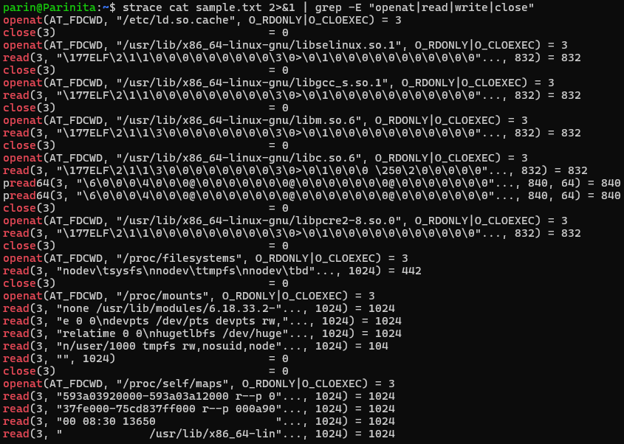

Observation / Analysis
The file-copy program uses open() to access the source and destination files, read() to obtain data from the source, write() to copy the data to the destination, and close() to release the file descriptors. The strace output shows openat(), read(), and close() system calls while cat executes. These system calls allow a user-space program to request services from the Linux kernel.

Result
The file contents were successfully copied, and the system calls generated by cat sample.txt were observed using strace.

