Steven Sparks

May 18, 2021

IT FDN 110 A Sp 21: Foundations Of Programming: Python

Assignment 06 Functions

<https://github.com/ssparky77/IntroToProg-Python-Mod06.git> (external site)

# Introduction

This paper discusses the steps I completed to add Functions and Libraries to the To-Do List program we wrote for Module 05. In this module, we learned how to create user-defined Functions, store the Functions in Libraries, then call the functions using a Python script. This assignment was the most difficult yet!

# Working with Functions

Developers can create Functions to store and reuse related statements that perform specific tasks in Python. Function definitions are set off by the “def” syntax and begin with the Function name followed by a set of parenthesis. The developer includes any arguments and defaults in the parenthesis with the name. An optional but recommended documentation string should be set off by triple quotes and describe what the Function does. Finally, the Function can optionally return values through a Return statement. See Figure 1 below for an example of a user-defined Function I created for a lab.

**def do_math(value_1, value_2):**

**sum = value_1 + value_2**

**diff = value_1 - value_2**

**prod = value_1 * value_2**

**if value_2 != 0:**

**quot = value_1 / value_2**

**else: quot = 0**

**return value_1, value_2, sum, diff, prod, quot**

### (Figure 1: Example code for creating a Function in Python.)

This project came with a starter file and we had to fill in code to build several functions. The end result displayed a menu that prompted the user to create a list of action items which the program stored in Dictionaries combined to make a table. The table was loaded from a text file at the beginning, and the user had the option to save the items to the text file at the end. See Figure 2 below for screen grab of the program running from my MacBook’s Terminal.

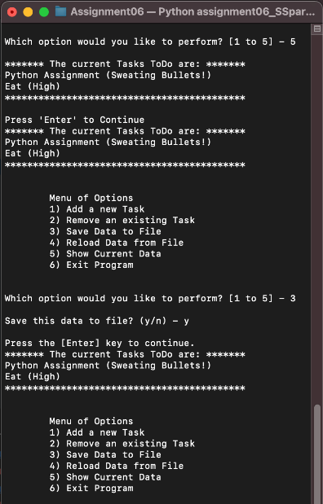

### (Figure 2: Screenshot of Assignment06_SSparks.py running in Terminal.)

As directed, I used PyCharm for the project. See Figure 3 below for a screenshot of some of the program’s code running in the preview window of PyCharm.

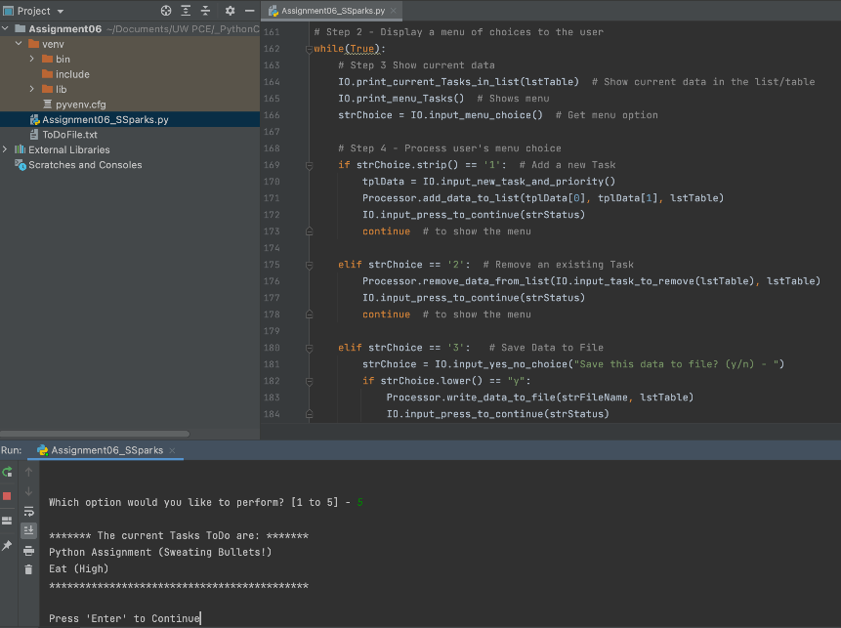

### (Figure 3: Assignment06_SSparks.py running in PyCharm.)

# Libraries

A Library in Python is a group of Functions that perform similar tasks such as “Processing” or “Input/Output.” The “class” syntax sets off a new Library, and individual Function definitions require “@staticmethod” at the beginning, which we will learn about in a later module. See Figure 4 below for a screenshot of a Library I modified for Assignment 06.

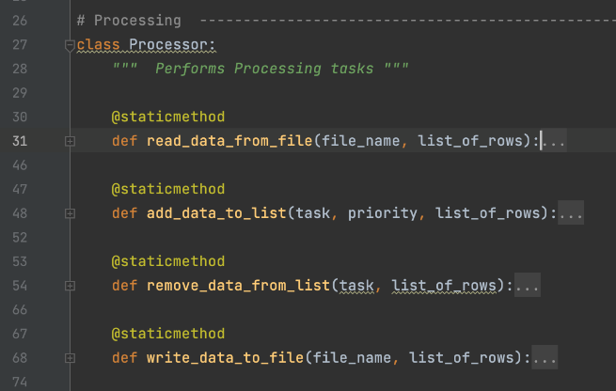

### (Figure 4: The Library we created in Assignment06_SSparks.py.)

# Summary

Functions are powerful tools and an ideal choice for storing groups of code that perform similar tasks in Python. Python developers use Libraries of Functions to organize groups of similar Functions together.