<RafaelDuarte_2026157811><Rodrigo Torres_2026143920>

Level 1-
After creating the “Actions” folder inside the “Assets” folder we created the file “Input Actions” in it we created the Action Map “Movement” with the Action “Move” and the Action Type “Value” and Control Type “Vector 2” inside the “Move” Action we added the “Add Up/Down/Left/Right Composite” Binding, for each element a key bind was assigned.

Level 2-
After finding the “Green Ninja” on the character animations folder we assigned its Pixel Units to 16, Filter Mode to Point (no filter), Compression to None and pressed “Apply”, then we changed the Sprite Mode to Single and Multiple according to the number of sprites each sheet had. On the Walk sprite sheet, we opened the Sprite Editor selected “Slice”, “Type” and “Grid by Cell”, after setting the Pixel Size to 16 on both X and Y values, then clicked “Slice” and applied.
Level 3-
We renamed the “Walk_0” sprite to “PlayerNinja” then on Additional Settings we added a “Sorting Layer” called “Player” and added it on the Sprite Renderer. On the “Assets” folder we created the “Scripts” folder with the “Player” folder in it then we created a script in the “Player” folder called “PlayerMovement” and added it as a component to “PlayerNinja”

Levels 4 and 5-
Code-
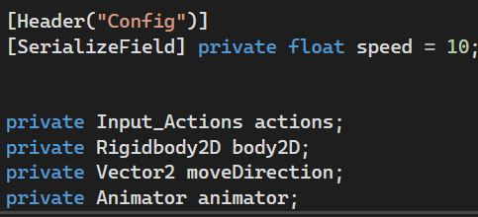
We created a Header called “Config” to separate the speed variable and created the following private variables:
float speed defaulted to 10 with a [SerializedField] so it appears on the Unity Inspector
Input_Actions called actions
RigidBody2D called body2d
Vector2 called moveDirection
Animator called animator
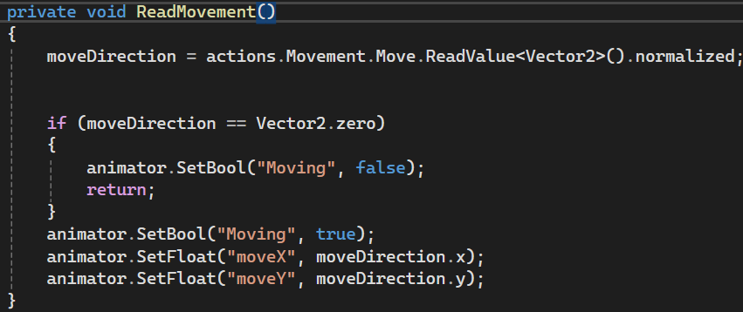
We created a private method ReadMovement() to find the values set up for the inputs inside the Action Map and set it as the moveDirection variable.
An “if” statement to detect that when the player isn’t moving which tells the animator and stops the script.
And when the player moves it tells the animator and depending on the X or Y direction plays the corresponding animations.
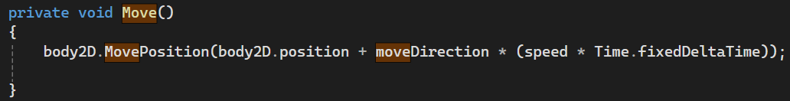
A private method Move to determine the position of the body2D by multiplying the moveDirection variable with the set speed and the fixedDeltaTime then adding its initial position.
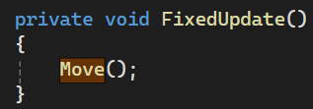
A private method FixedUpdate() to call the Move() function on a fixed interval.
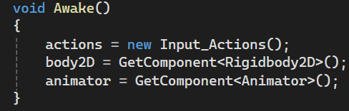
The Awake() method sets its following variables the moment the software starts running.

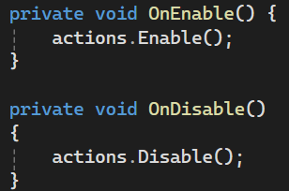
The private methods OnEnable() and OnDisable() enable or disable the player actions when the script is active or not.
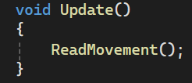
The method Update() calls the ReadMovement() function once every frame.

Animation-
We created the “Animations” folder inside the “Assets” folder with a “Player” folder and created 4 walking animations for each direction walk_up, walk_down, walk_left and walk_right. Created a Blend Tree called “Move Tree” and in it on the “Parameters” created the “float “moveX”” and “float “moveY”” then changed the Blend Type to “2D Simple Directional” and set them to moveX and moveY. On the Motion section we added 4 motions and added the corresponding walking animations to each of them and set their axis accordingly.
Bonus Level-
We created the 4 idle animations idle_down, idle_up, idle_left and idle_right and added them to the Blend Tree called “Idle Tree”, added the bool parameter called “Moving” on the Animator and made the Entry Tree transition to the Idle Tree and from the Idle Tree to the Move Tree then checked the inspector for the transition arrow and unselected the “Has Exit Time” and “Has Fixed Duration” functions and set “Transition Duration” to Zero, on the “Conditions” section added a new condition where Moving it set to True then create another transition from Moving Tree to the Idle tree with the same changes on the Inspector but the Moving condition is set to False.

