<RafaelDuarte_2026157811><Rodrigo Torres_2026143920>

Level 1 -
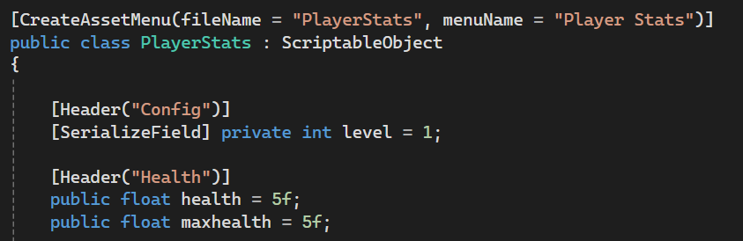
We created the “PlayerStats” script changing “MonoBehaviour” into “ScriptableObject”, then proceeded to add it to the Unity create menu using “[CreateAssetMenu(filename = “PlayerStats”, menuName = “Player Stats”)]” and added a new scriptable object into the “SO” folder. Lastly, we created the needed variables for this Lab.
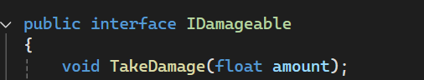
We created a new interface named “IDamageable” with the TakeDamage method (which depends on a float variable) and added it into a new folder.
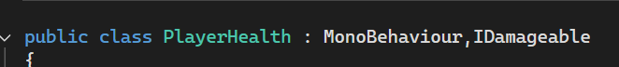
We created the “PlayerHealth” class inside the “Player” folder and subscribed to the IDamageable interface, allowing us access to the TakeDamage method.
Subscribing to an interface means assuring that it’s methods will be integrated within a new class, allowing other classes to call this method on any subscribed class with the benefit of each having their own logic for this same method.

Level 2 -
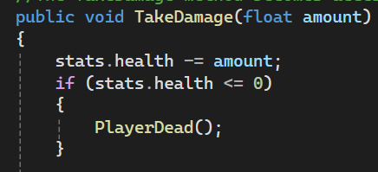
In the “PlayerHealth” class we altered the TakeDamage method in order to subtract a variable of the float type with the name amount from the current health value. Afterwards we added an if statement in order to check if the current health value dropped to or below 0 and, if so, we call the PlayerDead method.
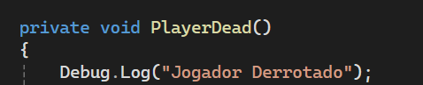
When the PlayerDead method gets called it writes a Log on the Console with the string “Jogador Derrotado”
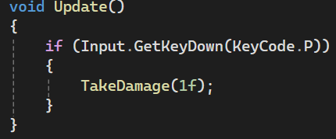
Inside the Update method we check if the “P” key on the keyboard was pressed this frame and if so, call the TakeDamage method with it’s variable value set to 1.

Level 3 -
Inside the Animator we created a new trigger named “Dead”, made a transition from “Any State” to “Dead” setting its “Has Exit Time” and “Fixed Duration” to unmarked, its “Transition Duration” to 0 and adding the “Dead” trigger as the transition condition.
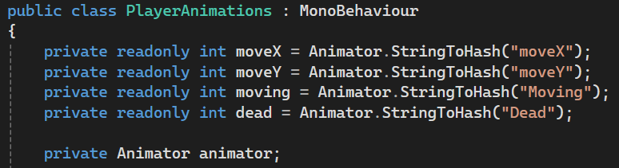
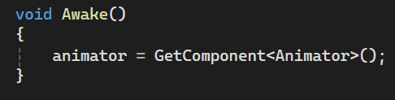
Inside the “Player” folder we created the “PlayerAnimations” script and added private, read only, variables in order to get the required parameters for already made transitions. We also added a new private variable called animator, which will be set as the Animator component once Awake is called.
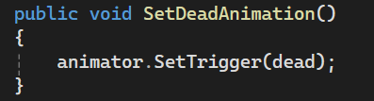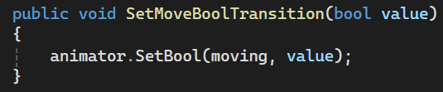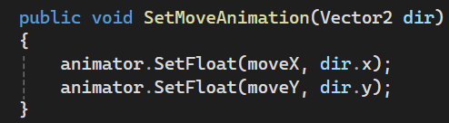
We created the public methos SetDeadAnimation, SetMoveBoolTransition and SetMoveAnimation methods which will handle animation transitions.
- SetDeadAnimation enables the previously defined dead trigger on the animator.
- SetMoveBoolTransition sets the Bool parameter “moving” to a new value
- SetMoveAnimation sets the float parameters required for the move direction to the X and Y components of a passed Vector2 variable.

Level 4 -
Inside the “PlayerMovement” and “PlayerHealth” classes we created a private variable for “PlayerAnimations” that will be obtained through its component.
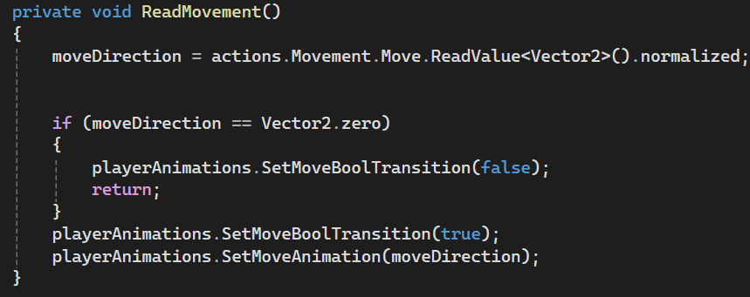
Inside the ReadMovement method we replaced the “SetBool” method with “SetMoveBoolTransition” with corresponding bool values and the “animator” variable with the new playerAnimations class.
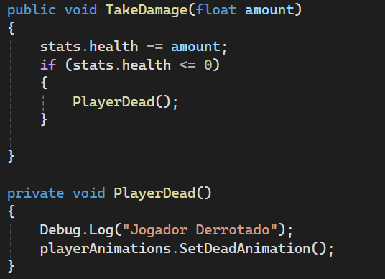
In the “PlayerHealth” class we changed the PlayerDead method so it additionally calls the newly added SetDeadAnimation method.

Level 5 -
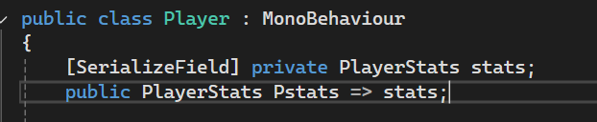
We created the “Player” class inside the “Player” folder with a private variable for the PlayerStats that can be observed in the Inspector alongside the public variable “stats” set to the previous one in order for it to be used by other classes
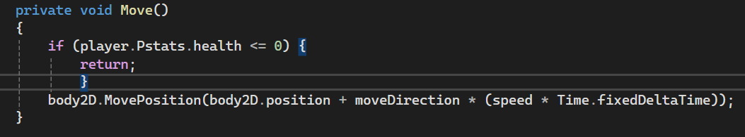
`We created the private variable “Player” inside the “PlayerMovement” class that will be obtained through its component, made it so if the player’s current health value dropped to or below 0, it interrupts the method, preventing the player from moving.

