<RafaelDuarte_2026157811><Rodrigo Torres_2026143920>
Level 1-
After renaming the scene no “WhyUI” we created a Canvas and a Game Object called “event System”, then created an Image to the Canvas anchoring it to the center with the Position coordinates set to Zero and attributed our image as a sprite to it and altered the game resolution to Full HD. We renamed the Canvas to” Background” and made it so the image stretches to fill the whole screen. We added a TextMeshPro inside “Background” and called it Title. We created the the second canvas called “QuizCanvas” and added a TextMeshPro as a placeholder. Inside “QuizCanvas” we added the Button Game Object and an empty Game Object called “Button Group” and gave it the “Vertical Layout Group” component, then after copying the Button three more times we added all of them to the Button Group and added their prefab to a prefab folder.

Level 2-
We replaced the copies of the button with the previously created prefabs.
Then created a Scripts folder with the “QuestionSO” ScriptableObject and used the “CreateAssetMenu” parameter for its Menu Name and File Name.
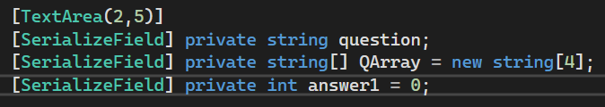
We created the question private variable making sure it appears on the Unity Inspector, defined the “TextArea” to specify its minimum and maximum number of lines, then we created an Array to group up four private string variables and made it observable in the Inspector and created the answer1 private int variable corresponding to a value from the array.

Level 3-
Created the Scriptable Object for the Question and saved it on a folder for Scriptable Objects.
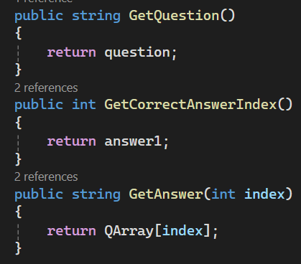
We created the following methods inside “QuestionSO”: “GetQuestion()” that returns the question text, “GetCorrectAnswerIndex()” that returns the number of the correct answer and “GetAnswer(int index)” that returns the element of the answers from the Array. We created the “Questionaire” script and associated it to “QuizCanvas”.
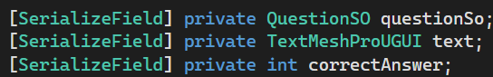
We created a private variable for the QuestionSO script, a TextMeshProUGUI variable for the text and an int variable that corresponds to the value of the correct answer, all observable on the Inspector.

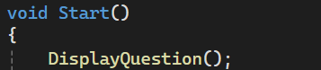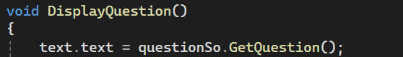
Then in the “Start()” method made it so the text changes to the Question text inside QuestionSO .
Level 4-
Created a Game Object Array for the Buttons and associated them to each Button on the Inspector.
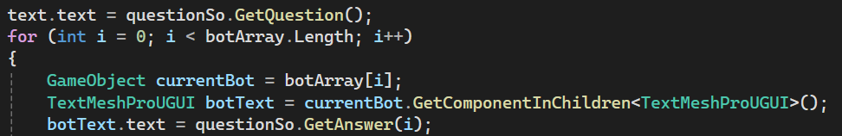
We created a for loop to fill out the Button Array and attribute their children TextMeshProUGUI with their corresponding Answer text.

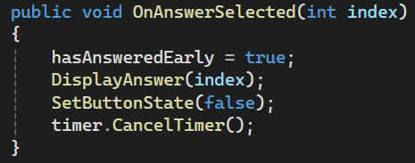
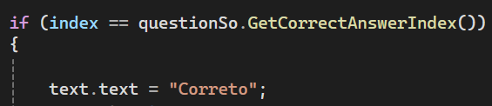
Created the “OnAnswerSelected(int index)” method that validates if the value selected is the same as the one saved on the Answer and if it is, it changes the text to “Correto”.
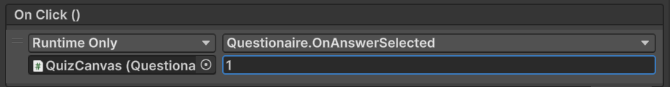
Then associated Questionaire.OnAnswerSelected to every buttons “OnClick()” and gave them their respective values.

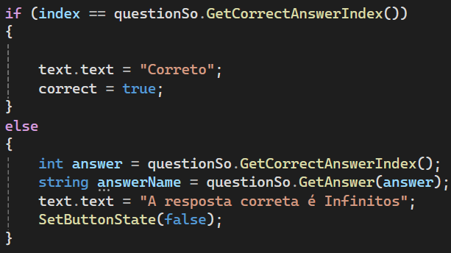
Added an “else” to verify if the answer is different from the one set on the QuestionSO it changes the text to “A resposta correta é Inifinitos”. Then we created the “DisplayAnswer()” method put the if-else in it and called it on “Start()”.
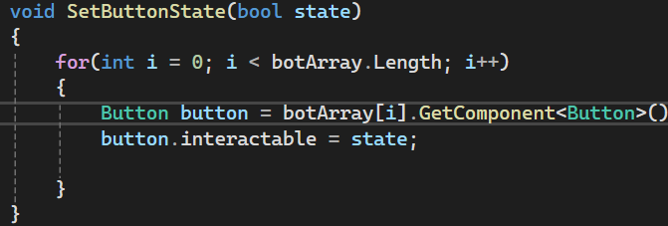
Created the “SetButtonState(bool state)” that verifies every button with an for loop array and changes if it’s interactable after being pressed. Then called it at the end of the “OnAnswerSlected()” method as false.

Level 5-
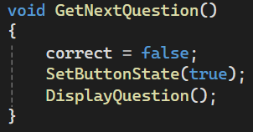
Created the “GetNextQuestion()” method that call calls the “SetButtonState” method as true and the “DisplayQuestion” text, then put “GetNextQuestion()” in “Start()”. Inside QuizCanvas we created a Game Object Image Circle, changed its Image Type to “Filled” and changed its fill origin to “Top”, then created a child Game Object in QuizCanvas called Timer and a Script called Timer associated to it.
Created the “timerValue” private float variable and the “timeToCompleteQuestion” and “timeToShowCorrectAnswer” private float observable variables.
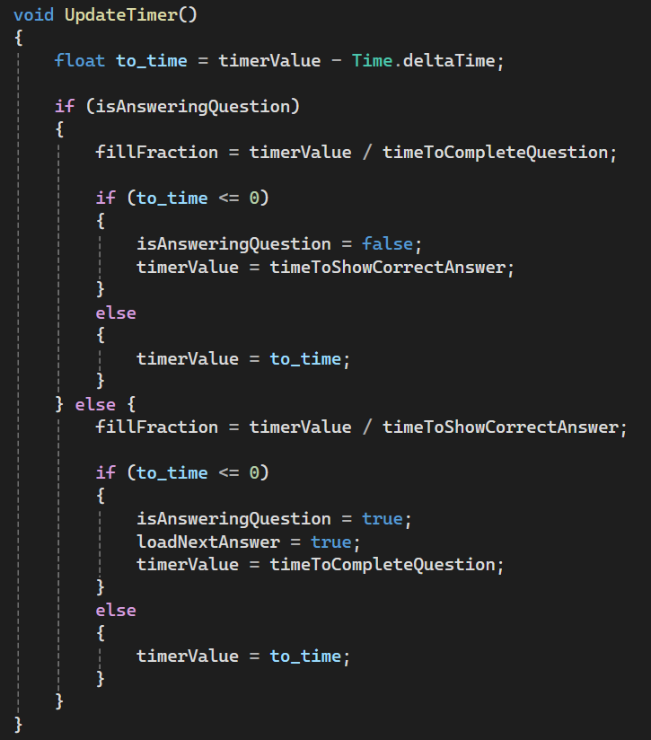
Created the “UpdateTimer()” method that reduces the “timerValue” variable and verify if its value is less or equivalent to Zero, and if it is “timerValue” will have the time value until the answer can be answered, then we called “UpdateTimer()” on “Update()” to call it every frame.

Created the “isAnsweringQuestion” public bool variable set to false and change “UpdateTimer()” to verify if the question is being answered and if it isn’t it shows the correct answer and if it is it loads the next question.
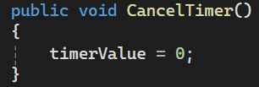
Created the cancel timer that sets the “timerValue” to Zero that effectively creates a reset.
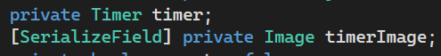
On the “Questionaire” script we created the Timer variable and Image variable that’s observable in the inspector.
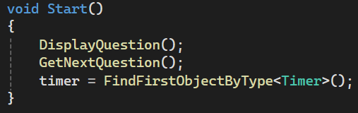
On the “Start()” method we obtain the Timer object inside the scene with the “FindFirstObjectByType<Timer>()” .

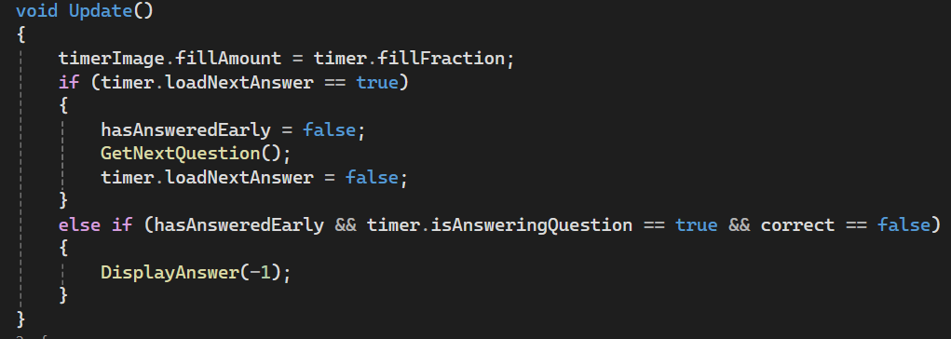
On the “Update” method we associate the timer image’s fill amount with the timer’s fill fraction

