**Weather Forecast and Prediction:**

Due to erratic rainfall in the state of Karnataka, the present government has assigned ‘Cylance Inc.’ to intimate the users about the upcoming weather. The company uses a software product, ‘CyWeather’ to serve customers. The company uses it to automate the process of gathering weather data and predicting the most optimal value. The user can then view data for the upcoming day, week or month. The application is specifically designed for the state with every city integrated in it.

**Class Diagram:**

s

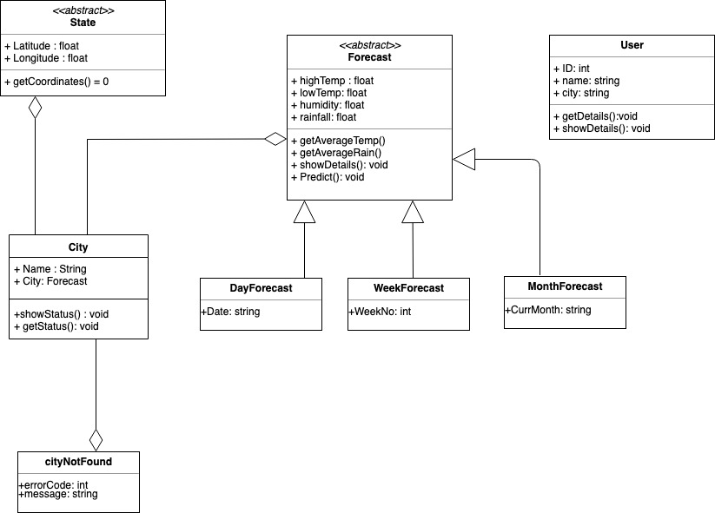

**DESIGN PATTERN: Template Style:**

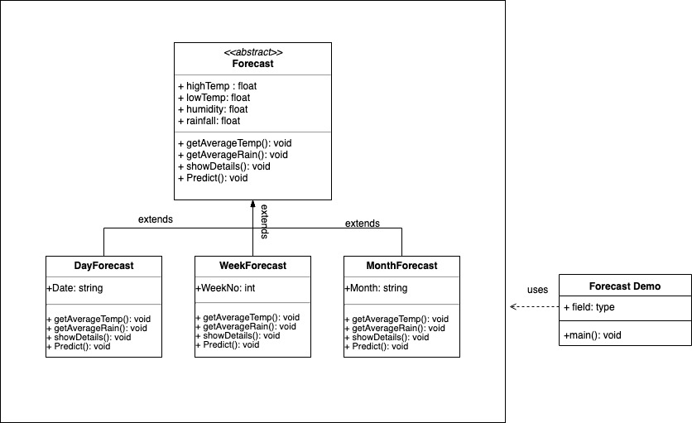

Note:

1. **The customer can provide the city name in Karnataka region, and get the all the weather details, average temperature and weather forecast.**

**Implementation details**

Class: State

|  |
| --- |
| State  <<abstract>> |
| +Lattitude : float  +Longitude: float |
| +getCoordinates() = 0 |

Contains the Latitude and Longitude of the Selected Location.

**Class** : City

|  |
| --- |
| City |
| +name : String  +currStat: Forecast |
| +showStatus():void  +getDetails(): void |

**Constructor**:

It initializes name of the city and other details inherited by the State class. The forecast should be available before the city has been entered.

**Validation**

City entered by the user must be present in the list of available in our database.

**Class:** User

|  |
| --- |
| User |
| +ID: int  +Name: String  +Place : String |
| +Customer(int, String, String)  +getDetails() : void  +showDetails() : void |

**Constructor**:

It initializes the users who will be using the software, it initializes with a unique id, name of the user and the place where they belong.

**Validation**:

The user must provide their details in order to user the software, also the place provided by the user.

**Class** : CityNotFound

|  |
| --- |
| CityNotFound |
| +errorCode : int  +message: String |
|  |

**Validation**

CityNotFound is the exception class which throws when the user requests a city which is not present in our citylist.

**Class:** Forecast

|  |
| --- |
| <<abstract>>  Forecast |
| +high_temp: float  +low_temp: float  +rainfall : float  +humidity: float |
| +getAvgTemp(): void  +getAvgRain(): : void  +showDetails() : void  +predict() : void |

**Validation**:

The forecast class contains the forecasting details of the the entered city. The various methods of the forecast class will be getting the statics of weather.

**Class** : DayForecast

|  |
| --- |
| City |
| +currDate: String |
| +DayForecast(String) : Void |

**Constructor**:

It initializes the current date and other details inherited by the Forecast class.

**Validation**

Date Entered must be in the format of dd-mm-yyyy.

**Class** : MonthForecast

|  |
| --- |
| City |
| +currMonth: String |
| +MonthForecast(String) : Void |

**Constructor**:

It initializes the current month and other details inherited by the Forecast class.

**Validation**

Date Entered must be in the format like “April”.

**Class** : YearForecast

|  |
| --- |
| City |
| +currYear: String |
| +YearForecast(String) : Void |

**Constructor**:

It initializes the current Year and other details inherited by the Forecast class.

**Validation**

Date Entered must be in the format like “2018’.