Food processing sector research

IEA information

* <https://iea.blob.core.windows.net/assets/25266100-859c-4b9c-bd46-cc4069bd4412/WORLDBAL_Documentation.pdf>
  + Food and tobacco – FOODPRO – ISIC Rev. 4 Divisions 10 to 12
    - Division 10 – manufacture of food products; Division 11 – manufacture of beverages; Division 12 – manufacture of tobacco products (see descriptions below of what these correspond to)
  + Industry non-specified in IEA:
    - “Including but not limited to: [ISIC Rev. 4 Divisions 22, 31 and 32] Any industry not included above. Note: Most countries have difficulties supplying an industrial breakdown for all fuels. In these cases, the non-specified (industry) row has been used. Regional aggregates of industrial consumption should therefore be used with caution.”
    - ISIC Divisions 22, 31 and 32 – manufacture of rubber and plastics products, manufacture of furniture, other manufacturing (sports goods, games, toys, jewelry, medical and dental instruments, musical instruments, etc.)
  + “Memo: Non-energy use in food/beverages/tobacco NEFOODPRO Non-energy use in food/beverages/tobacco (please see above for more details on industry sub-sector definitions).”
  + Australia - “In the 2016 edition of this publication, the Australian administration revised primary solid biofuels back to 2010 which impact mostly final consumption in food and tobacco. This created breaks in time series.”
  + Chile - “Electricity consumption in mining and quarrying includes: coal mining; industry (non-specified) includes food, beverages, and tobacco; and wood and wood products; commercial and public services includes gas works.”
  + Finland - “Food, tobacco and beverages reports 1kt consumption of coke oven coke in 2019 after zero in 2018. This is due to rounding (2018: 0,46 kt and 2019: 0,72 kt).”
  + France - “Due to confidentiality reasons, some demand flows have been merged for the products other bituminous coal and anthracite, starting in 2020. Those aggregations are: paper, pulp and printing, food, beverage and tobacco, and not elsewhere specified (industry); machinery, non ferrous metals and non-metallic minerals”; “From 2018, consumption of gas/diesel oil in bakeries is reported in food, beverage and tobacco. In previous years, this consumption is included in commercial and public services.”
  + Ireland - “The consumption of other bituminous coal and peat in the food, tobacco and beverages industry stopped in 2019.”; “In 2004, there is a break in the time series in food, beverages and tobacco consumption due to a change in methodology”
  + Korea – “The consumption of other bituminous coal in the Food, beverages and tobacco industry stopped in 2018.”
  + Mexico – “The category Non-specified (Industry) in the coking coal balance includes the industries of transport equipment, chemical, food and glass. Disaggregated values are not available”
  + New Zealand – “In the 2020 edition, the repetition of data is an estimate by the New Zealand administration for the consumption of biogases in the food, beverages and tobacco sector for the years 1990 to 2018 due to unavailability of data.”
  + Norway – “Decreases in the consumption of solid biofuels in the chemical/petrochemical, non-metallic minerals and food, beverages and tobacco in 2018 are related to the fact that charcoal was included before but now it has been deducted.”
  + Sweden – “Due to confidentiality issues, solid biofuels consumption in food, beverages and tobacco is reported with paper, pulp and printing for 2014 data.”
  + Belarus – “In the 2019 edition, coke oven coke use between 1998 and 2017 was revised as non-energy use was formerly reported in the food, beverage and tobacco sector.”
  + Brazil – “Allocation of consumption to subsectors in national energy statistics is done according to the National Classification of Economic Activities (CNAE). Energy consumption in the tobacco, construction, transport machinery and machinery sectors is included in “other industries” in national data, which is allocated in the IEA Balance to non-specified industry. As such, consumption in the food and tobacco sector excludes the tobacco sector.”
  + Kenya – “In the 2021 edition, new information became available on the food and tobacco industry activity, leading to revisions of the estimations for energy consumption in the sector from 1996 onward.”
  + Heat fuel in IEA – “Heat production includes all heat produced by main activity producer CHP and heat plants, as well as heat sold by autoproducer CHP and heat plants to third parties. Fuels used to produce quantities of heat for sale are included in the transformation processes under the rows CHP plants and Heat plants. The use of fuels for heat which is not sold is included under the sectors in which the fuel use occurs. Data on heat have become available in different years for different countries and thus any aggregated data should be used with caution.”
* ISIC Rev. 4 Divisions 10-12
  + 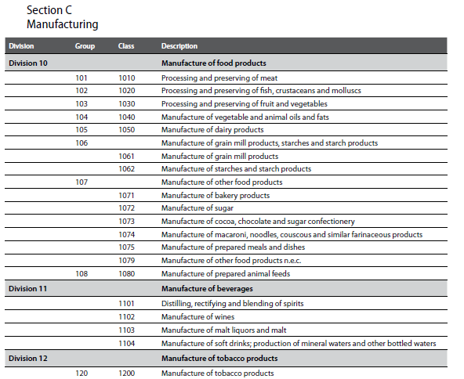
  + “This division includes the processing of the products of agriculture, forestry and fishing into food for humans or animals, and includes the production of various intermediate products that are not directly food products. The activity often generates associated products of greater or lesser value (for example, hides from slaughtering, or oilcake from oil production).”
  + “Some activities are considered manufacturing (for example, those performed in bakeries, pastry shops, and prepared meat shops etc. which sell their own production) even though there is retail sale of the products in the producers’ own shop. However, where the processing is minimal and does not lead to a real transformation, the unit is classified to Wholesale and retail trade (section G).”
  + “Production of animal feeds from slaughter waste or by-products is classified in 1080, while processing food and beverage waste into secondary raw material is classified to 3830, and disposal of food and beverage waste in 3821.”
  + IEA includes refrigerated hauling in freight transport, not food processing

General food processing literature:

Overall summary of information:

* Food processing has decently high energy use in some developed countries (e.g., US, UK, EU), but relatively low energy consumption per dollar value of product
* In the US, electricity consumption is primarily for cooling and refrigeration and machine drives, with variation by food type in terms of what uses the most; natural gas is primarily for boilers and process heating, with similar variation
* Main categories for energy consumption, across all food types: process heating and drying (59%), cooling and refrigeration (16%), mechanical equipment (12%), infrastructure (8%)
* Energy intensive processes: "materials reception and preparation; size reduction, mixing and forming; separation techniques; product processing technologies; heat processing; concentration by heat; chilling and freezing; post-processing operations; and utility processes"
* Low temperature processing is key
* Energy savings and decarbonization options
  + Energy efficiency measures, refrigeration improvements, process optimization
  + Waste heat utilization (MRV – mechanical vapor recompression)
  + CHP/cogen (potentially combined with absorption chillers - trigeneration)
    - Might be pretty low in use currently
  + Electrification of heat (heat pumps and electric boilers)
  + Fuel switching to renewables - biomass energy sources, solar thermal heating, geothermal heat pumps
  + Carbon capture
  + Food waste reduction, demand side measures
* Cogeneration levels currently seem pretty low (explicitly found information for the US, not many other places, but only was really finding feasibility studies)
  + US: “According to the EPA, only 9% of the food industry's electricity demand in 2004 was met using on-site power generation and 95% of that is produced using CHP”
  + UK: “We observe that heat generation from gas boilers represents a significant proportion (56%) of the energy used in the industry, followed by direct gas heating (22%), natural gas Combined Heat and Power CHP (14%), grid electricity (7%) and biomass direct heating (1%)”
  + Europe: general, overall, around 10% of electricity and 15% of heat <https://www.marketwatch.com/press-release/europe-combined-heat-and-power-market-size-projected-to-deliver-greater-revenues-during-the-forecast-period-2022-2031-2022-09-12?mod=search_headline>
* Questions:
  + Use of CO2 (e.g., as refrigerant, carbonized beverages, shelf life enhancement, etc.) that mean that CO2 emissions are not always directly related to energy use - can/should we account for this?
  + Calibrate to internally produced crops, or traded crops? Where does processing happen along the chain?

Detailed information:

* Mapping energy consumption in food manufacturing – Ladha-Sabur et al. 2019, <https://www.sciencedirect.com/science/article/pii/S0924224417303394>
  + “To gain a better understanding of the energy employed in manufacturing and distribution of foods - within the UK and globally - energy usage within the food industry has been collected from literature and clustered by product, processing technique and transportation method.”
  + “Energy figures show that instant coffee, milk powder, French fries, crisps and bread are among the most energy intensive food products. The thermal processes involved in their manufacturing consumed large proportions of the total processing energy. In the meat and dairy processing sectors, energy and water use have increased due to a rise in hygienic standards and cleaning requirements. Additionally, meat products are processed - and sometime over processed - to a higher degree for consumer convenience, all this increasing the associated energy usage for manufacture. Regarding food transportation, more than 98% of all foods within the UK are transported by road, and the distances travelled have increased in recent years. Tertiary distribution using rigid vehicles was the most energy intensive transportation method, while primary distribution at ambient temperature was the least. Refrigerated transportation, which is more intensive than stationary refrigerated systems, has also increased during the past years.”
* Energy efficiency technologies for sustainable food processing – Wang, 2014 <https://link.springer.com/article/10.1007/s12053-014-9256-8?utm_source=getftr&utm_medium=getftr&utm_campaign=getftr_pilot>
  + 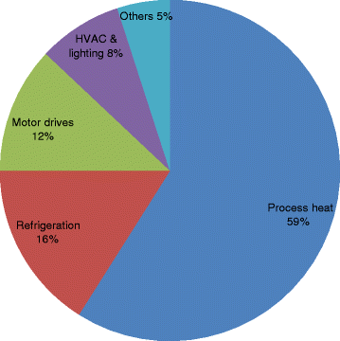 Energy consumption by end users in food processing
  + “The food manufacturing industry produces about 9 % of the electricity with its onsite power systems; 95 % of which are the heat and power cogeneration systems (U.S. EPA [2007](https://link.springer.com/article/10.1007/s12053-014-9256-8#ref-CR57)).”
* Food processing industry energy and water consumption in the Pacific Northwest – Compton et al. 2018, <https://www.sciencedirect.com/science/article/pii/S1466856418301917>
  + “Energy and water consumption in PNW food processing facilities are quantified as well as techniques to increase efficiency and reduce waste. Mechanical drive systems and refrigeration consumes the most electricity in the industry and the implementation of energy management plans has the largest potential to save electricity in PNW facilities. Heating and cooling process needs are the largest consumers of energy in the food processing industry. Implementing cogeneration/trigeneration technology, replacing of older equipment, capturing waste heat, and reusing wastewater can have significant impacts on both energy and water consumption. Novel, emerging technologies such as membrane separation, high-pressure processing, microwave assist, ultrasound, pulsed high electric fields, ozone, and hydrogen/electricity generation have significant potential to benefit the food processing industry by increasing efficiency and allowing companies to stay competitive in an industry where sustainable practices are becoming increasingly important to the public.”
  + “According to a 2007 U.S. Environmental Protection Agency (EPA) report, the U.S. food industry is the fifth largest consumer of energy in the manufacturing sector, ranking below chemicals, petroleum, paper, and iron/steel ([United States Environmental Protection Agency, 2007](https://www.sciencedirect.com/science/article/pii/S1466856418301917" \l "bb0290)).”
  + “Energy consumption per dollar value of the product is quite low however, compared to nearly every other form of manufacturing.”
  + “Data for the food manufacturing industry is not available in terms of water consumption. However, data provided by the U.S. Geological Survey in 2010 show that 90% of water withdrawals in the U.S. are used for thermoelectric power generation, irrigation, and public/domestic use ([Maupin et al., 2010](https://www.sciencedirect.com/science/article/pii/S1466856418301917" \l "bb0135)). The entire industrial/manufacturing sector accounts for only 4% of water withdrawals.”
  + “More than 66% of global freshwater abstraction is for the production of food ([Kirby, Bartram, and Carr, 2003](https://www.sciencedirect.com/science/article/pii/S1466856418301917" \l "bb0090)).”
  + “Other factors that affect the environmental footprint of the food industry, such as irrigation and transportation, are not considered in this study. While irrigation is a major consumer of water in the production of food, it is not directly part of the food manufacturing industry. To illustrate this distinction, the water and energy used to grow apples in Washington State which are then consumed or exported is not within the scope of this study, but the water and energy used to produce apple juice or other products is within the scope.”
  + “At the national scale, the food processing industry in the United States consumed a total of 1.2 trillion MJ (1158 trillion BTU) in energy in 2010, representing approximately 8% of energy consumption of all manufacturing sectors ([United States Energy Information Administration, 2010a](https://www.sciencedirect.com/science/article/pii/S1466856418301917" \l "bb0280)). The vast majority of energy use is in the form of electricity, accounting for 75 TWh, followed by 16 billion m3 (563 billion ft3) of natural gas. Fuel energy is supplied almost entirely by natural gas in the food industry and coal is rarely used. Each sector has different energy needs and usage will also vary between individual locations.”
  + 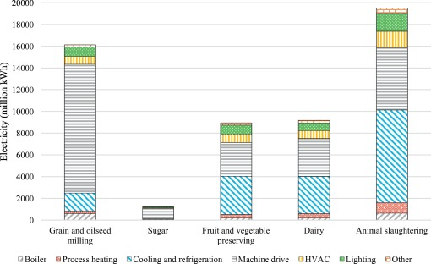US electricity consumption in food processing sectors
  + 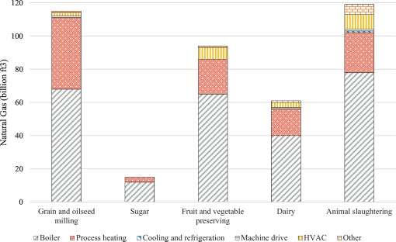 US natural gas consumption in food processing sectors
  + Four main categories for food industry energy consumption: process heating and drying, cooling and refrigeration, mechanical motor-driven systems and product handling equipment, and infrastructure
  + “**Process heating and refrigeration such as ovens, furnaces, and refrigeration equipment account for 75% of the total energy needs throughout the food industry**. **Mechanical equipment like motors, air compressors, fans, grinders, mixers, etc. use 12%. Infrastructure such as building HVAC and lighting account for approximately 8%. Energy requirements vary widely depending on the type of product being handled.** Heating and cooling often have very large energy requirements in every sector due to the need to meet food safety regulations. Cooling and refrigeration needs in meat processing and dairy industries can be significantly larger, approaching nearly 90% of energy needs in some cases ([Nunes, Silva, Andrade, and Gaspar, 2016](https://www.sciencedirect.com/science/article/pii/S1466856418301917" \l "bb0195); [Wang, 2014](https://www.sciencedirect.com/science/article/pii/S1466856418301917" \l "bb0300)).” 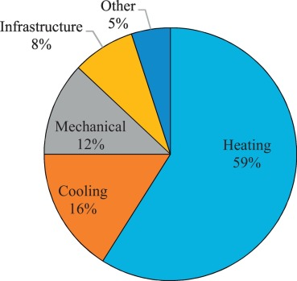
  + 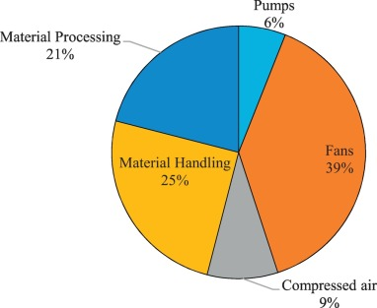Machine driven electricity consumption in PNW food processing plants
  + Energy savings measures:
    - “**Various energy management programs account for over 46% of potential savings**. These programs are broken into three categories and increase in complexity. Plant energy management measures include basic conservation measures such as utilizing utility incentives and subsidies, preventative maintenance, and system operator training. Energy project management takes this further to include the assignment of an energy engineer, identification and prioritization of capital projects, and the use of system optimization tools and practices of key operations. Finally, integrated plant energy management programs consist of the implementation of an energy management plan made up of policies, accountability, and department/system level target goals as well as independent verification of energy savings.”
    - “**Improvements in refrigeration account for 33% of potential energy savings**. Improvements in refrigeration cooling and storage include installing evaporator fan variable frequency drives, closed loop electronic demand controls, and improving operational and maintenance procedures. Refrigeration tune-ups consists of measures such as temperature and pressure set point adjustments, algorithms and sequencing order optimization, coil cleaning, and valve adjustment/repair”
    - “**Major electricity saving measures include the introduction of energy management plans at the facility or even corporate levels, the introduction of VFDs for motors, and upgrading outdated equipment**. There is a large potential in the PNW to **generate electricity onsite using cogeneration** technology. Combining this with absorption chillers to capture low temperature
    - waste heat in a trigeneration configuration can greatly increase the sustainability footprint of a processing plant. Heating needs are commonly met using natural gas, often in the form of steam produced in boilers. **Capturing waste heat where available is strongly encouraged to reduce waste energy and increase the efficiency**.”
      * Cogen – “Food processing plants have a diverse range of power and thermal needs, making them a good fit for combined heat and power (CHP) technology. According to the EPA, only 9% of the food industry's electricity demand in 2004 was met using on-site power generation and 95% of that is produced using CHP ([United States Environmental Protection Agency, 2007](https://www.sciencedirect.com/science/article/pii/S1466856418301917#bb0290)). In 2010 the U.S. Energy Information Administration (EIA) estimated that only 2% of food processing establishments had any cogeneration technology in use ([United States Energy Information Administration, 2010b](https://www.sciencedirect.com/science/article/pii/S1466856418301917" \l "bb0285)). A recent assessment of the CHP potential in the U.S. showed that of all the sites capable of supporting CHP technology in the food industry, only about 40% currently have systems in place ([United States Department of Energy, 2016](https://www.sciencedirect.com/science/article/pii/S1466856418301917" \l "bb0275)).”
  + Water – “Many processes require the use of water and due to safety concerns, the water must be treated sufficiently before it can be reused. This produces a very large amount of wastewater. Older processing equipment should be maintained or replaced to reduce water consumption while increasing efficiency. Often an improvement addressing one issue can prove beneficial on multiple levels. For example, meeting process heating requirements using methods other than steam can significantly reduce water consumption while also reducing fuel consumption. Investigating newly developing technologies such as high-pressure processing, microwave assist, ultrasound assist, refractive window dehydration, refractive window dehydration, infrared, ozone, hydrogen and electricity generation, or [pulsed electric fields](https://www.sciencedirect.com/topics/biochemistry-genetics-and-molecular-biology/pulsed-electric-field) can benefit a facility by reducing the consumption of electricity, fuel, and water.”
* Decarbonizing the food and beverages industry: A critical and systematic review of developments, sociotechnical systems and policy options – Sovacool et al. 2021, <https://www.sciencedirect.com/science/article/pii/S1364032121001507>
  + “To offer some context, the United States has the largest food and beverage industry and is the largest market for eating out in restaurants [[30](https://www.sciencedirect.com/science/article/pii/S1364032121001507" \l "bib30)**]. In the United Kingdom, the food processing industry is the largest single manufacturing sector [****[3](https://www.sciencedirect.com/science/article/pii/S1364032121001507" \l "bib3)], and the second largest industrial energy user, after chemicals** [[31](https://www.sciencedirect.com/science/article/pii/S1364032121001507" \l "bib31)]. In the United Kingdom, the food chain involves about 300,000 enterprises, employs 3.3 million people and generates 15 million tons of food each year [[21](https://www.sciencedirect.com/science/article/pii/S1364032121001507" \l "bib21)]. This makes it larger than the automotive and aerospace industries combined [[32](https://www.sciencedirect.com/science/article/pii/S1364032121001507" \l "bib32)]. It is also a rapidly growing sector, with its economic contribution increasing by 27% from 1997 to 2015 [[33](https://www.sciencedirect.com/science/article/pii/S1364032121001507" \l "bib33)]. Across the European Union as a whole, the food and drink sector remains the largest industrial manufacturing sector as well, with annual turnover for food and drink manufacturing exceeding €1.109 trillion, and with 4.57 million employees [[22](https://www.sciencedirect.com/science/article/pii/S1364032121001507" \l "bib22),[34](https://www.sciencedirect.com/science/article/pii/S1364032121001507" \l "bib34)].”
  + “…the diversity of products offered and consumed, and consequently differential supply chains and retailers. The sector is “very heterogeneous” and must make “a highly diverse range of food and drink products.” [[23](https://www.sciencedirect.com/science/article/pii/S1364032121001507" \l "bib23)] These can cut across processes such as fish processing, the raising of livestock, distilling whisky, or the manufacturing of chocolate. **Each of these**[**subsectors**](https://www.sciencedirect.com/topics/engineering/subsectors)**has different processes—including those for materials reception, mixing, separation techniques, heat processing, and waste streams—alongside supply chains and markets**. As one study surmised, the “food processing industry is diverse and extensive, involving small scale, low-technology, localized operations relying on short supply lines to large, high-technology operations with complex, interconnected lines between suppliers and subsidiaries around the world.””
  + Classifications for energy-intensive processes in food manufacturing: **“materials reception and preparation; size reduction, mixing and forming; separation techniques; product processing technologies; heat processing; concentration by heat; chilling and freezing; post-processing operations; and utility processes”**
    - “Among food and drink processing activities, energy and related greenhouse gas emissions are very heterogeneous. Food canning is very steam intensive, with boilers using 70% of the activity energy; baking requires large ovens using 60% of the activity energy; frozen and chilled foods have large refrigeration loads using 60% of the activity energy; and flour milling plants have large electrical loads using 80% of the activity energy”
  + “For instance, in the United Kingdom it has been estimated that the food processing industry consumes 68% of its energy in fuel-fired boilers and [direct heating systems](https://www.sciencedirect.com/topics/engineering/direct-heating-system), followed by 16% for electric motors, 8% for electric heating, and 6% for refrigeration and air compressors [[21](https://www.sciencedirect.com/science/article/pii/S1364032121001507#bib21)]. The fuel use for the sector is dominated by natural gas (almost two-thirds) followed by electricity with then a minor amount of oil and coal making up the remainder [[60](https://www.sciencedirect.com/science/article/pii/S1364032121001507" \l "bib60)]. When looking at the UK food processing sector by process, it was the high heat demand for drying, evaporation, baking ovens, pasteurization, kilning, and steam production that had the largest consumption, and it was refrigeration and cooling that had the largest electricity consumption”
  + “For the United States, the bulk of this (613 trillion BTUs, or 179.6 TWh) go for processing heating followed by machine drives and pumps (136 trillion BTUs, 39.9 TWh) and then process cooling and refrigeration (69 trillion BTUs, or about 2 TWh).”
  + “**But carbon footprints are not always commensurate to energy consumption profiles for one key difference: the food and beverage industry actively uses, and processes, carbon dioxide alongside whatever carbon flows arise from energy, heat, and steam.** The industry uses carbon dioxide for example as an “increasingly popular refrigerant.” [[73](https://www.sciencedirect.com/science/article/pii/S1364032121001507" \l "bib73)] Carbon is also directly used to carbonize beverages, to produce [deoxygenated water](https://www.sciencedirect.com/topics/engineering/deoxygenated-water), to undertake casein precipitation, to pretreat olives, to serve as an acidifier, and to enhance the [shelf life](https://www.sciencedirect.com/topics/engineering/shelf-life) of some fruits and vegetables”
    - Do we need to account for this?
  + Food and beverage manufacturing decarbonization options
    - Automation and process optimization
    - Thermal management and heat recovery
      * “It has been estimated that at many food processing facilities, process heat alone accounts for about 60–70% of total energy needs”
    - Combined heat and power systems
    - Switch to renewables
      * “The International Renewable Energy Agency projects that after the pulp and paper sector, the food and tobacco sector has the greatest potential for the adoption of renewable sources of electricity or heat. They project that 60% of existing heat demands can be provided instead by renewable energy, especially those needing low to medium temperatures [[101](https://www.sciencedirect.com/science/article/pii/S1364032121001507" \l "bib102)]. As they summarize in [Table 10](https://www.sciencedirect.com/science/article/pii/S1364032121001507" \l "tbl10), the options with the most potential are better integration of biomass energy sources, solar thermal heating, and [geothermal heat pumps](https://www.sciencedirect.com/topics/engineering/geothermal-heat-pump). [Heat pumps](https://www.sciencedirect.com/topics/engineering/heat-pumps) in particular can increase the drying efficiency of conventional air dryers and also operate as a dehumidifier”
    - Energy efficiency
      * “General efficiency efforts include better energy management and maintenance practices, things like avoiding idle equipment, better production scheduling, and correctly sizing and maintaining controls, motors or steam networks. Energy efficient technologies include the adoption of new devices such as advanced [refrigeration technologies](https://www.sciencedirect.com/topics/engineering/refrigeration-technology), or installing advanced insulation on equipment and piping. Accelerator technologies include microwave drying and heating, advanced oven technologies (including electric ovens), or mechanical and thermal vapor [recompression](https://www.sciencedirect.com/topics/engineering/recompression) techniques”
    - More sustainable packaging
* Industrial energy use and carbon emissions reduction: a UK perspective – Griffin et al. 2016, <https://wires.onlinelibrary.wiley.com/doi/10.1002/wene.212>
  + 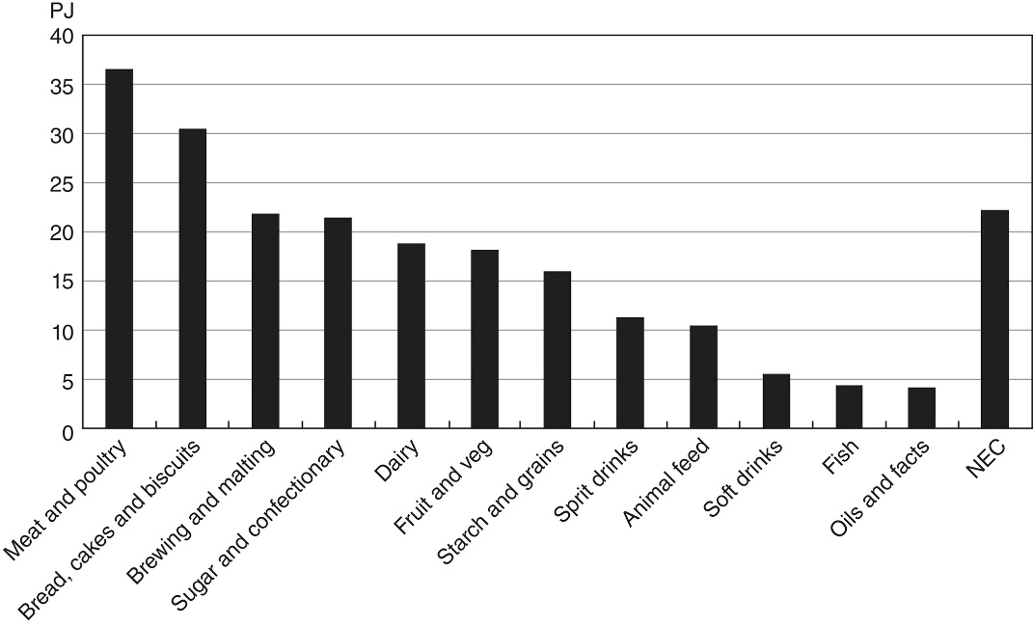Primary energy demand in UK, mean over 2002-2006 disregarding highest and lowest over those periods, NEC = not otherwise classified
  + “The dominance of low temperature processing within *Food & Drink* is clear. Drying and separation, as well as space heating (included within ‘Other energy uses’ in Figure [7](https://wires.onlinelibrary.wiley.com/doi/10.1002/wene.212#wene212-fig-0007)), also contribute to the demand at the low temperature end of the energy cascade.[18](https://wires.onlinelibrary.wiley.com/doi/10.1002/wene.212#wene212-bib-0012) A large proportion of this heat is supplied by steam systems. The UK Food and Drink Federation (FDF) estimate 49% of the subsector emissions arise from boilers, with another 27% from direct heating.[59](https://wires.onlinelibrary.wiley.com/doi/10.1002/wene.212#wene212-bib-0053) For comparison, the US *Food & Drink* subsector uses an estimated 52% of delivered energy in steam systems”
  + Energy efficiency improvements: “This includes the improvement of steam system efficiency, as well as the increased use of both CHP [cogen] plants and heat pumps. Cross-cutting technologies that are not explicitly examined include improvements to motor systems (such as those used for producing refrigeration and compressed air), lighting, and space heating (although space heating has some common ground with the discussion of low temperature heating here).”
    - “The thermal output of CHP plants is normally steam and/or hot water, which is suited to many of the demands of the *Food & Drink* subsector with its large use of steam systems and hot water for cleaning. *Food & Drink* also holds potential for an extension of CHP into ‘*combined cooling, heat and power*’ (CCHP, or ‘trigeneration’), where a cooling load is also provided via an integrated absorption chiller powered by low temperature heat.”
    - “There was 390 MWe of installed CHP capacity in 2010 within the UK *Food & Drink* subsector.”
    - “A US *Department of* Energy study[73](https://wires.onlinelibrary.wiley.com/doi/10.1002/wene.212#wene212-bib-0067) investigating the industrial application of heat pumps identified several opportunities in the Food & Drink subsector. The majority of these involved the concentration of a fluid, such as that related to the production of alcohol, beer, sugar, dairy, and fruit juice or other soft drinks. This was based more on a demand for relatively low temperature heat, than the matching of suitable heat supplies with demand.”
* Energy efficiency, carbon emissions, and measures towards their improvement in the food and beverage sector for six European countries – Meyers et al. 2016, <https://www.sciencedirect.com/science/article/pii/S0360544216303644>
  + Austria, France, Germany, Poland, Spain, UK
  + Includes a big table on energy use for various food productions, “SEC (specific energy consumption) for [food and beverage products](https://www.sciencedirect.com/topics/engineering/food-and-beverage-product), referred to as a Benchmark, often reported in kilowatt-hours (thermal or electric) per product quantity required for its production” but with caveats – wide range, different size companies with different efficiencies, different processes
  + “The role of SME (small and medium sized enterprises) is rather important in this context. The overwhelming majority (>99%) of the 285,000 companies in the F&B sector within the EU are deemed “SME,” meaning that the companies employ less than 250 people and/or have an annual turnover of less than 50 million € [[3]](https://www.sciencedirect.com/science/article/pii/S0360544216303644#bib3). The collection of EU SMEs contributes a share of 52% of the F&B turnover and 64% of the F&B employment (approx. 2.6 million),”
  + Decarbonization options - “Process Optimization (reconfiguration of existing processes), followed by Heat Recovery, Heat/Cold Supply Optimization, (improvement of older technology), and ending with integration of [Solar Thermal Energy](https://www.sciencedirect.com/topics/engineering/solar-thermal-energy), [Combined Heat and Power](https://www.sciencedirect.com/topics/engineering/cogeneration-combined-cooling-heating-power), and [Heat Pumps](https://www.sciencedirect.com/topics/engineering/heat-pumps) (introduction of new technology)”
  + 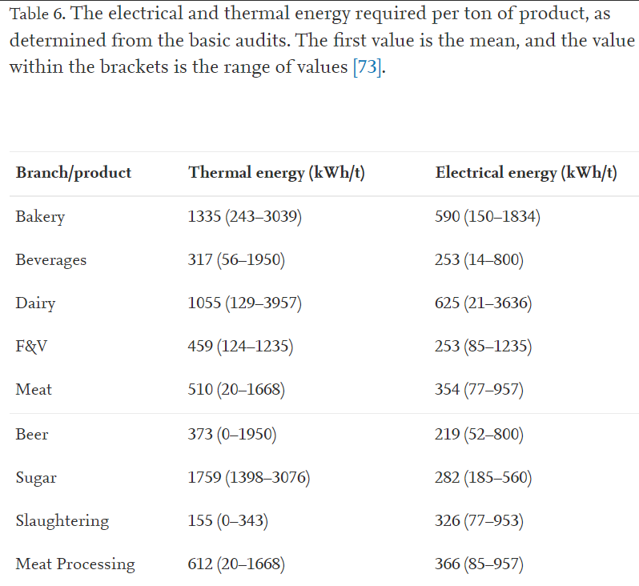
  + F&V = fruit and vegetable
  + “Both the mean thermal and electrical energy demand within the Bakery branch were higher than most average values reported in literature [[18]](https://www.sciencedirect.com/science/article/pii/S0360544216303644" \l "bib18), [[19]](https://www.sciencedirect.com/science/article/pii/S0360544216303644" \l "bib19), [[20]](https://www.sciencedirect.com/science/article/pii/S0360544216303644" \l "bib20), [[21]](https://www.sciencedirect.com/science/article/pii/S0360544216303644#bib21) and less than found by Monforti-Ferrario and Pascua [[2]](https://www.sciencedirect.com/science/article/pii/S0360544216303644" \l "bib2), while the range of energy demand was large and encompassed the prior literature. Results from the Beverage branch, and more specifically Breweries, were comfortably within the ranges expressed in other studies [[2]](https://www.sciencedirect.com/science/article/pii/S0360544216303644#bib2), [[18]](https://www.sciencedirect.com/science/article/pii/S0360544216303644#bib18), [[22]](https://www.sciencedirect.com/science/article/pii/S0360544216303644#bib22), [[23]](https://www.sciencedirect.com/science/article/pii/S0360544216303644#bib23). The Dairy branch however showed significant differences from reported literature, due to multiple dairy products (milk, cheese, yogurt, milk powder) produced at one site with no means to differentiate the required energy per product, an [artifact](https://www.sciencedirect.com/topics/engineering/artefact) of the general nature of the “basic audit”. Taken on an average, the mean Dairy results did rest within the range of previously assess energy intensities [[4]](https://www.sciencedirect.com/science/article/pii/S0360544216303644" \l "bib4), [[8]](https://www.sciencedirect.com/science/article/pii/S0360544216303644" \l "bib8), [[18]](https://www.sciencedirect.com/science/article/pii/S0360544216303644#bib18), [[24]](https://www.sciencedirect.com/science/article/pii/S0360544216303644" \l "bib24), [[25]](https://www.sciencedirect.com/science/article/pii/S0360544216303644" \l "bib25), [[26]](https://www.sciencedirect.com/science/article/pii/S0360544216303644" \l "bib26), [[27]](https://www.sciencedirect.com/science/article/pii/S0360544216303644" \l "bib27). F&V exhibited similar results as compared to prior studies [[2]](https://www.sciencedirect.com/science/article/pii/S0360544216303644#bib2), [[4]](https://www.sciencedirect.com/science/article/pii/S0360544216303644#bib4), with canning operations consuming significant quantities of thermal energy, and freezing operations electrical. Sugar processing, while not included in F&V, agreed with the data shown in Lauterbach et al. and Lehmann and Nielsen [[30]](https://www.sciencedirect.com/science/article/pii/S0360544216303644#bib30), [[31]](https://www.sciencedirect.com/science/article/pii/S0360544216303644#bib31), but was greater than the combined energy values in Monforti-Ferrario and Pascua [[2]](https://www.sciencedirect.com/science/article/pii/S0360544216303644#bib2). The final branch, Meat, was specifically separated into slaughtering and processing [Table 1](https://www.sciencedirect.com/science/article/pii/S0360544216303644" \l "tbl1), showing a larger thermal demand for processing than slaughtering, due to the cooking requirement, while the electrical demand was similar. Results were in general agreement with the European Commission, Meyer et al., Nordic Council of Ministers, and Wojdalski et al. [[4]](https://www.sciencedirect.com/science/article/pii/S0360544216303644#bib4), [[18]](https://www.sciencedirect.com/science/article/pii/S0360544216303644#bib18), [[28]](https://www.sciencedirect.com/science/article/pii/S0360544216303644" \l "bib28), [[29]](https://www.sciencedirect.com/science/article/pii/S0360544216303644" \l "bib29), but not with Ramírez et al. [[17]](https://www.sciencedirect.com/science/article/pii/S0360544216303644" \l "bib17), as this study included the freezing of meat, significantly increasing the energy demand.”
* UK Industrial Decarbonisation & Energy Efficiency Roadmaps to 2050 – Food and Drink, 2015, <https://assets.publishing.service.gov.uk/government/uploads/system/uploads/attachment_data/file/416672/Food_and_Drink_Report.pdf>
  + “The main processing techniques and unit operations applied throughout the entire food and drink sector include materials reception and preparation; size reduction, mixing and forming; separation techniques; product processing techniques; heat processing; concentration by heat; processing by removal of heat; post-processing operation; and utility processes. The five biggest subsectors are other groceries, cereals and bakery, meat, dairy, and fish and seafood”
  + “The most common technologies for the food and drink sector and their share in energy consumption are boilers (54%), direct heating (27%), motors (12%), refrigeration (5%) and compressed air (2%). The fuel use in the sector is dominated by natural gas (about two-thirds), followed by electricity, and a minor amount of oil and coal. The high heat demand of several processes (drying, evaporation, baking ovens, pasteurisation, kilning, steam production, etc.), together with indirect emissions from electricity consumption (used for refrigeration and cooling, mixing, conveying, compressed air, pumps and fans, stirring, rendering, grinding, etc.) mainly make up the food and drink sector carbon dioxide emissions shown in Table 1.”
  + Decarbonization options –
    - “Electrification of heat is one of the most important options available for the food and drink sector”
    - “Biomass clearly has significant potential as an alternative fuel for the food and drink industry, and provides an opportunity to decarbonise the sector. The sector can use a part of its own product flow to convert to green energy, and is already using biomass in this way. … It is noted that there is significant added value to use biomass for heat and power (via CHP technology) compared to power generation only, and this is recognised in government electricity market support policy”
    - “Energy management and improved process design are key for a structured approach in the evolution towards an energy-efficient and low-emissions process.”
  + Main processes:
    - Materials reception and preparation
      * Receipt, unpacking, storage, conveyance, sorting and screening, peeling, washing, thawing
    - Size reduction, mixing and forming
      * Can include grinding/milling/crushing, forming/molding/extruding
    - Separation techniques
      * Extraction, centrifugation and sedimentation, filtration, distillation, others particular to subsectors
    - Product processing technologies
      * Soaking, fermentation, others
    - Heat processing
      * Pasteurization, baking, melting, blanching, roasting, frying, others
    - Concentration by heat
      * Evaporation, drying, freeze-drying
    - Chilling and freezing
      * Refrigeration, cooling/chilling, freezing
    - Post-processing operations
      * Packing and filling, gas flushing
    - Utility processes
      * Cleaning and disinfection, water processing, vacuums, compressed air
  + “The most common technologies for the food and drink sector and its share in energy consumption are: boilers (54%), direct-fired applications (21%), cooling and freezing (10%) and fans and pumps (7%) (FDF, 2008)… The 2012 fuel mix for the UK food and drink sector is shown in Figure 7. For the sector as a whole, the distribution of the energy carriers is: 66% natural gas, 28% electricity and 5% petroleum products and coal.”
  + Energy-saving strategies
    - General energy efficiency measures
    - Energy efficient technologies – CHP, waste heat recovery, process design, new technologies
    - Electrification of heat
    - Fuel shift to biomass boilers and CHP, biomass and bioenergy
    - Supply chain options – food waste reduction, packaging reduction
    - Carbon capture
  + Challenges with using its own biomass for energy generation in food processing –
    - “Biomass is clearly an alternative fuel for the food and drink sector: with the exception of the pulp and paper industry, it is the only industry that can use a part of its own product flow to convert to green energy. The industry is already using biomass that is considered carbon neutral (e.g. wood fuel such as wood chip and pellets, or by-products, biomass waste, biogas from anaerobic digestion, sludge, algae, etc.).”
    - “For example, when food currently classified as by-product for use in animal feed would be used as low-carbon biomass source for energy production, this would result in less food available for the production of animal feed. In turn, this animal feed would have to be sourced elsewhere, causing potential adverse impact on carbon emissions within the supply chain”
    - “Feedstock availability is less of a barrier than in the pulp and paper sector, as the only competition for using own food waste or by-products is the animal feed sector. There is significant added value in using biomass for CHP compared to power generation only and this should be considered by the government in its ambition to decarbonise the electricity grid. But compared to pulp and paper, the biomass in the food and drink industry is not always of the same quality (leading to biogas produced with a variable composition), which can pose an additional barrier on successfully implementing biomass CHPs”
  + “Food and drink plants and the process equipment tend to be built (or purchased) as complete plants through some turnkey suppliers and typically have a life expectancy of over 30 years. In many sectors, the change in processing lines can be more frequent due to changes in product mix or because of new product development, but the utilities services equipment (such as boilers, ovens, refrigeration plants, etc.) can have long life cycles.”
    - “CHPs and turbines have a typical life span of around 20 years (with a major refurbishment after ten years). Vacuum pumps can also easily reach 25 years’ life whereas smaller utilities (compressed air, HVAC (heating, ventilation and air conditioning), lighting) have typical lifetimes of 10-15 years before replacement or major upgrade. ESP filters in exhaust systems can last for several decades (EC, 2013). Boilers typically last for at least 30 years”
* Energy use in the EU food sector: State of play and opportunities for improvement, 2015 - <file:///C:/Users/spei632/Downloads/ldna27247enn.pdf> <https://publications.jrc.ec.europa.eu/repository/handle/JRC96121>
  + “According to Eurostat, the total direct energy consumed by the European food industry amounted to 28.4 Mtoe, accounting for about 2.6 % of the EU-28 average final energy consumption in 2013. In Member States this share broadly ranged between a few tenths of percentage points and 4 % of the national final energy consumption. Figure 3.1 shows the actual energy mix of the food sector industry in the EU-28 in absolute (top panel) and relative (bottom panel) terms in 2013. Gas (47.8 %), electricity (34 %) and oil (7 %) have dominated this sector’s energy mix in 2013 with renewables accounting for 3 %.”
  + 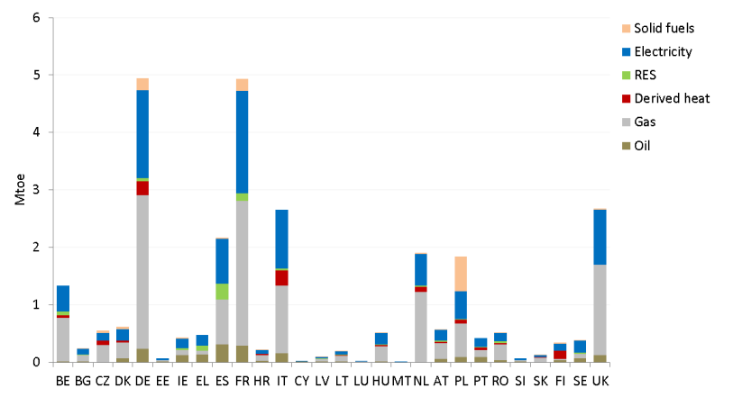
  + “According to UNIDO (2007) as cited by FAO (2012, p. 29), the degree of industrial food processing depends on the economy of the country: in low-income countries, 30 % of food is industrially processed, while in high-income countries 98 % of food is processed more or less intensively”
  + “Firstly, from the business-size perspective, the food industry in the EU-28 is largely dominated by small and medium-sized enterprises (SMEs)…Among many others, Thollander and Palm (2013) have explained how applying effective energy-efficiency measures or promoting RE deployment in diversified and parcelled sectors is especially challenging.”
  + 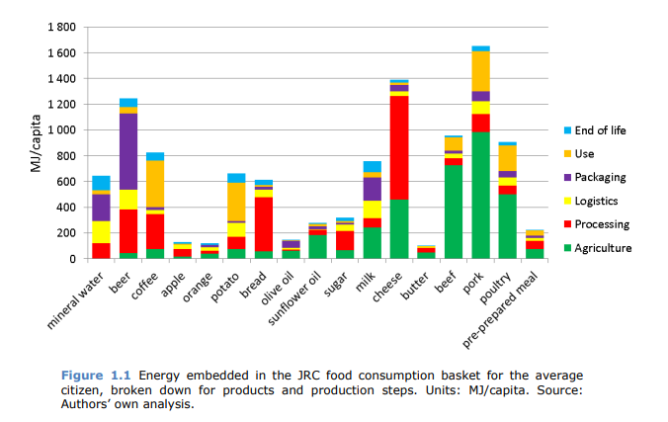
  + 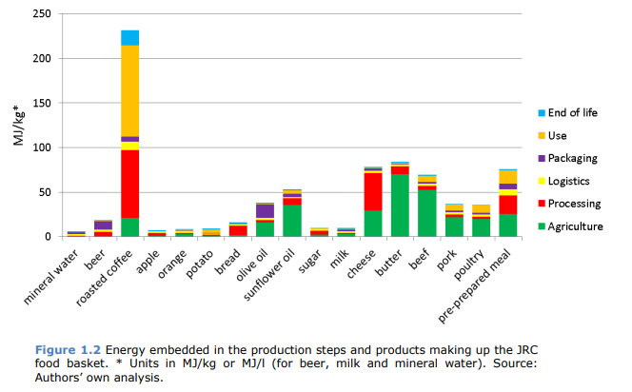
* Best Available Techniques (BAT) Reference Document for the Food, Drink and Milk Industries, 2019 - <https://eippcb.jrc.ec.europa.eu/sites/default/files/2020-01/JRC118627_FDM_Bref_2019_published.pdf>
  + Has a TON of info, for each subsector: processes and techniques, current consumption and emissions levels, techniques to facilitate achieving BAT (energy efficiency, water, waste, air emissions); then final BAT conclusions for the different sectors
* Bottom-up estimates of deep decarbonization of U.S. manufacturing in 2050 – Worrell & Boyd, 2022, <https://www.sciencedirect.com/science/article/pii/S0959652621039342?via%3Dihub>
  + For “light industries” including food processing, hydrogen is likely to be less attractive relative to electrification and renewables; also unlikely to use CCS because the costs of CCS infrastructure will be high and emissions are relatively low on a per-plant basis
    - “Industries that are co-located with larger industrial sites and emission sources might benefit from better CCUS economics, but in this analysis we do not assume that CCUS will play a discernible role in these industries.”
  + More important for light industries are electric boilers and heat pumps, mechanical vapor recompression (heat recovery and generation of low-pressure steam from waste heat)
    - Potential for replacing all process heat with fully electric in their assumptions
  + Their estimate of various decarbonization strategy potentials for light industry:
    - Energy efficiency potential: “Based on a variety of broader studies (e.g., Aas et al., 2018; Fais et al., 2016), the ENERGY STAR Energy Guides, and statistical data seen through manufacturing plant energy performance benchmarks developed for the ENERGY STAR program (for example, see Boyd, 2017), we estimate an energy efficiency improvement potential of 25%–30%. **For this study, we assume savings of 25% for fuel end uses, and 30% for electric end uses** (e.g., motor drives, HVAC, lighting).”
    - Material efficiency potential: “We assume that **demand will be reduced by 10% (on average) across all other industries**, relative to the reference case.”
    - Renewables: “For this study, we assume **that 25% of heat demand can be met by renewables**. While CHP applications also will generate electricity, no studies have explicitly estimated the contribution for the United States. We assume that half of the heat is produced in biomass-fired CHP units (and some geothermal), with an assumed power-to-heat ratio of 0.25 (i.e., for every kWh of heat, 0.25 kWh of electricity is generated).”
    - Hydrogen and CCUS relatively not attractive, assumed to not play notable roles
    - Electrification: “For this study we assume that, **of the remaining hot water and steam demand, about 30% can be generated with electric boilers (replacing 1 unit of heat by 0.9 units of electricity) and 20% by heat recovery using heat pumps** (replacing 1 unit of heat by 0.3 units of electricity). The remaining heat can be generated by on-site renewables (e.g., biomass waste flows, geothermal or solar thermal). We assume that **all remaining process heat demand can be replaced by fully electric alternatives** (replacing 1 unit of heat by 0.9 units of electricity).”
* A review of cross-sector decarbonisation potentials in the European energy intensive industry – Gerres et al., 2019, <https://www.sciencedirect.com/science/article/pii/S095965261833436X?via%3Dihub>
  + They find in their review that the GHG abatement options mentioned for food processing are process heat provision, industrial ovens, catalyst processes and membrane technology, heat recovery, CHP, CCS, biomass and bio-based waste, alternative feedstocks; most mentioned are process heat provision, industrial ovens, CHP, and biomass and bio-based waste
  + “Natural gas [fired boilers](https://www.sciencedirect.com/topics/engineering/fired-boiler) are the primary source for steam in the food industry with [cogeneration systems](https://www.sciencedirect.com/topics/engineering/cogeneration-system) offering a valuable alternative ([JRC, 2013](https://www.sciencedirect.com/science/article/pii/S095965261833436X?via%3Dihub" \l "bib93)). Processes are characterised by low temperature ranges. Data for the French food & drinks industry shows that almost all heat is required at temperatures below 140 °C ([Hita et al., 2011](https://www.sciencedirect.com/science/article/pii/S095965261833436X?via%3Dihub" \l "bib81)). Roadmaps and pathway analyses suggest electro-thermal technologies, especially heat pumps, for providing the required heat. A study of novel and emerging technologies for food processing ranks heat pumps first before other electromagnetic technologies ([Jermann et al., 2015](https://www.sciencedirect.com/science/article/pii/S095965261833436X?via%3Dihub" \l "bib89)). Heat pumps can reduce fuel consumption for specific diary processes by more than 40% ([Becker et al., 2011](https://www.sciencedirect.com/science/article/pii/S095965261833436X?via%3Dihub#bib20)). In case of Spain, process heat accounts for 37% of the energy required in the food processing industry and is entirely provided by fossil fuels ([Aranda-Usón et al., 2012](https://www.sciencedirect.com/science/article/pii/S095965261833436X?via%3Dihub#bib8)). Electrification of heat provision can reduce emissions related to these thermal processes. [Wang (2014)](https://www.sciencedirect.com/science/article/pii/S095965261833436X?via%3Dihub" \l "bib156) estimates that 57% of fossil fuel used in food processing is used for steam production. Electrifying the steam provision could reduce emission reduction by 57%.”
  + Industrial ovens for food processing would mean electrification of low temp cooking and baking
  + “Advancements in membrane technology can also reduce heat and energy intensity of the food-processing subsector. The advantages of large scale implementation of membrane technology in the food industry are discussed by multiple authors, as [Cassano (2015)](https://www.sciencedirect.com/science/article/pii/S095965261833436X?via%3Dihub" \l "bib38), but many applications are still in laboratory or pilot phase ([Alkhudhiri et al., 2012](https://www.sciencedirect.com/science/article/pii/S095965261833436X?via%3Dihub#bib4)). No quantification of the abatement potential for the subsector is possible.”
  + 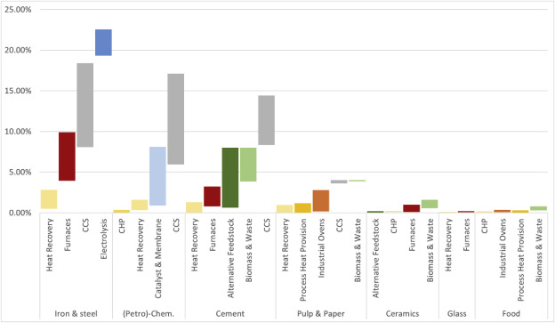
* Assessing decarbonisation pathways in the food and beverage sector: A multi-criteria decision analysis approach – O’Shea et al. 2022, <https://www.sciencedirect.com/science/article/pii/S0959652622031146#bib21>
  + “Decarbonisation roadmaps to 2050 for the European food and beverage sector recognised the need for companies to implement multiple measures (owing to the lack of a “silver bullet” solution) including: MVR; electrification; heat recovery; high efficiency boilers; and the use of renewable gaseous fuels. These measures along with differing degrees of technology adoption are expected to result in a 47%–92% reduction in GHG emissions compared to 1990 ([Cameron et al., 2021](https://www.sciencedirect.com/science/article/pii/S0959652622031146" \l "bib10)). In the UK, 97% of heat related industrial GHG emissions were from natural gas combustion, 65% of the heat used in the manufacturing sector was provided by boilers and the main options for reducing these emissions are decarbonisation of the gas supply and the use of electric steam generators ([Piercy, 2020](https://www.sciencedirect.com/science/article/pii/S0959652622031146" \l "bib51)). Options for the decarbonisation of the Dutch starch processing sector include AD of by-products to produce biogas, MVR, high temperature heat pumps, [biomass boilers](https://www.sciencedirect.com/topics/engineering/biomass-boiler), electric steam generation, and hydrogen use ([Bazan et al., 2020](https://www.sciencedirect.com/science/article/pii/S0959652622031146" \l "bib7)); similar technologies were highlighted for the Dutch potato processing industry ([West et al., 2021](https://www.sciencedirect.com/science/article/pii/S0959652622031146" \l "bib67)) and the Dutch brewing and malting industry ([Muller et al., 2021](https://www.sciencedirect.com/science/article/pii/S0959652622031146" \l "bib44)).”
* Cost-Energy Optimum Pathway for the UK Food Manufacturing Industry to Meet the UK National Emission Targets – Gowreesunker et al. 2018, <https://www.mdpi.com/1996-1073/11/10/2630>
  + “This paper investigates and outlines a cost-energy optimised pathway for the UK food manufacturing industry to attain the national Greenhouse Gas (GHG) emission reduction target of 80%, relative to 1990 levels, by 2050. The paper employs the linear programming platform TIMES, and it models the current and future technology mix of the UK food manufacturing industry. The model considers parameters such as capital costs, operating costs, efficiency and the lifetime of technologies to determine the cheapest pathway to achieve the GHG emission constraints. The model also enables future parametric analyses and can predict the influence of different economic, trade and dietary preferences and the impact of technological investments and policies on emissions. The study showed that for the food manufacturing industry to meet the emission reduction targets by 2050 the use of natural gas as the dominant source of energy in the industry at present, will have to be replaced by decarbonised grid electricity and biogas. This will require investments in Anaerobic Digestion (AD), Combined Heat and Power (CHP) plants driven by biogas and heat pumps powered by decarbonised electricity.”
  + Has data on efficiencies, CAPEX, OPEX that they used for their technologies in their disaggregation of the food processing sector from general industry – this could be very useful
  + Boilers, ovens, CHP, drying can be coal, oil, gas, biomass; motor-driven applications, pumps, compressed air, chilling/freezing, separation, fans, lighting, heat pumps are electric
  + “A survey of the UK food manufacturing industry by the Food and Drink Federation (FDF) reveals the energy consumption distribution to be as shown in [Figure 3](https://www.mdpi.com/1996-1073/11/10/2630/htm#fig_body_display_energies-11-02630-f003). We observe that heat generation from gas boilers represents a significant proportion (56%) of the energy used in the industry, followed by direct gas heating (22%), natural gas Combined Heat and Power CHP (14%), grid electricity (7%) and biomass direct heating (1%).”
* Energy efficiency technologies for sustainable food processing – Wang, 2014, <https://link.springer.com/article/10.1007/s12053-014-9256-8>
  + “There are six main food processing sectors in terms of food products, which include (1) grains and oilseed milling, (2) sugar and confectionary processing, (3) fruit and vegetable processing, (4) dairy processing, (5) meat processing, and (6) bakery processing.”
  + 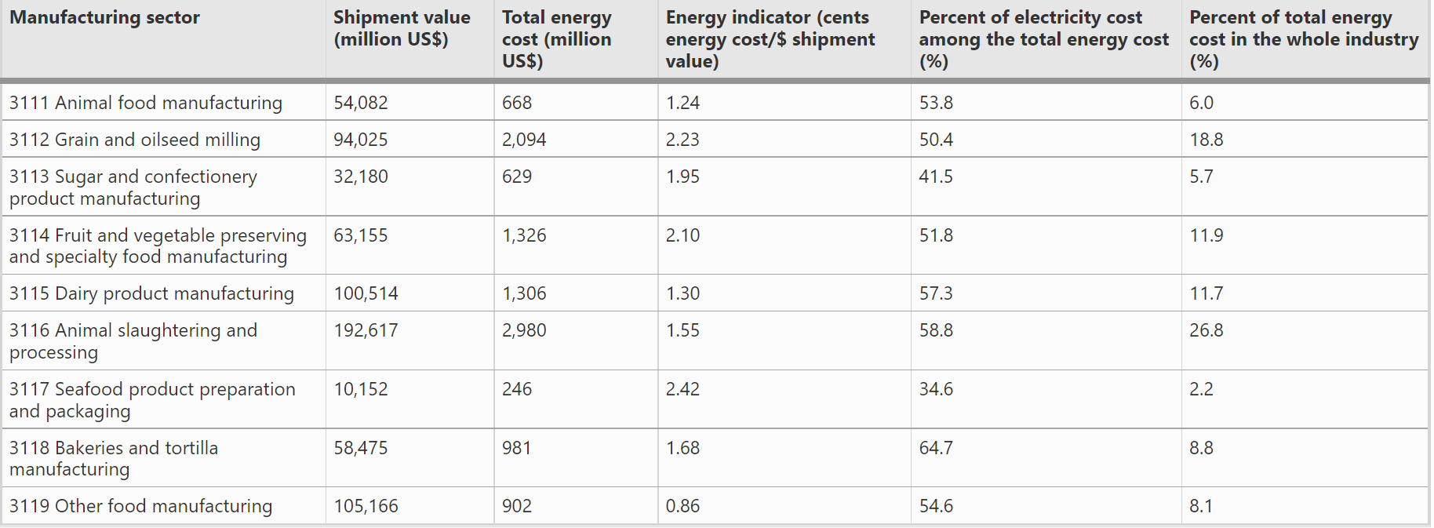
  + “However, in other developed countries, the distribution of the energy use in different food sectors may be different. Each of the manufacturing sectors of (1) fruits and vegetables, (2) meat products, (3) vegetable oil and animal fat, (4) dairy products, (5) prepared animal feeds, and (6) grain mill, starches, and starch products consumed about 10–15 % of the total energy input into the whole food industry in the Netherlands in 2001 (Ramirez et al. [2006a](https://link.springer.com/article/10.1007/s12053-014-9256-8#ref-CR45)).”
  + “Fuels are mainly used for process heat and space heating while electricity is used for refrigeration, motor drives, and automation.”
  + Includes lots of energy efficiency options
* US DOE Industrial Decarbonization Roadmap (DOE/EE-2635) food and beverage manufacturing section
  + “Unique obstacles include the fact that the subsector is particularly heterogeneous even within industry, manufacturing a highly diverse range of products using several different processes. Additionally, there is the need to maintain strict levels of product safety and quality compared to other industries.”
  + Energy efficiency, electrification, and CCUS
  + “Food manufacturing is one of the largest energy-consuming and GHG-emitting industries in the United States. The subsector is responsible for 6% of total industrial CO2 emissions, with an estimated 78 million MT CO2 emissions in 2020”
  + In their near-zero GHG scenario, emissions reductions from food and beverage manufacturing come mostly from energy efficiency and electrification and low carbon fuels and feedstocks and energy – “Efficiency and electrification make the largest contribution to CO2 emissions reduction. CCUS has limited potential in food and beverage manufacturing because of the high number of small-scale, dispersed production plants and lower concentration of point-source CO2 emissions.”
* The energy implication of China’s food system transformation – Song et al. 2019, <https://www.sciencedirect.com/science/article/pii/S0306261919303666>
  + “China has experienced vast economic and income growth, urbanization, and globalization since the 1980s. The higher incomes and changing lifestyles have led to substantial changes in what people eat. Consumption of grains has fallen while intakes of animal products (meat of all kinds as well as eggs, milk, fish and other aquaculture products), vegetable oils, sugar and processed foods have substantially increased [[13]](https://www.sciencedirect.com/science/article/pii/S0306261919303666" \l "b9005), [[14]](https://www.sciencedirect.com/science/article/pii/S0306261919303666" \l "b9010), [[15]](https://www.sciencedirect.com/science/article/pii/S0306261919303666" \l "b0060). Along with the diet changes, China’s traditional food supply system has been transforming to a more modernized system.”
  + “The distribution of the [energy footprint](https://www.sciencedirect.com/topics/engineering/energy-footprint) along the segments of the food supply chain has evolved over the years.”
  + 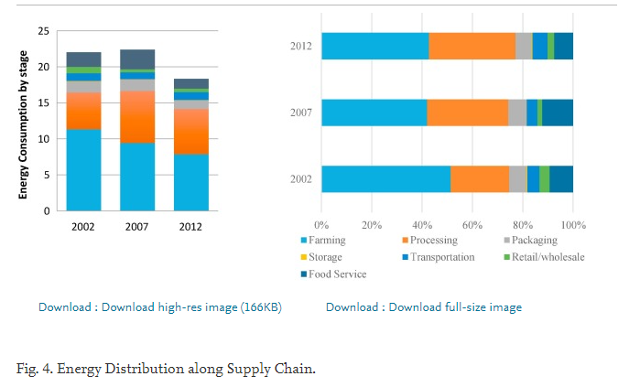
  + Energy intensity changes along supply chain: 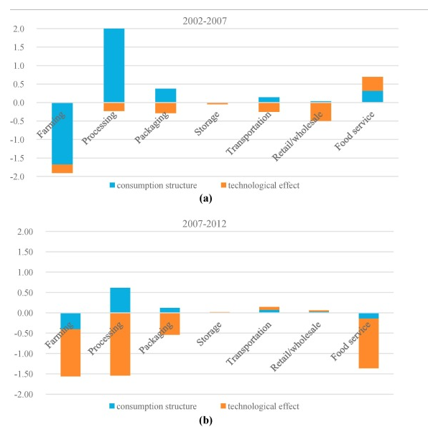
* CO2 emissions of China's food industry: an input–output approach – Lin et al. 2016, <https://www.sciencedirect.com/science/article/pii/S0959652615008525?via%3Dihub>
  + “According to the statistics of energy consumption of the food industry (including four sub-industries: food from agricultural products processing, foods manufacturing, beverages manufacturing, and tobacco manufacturing) in the China Energy Statistical Yearbook, the industry utilizes mainly five kinds of final energy: coal, [petroleum products](https://www.sciencedirect.com/topics/earth-and-planetary-sciences/petroleum-hydrocarbon), natural gas, heat and electricity. This paper calculates the CO2 emissions in the food industry from 1991 to 2012 by summarizing the products of all kinds of energy consumed and their CO2 emission factors.”
* <http://lwzb.stats.gov.cn/pub/lwzb/tzgg/202205/W020220511399105291535.pdf> and <http://lwzb.stats.gov.cn/pub/lwzb/tzgg/202107/W020210723348608146791.pdf> - data on China food industry output

|  |  |  |  |  |  |
| --- | --- | --- | --- | --- | --- |
| Product | Unit | Yield 2021 | Growth over previous year (%) 2021 | Yield 2020 | Growth over previous year (%) 2020 |
| Refined edible vegetable oil | Tons | 4973.1 | -5.0 | 5476.2 | 2.5 |
| Finished sugar | Tons | 1457.1 | 0.0 | 1431.3 | 3.0 |
| Fresh and frozen meat | Tons | 3298.2 | 24.5 | 2554.1 | -10.0 |
| Dairy products | Tons | 3031.7 | 9.4 | 2780.4 | 2.8 |
| Liquor (65% off?, commodity quantity) | Million liters | 715.6 | -0.6 | 740.7 | -2.5 |
| Beer | Million liters | 3562.4 | 5.6 | 3411.1 | -7.0 |
| Wine | Million liters | 26.8 | -29.1 | 41.3 | -6.1 |
| Drinks | Million liters | 18333.8 | 12.0 | 16347.3 | -7.7 |
| Cigarettes | billion | 24182.4 | 1.3 | 23863.7 | 0.9 |

* <https://www.sciencedirect.com/science/article/pii/S019689042201127X> - “Bottom-up assessment of industrial heat pump applications in U.S. Food manufacturing” – Zuberi et al. 2022
  + “This study employs a bottom-up approach to investigate the techno-enviro-economic potentials of deploying high-temperature and steam-generating heat pumps in the major U.S. food manufacturing sectors in different timeframes. The results show that the annual technical potential energy and CO2 savings by electrifying process heat supply are 325 PJ (or approximately 20% of the total final energy demand in U.S. food manufacturing) and 31 MtCO2 (equivalent to the annual CO2 emissions from over 6 million cars in the U.S.) in 2050, respectively; however, these incur additional costs in each sector. Although there may be individual cost-effective opportunities for electrifying heat supply in specific industrial sites, the overall costs are estimated to be high in the food sectors due to the large disparity between electricity and natural gas prices and low heat source temperatures. To overcome the identified techno-economic barriers, comprehensive action plans for different stakeholders are needed.”
  + “Zuberi et al. (2018) [39] estimated the IHP capital costs based on catalog prices of necessary components given by different manufacturers while the installation costs were assumed as 25 % of the total equipment costs. This study has adapted these capital costs for the U.S. industry as shown in Fig. 2. The range of capital costs of an IHP as a function of heating capacity includes equipment and installation costs and are presented in the figure after adjustments to correct for the regional differences in material and labor costs and exchange rates. The estimated specific capital costs are also in good agreement with [40]. The annual fixed operations and maintenance (O&M) costs of IHPs are assumed to be 1 % of the capital costs based on [41].” 🡪 useful for the non-energy costs
* <https://www.sciencedirect.com/science/article/pii/S0360544220311907> – “Solar for industrial process heat: A review of technologies, analysis approaches, and potential applications in the United States”
  + 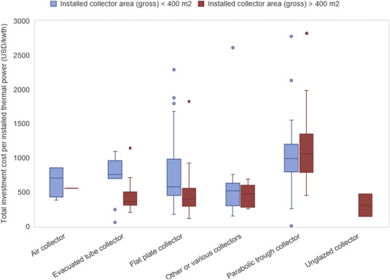
  + “The high frequency of global installations in food and beverages indicates target industries for SIPH in the U.S.”
  + 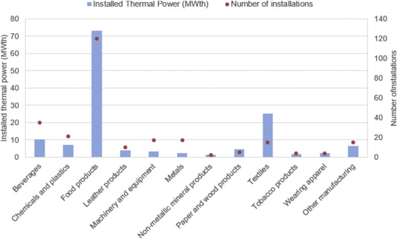
* <https://www.sciencedirect.com/science/article/pii/S1364032111004497?via%3Dihub> – The potential for renewable energy in industrial applications
  + 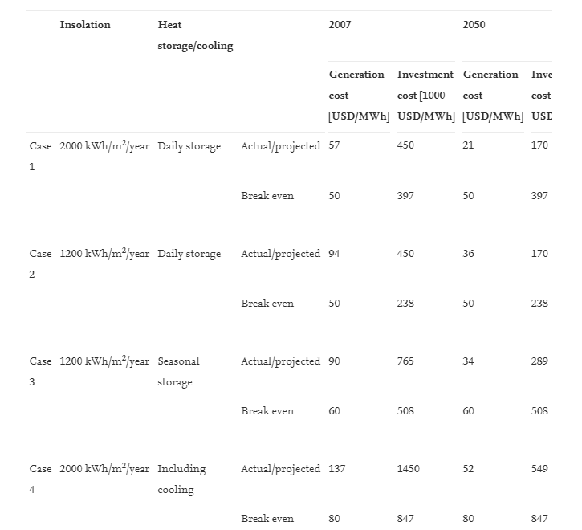”Assuming, based on IEA data on capacity and production, a world average load factor for 2007 of 605 full load hours/year, a 7% interest rate, and a capital recovery factor of 9%. O&M costs, in USD/MWh/year, are 2.5% of the ratio between investment costs and full load hours.”
* <https://www.sciencedirect.com/science/article/pii/S1364032117305610> - “Solar industrial process heating: A review”
  + Has a table on costs of different solar collectors for industrial process heating per collector area
* <https://www.sciencedirect.com/science/article/pii/S0196890419306363#b0005> “Global advancement of solar thermal energy technologies for industrial process heat and its future prospects: A review”
  + “For non-concentrating collectors, system costs between EUR 250–1000/kW in Europe, and around EUR 200–300/kW in South Africa and India. The energy costs for non-concentrated solar thermal systems range from eurocents 2.5–8/kWh [130]. For concentrating collectors, system costs between EUR 350–1700/kW [29]. The energy costs for concentrated solar thermal systems range from eurocents 6–9/kWh [130].”
  + 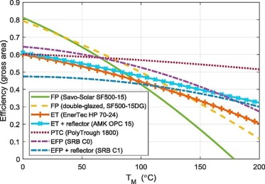
* <https://ift.onlinelibrary.wiley.com/doi/full/10.1111/1541-4337.13035> - “Technologies for sustainable heat generation in food processing”
  + Has a table (Table 3) of heating method and emissions and cost – levelized cost of heat – but that probably includes fuel costs…
  + “There is little published data on levelized costs of energy or heat for the use of geothermal energy and the associated costs highly depend on the region and well depth. One study reported a levelized costs of energy of around 28–31€ per MWh (31$−34$) for a coaxial borehole heat exchanger that was used for direct space heating (without heat pump) with a well depth of 2500–3000 m (Xia et al., 2021). Moreover, a recent study reported that the levelized costs of heating ranged from $13 to $350 per MWh at different locations in the United States for direct geothermal use (without heat pump), depending on the subsurface conditions, surface configurations, and cost and financing assumptions (Beckers et al., 2021). As reported in the previous section, geothermal heat pumps are associated with a levelized costs of heating of 105€/116$ per MWh (Hansen, 2019).”
* <https://www.nrel.gov/docs/fy17osti/66763.pdf> - “Generation and Use of Thermal Energy in the U.S. Industrial Sector and Opportunities to Reduce its Carbon Emissions”
* “Solar Heat for Industrial Processes: Technology Brief” - <https://www.irena.org/-/media/Files/IRENA/Agency/Publication/2015/IRENA_ETSAP_Tech_Brief_E21_Solar_Heat_Industrial_2015.pdf?rev=8ac12a0d56b74c27b440f90919f5c7a0>
  + Has useful information on processes and temperatures, some costs data, information on types of collectors and temperature ranges – Table 5 on page 27 on key figures and data for solar heat for industrial processes
  + “Recent assessments in Europe suggest cost reductions of 43% by 2020 (ESTTP, 2012), and an industry roadmap for Europe targets a system price (inclusive storage) of EUR 350/kWth and solar heating costs of eurocents 5-8/kWh by around 2016/2017 for conventional systems reaching a solar fraction of 10-20%, and a systems price (exclusive storage) of EUR 400/kWth for higher-temperature systems (< 250°C).”
* “Solar heat in the Brazilian dairy industry: a preliminary economic assessment” - <http://proceedings.ises.org/paper/swc2019/swc2019-0057-Lemos.pdf>
  + Considers flat plate or evacuated tube collector (FPC, ETC) with or without storage, or parabolic trough collector (PTC)
  + Uses operation and maintenance costs as 1% of total initial investment cost
  + 20 year analysis period
* “Design optimization of a multi-temperature solar thermal heating system for an industrial process” - <https://www.sciencedirect.com/science/article/pii/S0306261917312217>
  + “As a case study, a Casablanca based Moroccan milk processing company is evaluated and the life cycle cost method is practiced to select the optimal size of the main design parameters for decision-making. It was found that 400 m2 of evacuated tube collectors tilted at an angle of 30° and connected to a 2000 l storage tank can lead to a maximum life cycle saving cost of 179 kUSD for a total annual heat demand of 528.23 MWh. In this optimal configuration, the overall annual solar fraction is found to be 41% and the payback period of 12.27 years attained. The system has the potential to reduce around 77.23 tons of CO2 equivalents of greenhouse gas emissions annually. The economic competitiveness of the solar thermal heating plant can be considerably improved with higher inflation rates and lower initial investments.”
  + Finds solar fractions ranging from ~30% in winter to ~45-50% in summer, overall annual 41%
  + Assumes O&M costs 1.5% of initial investment, increasing 0.5% per year
* “Minimizing greenhouse gas emissions through the application of solar thermal energy in industrial processes” - <https://www.sciencedirect.com/science/article/pii/S0959652606002642>
  + “Most production processes of the food industry (milk products, vegetable, meat, fruits, beer [8] …) run at temperatures below or near 100 °C (Fig. 4). In addition to many cleaning processes, pasteurising, sterilising and cooking are processes occurring in many applications. Drying processes (kiln drying) are also relevant in terms of energy economics, as are concentration processes. An especially interesting application for solar energy might be defrosting processes, as they require relatively low temperatures.”
* “Evaluating the economic parity of solar for industrial process heat” - <https://www.sciencedirect.com/science/article/pii/S2667113121000115>
* “Process Heat Generation Potential from Solar Concentration Technologies in Latin America: The Case of Argentina” - <https://www.mdpi.com/1996-1073/10/3/383>
  + Uses O&M costs as 2.5-5.5 % of investment costs based on type of collector, annually
  + 30 year lifetime
* “Process intensification and integration of solar heat generation in the Chinese condiment sector – A case study of a medium sized Beijing based factory” - <https://www.sciencedirect.com/science/article/pii/S019689041500967X#s0105>
  + “Results showed that for the heating of process water, flat plate solar collectors performed best with an estimated 20 year Levelised Cost of Energy of 0.063 €/kW h. Steam generation was most cost effective with a cascade system of photovoltaic and flat plate collectors, with an estimated 20 year Levelised Cost of Energy of 0.145 €/kW h. The model predicts that integration of this technology would lead to a reduction of 14% in heating utility demand.”
* “Renewable process heat from solar thermal and photovoltaics: The development and application of a universal methodology to determine the more economical technology” - <https://www.sciencedirect.com/science/article/pii/S0306261917317798?via%3Dihub#b0405>
  + Uses O&M costs as 2% of investment costs
  + 20 year lifetime
  + Finds a range of about 30-70% utilization rate
  + “The German Federal Office for Economic Affairs and Export Control has collected data through their solar thermal subsidy program for ST process heat plants greater than 100 m2ap [81]. Their results echoed similar investments to the SHIP database, with FPC plant investments between 400 and 1000 €/m2ap and ETC/CPC from 600 to 1200 €/m2ap. Specific investments tended to decrease as the size of the plant increased (up to 1000 m2ap).”
* “Case Study of a Californian Brewery to Potentially Use Concentrating Solar Power for Renewable Heat Generation” - <http://proceedings.ises.org/paper/swc2019/swc2019-0056-Kurup.pdf>
  + Considers concentrating parabolic troughs
  + 15 year lifetime
  + Finds decrease in natural gas consumption from the site by 60% per year
* “Opportunities for Solar Industrial Process Heat in the United States” - <https://www.nrel.gov/docs/fy21osti/77760.pdf>
  + Indicates that flat plate collectors could potentially meet 40-45% of demand in the US? In 25% of counties in the US could meet demand >50% of the year
  + “Non-tracking collectors—which can be non-concentrating collectors, such as FPCs and evacuated tubes, or concentrating collectors, such as compound parabolic troughs—are the most common solar thermal technology for providing hot unpressurized water (REN21 2018). Each technology operates and reaches maximum efficiency over different temperature ranges. For FPCs, this range is typically 30°C–80°C, but recent collectors that use vacuum insulation can provide temperatures up to 100°C (REN21 2018). Selective coatings can push this temperature range even higher, and stagnant fluid temperatures have been shown to reach 200°C (Moss et al. 2018; Rockenbaugh et al. 2016; Sakhaei and Valipour 2019).”
  + 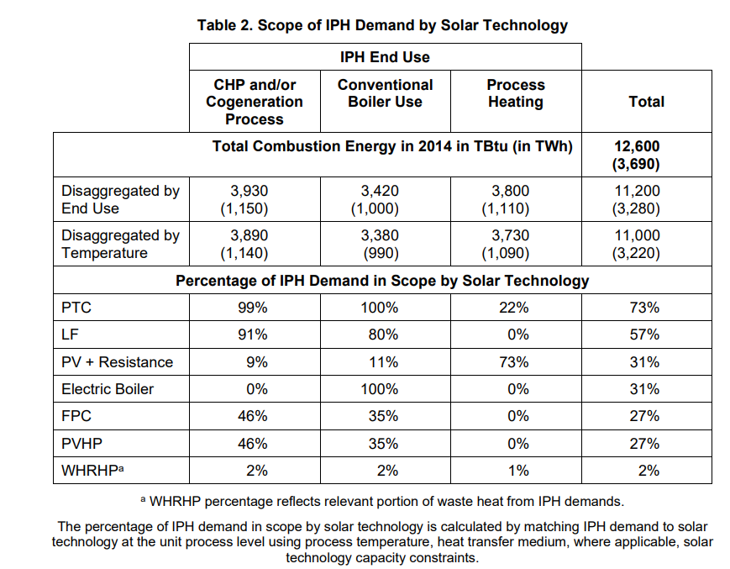
* “Financial viability of solar industrial process heating and cost of carbon mitigation: A case of dairy industry in India” - <https://www.sciencedirect.com/science/article/pii/S2213138817302412?via%3Dihub#b0140>
  + Uses annual O&M as 1% of capital cost
  + Capital costs estimates included
  + 25 year lifetime
  + Finds solar fractions ranging from 0.16-0.33, mostly around 0.23 without storage, 0.25 with storage
* “Renewable energy options for industrial process heat” - <https://arena.gov.au/assets/2019/11/renewable-energy-options-for-industrial-process-heat.pdf> and appendix - <https://arena.gov.au/assets/2019/11/appendices-renewable-energy-options-for-industrial-process-heat.pdf>
  + 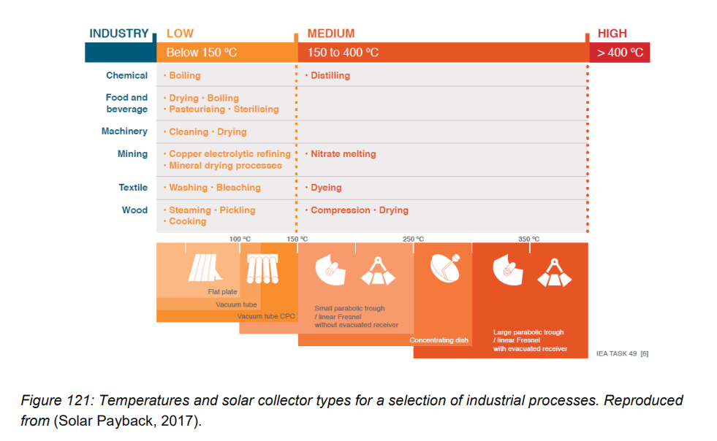
  + 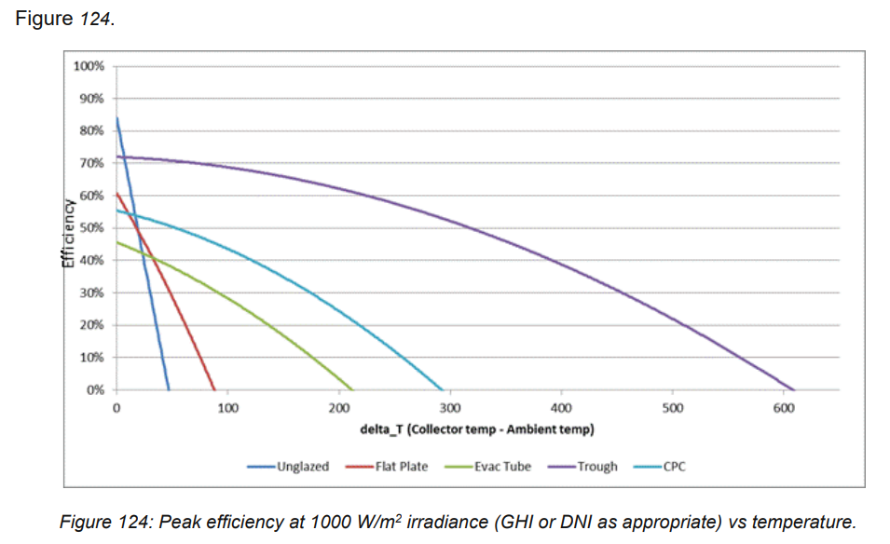
  + Could probably use around 40% efficiency estimate
* Cogen/CHP info
  + US ~8-9% of food processing electricity from cogen; 8% of CHP capacity for food (see link below on China)
  + UK ~14% of energy in food processing is from natural gas CHP; 9% of UK capacity is in the food and drink sector (<https://www.edina.eu/news/uk-chp-capacity-growing-government-energy-mix>)
  + EU: general, not specific to food and drink: % of total electricity production from CHP by country 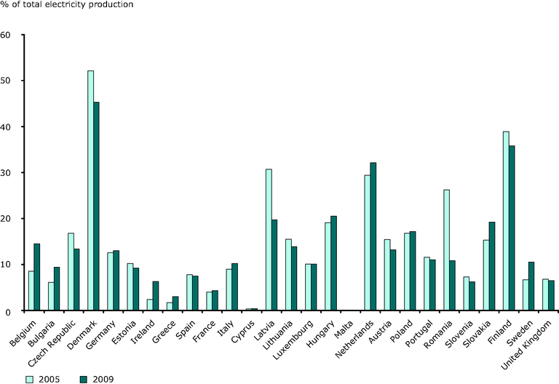 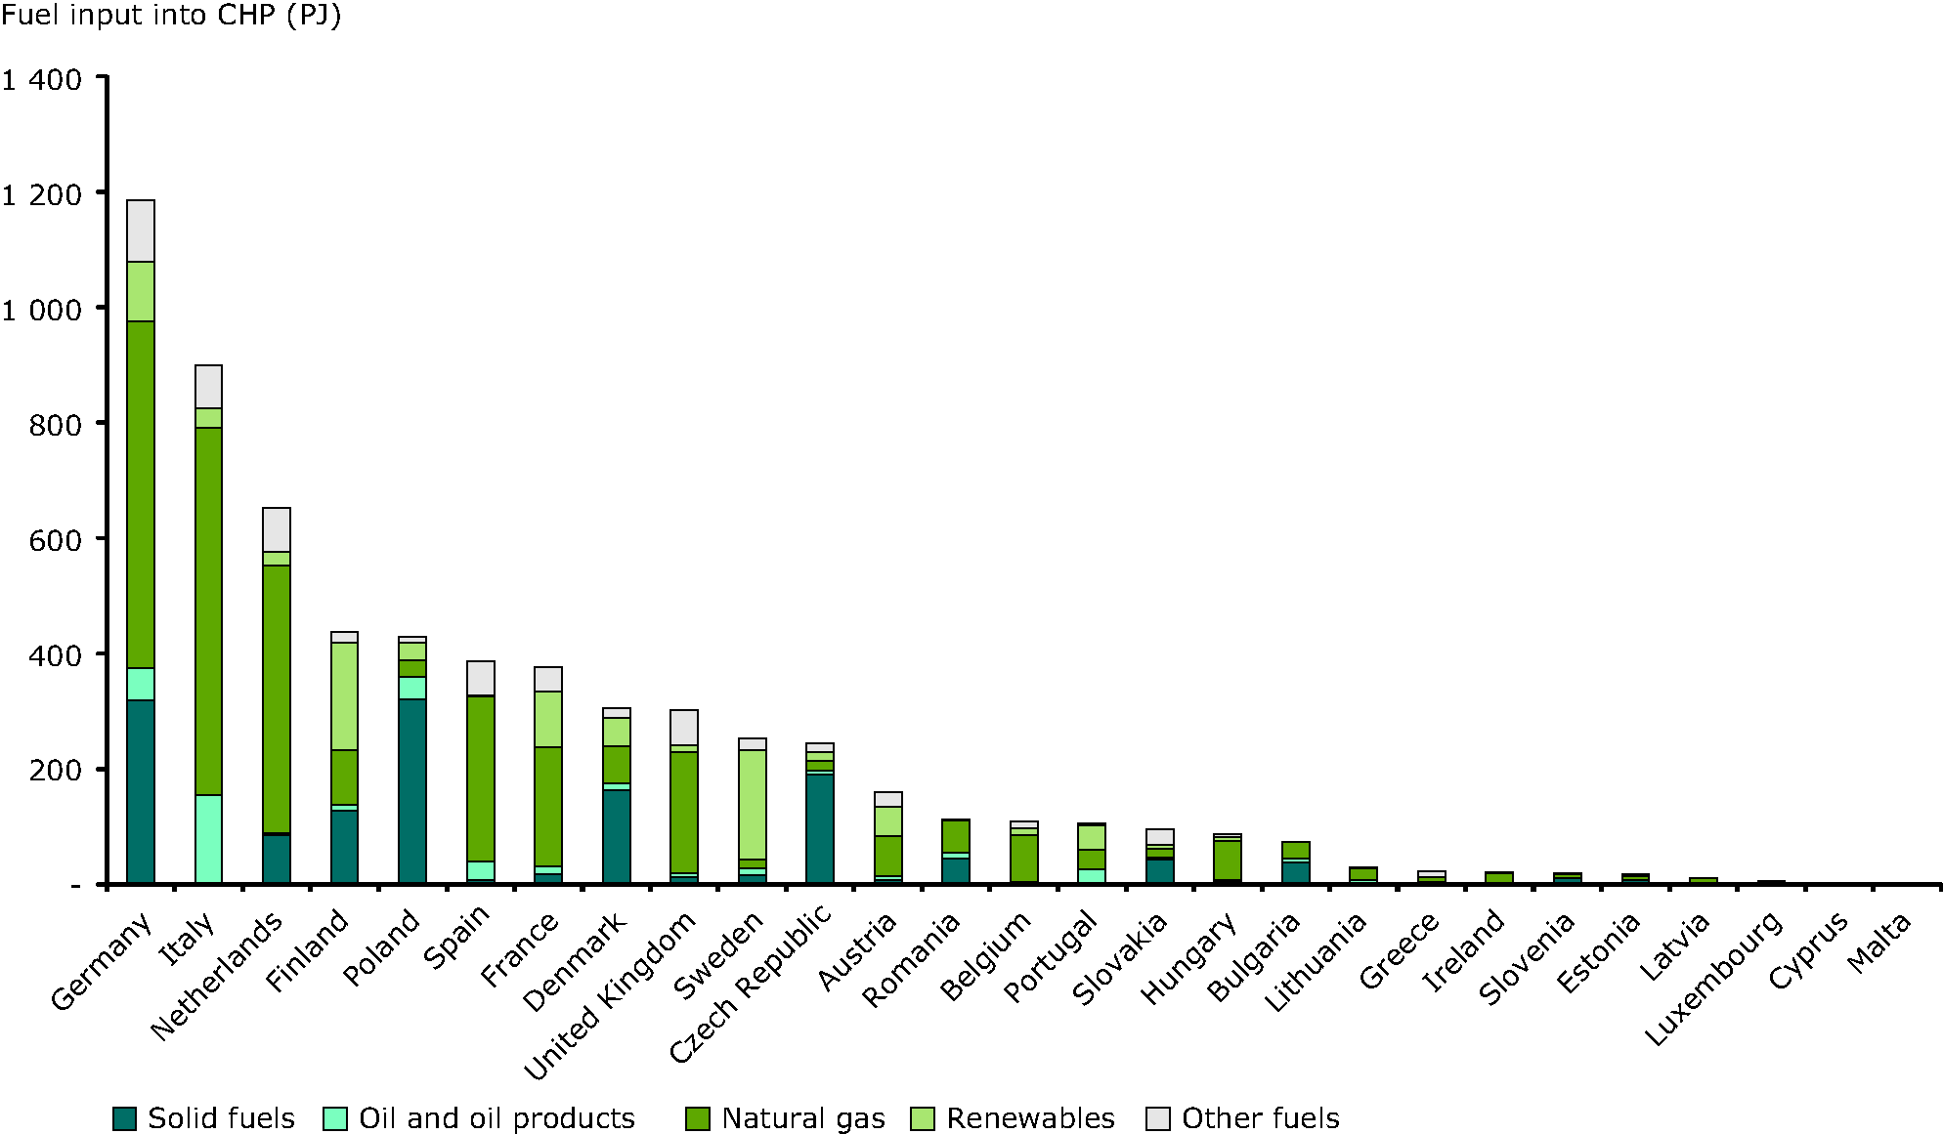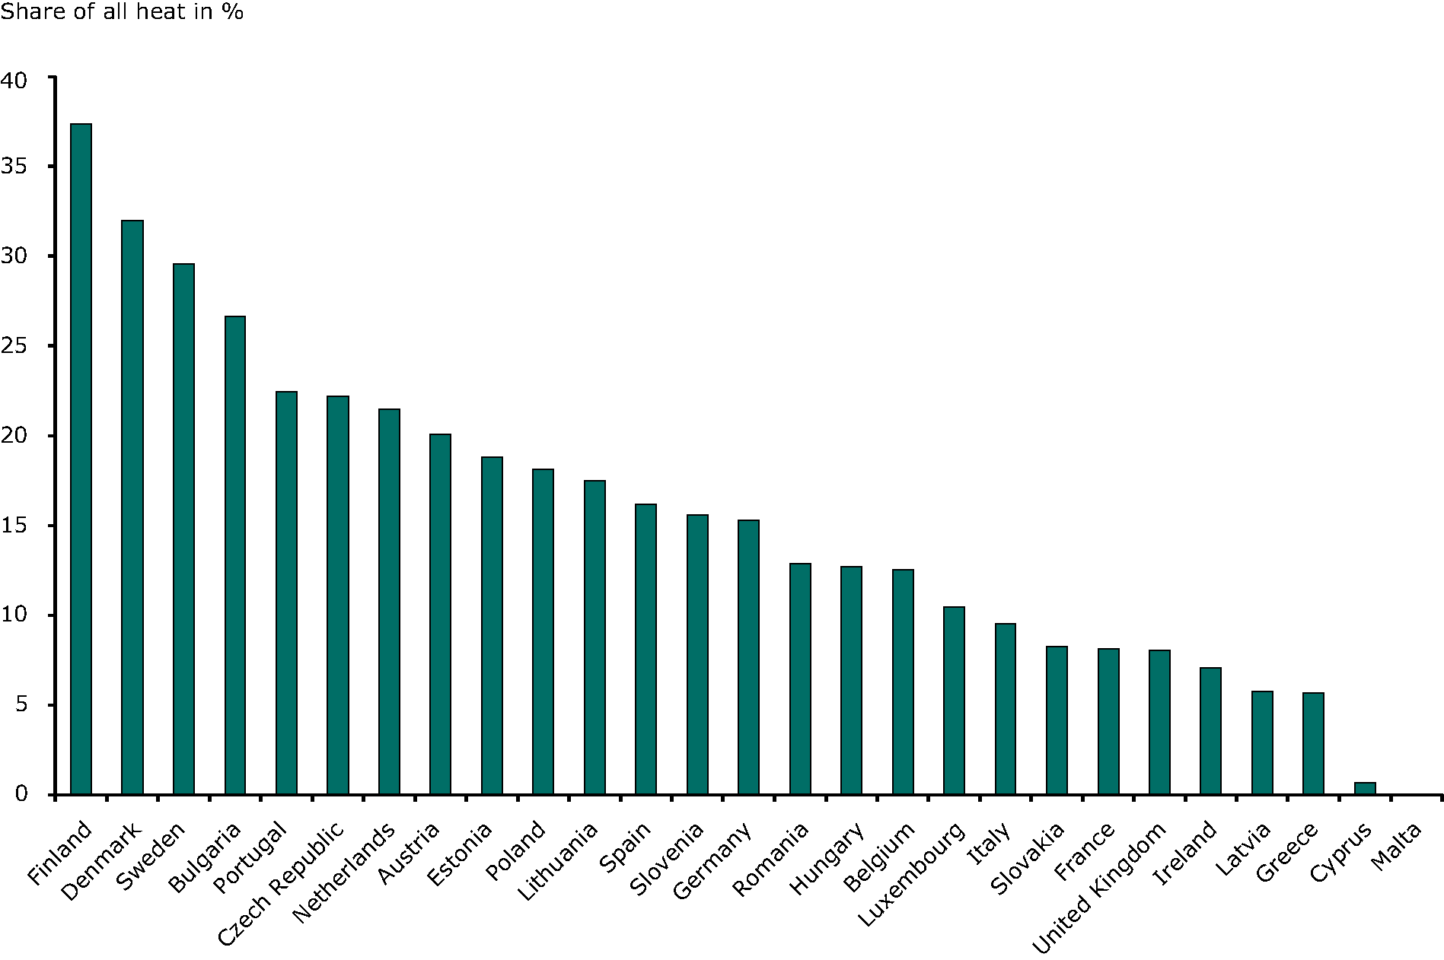
    - “The share of CHP production in gross electricity production was significantly higher in 2009 in the new Member States (15.6 % of total gross electricity production) compared to the EU-15, where the share was 11.0% (see Figure 1a).  Countries with a high market penetration of CHP electricity include Denmark (45.3%), Finland (35.8%), and the Netherlands (32.5%).”
    - “However, in 2009, as in 2008, renewables provided only 11.0% (of the fuel input in CHP plants in the EU-27 (see Figure 2a).  Natural gas accounted for 53.6% of the fuel input in EU-15 and 22.6% in the new Member States in 2009. Solid fossil fuels such as coal and lignite provided 14.6% of the fuel input in EU-15 and 74.2% of in the new Member States in 2009 (see Figure 2b).”
    - “The share of heat production supplied by CHP has been estimated.  Total heat is not reported by Eurostat, but it has been estimated by analysing fuel that was used by final consumers (excluding energy industries, non fuel uses and transport).  Eurostat does collect data on derived heat from district heating.  These two data sets have been combined and assumptions used for boiler efficiency and other uses (see note 6).  Using this method, CHP supplied 15.2% of heat demand of the EU-27.”
  + China – “China already produces more than 13 percent of its electricity with CHP and is working to improve that.” Shout out to Meredydd
    - <https://kipdf.com/facilitating-deployment-of-highly-efficient-combined-heat-and-power-applications_5b16d1777f8b9ad4628b462d.html>
    - But seems that most of the installed capacity are in petroleum, chemicals, pump and paper, metals, and district heating?
* Water in food processing
  + <https://link.springer.com/article/10.1007/s11367-017-1327-6> - Calculating the energy and water use in food processing and assessing the resulting impacts
    - 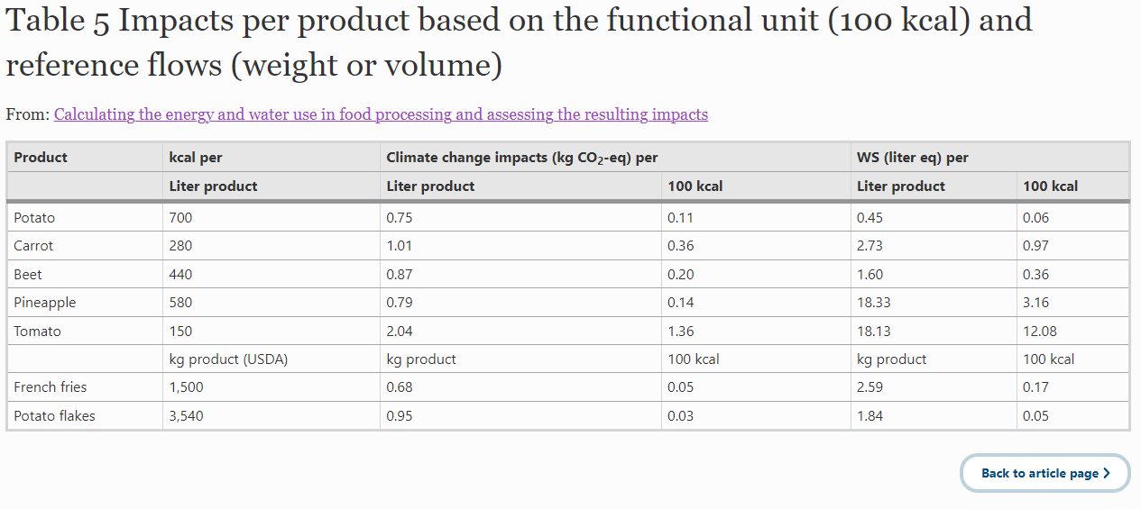
  + https://www.ers.usda.gov/webdocs/publications/101625/err-288.pdf?v=8878.3
    - 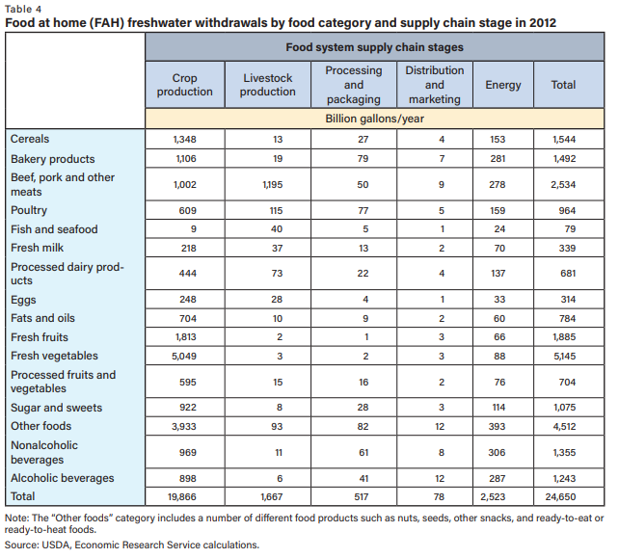
  + <https://db.iseki-food.net/sites/default/files/digital_library_attachments/12908_0.pdf> - SURVEY OF WATER USE IN THE CALIFORNIA FOOD PROCESSING INDUSTRY
    - 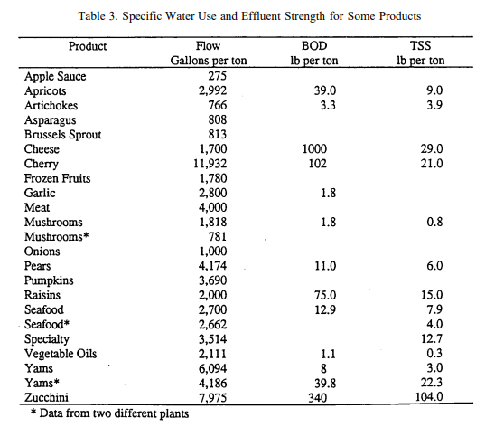
  + Vassolo and Doll, 2004 - Global-scale gridded estimates of thermoelectric power and manufacturing water use
    - 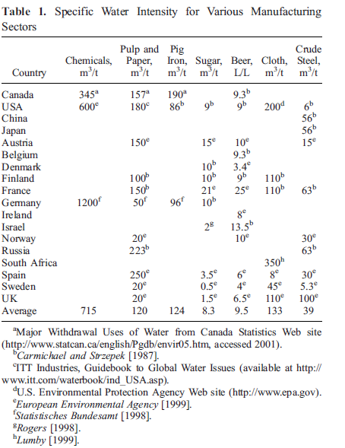
  + <https://link.springer.com/article/10.1007/s41101-017-0036-0/tables/1> - Benchmarking Water Use in the UK Food and Drink Sector: Case Study of Three Water-Intensive Dairy Products
    - 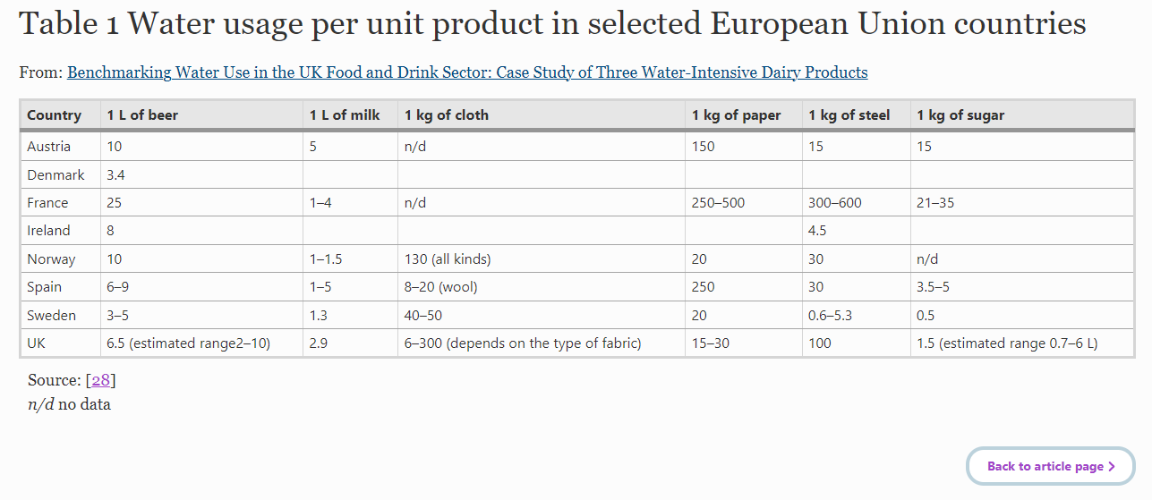

Food demand and food demand function:

* Edmonds et al. 2017
  + “because we use FAO data, which measure calories available for human consumption rather than calories ingested, total calories per person can exceed daily food requirements. Thus, measured consumptions includes transformation and waste losses.”
  + “Regional producer prices are calculated for each region and aggregate commodity. To do this, we begin with the assumption that all commodities are globally traded, with a single global price in each year, for which we use the US producer price”
  + “estimate the price per 1000 calories of the aggregate commodities as the regional total expenditures of the component goods divided by total caloric intake of the aggregate commodities”
  + “Although our data show some level of regional price variation, the use of global producer prices tends to underestimate both the actual prices of food paid by consumers and the regional variability in prices for our aggregate goods as they do not include regionally-specific factors that impact the actual food prices paid by consumers, such as processing, marketing, storage, and transportation.”
  + “Therefore, using producer prices tends to obscure large regional variability of consumer prices and potentially generate some of the regional bias when analyzing demand.”
  + 🡪 demand output is calibrated using producer prices
  + “Another possible explanation for regional bias is that it results from region-specific differences in dietary preferences.”
  + Questions
    - Where do current food prices in GCAM come from – how are they calculated? (paper suggests FAO data would be producer prices)

where *E* = energy use in EJ

*C* = calorie consumption of non-staples in Pcal

*GDP* = GDP in million 1990 USD

*a* = 0.00152 EJ/Pcal, derived from best fit model

*b* = 9.77*10^-8 EJ/(million 1990 USD), derived from best fit model

*c* = 0.0467 EJ, derived from best fit model

= additional intercept for region , if that region is present in the data used to calculate the best fit model; derived from best fit model and shown in the table below