Assignment-1

Q1. Which of the following defines a variable in Python?

• Var name = “Steve”

• String name = “Steve”

• Name = “Steve”

• All of the above

Q2. How to get the type of following variable (i=10)?

• Type(i)

• exec(i)

• print(i)

• help(i)

• type(i)

Q3. What is the output of the following code?

S1 = {1,2,3,4}

S2 = {4,5,6,7}

print(S1&S2)

• {1,2,3,4,5,6,7}

• {1,2,3,4,4,5,6,7}

• {1,2,3,5,6,7}

• {4}

• {1,2,3}

Q4. What will be the output of the following code

x = 100

type(x)

• integer

• int

• < class ‘int’>

• <class ‘number’>

Q5. What is the difference between append and extend in lists in Python?

A5= append just adding the item in the list but extend is combined two list together into one.

Q6. What does del do in Python?

A6= Del is deleted the variable completely when project is done.

Q7. Which function do we use in order to find the position of an element in the list?

A7: “Index” function will be use.

Q8. How to find the total number of elements present in a list?

A8: “Count” function will be use

Q9. Create a list of 10 elements and write a code on that list that returns every second element in that list as an output.

A9: x=[10,20,40,50,70,13,16,11,32,33]

x.index(20)

Q10. Create a list of 10 elements and then sort the list in descending order.

A10: x=[10,20,40,50,70,13,16,11,32,33]

x.sort(reverse=True)

Q11. What is the difference between positive indexing and negative indexing in Python?

A: Positive indexing is start from 0, 1, 2 … and negative indexing is start from -1 is the first index.

Q12. Create a tuple of some five elements and then write a program to add a value to the tuple.

A12:

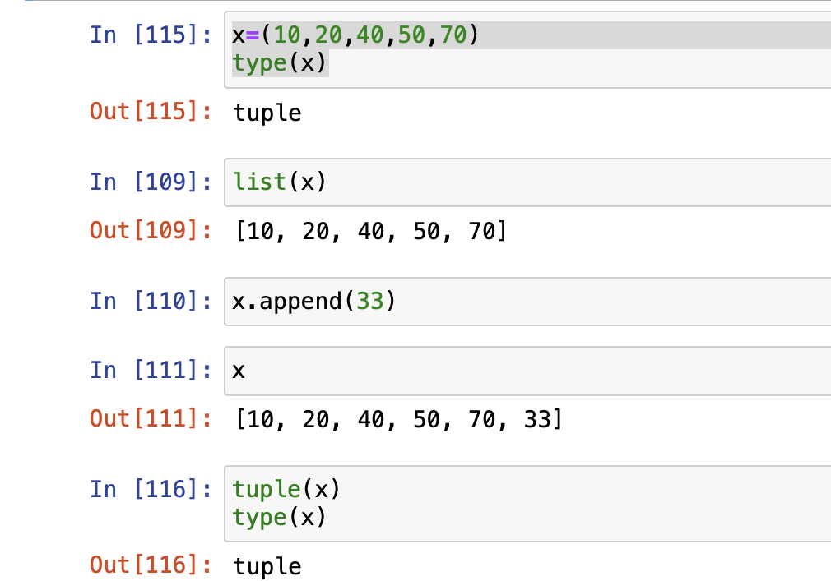

Q13. What is the difference between (difference, difference_update) and (symmetric_difference, symmetric_difference_update) in Python?

A13: difference is only calling the elements that different from one variable and another but difference_update will update the variable to the new element that is different from 2 variables.

Q14. Create two sets and then write a program to find the elements of set1 that is not present in set2?

A14:

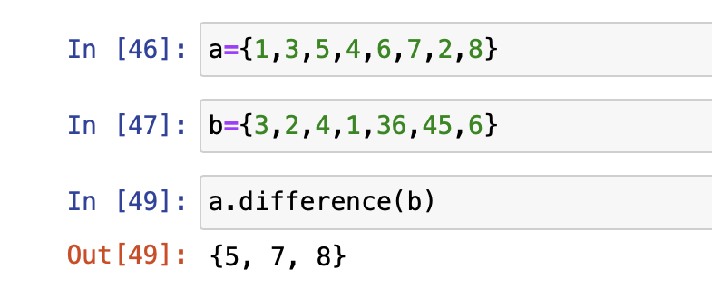

Q15. Create two sets and make sure that you have some common elements in both set and then write a program to remove the intersection of 2nd set items from set1?

A:15

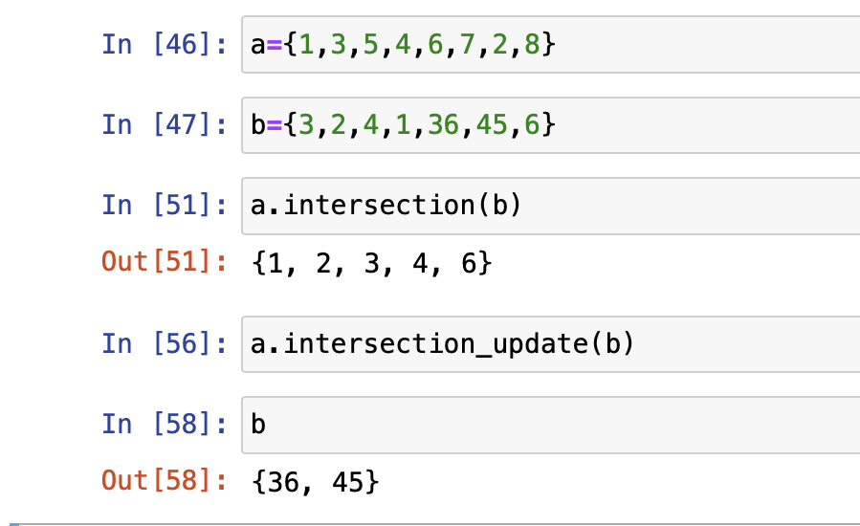

Q16. Create a dictionary and then write a Python code to add a new key value pair in that dictionary.

A16:

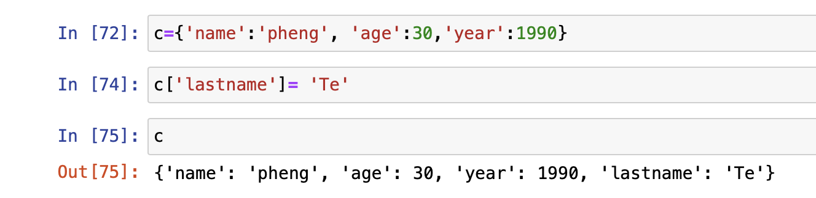

Q17. Create two dictionaries and then write a Python code to merge two dictionaries?

A17:

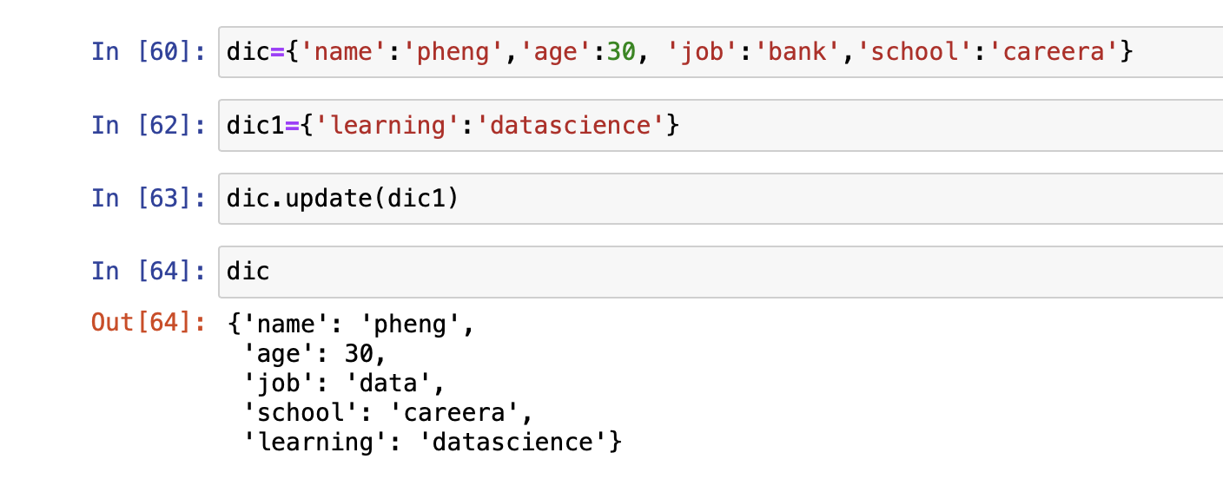

Q18. Write a program to check wether a number entered by the user if even or odd?

A:18

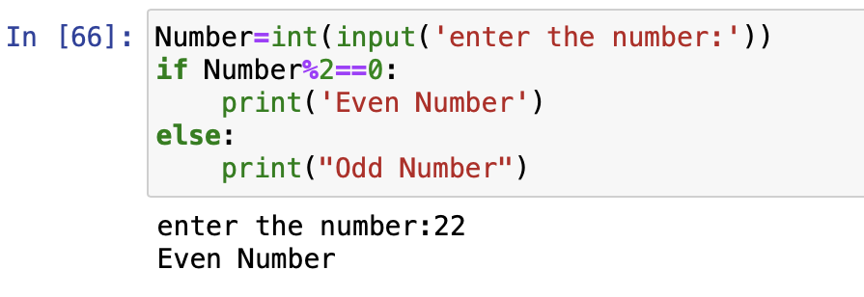

Q19. Write a program to display “Hello” if a number entered by the user is a multiple of five, otherwise print “Bye”.

A19:

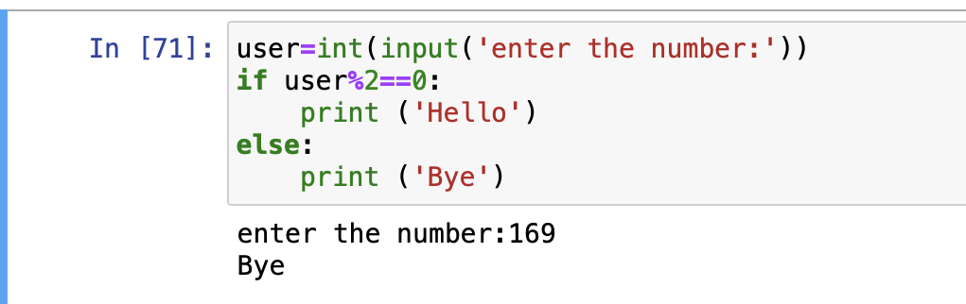

Q20. Write a python program to accept the cost price of a bike and display the road tax paid according to the following criteria:

Cost Price Tax

>100,000 15%

> 50,000 and <=100000 10%

<=50,000 5%

A20:

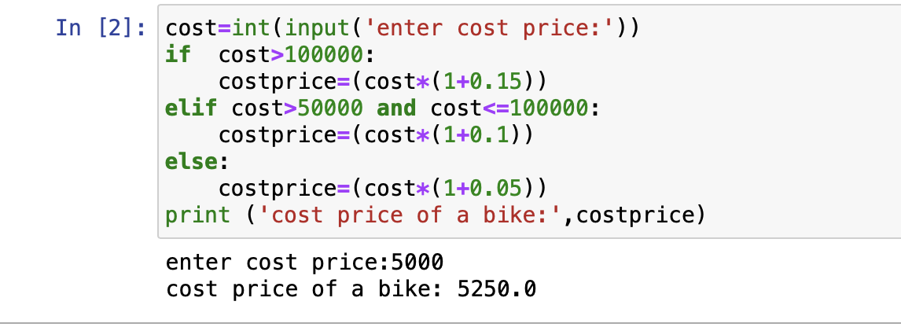

Q21. Write a program to check wether a number entered by the user is a three digit number or not?

A21:

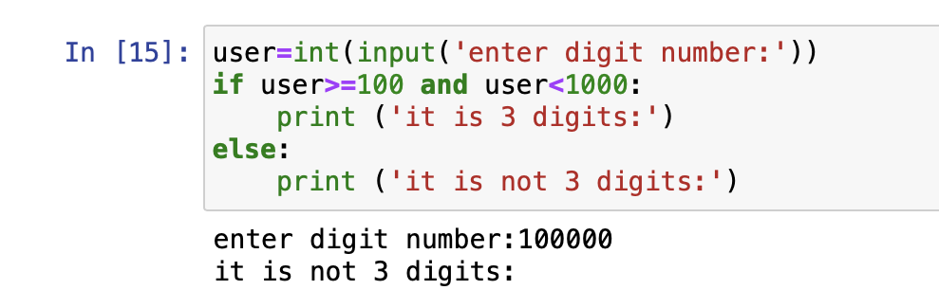

Q22.Write a program to check wether a number (accepted from user) is divisible by 2 and 3 both?

A22: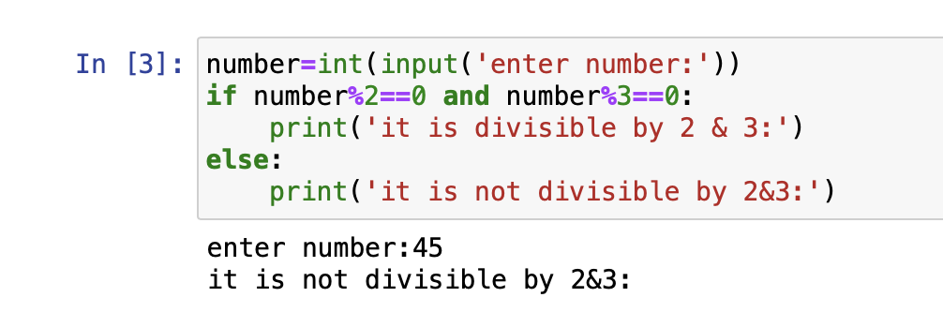

Q23. Write a program to check if a character entered by any user is a vowel or not.

A23: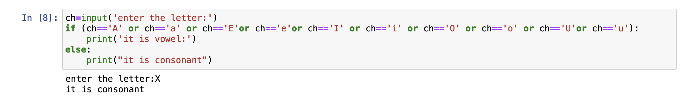

Q24. A company decides to give bonus to employee according to the following criteria:

Time period of service Bonus

More than 10 years 10%

>=6 and <=10 8%

Less than 6 years 5%

Ask user their salary and years of service and print the net bonus amount.

A24: 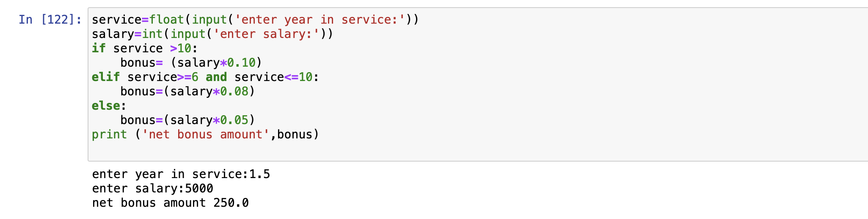

Q25. Accept three sides of a triangle from the user and check wether it is equilateral, isosceles or scalene triangle.

An equilateral triangle is a triangle in which all three sides are equal .

A scalene triangle is a triangle that has three unequal sides.

An isosceles triangle is a triangle with at least two equal sides.

A25:

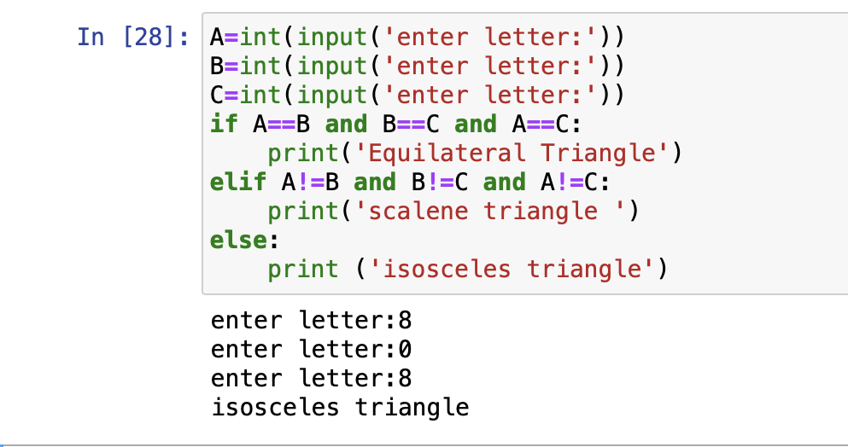

Q26. Write a program to accept two numbers and a mathematical operators and perform operation accordingly.

A26:

