**Configuration for Console Application:**

**Step1:**

Create a database **‘imdbmovies’** and run the below query in your MySQL workbench.

CREATE TABLE `imdbmovies`.`movies` (

`IMDBID` VARCHAR(45) NOT NULL,

`Title` VARCHAR(255) NOT NULL,

`Genre` LONGTEXT NOT NULL,

`Year` INT(4) NOT NULL,

`URL` LONGTEXT NOT NULL,

`Audience_Rating` FLOAT NOT NULL,

`Critic_Rating` FLOAT NOT NULL,

`Budget_In_Millions` FLOAT NOT NULL,

`User_Review` LONGTEXT NOT NULL,

`Polarity` VARCHAR(45),

PRIMARY KEY (`IMDBID`));

**Step2**:

Load the dataset **‘movies.csv’** provided in the attachment to ‘movies’ table that got created in your ‘imdbmovies’ database.

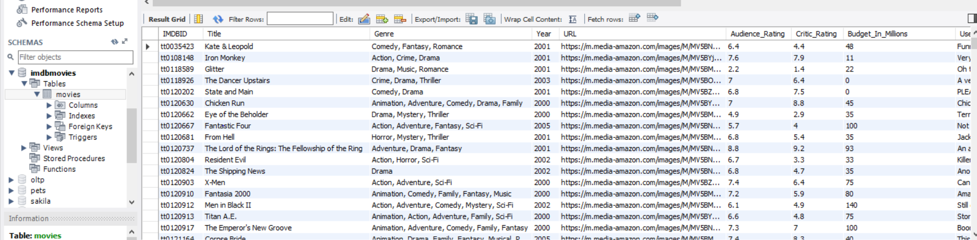

**Step3: IMDBProject.py file**

-line number 49 is use to call a function name DatabaseConnection() which is use to establish the connection when object is created. Here you can provide your username, password and database name.

Change the username & password



**Step 4: Import and download the libraries.**

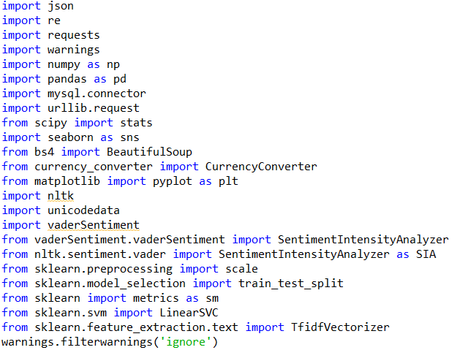

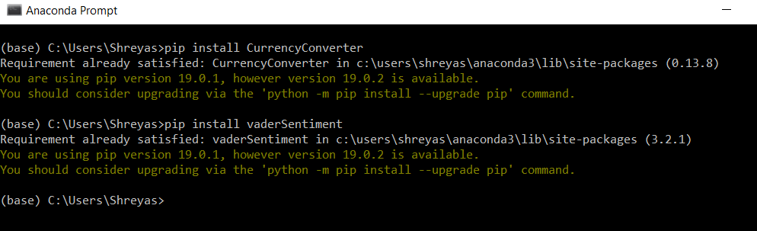

* Note: Make sure that you’ve downloaded nltk.download(‘vader_lexicon’)

**Step 5: Run the entire code along with MainFunction().**

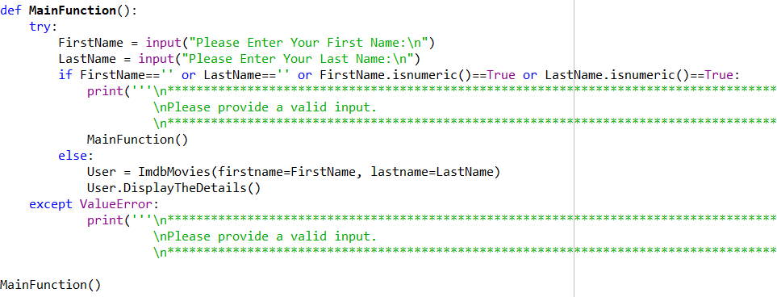

**Configuring Django Framework**

Step 1: Install Django

Please check this website: <https://docs.djangoproject.com/en/2.1/howto/windows/>

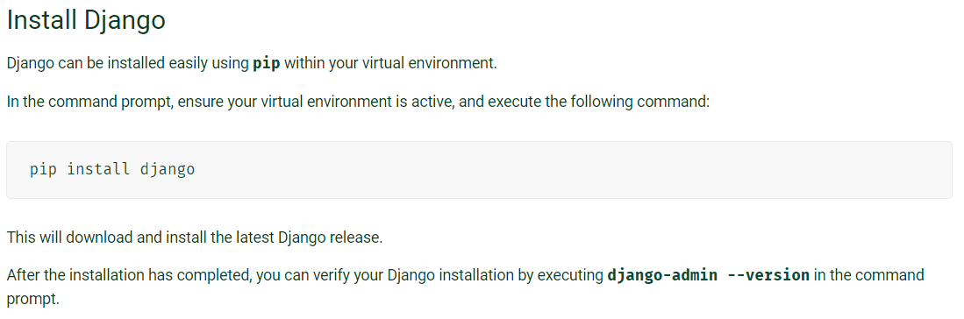

Step 2: Extract Django_Stuff.zip

Step 3: Change Database credentials

1. From extracted files open settings.py file and do following changes(line:81):
2. Change database name according to MYSQL database (‘NAME’: “database_name”)
3. Change user as per MYSQL user (‘USER’:’mysql_user’)
4. Change password as per MYSQL password (‘PASSWORD’: ‘mysql_password’)

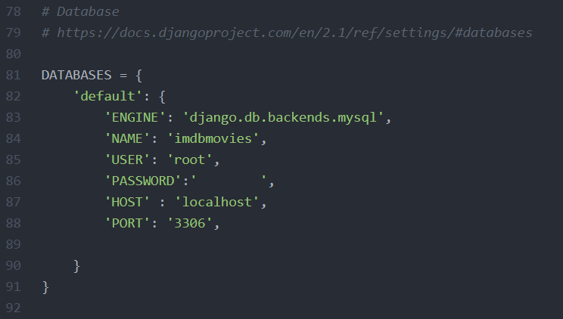

1. Open views.py file and do following changes
2. Changes mysql user, password and database name(line : 68)

Mydb = DatabaseConnection(‘<user id>’,’<password>’,’<data_base_name>’)

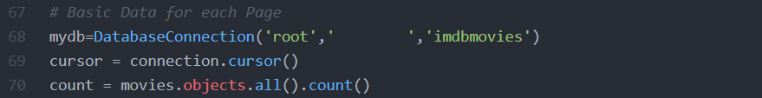

Step 4: Migrations

1. Open Anaconda Command prompt and browse to first_prject directory
2. Run this command

**Python manage.py migrate**

1. After successful execution run this command

**Python manage.py makemigrations**

Every time if we do any changes in models.py we need to execute this command

Step 5: import data into Django model generated table in MySql

1. Open MySql and goto defined database
2. You should see following tables generated.

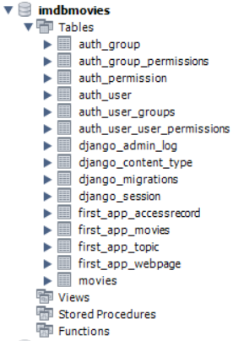

1. Now copy all the data from movies table to new generated table



Step 6: Running Server

1. Run this command :

**python manage.py runserver**

1. Copy the ip address and open in Google chrome.