Abstract
Recruitment processes can be fragmented across spreadsheets, emails, and other disconnected tools, making it difficult to manage candidates, vacancies, interviews, and recruitment progress efficiently. Altrium is a web-based Applicant Tracking System (ATS) designed to centralise the recruitment process in one platform. It allows recruiters to manage vacancies and candidates, track recruitment stages, schedule interviews, and monitor recruitment activities. The system aims to reduce administrative work, improve collaboration between recruitment stakeholders, and provide a more efficient and organised recruitment experience.

Sprint 1
The goal of Sprint 1 is to develop the core recruitment workflow of the Altrium ATS by enabling recruiters to manage vacancies, receive candidate applications, shortlist candidates, manage the recruitment pipeline, schedule interviews, and track candidate activity.

Sprint 1 product Backlog

PB ID | Feature
PB01 | Manage Vacancies
PB02 | Candidate Online Application
PB03 | Shortlist Candidates
PB04 | Manage Recruitment Pipeline
PB05 | Schedule Interviews
PB11 | View Candidate Activity History and Timeline
PB13 | Manage Users

MoSCoW Justification – Sprint 1

Feature | Priority | Justification
Manage Vacancies | Must Have | Vacancies are needed before candidates can apply or be managed.
Candidate Online Application | Must Have | Allows candidates to apply and provides the information needed for the recruitment process.
Manage Recruitment Pipeline | Must Have | Allows recruiters to track candidates through the different recruitment stages.
Shortlist Candidates | Should Have | Helps recruiters identify suitable candidates, but the basic system can work without it.
Schedule Interviews | Should Have | Helps arrange interviews, but depends on candidates being processed through the recruitment pipeline first.
View Candidate Activity History and Timeline | Could Have | Provides useful candidate history but is not essential for the main recruitment process.

High Level Use Case Diagram
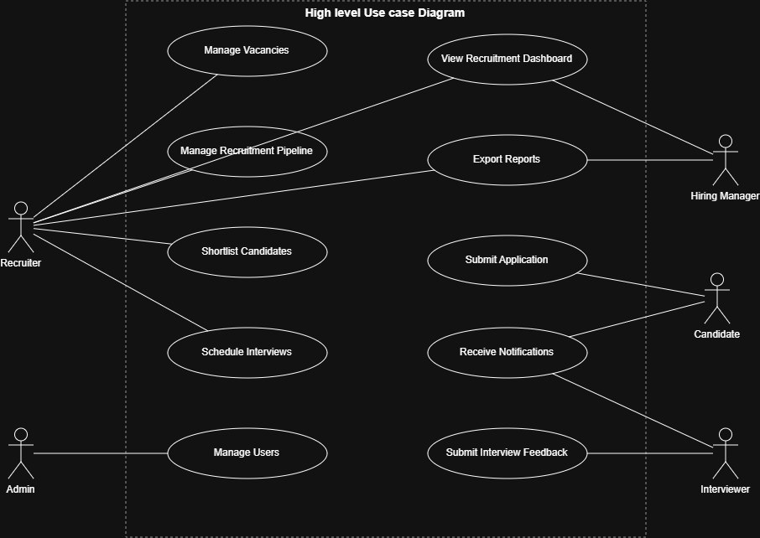
Figure 1: High level use case diagram

Vacancy Management

User stories:
As a Recruiter, I want to create a new vacancy with job title, description, and requirements, so that I can open a position for candidates to apply to.
As a Recruiter, I want to edit an existing vacancy's details, so that I can update outdated or incorrect information.
As a Recruiter, I want to publish a vacancy, so that it becomes visible and candidates can apply.
As a Recruiter, I want to close a vacancy, so that no further applications are accepted once the position is filled.
As a Recruiter, I want to view a list of all vacancies with their current status (open/closed), so that I can track which positions are active.

Use case
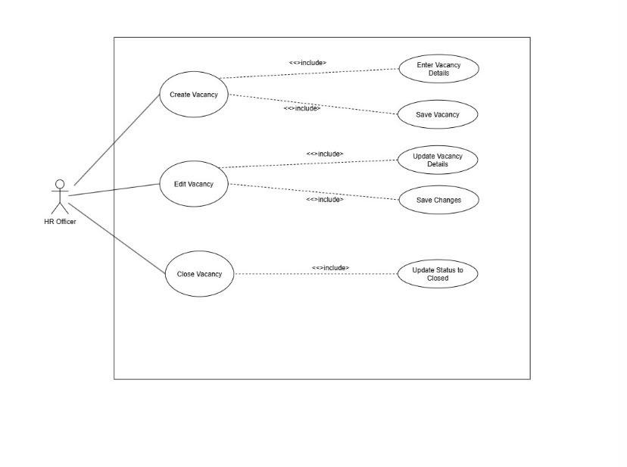
Figure 2: Vaccnacy Management use case
Activity Diagram
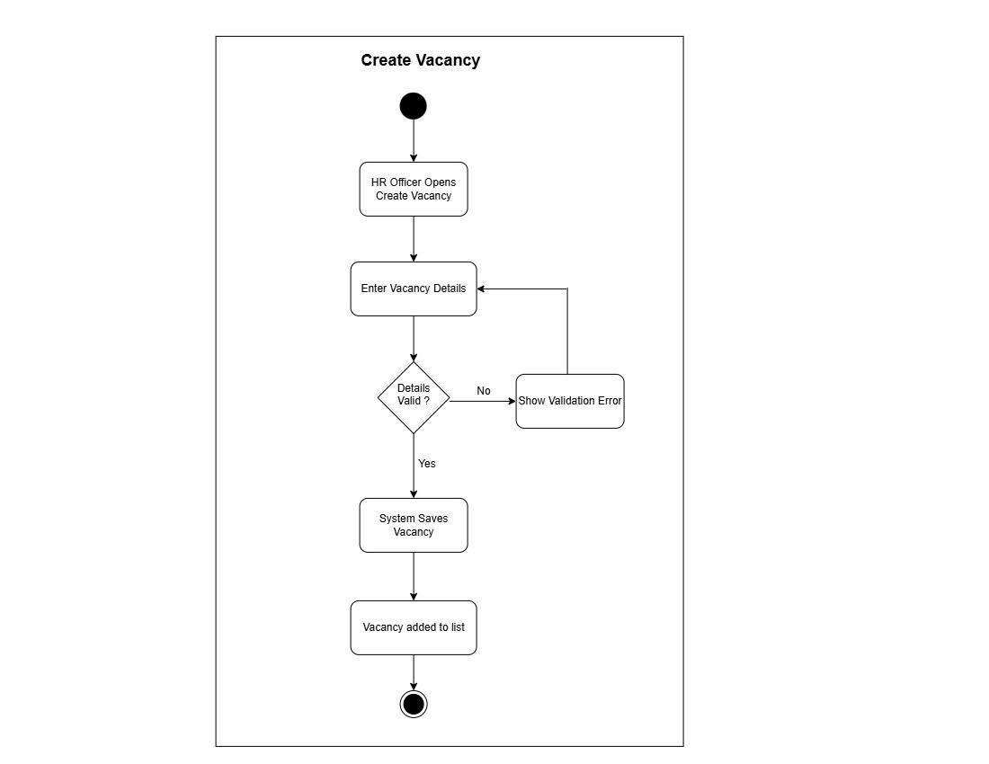
Figure 3: Vaccnacy Management: Activity Diagram
Sequence Diagram
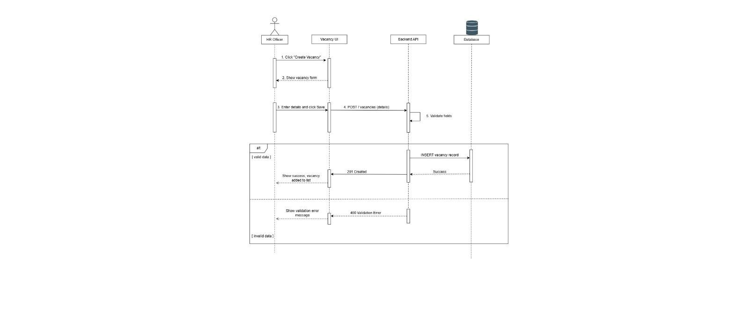
Figure 4: Vaccnacy Management: SequenceDiagram

Candidate Online Application
User stories:
As a Candidate, I want to view open vacancies, so that I can find positions relevant to me.
As a Candidate, I want to submit my personal and contact details through an online application form, so that I can apply for a vacancy.
As a Candidate, I want to upload my CV during the application, so that the recruiter has access to my qualifications and experience.
As a Candidate, I want to submit my completed application, so that I officially enter the recruitment pipeline for that vacancy.
As a Candidate, I want to receive confirmation after submitting my application, so that I know it was successfully received.

Use case diagram
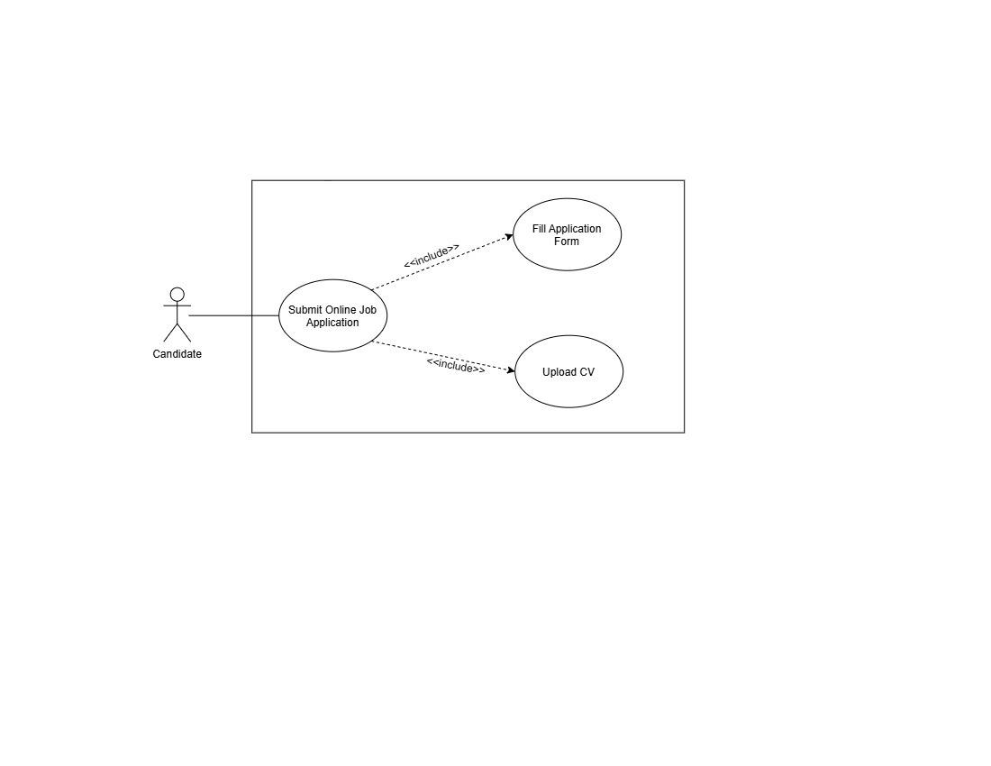
Figure 5: online application- use case diagram

Activity Diagram
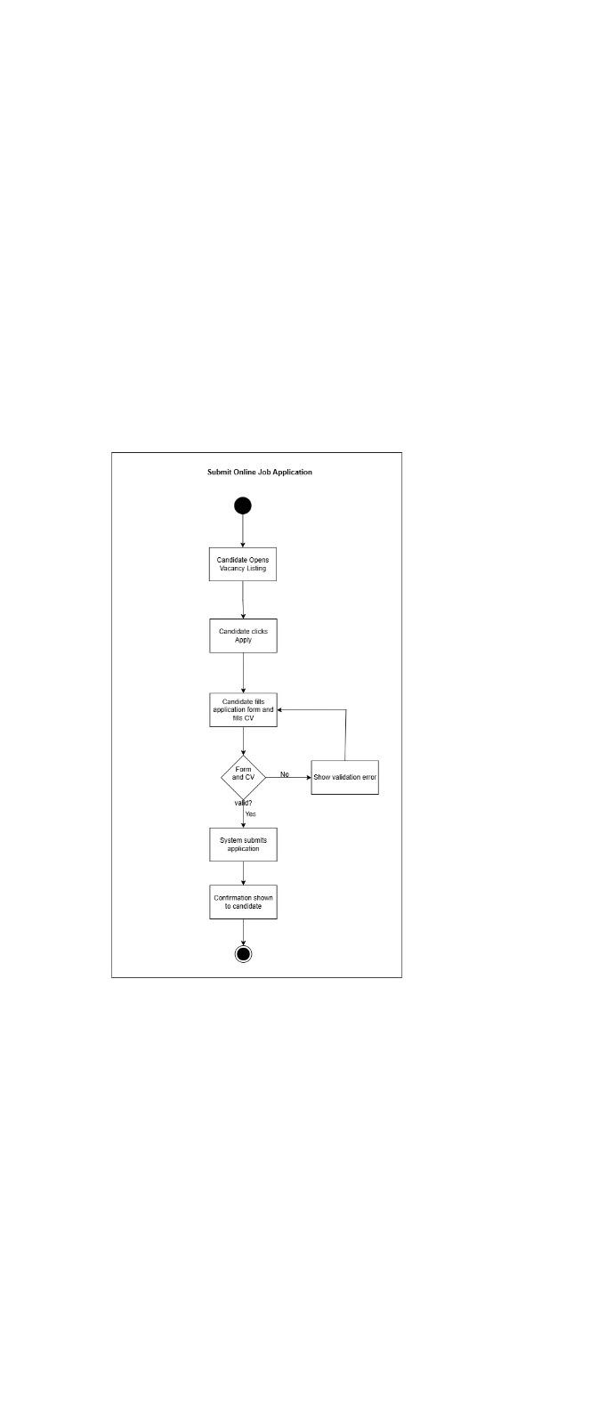
Figure 6: online application- activity diagram
Sequence Diagram
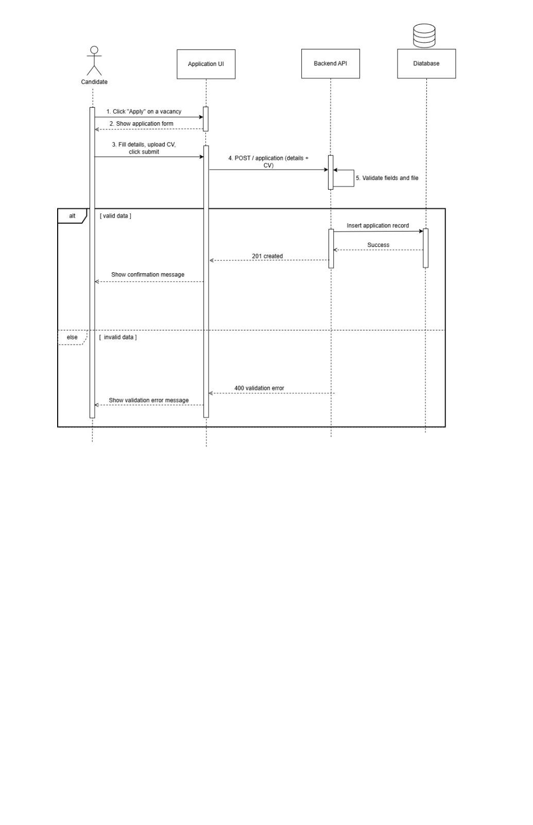
Figure 7: online application- sequence diagram

