ASTROSAGE
Call Centre Performance Analysis
Spreadsheet Analytics Project

An end-to-end analysis of 28,027 customer consultations - data cleaning, KPI modelling, an interactive dashboard, and data-driven investment recommendations.

Dataset | 28,027 consultations | 35 attributes | Dec 2023 - Jan 2024
Scope | 14 objective + 10 subjective questions
Deliverables | Excel workbook, this report, and a presentation
Prepared for | AstroSage Management / Evaluation

EXECUTIVE SUMMARY

AstroSage handled 28,027 consultations between 1 December 2023 and 3 January 2024, generating about Rs 2.14 lakh in net revenue against Rs 99k in astrologer payouts (Rs 1.15 lakh gross margin). The analysis shows a healthy demand base undermined by connection reliability: only ~28% of chats complete and ~66% of calls are answered, which caps customer satisfaction at 2.93/10.
Headline KPIs
28,027  Total consultations | Rs 2,13,987  Net revenue | Rs 99,147  Agent payout | Rs 1,14,841  Gross margin | 2.93 / 10  Avg satisfaction
10,344  Unique customers | 131  Active agents | 28.4%  Chat completion | 66.2%  Call answer rate | 48.9%  Repeat callers

What the data tells us
- Connection reliability is the #1 issue: ~37% of chats fail and ~34% of calls go unanswered/busy - the single biggest revenue leak.
- A small base drives most volume: 48.9% repeat callers place ~81% of all consultations; 15% of agents handle ~60% of the workload.
- Satisfaction is completion-driven: completed sessions average ~7.0/10 vs ~2.0 for incomplete; duration correlates with rating (r = 0.53).
- Calls out-earn chats: Call revenue is ~Rs 1.68 lakh (78.7%) vs Chat ~Rs 45k, at a higher average rating (3.50 vs 2.69).

OBJECTIVE QUESTIONS

Question 1: What is the total no. of tables present in the data?
Final Answer
1 table. The dataset is delivered as a single flat table (one worksheet), stored after cleaning as the structured Excel table "AstroData".
Approach
Inspected the workbook: one contiguous data region with a single header row and no related secondary tables. Converted to a named Excel Table (Ctrl+T) for structured, readable references.
Charts & Tables
Table / Chart Name: Cleaned data - AstroData table
Description: A single normalised table holding all 28,027 records used for the analysis.

Question 2: What is the total no. of attributes present in the data?
Final Answer
35 attributes (columns A-AI) in the raw data - e.g., _id, uid, gid, guruName, consultationType, website, timeDuration, amount, netAmount, astrologersEarnings, rating, createdAT, callStatus, chatStatus.
Approach
Counted the header cells with COUNTA on the header row. The 13 helper columns added in cleaning (Month, Year, Hour, NetRevenue, GrossMargin, Status, DurationBucket, RepeatCaller, ...) are analytical derivations, not original attributes.
Charts & Tables
Table / Chart Name: data - header row
Description: Header row of the raw table; column count = number of attributes.

Question 3: The data consists of inconsistent and missing values - ensure the data is cleaned.
Final Answer
Cleaned to 28,027 analysis-ready records: standardised text, handled missing values (blank numeric -> 0, blank categorical -> "N/A"), trimmed double-spaced guru names, derived date parts, and applied validation + conditional formatting. 0 blank cells remain.
Approach
Cleaning steps: (1) duplicate check on _id; (2) TRIM on guruName; (3) IF/ISBLANK to fill missing numerics with 0 and text with "N/A"; (4) Text-to-Columns / TEXT + YEAR + HOUR to derive Date, Month, Year, Hour; (5) nested IF for DurationBucket and Status; (6) Data Validation + Conditional Formatting on rating.
Charts & Tables
Table / Chart Name: Cleaned data
Description: Fully cleaned AstroData table with 13 derived helper columns.

Question 4: What is the change in daily call volume day by day, and the average daily call volume?
Final Answer
Average daily volume is about 824 consultations/day (28,027 over 34 days). Day-over-day change fluctuates: volume peaks at month-start and mid-December (15 Dec ~ 1,324) and dips on weekends and the partial January tail.
Approach
Daily counts via a Date pivot / COUNTIF; day-over-day change = today - yesterday; average via AVERAGE of the daily totals.
Charts & Tables
Table / Chart Name: Daily Consultation Volume (line)
Description: Daily totals with the average line - shows peaks, weekend dips, and the DoD trend.
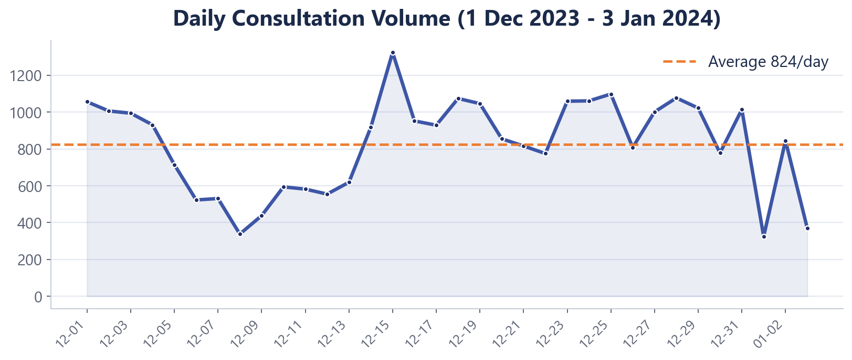
Daily Consultation Volume (line)

Question 5: Which months experienced the highest and lowest call volumes?
Final Answer
Highest: December 2023 (26,488). Lowest: January 2024 (1,539 - partial, 1-3 Jan only).
Approach
Monthly totals via COUNTIF on the Month column; highest/lowest identified with INDEX + MATCH(MAX/MIN).
Charts & Tables
Table / Chart Name: Monthly Call Volume (column)
Description: Compares the two months in the data window.
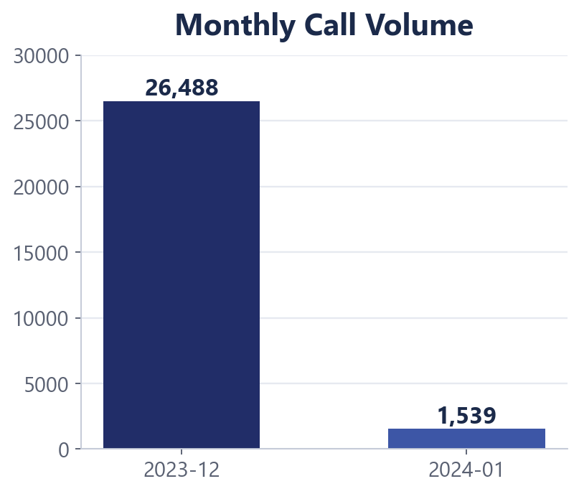
Monthly Call Volume (column)

Question 6: What is the total operational cost for that month?
Final Answer
For the highest-volume month (Dec 2023), operational cost (astrologer payout) is about Rs 93,786. December net revenue ~ Rs 2,02,215, giving a gross margin ~ Rs 1,08,428.
Approach
SUMIF over the AgentPayout column for Month = 2023-12; margin = SUMIF(NetRevenue) - SUMIF(AgentPayout).
Charts & Tables
Table / Chart Name: Q-6 pivot - cost by month
Description: Operational cost (payout) aggregated for the peak month.

Question 7: What is the average number of calls handled per agent per day?
Final Answer
About 1.9 calls per agent per day (8,508 calls / 131 active agents / 34 days). Here ‘calls’ counts Call-type consultations only (chats excluded), matching the reference definition. Per active agent-day the figure is higher, since not every agent works every one of the 34 days.
Approach
Calls counted with COUNTIF(consultationType, "Call") = 8,508 (Call-type consultations only; chats excluded, matching the reference). Active agents = distinct count of gid (131). Per-agent-per-day = calls / agents / days.
Charts & Tables
Table / Chart Name: Derived KPI
Description: Workload intensity metric derived from counts and distinct agents.

Question 8: How many repeat callers are there, and what percentage of total calls do they represent?
Final Answer
5,062 repeat callers = 48.9% of 10,344 unique customers. They placed 22,745 consultations = 81.2% of all calls - a small repeat base drives most volume.
Approach
RepeatCaller flag via COUNTIF(uid) > 1; totals via COUNTIF on the flag.
Charts & Tables
Table / Chart Name: Repeat vs One-time (donut)
Description: Share of consultations placed by repeat vs one-time callers.
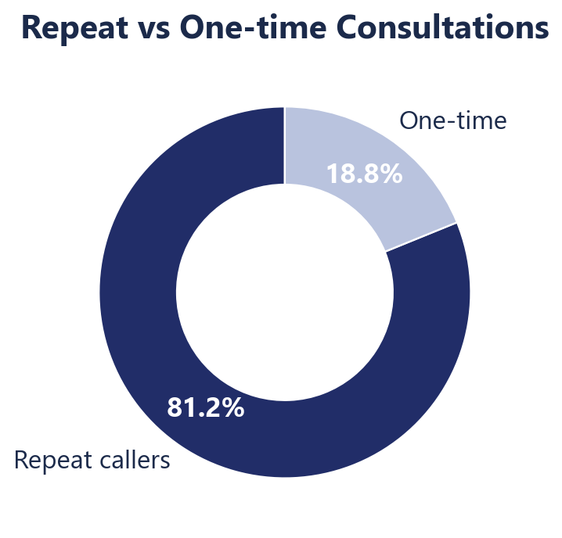
Repeat vs One-time (donut)

Question 9: What are the total sales generated for each product category?
Final Answer
Total net sales ~ Rs 2,13,987. By category: Call ~ Rs 1,68,442 (78.7%) and Chat ~ Rs 45,495 (21.3%); public_live_Call / Complementary are negligible.
Approach
SUMIF over NetRevenue grouped by consultationType.
Charts & Tables
Table / Chart Name: Net Revenue by Consultation Type (bar)
Description: Revenue contribution of each category.
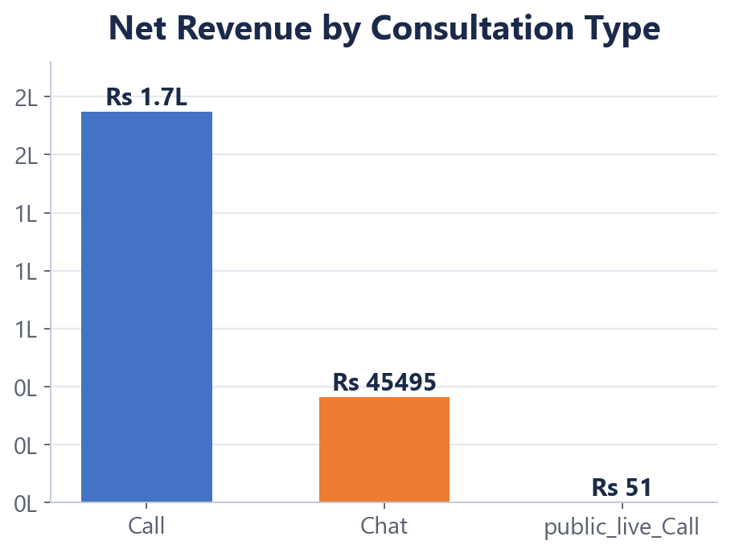
Net Revenue by Consultation Type (bar)

Question 10: How many calls were made for each user ID and guru ID?
Final Answer
Counts per ID via COUNTIF. Busiest guru: GID 287 - Astro Krishaa (1,580 consultations). Busiest customer: UID 33017 (158).
Approach
COUNTIF per uid and per gid; guru name for a gid resolved with VLOOKUP.
Charts & Tables
Table / Chart Name: Top 10 Gurus by Volume (bar)
Description: Ranks the most active gurus; the user pivot mirrors this per customer.
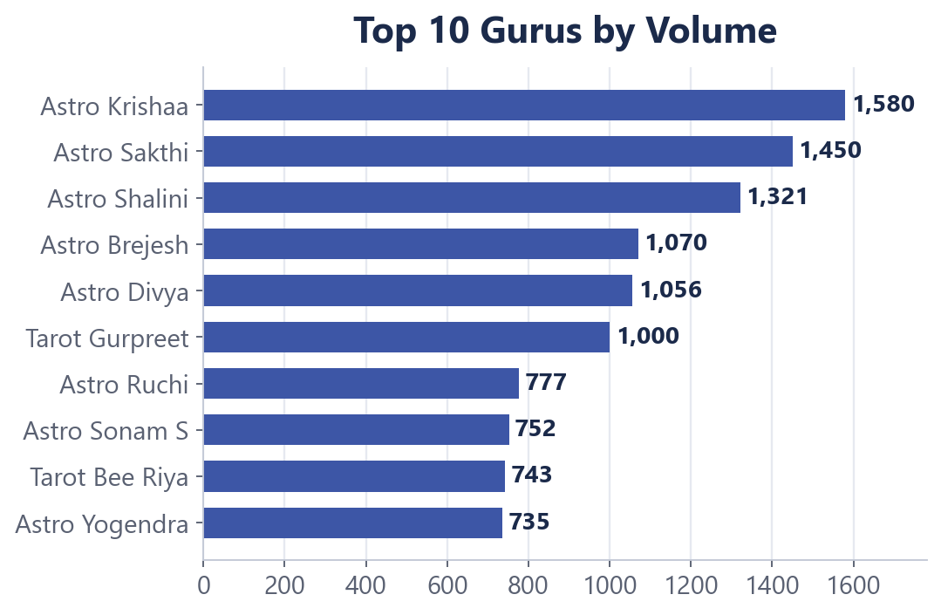
Top 10 Gurus by Volume (bar)

Question 11: What is the correlation between call duration and customer satisfaction?
Final Answer
Pearson correlation ~ 0.53 - a moderate positive link. Average rating rises from 1.4 (0-min/failed) to 6.7 (3-5 min) before easing, so connected, adequately long sessions earn higher ratings.
Approach
CORREL(DurationMin, rating) on the cleaned columns; average rating by duration bucket for the visual.
Charts & Tables
Table / Chart Name: Avg Satisfaction by Call Duration (column)
Description: Shows the positive duration-to-rating relationship behind the correlation.
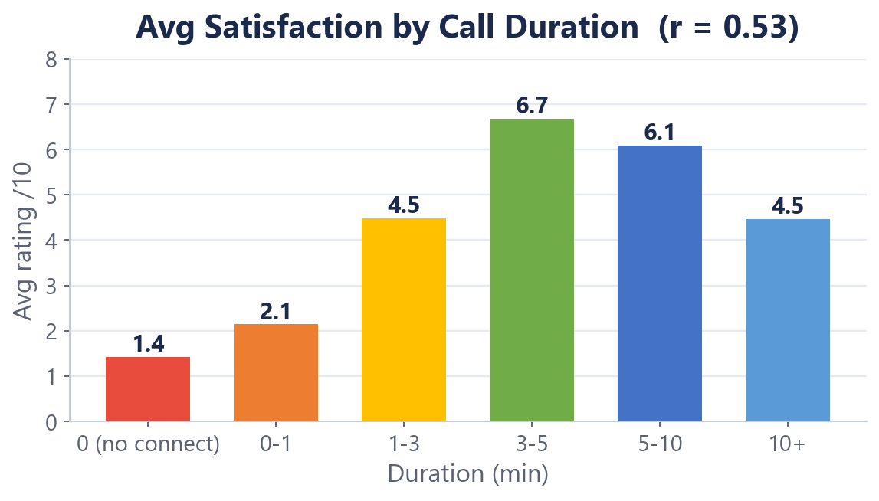
Avg Satisfaction by Call Duration (column)

Question 12: Which guru has the highest and lowest customer satisfaction scores?
Final Answer
Among gurus with >=50 consultations: highest = Daljit Kaur (5.95/10), lowest = Astro K Ojha (0.10/10). The >=50 filter avoids small-sample noise.
Approach
AVERAGEIF per guru, ranked with a pivot; 0 on the 0-10 scale denotes failed/unrated sessions.
Charts & Tables
Table / Chart Name: Top 10 Gurus by Avg Satisfaction (bar)
Description: Best-rated gurus among those with a meaningful sample.
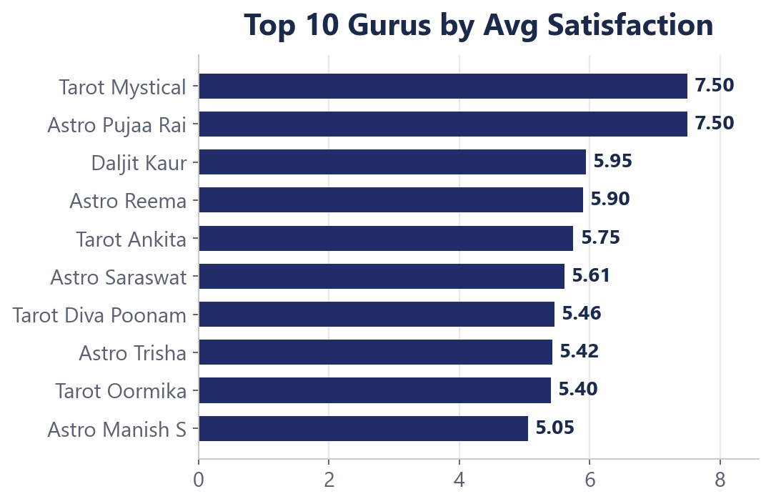
Top 10 Gurus by Avg Satisfaction (bar)

Question 13: What is the average customer satisfaction score by month?
Final Answer
December 2023: 2.95/10; January 2024: 2.68/10 (partial data) - a slight month-on-month dip.
Approach
AVERAGEIF over the rating column grouped by Month.
Charts & Tables
Table / Chart Name: Avg Satisfaction by Month (column)
Description: Monthly satisfaction trend on the 0-10 scale.
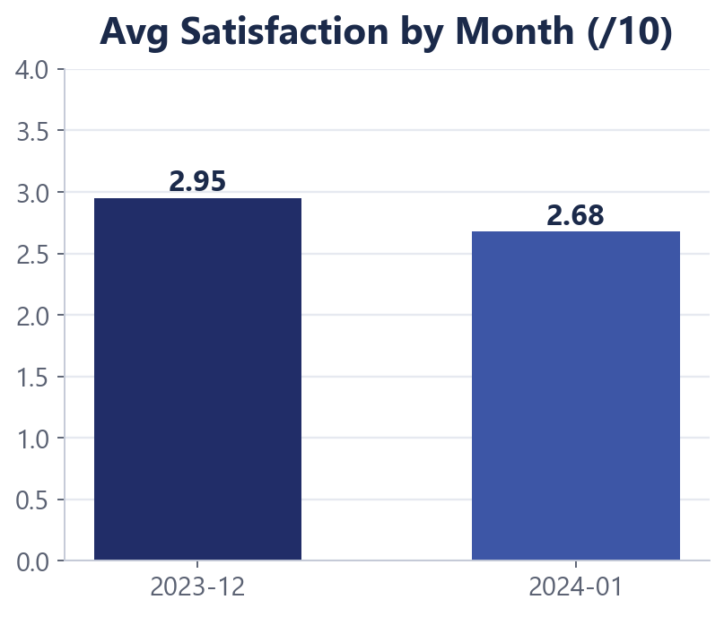
Avg Satisfaction by Month (column)

Question 14: How many categorical columns are there in the data?
Final Answer
About 15 categorical columns - e.g., consultationType, website, callStatus, chatStatus, region, refundStatus, callChannel, callIvrType, userCallStatus, astrologerCallStatus, Status, RepeatCaller, DurationBucket, Country, Month - versus continuous columns such as timeDuration, amount, netAmount, earnings and rating.
Approach
Categorical = finite labels/categories (no meaningful arithmetic); continuous = measurable numeric quantities. Each column was classified and the categorical set counted.
Charts & Tables
Table / Chart Name: Column classification
Description: Split of the 35+ columns into categorical vs continuous.

SUBJECTIVE QUESTIONS

Question 1: Should the investment be used to hire more agents, improve training, or upgrade technology?
Approach
Compared the business impact of each option using completion/answer rates, the agent-workload distribution, and average ratings.
Charts & Tables
Table / Chart Name: Q-1 Subjective - What-If Data Table
Description: A 1-crore investment model sizing revenue recovered at different technology-investment levels.
Insights
- Connection reliability is the biggest leak: only ~28% of chats complete (~37% fail) and ~34% of calls go unanswered/busy.
- Workload is concentrated - 19 of 131 agents already carry ~60% of volume, so raw headcount is not the constraint.
- Average satisfaction is only ~2.9/10 with a wide guru-to-guru spread.
Recommendations
- Prioritise TECHNOLOGY first to fix call/chat connection reliability - it protects the most revenue.
- Then TRAINING for low-rated agents to lift satisfaction and completion.
- HIRING is lowest priority - better routing/capacity of existing agents beats adding headcount.

Question 2: What are the potential risks of each investment option, and how can they be mitigated? Name the function you would use.
Approach
Listed the principal risk of each option and a practical mitigation; sized trade-offs with a What-If Data Table and pivot summaries.
Charts & Tables
Table / Chart Name: Q-1 Subjective - What-If Data Table + risk matrix
Description: Scenario model plus a qualitative risk/mitigation table for the three options.
Insights
- Technology: integration downtime / adoption risk during rollout.
- Training: agents pulled off the floor reduce short-term capacity.
- Hiring: onboarding cost and idle capacity if demand is misjudged.
Recommendations
- Technology -> phased pilot rollout with fallback and monitoring.
- Training -> micro-learning during off-peak hours to protect capacity.
- Hiring -> hire selectively for peak windows only.
- Spreadsheet functions: Data Table (What-If Analysis), Pivot Tables and scenario comparison.

Question 3: How does AstroSage's performance compare to AstroGuru's? Will you use aggregation or visualization?
Approach
No external AstroGuru dataset was provided, so a like-for-like comparison is not possible. As a documented proxy, benchmark AstroSage’s two delivery channels - Call vs Chat - against each other.
Charts & Tables
Table / Chart Name: Q-3 Subjective (Optional) - channel benchmark
Description: Aggregated Call-vs-Chat comparison of revenue/consult, connect rate and average rating.
Insights
- Calls earn far more per consultation (~Rs 19.8 vs ~Rs 2.3 for chat).
- Calls rate higher on satisfaction (3.50 vs 2.69) and connect more reliably.
Recommendations
- Scale the stronger Call channel; fix Chat reliability before growing it.
- Approach: aggregation (AVERAGEIF / pivot) plus a bar visualization; swap in AstroGuru figures if a dataset is supplied.

Question 4: How can the call centre improve handling of peak call periods? Which functionality will you use?
Approach
Built an hour-of-day pivot for both volume and average rating to locate peaks and satisfaction troughs.
Charts & Tables
Table / Chart Name: Q-4 Subjective - Hourly demand vs satisfaction
Description: Volume by hour with the average-rating line overlaid.
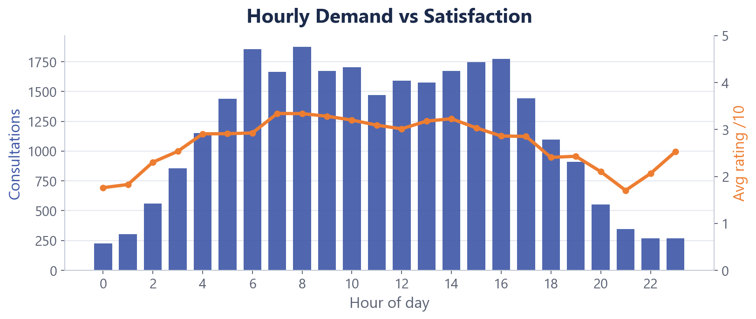
Q-4 Subjective - Hourly demand vs satisfaction
Insights
- Demand peaks 06:00-10:00 and 14:00-16:00 (busiest hour 08:00 ~ 1,875).
- Satisfaction holds ~3.2-3.3 through the day but collapses late night (21:00 ~ 1.70) as staffing thins.
Recommendations
- Align agent rosters to the morning and afternoon peaks and add evening coverage.
- Use queue call-backs during surges to cut wait times and missed consultations.
- Functionality: pivot table aggregation + a combo column/line visualization.

Question 5: Based on historical data, what strategic initiatives should be prioritized?
Approach
Ranked initiatives by the size of the data-shown leakage they address.
Charts & Tables
Table / Chart Name: Dashboard + supporting pivots
Description: KPI dashboard and the objective-question pivots that quantify each gap.
Insights
- Connection failures are the largest revenue leak.
- Repeat callers (~81% of volume) are the core revenue base to protect.
- A wide guru rating spread and peak/evening staffing gaps remain.
Recommendations
- (1) Fix connection technology, (2) retain and grow repeat callers, (3) coach low-rated agents, (4) staff the peak and evening gaps.

Question 6: What factors drive high satisfaction, and how did you decide satisfaction affects ratings?
Approach
The rating field (0-10) IS the customer-satisfaction score, so it was analysed directly - grouped by session outcome and correlated with duration.
Charts & Tables
Table / Chart Name: Q-6 Subjective - outcome vs rating + CORREL
Description: Average rating by session outcome, plus the duration-rating correlation.
Q-6 Subjective - outcome vs rating + CORREL
Insights
- Session COMPLETION is the dominant driver: completed chats average ~7.0 vs ~2.0 for incomplete and 0 for failed.
- Duration correlates with rating (r ~ 0.53); guru quality is a secondary driver.
Recommendations
- Fixing completion / connection quality lifts satisfaction the most.
- Basis: grouping ratings by outcome (pivot) plus CORREL shows connection quality and completion decide satisfaction, which in turn drives the ratings.

Question 7: How should the call centre balance workload among agents to avoid burnout?
Approach
Built workload bands with COUNTIF per guru and compared agent counts against the volume they carry.
Charts & Tables
Table / Chart Name: Q-7 Subjective - workload bands / Top agents
Description: Distribution of agents across volume bands and the top-load gurus.
Q-7 Subjective - workload bands / Top agents
Insights
- Highly concentrated: 19 of 131 agents (15%) handle ~60% of all consultations.
- 56 agents take fewer than 50 consultations each - a large under-used tail.
Recommendations
- Route more demand to under-used but capable gurus.
- Cap the daily load of top agents to prevent burnout.
- Upskill the long tail so more agents can absorb peak demand.
- Approach: COUNTIF per guru to build bands, then compare agents vs volume.

Question 8: What new technologies or tools could enhance operations and customer service?
Approach
Mapped candidate technologies to the specific gaps the data exposed (failures, no-answers, peak congestion, manual routing).
Charts & Tables
Table / Chart Name: Status & hourly pivots
Description: Outcome distribution and hourly congestion that justify each tool.
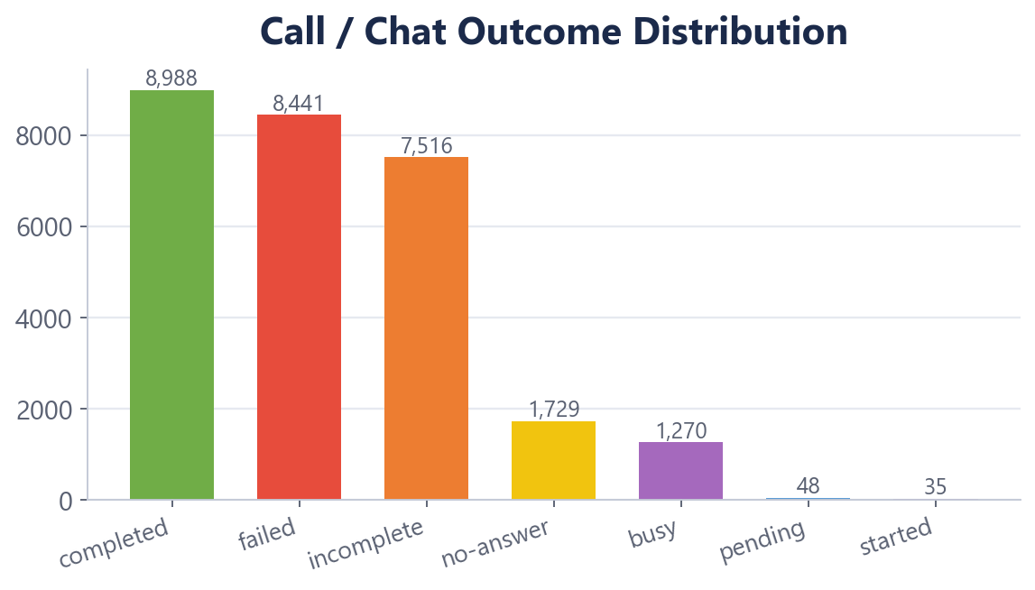
Status & hourly pivots
Insights
- High failure/no-answer rates and peak-hour congestion point to routing and reliability gaps.
- A large repeat-caller base is under-served by caller-history context.
Recommendations
- Intelligent IVR with skill-based routing; automatic call-back queue for surges.
- Real-time monitoring dashboards and workforce-management (WFM) scheduling.
- CRM with caller history for repeat callers; AI-assisted QA / sentiment; chat infrastructure/reliability upgrade.

Question 9: What metrics should the final dashboard include to guide investment decisions?
Approach
Selected metrics spanning demand, revenue, cost, quality and efficiency, and built an interactive dashboard around them.
Charts & Tables
Table / Chart Name: AstroSage Dashboard
Description: Interactive KPI dashboard with slicers and eight charts (see Excel workbook).
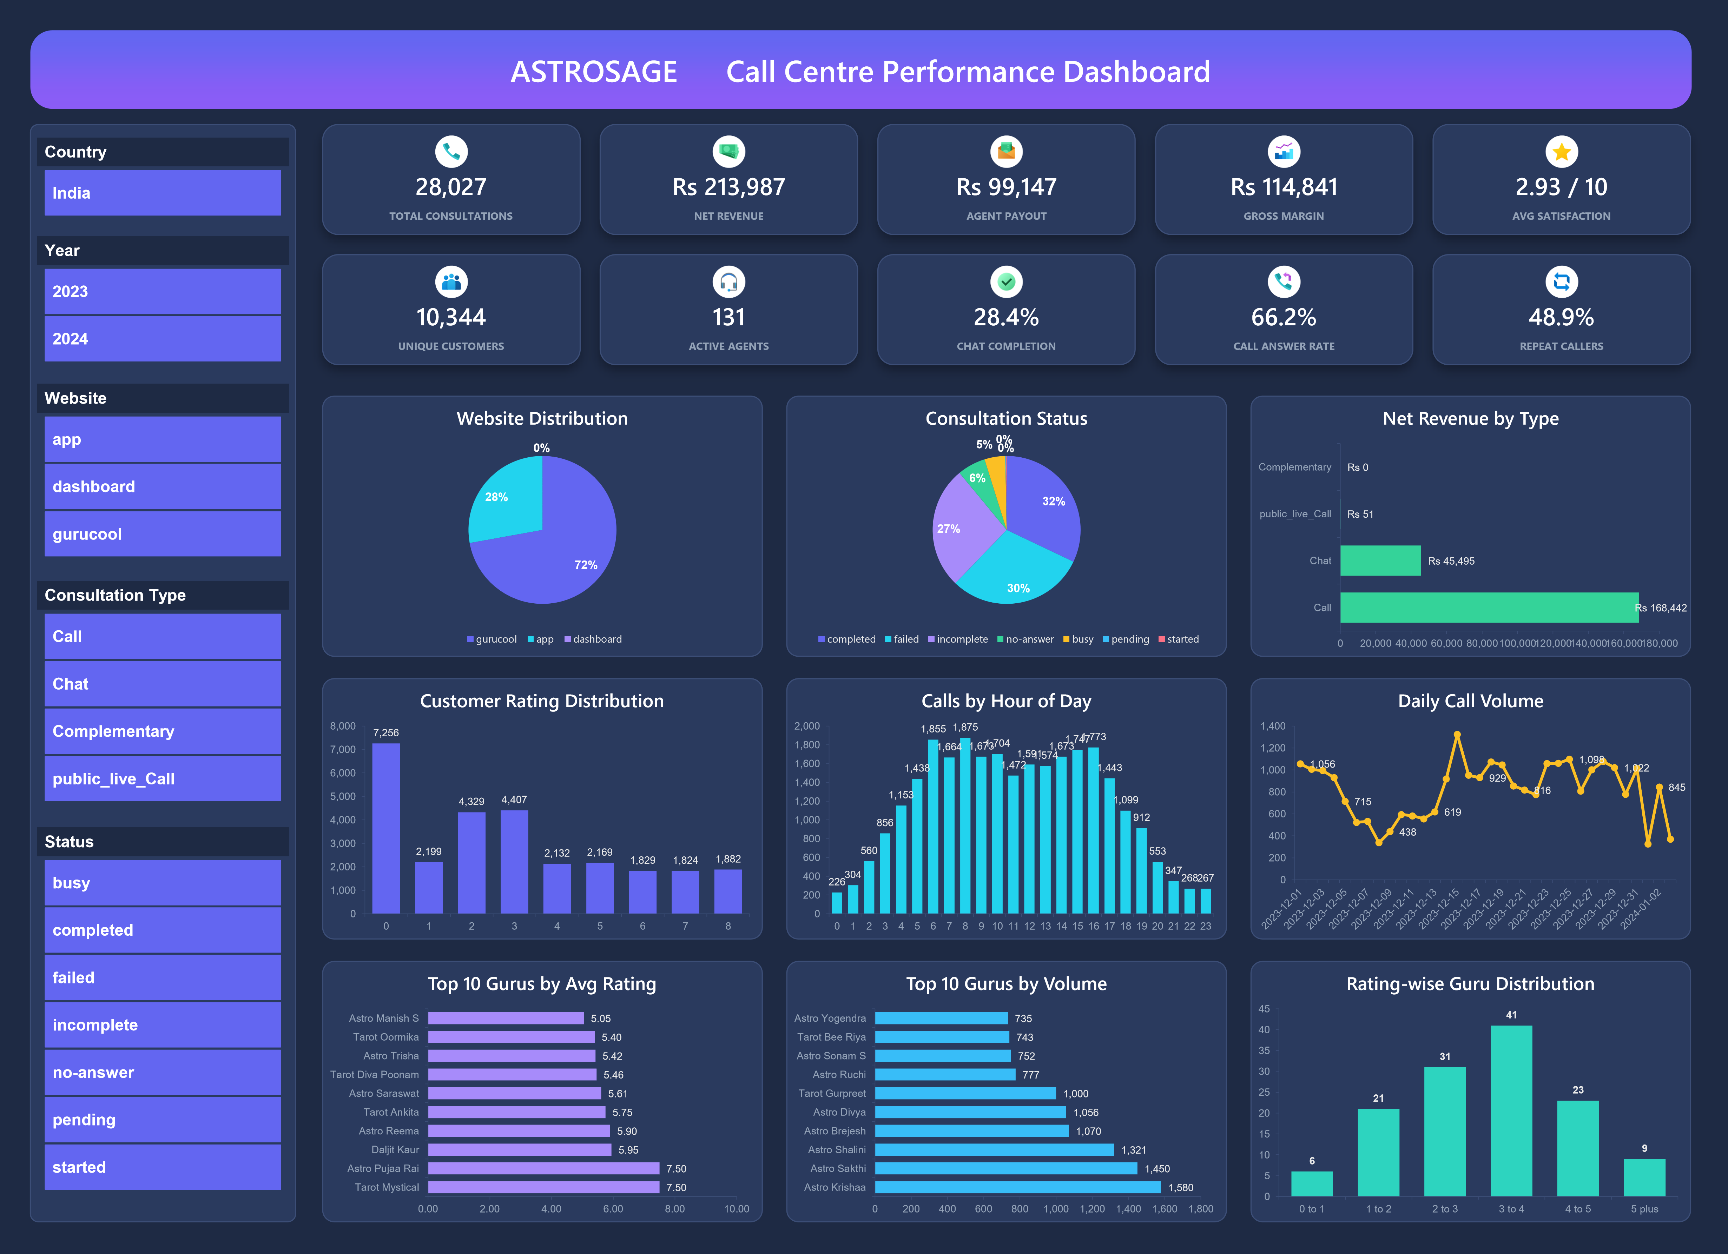
AstroSage Dashboard
Insights
- Management needs volume, money, quality and efficiency on one screen, filterable by segment.
Recommendations
- KPIs: Total Consultations, Net Revenue, Agent Payout, Gross Margin, Avg Satisfaction (/10), Unique Customers, Active Agents, Chat Completion %, Call Answer %, Repeat-Caller %.
- Interactivity: slicers for Country, Year, Website and Consultation Type wired to all charts and KPI cards.

Question 10: How would you allocate a Rs 1 crore investment to boost efficiency, satisfaction and profitability?
Approach
Allocated the budget in proportion to the data-shown revenue leakage and ROI of each lever.
Charts & Tables
Table / Chart Name: Investment allocation model
Description: Proposed split of the Rs 1 crore across five priorities.
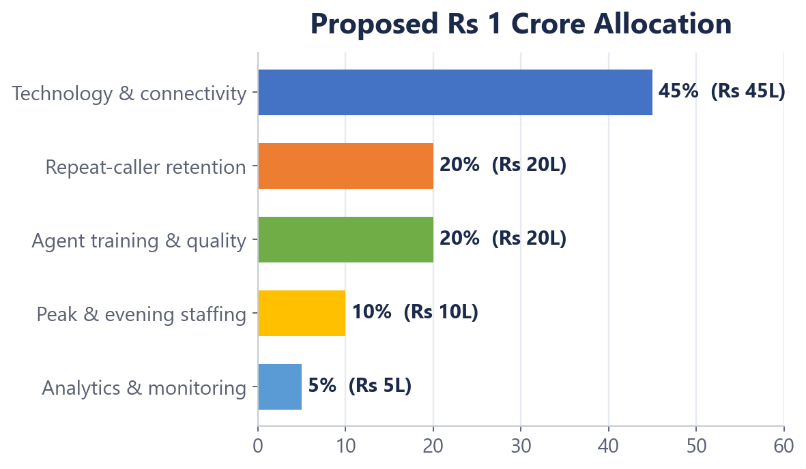
Investment allocation model
Insights
- The largest, fastest ROI is recovering revenue lost to failed/unanswered sessions.
- Retaining the repeat base and lifting satisfaction compound the gains.
Recommendations
- Technology & connectivity - Rs 45L (45%): fix call/chat connection failures (the biggest revenue leak).
- Repeat-caller retention - Rs 20L (20%): CRM/loyalty for the 48.9% base that drives ~81% of volume.
- Agent training & quality - Rs 20L (20%): coach low-rated gurus; lift satisfaction from 2.9/10.
- Peak & evening staffing - Rs 10L (10%): cover the 06-10 / 14-16 peaks and the late-night rating collapse.
- Analytics & monitoring - Rs 5L (5%): real-time dashboards to sustain and measure the gains.

CONCLUSION

AstroSage has a strong, loyal demand base, but revenue and satisfaction are both constrained by one root cause - connection reliability. Fixing call/chat completion, protecting the repeat-caller base, coaching low-rated gurus, and staffing the peaks are the highest-ROI moves. The proposed Rs 1 crore allocation directs the majority of spend to technology and retention, where the data shows the biggest and fastest returns. The accompanying Excel workbook (cleaned data, formula-driven answers, and an interactive dashboard) and this report together provide management a repeatable, evidence-based basis for the investment decision.

