ANALYTICAL CRM FOR A BANK
CUSTOMER CHURN

Objective & Subjective Question Report

Contents
Contents 2
List of Figures 4
List of Tables 5
Table of Queries 6
Executive Summary 7
Key findings 7
What we recommend 7
Data Overview & Model 8
Data Cleaning & Preparation 8
Objective Questions 9
Objective Q1 · Distribution of account balances across regions 9
Objective Q2 · Top 5 salaries in the last quarter (Oct–Dec) 10
Objective Q3 · Average products held by credit-card holders 10
Objective Q4 · Churn rate by gender, most recent year 11
Objective Q5 · Average credit score — exited vs retained 11
Objective Q6 · Gender salary vs active accounts 12
Objective Q7 · Credit-score segment with the highest exit rate 13
Objective Q8 · Region with most active customers, tenure > 5 years 14
Objective Q9 · Impact of holding a credit card on churn 15
Objective Q10 · Most common product count among leavers 16
Objective Q11 · Joining trend over time & seasonality 16
Objective Q12 · Products vs balance for exited customers 19
Objective Q13 · Balance outliers among retained customers 20
Objective Q14 · How many tables, and which are purely categorical 21
Objective Q15 · Gender-wise average income per region, ranked 22
Objective Q16 · Average tenure of leavers by age bracket 22
Objective Q17 · Correlation between salary and balance 23
Objective Q18 · Correlation between salary and credit score 24
Objective Q19 · Rank credit-score buckets by churned count 24
Objective Q20 · Credit cards per age bucket (below average) 26
Objective Q21 · Rank locations by churned count and average balance 27
Objective Q22 · Create a CustomerID_Surname key 28
Objective Q23 · Get ExitCategory without using JOIN 28
Objective Q24 · Missing values and how to handle them 28
Objective Q25 · Customers whose surname ends in 'on' 29
Objective Q26 · Data discrepancy: IsActiveMember vs Exited 30
Subjective Questions — Insights & Recommendations 32
Subjective S1 · Customer behaviour — long-term vs new 32
Subjective S2 · Product affinity & cross-selling 32
Subjective S3 · Geographic market trends 32
Subjective S4 · Risk management — highest-risk segments 33
Subjective S5 · Customer tenure / lifetime-value forecast 33
Subjective S6 · Marketing-campaign effectiveness 34
Subjective S7 · Common characteristics of leavers 34
Subjective S8 · Are Tenure, Products, Activity & Salary predictive? 34
Subjective S9 · SQL segmentation by demographics & account 35
Subjective S10 · Conditional formatting for at-risk customers 35
Subjective S11 · Churn per year, and strategies to cut it 35
Subjective S12 · Dashboard with KPIs and a slicer 36
Subjective S13 · Approach if no questions were given 37

List of Figures
Figure 1 — Churn rate by number of products — the single biggest driver. 7
Figure 2 — Average account balance by region. 9
Figure 3 — Churn rate by gender (all years). 11
Figure 4 — Average estimated salary by gender. 12
Figure 5 — Exit rate by credit-score segment. 13
Figure 6 — Credit-card ownership vs churn. 15
Figure 7 — Exited customers by number of products. 16
Figure 8 — New customers per year. 17
Figure 9 — Monthly acquisition seasonality. 17
Figure 10 — Average balance of exited customers by product count. 20
Figure 11 — Estimated salary vs balance — no linear pattern. 23
Figure 12 — Churned customers by credit-score bucket. 25
Figure 13 — Credit-card holders by age bracket (dashed line = average). 26
Figure 14 — Churn rate by region. 27
Figure 15 — Product count vs churn — two products is the retention sweet spot. 32
Figure 16 — Germany: highest balances but highest churn. 33
Figure 17 — Churn accelerates with age. 34
Figure 18 — Churn rate by cohort year — broadly stable near 20%. 36
Figure 19 — Bank Customer Churn — the interactive Power BI dashboard delivered for this project. 37

List of Tables
Table 1 — Source tables supplied in the dataset. 8
Table 2 — Distribution of account balances across regions 10
Table 3 — Top 5 salaries in the last quarter (Oct–Dec) 10
Table 4 — Churn rate by gender, most recent year 11
Table 5 — Average credit score — exited vs retained 12
Table 6 — Gender salary vs active accounts 13
Table 7 — Credit-score segment with the highest exit rate 14
Table 8 — Region with most active customers, tenure > 5 years 15
Table 9 — Impact of holding a credit card on churn 15
Table 10 — Most common product count among leavers 16
Table 11 — Joining trend over time & seasonality 19
Table 12 — Products vs balance for exited customers 20
Table 13 — How many tables, and which are purely categorical 22
Table 14 — Gender-wise average income per region, ranked 22
Table 15 — Average tenure of leavers by age bracket 23
Table 16 — Correlation between salary and balance 24
Table 17 — Rank credit-score buckets by churned count 25
Table 18 — Credit cards per age bucket (below average) 26
Table 19 — Rank locations by churned count and average balance 27
Table 20 — ExitCategory derived without a JOIN 28
Table 21 — Customers whose surname ends in 'on' 30
Table 22 — Data discrepancy: IsActiveMember vs Exited 31
Table 23 — Behaviour of long-term vs newer customers. 32
Table 24 — High-risk segments ranked by balance at stake. 33
Table 25 — Churn rate by leaver characteristic vs the 20.4% average. 34
Table 26 — Predictive value of the four candidate features. 35
Table 27 — SQL segmentation by demographics & account 35
Table 28 — Churn rate by cohort year. 36

Table of Queries
Query 1 — Distribution of account balances across regions 9
Query 2 — Top 5 salaries in the last quarter (Oct–Dec) 10
Query 3 — Average products held by credit-card holders 10
Query 4 — Churn rate by gender, most recent year 11
Query 5 — Average credit score — exited vs retained 12
Query 6 — Gender salary vs active accounts 13
Query 7 — Credit-score segment with the highest exit rate 14
Query 8 — Region with most active customers, tenure > 5 years 14
Query 9 — Impact of holding a credit card on churn 15
Query 10 — Most common product count among leavers 16
Query 11 — Joining trend over time & seasonality 18
Query 12 — Products vs balance for exited customers 20
Query 13 — Balance outliers among retained customers 21
Query 14 — How many tables, and which are purely categorical 21
Query 15 — Gender-wise average income per region, ranked 22
Query 16 — Average tenure of leavers by age bracket 23
Query 17 — Correlation between salary and balance 24
Query 18 — Correlation between salary and credit score 24
Query 19 — Rank credit-score buckets by churned count 25
Query 20 — Credit cards per age bucket (below average) 26
Query 21 — Rank locations by churned count and average balance 27
Query 22 — Create a CustomerID_Surname key 28
Query 23 — Get ExitCategory without using JOIN 28
Query 24 — Missing values and how to handle them 29
Query 25 — Customers whose surname ends in 'on' 29
Query 26 — Data discrepancy: IsActiveMember vs Exited 31
Query 27 — SQL segmentation by demographics & account 35

Executive Summary
This report examines 10,000 bank customers across seven related tables to answer one question: who is leaving, and how can the bank keep them. Overall, 2,037 customers have exited — a churn rate of 20.37%. The loss is not spread evenly; it concentrates in a handful of customer profiles, which is what makes it fixable.

Key findings
- Product count is the biggest signal — churn runs 27.7% at one product, just 7.6% at two, then jumps to 82.7% at three and 100% at four.
- Age is the second driver — churn climbs from 7.5% (18–30) to 44.6% for the over-50s.
- Germany is the hotspot — 32.4% churn (double France and Spain) while holding the highest average balance (€119,730).
- Inactivity roughly doubles churn — 26.9% for inactive members vs 14.3% for active ones.
- Women churn more — 25.1% vs 16.5% for men, on near-identical salaries.
- Salary and credit-card ownership don't predict churn — both are effectively flat against exit.

What we recommend
- Win the second product. Move single-product customers to a well-matched second product — the 2-product group is four times stickier — and stop pushing third and fourth products.
- Protect Germany. Stand up a retention play for high-balance, older, inactive German customers.
- Re-engage early. Trigger outreach the moment a customer goes inactive, the loudest behavioural warning.
- Score the risk. Operationalise a products + age + activity + geography risk flag in Power BI for proactive outreach.
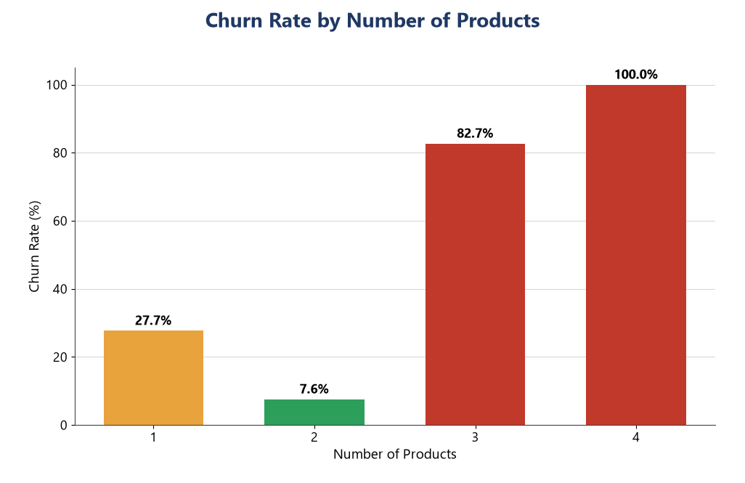
Figure 1 — Churn rate by number of products — the single biggest driver.

Data Overview & Model
The bank supplied seven tables forming a classic star schema: two fact tables at customer grain (Bank_Churn and CustomerInfo) surrounded by five categorical lookup tables. Bank_Churn and CustomerInfo join one-to-one on CustomerId (10,000 clean, unique keys on each side).
Table | Rows | Type | Key columns
Bank_Churn | 10,000 | Fact | CustomerId, CreditScore, Tenure, Balance, NumOfProducts, HasCrCard, IsActiveMember, Exited
CustomerInfo | 10,000 | Fact | CustomerId, Surname, Age, GenderID, EstimatedSalary, GeographyID, Bank DOJ
Geography | 3 | Lookup (categorical) | GeographyID → France / Spain / Germany
Gender | 2 | Lookup (categorical) | GenderID → Male / Female
CreditCard | 2 | Lookup (categorical) | CreditID → holder / non-holder
ActiveCustomer | 2 | Lookup (categorical) | ActiveID → Active / Inactive
ExitCustomer | 2 | Lookup (categorical) | ExitID → Exit / Retain
Table 1 — Source tables supplied in the dataset.

Relationships used in Power BI: CustomerInfo[GenderID]→Gender, CustomerInfo[GeographyID]→Geography, Bank_Churn[Has_creditcard]→CreditCard, Bank_Churn[IsActiveMember]→ActiveCustomer, Bank_Churn[Exited]→ExitCustomer, and Bank_Churn[CustomerId]→CustomerInfo[CustomerId].

Data Cleaning & Preparation
- Missing values — after consolidating all seven tables, a completeness check returned zero nulls across the 10,000 rows (Objective Q24), so no imputation was needed.
- Date parsing — Bank DOJ was cast to a Date type to enable year / month / quarter analysis.
- Column rename — HasCrCard was renamed to Has_creditcard for clarity and consistency across the model (ALTER TABLE … RENAME COLUMN).
- Activity vs exit contradiction — 735 customers were flagged Exited = 1 yet IsActiveMember = 1, which is impossible; since Exited is authoritative, these were corrected (Objective Q26).
- Column engineering — added the CustomerID_Surname composite key (Q22) and ExitCategory (Q23), plus analytical bands: CreditScoreBand, AgeBand, BalanceBand, TenureBand and Join Year / Month / Quarter.
All cleaning was performed in Power Query / Excel and mirrored in SQL; the cleaned model is provided in BankChurn_Consolidated.xlsx (sheet 'Cleaning_Log').

Objective Questions

Objective Q1 · Distribution of account balances across regions
Answer. Germany holds far more money per head than its size suggests. With 2,509 customers — half of France's 5,014 — its average balance of €119,730 is nearly double France (€62,093) and Spain (€61,818), and it carries the largest total deposits (€300M). Balance is concentrated, not spread evenly.
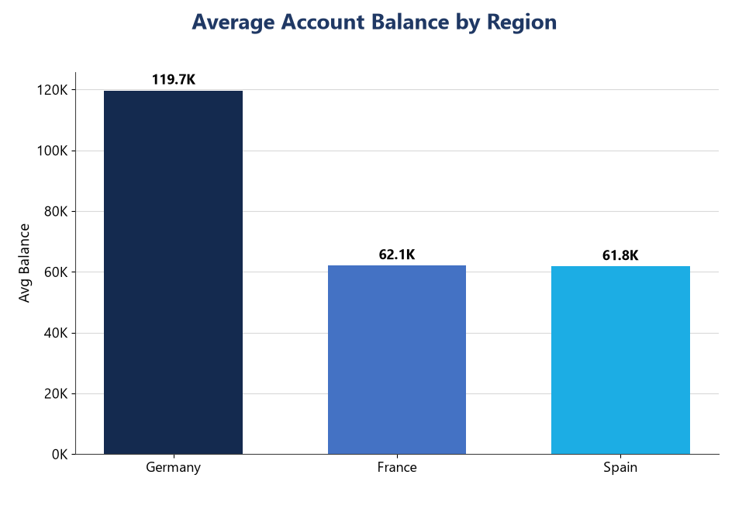
Figure 2 — Average account balance by region.
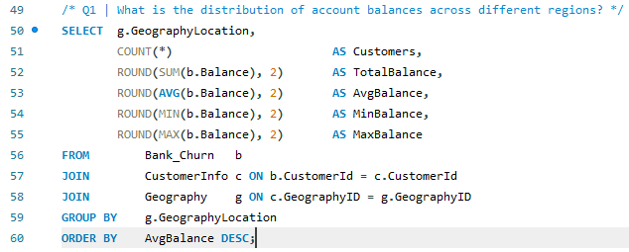
Query 1 — Distribution of account balances across regions

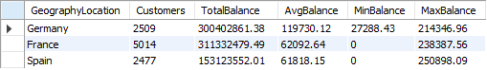
Table 2 — Distribution of account balances across regions

Objective Q2 · Top 5 salaries in the last quarter (Oct–Dec)
Answer. Ranking Q4 (Oct–Dec) joiners by estimated salary, the top five all sit above €199,600 — Dyer, Oluchukwu, Mai, Palerma and Dimauro.
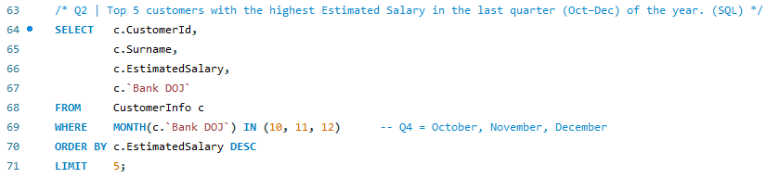
Query 2 — Top 5 salaries in the last quarter (Oct–Dec)

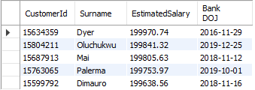
Table 3 — Top 5 salaries in the last quarter (Oct–Dec)

Objective Q3 · Average products held by credit-card holders
Answer. Card holders average 1.53 products — the same as the book as a whole (1.53). Holding a card does not push customers toward more products.
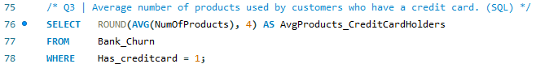
Query 3 — Average products held by credit-card holders

Objective Q4 · Churn rate by gender, most recent year
Answer. In the latest cohort (2019) women churned at 25.05% against 15.37% for men — a 10-point gap that mirrors every prior year, so it is structural rather than a one-off.
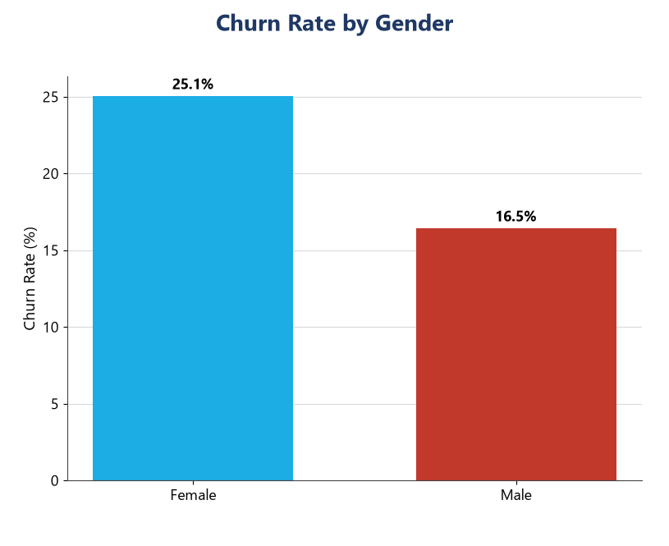
Figure 3 — Churn rate by gender (all years).
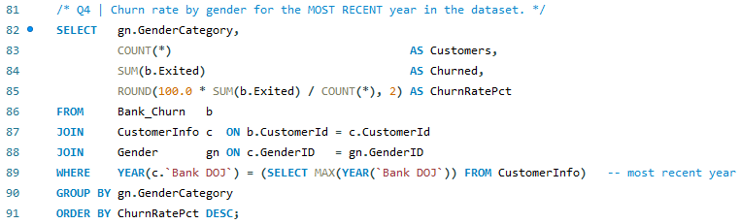
Query 4 — Churn rate by gender, most recent year
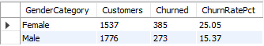
Table 4 — Churn rate by gender, most recent year

Objective Q5 · Average credit score — exited vs retained
Answer. The two groups are almost indistinguishable — leavers average 645 and stayers 652, a 6-point gap. Credit score on its own barely separates churn.
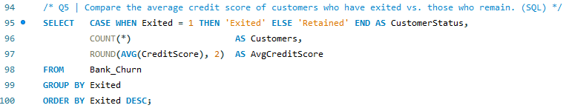
Query 5 — Average credit score — exited vs retained

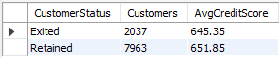
Table 5 — Average credit score — exited vs retained

Objective Q6 · Gender salary vs active accounts
Answer. Women earn marginally more (€100,602 vs €99,665) yet are less engaged — 50.3% active vs 52.5% for men, and fewer active accounts overall. Higher pay is not translating into activity, and women also churn more (Q4).
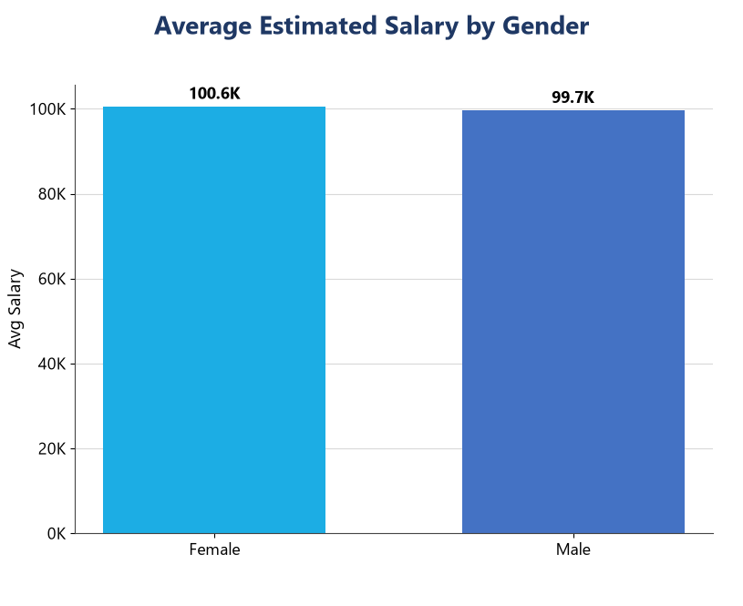
Figure 4 — Average estimated salary by gender.
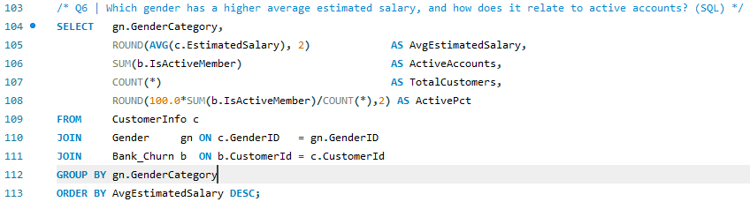
Query 6 — Gender salary vs active accounts
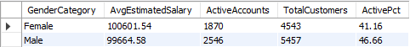
Table 6 — Gender salary vs active accounts

Objective Q7 · Credit-score segment with the highest exit rate
Answer. The Poor (300–579) band leaves most, at 22.02%, edging out Fair (20.56%) and Very Good (20.59%). Weak-credit customers are the most flight-prone, though the spread is narrow.
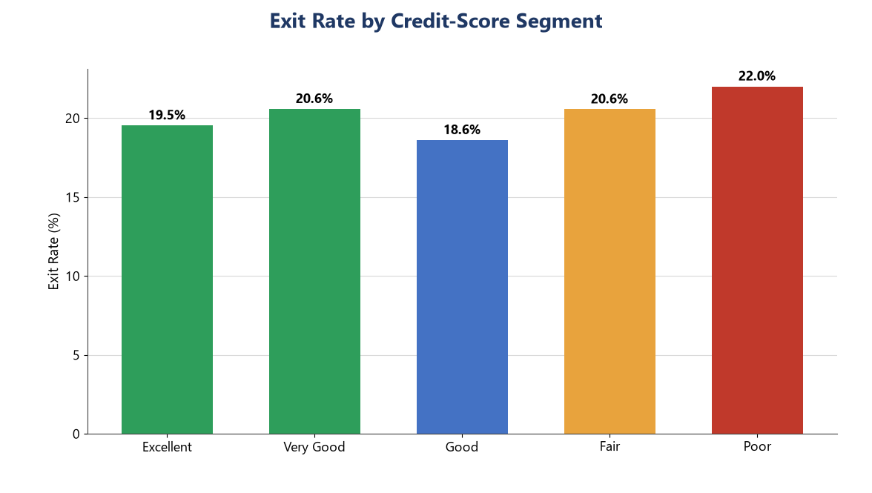
Figure 5 — Exit rate by credit-score segment.
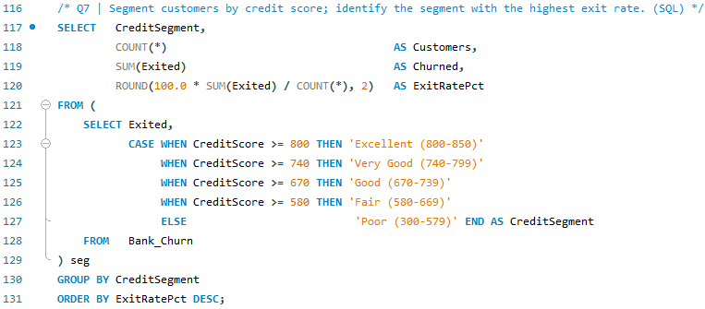
Query 7 — Credit-score segment with the highest exit rate

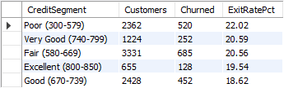
Table 7 — Credit-score segment with the highest exit rate

Objective Q8 · Region with most active customers, tenure > 5 years
Answer. France has the deepest base of loyal, active customers with more than five years' tenure — 797, well ahead of Spain and Germany.
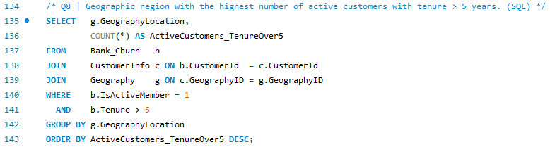
Query 8 — Region with most active customers, tenure > 5 years

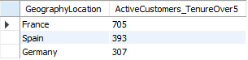
Table 8 — Region with most active customers, tenure > 5 years

Objective Q9 · Impact of holding a credit card on churn
Answer. Owning a card is not a retention lever — holders churn 20.18% and non-holders 20.81%, a 0.6-point difference well inside noise.
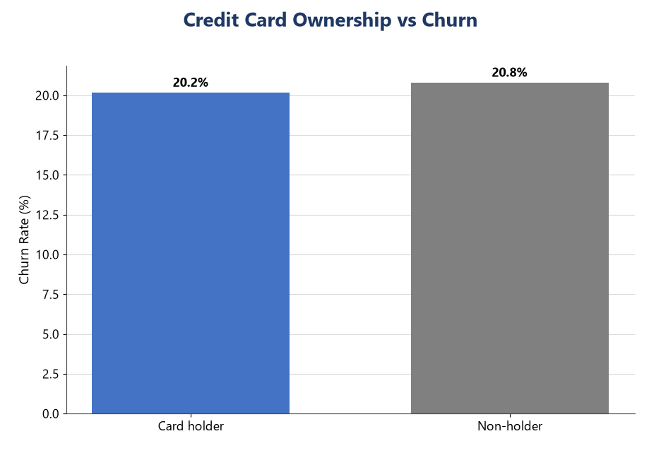
Figure 6 — Credit-card ownership vs churn.
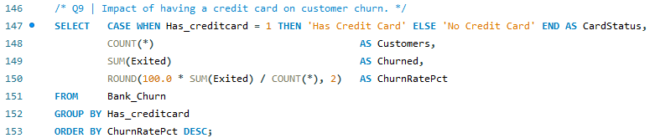
Query 9 — Impact of holding a credit card on churn
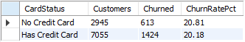
Table 9 — Impact of holding a credit card on churn

Objective Q10 · Most common product count among leavers
Answer. Single-product customers dominate the losses: 1,409 of 2,037 leavers (69%) held just one product. In sheer volume, that is where churn lives.
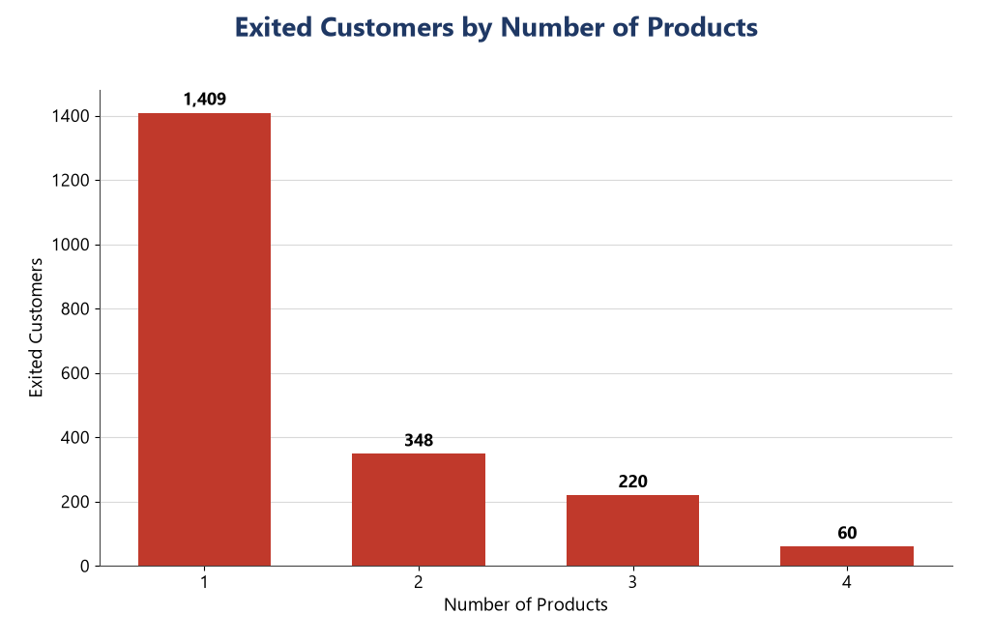
Figure 7 — Exited customers by number of products.
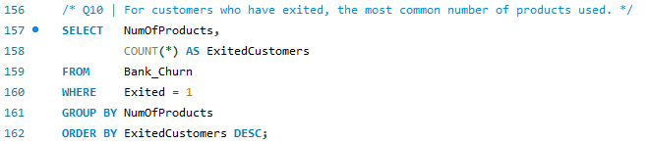
Query 10 — Most common product count among leavers
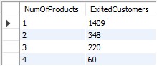
Table 10 — Most common product count among leavers

Objective Q11 · Joining trend over time & seasonality
Answer. Acquisitions rose every year, from 1,951 in 2016 to 3,313 in 2019 (+70%). Within the year the bank onboards in bursts — September, November and December peak while February is quietest, a clear year-end drive.
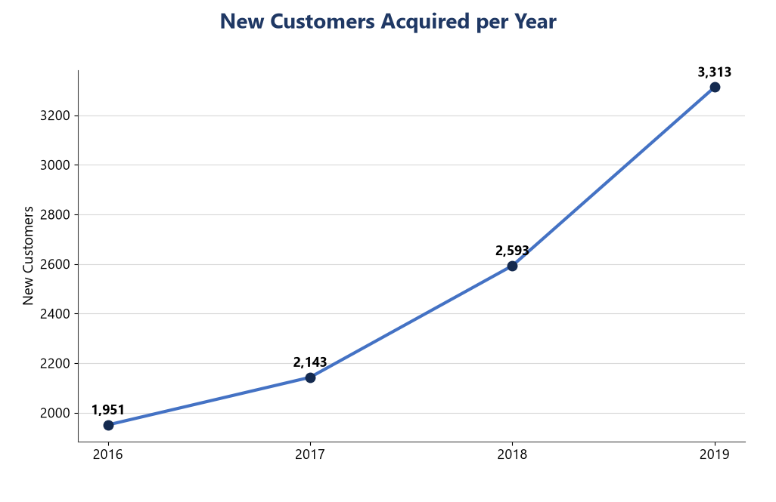
Figure 8 — New customers per year.
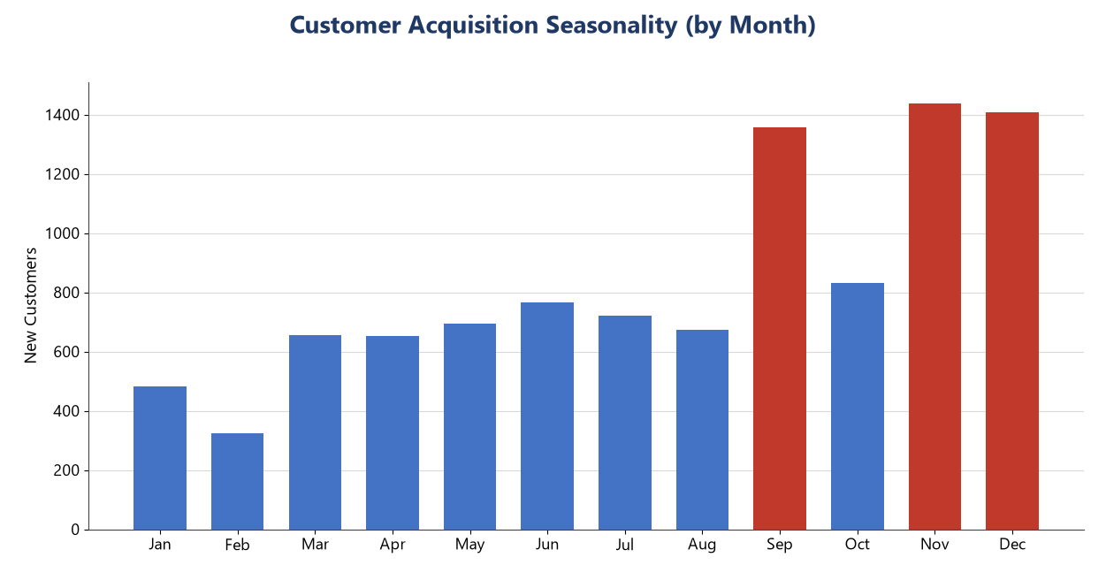
Figure 9 — Monthly acquisition seasonality.
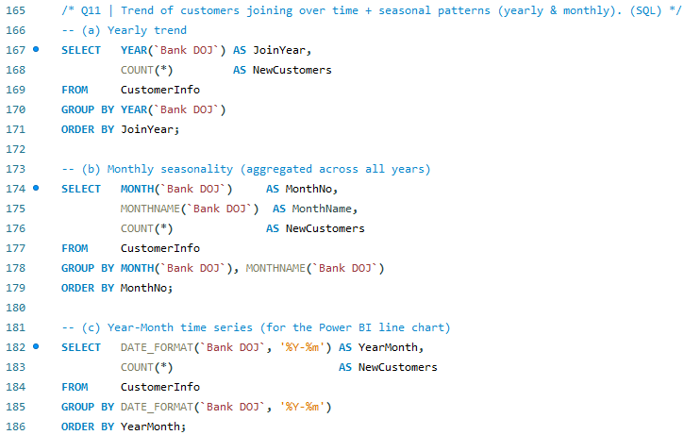
Query 11 — Joining trend over time & seasonality

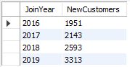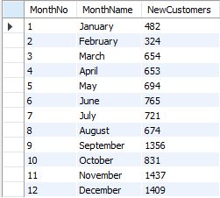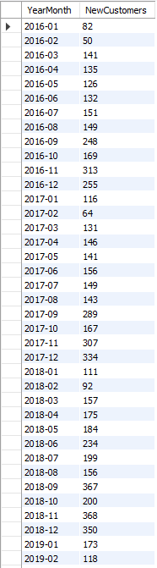
Table 11 — Joining trend over time & seasonality

Objective Q12 · Products vs balance for exited customers
Answer. Leavers were not low-value — average balances stayed between €85.9K and €93.7K across all product counts, with the one- and four-product leavers the richest (~€92–94K). The bank is losing money, not just accounts.
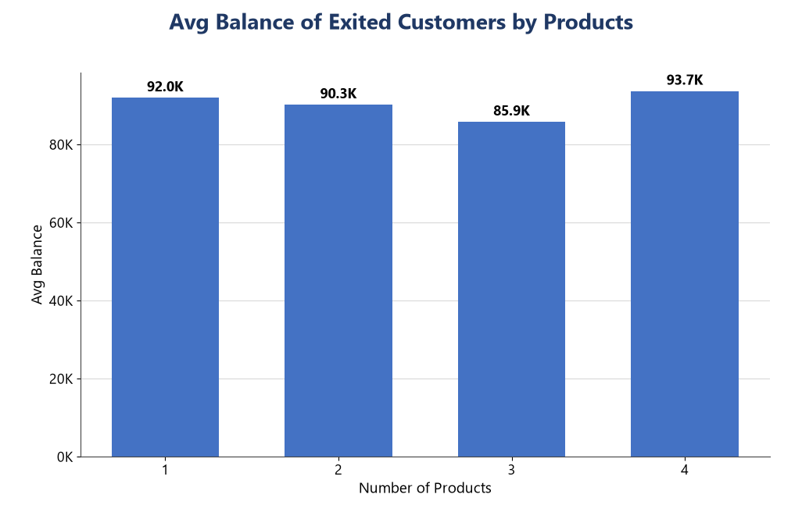
Figure 10 — Average balance of exited customers by product count.
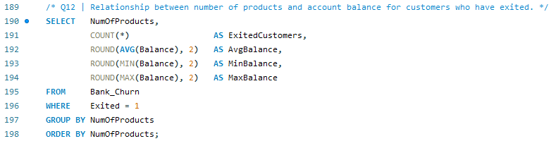
Query 12 — Products vs balance for exited customers

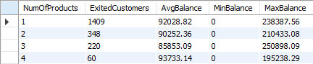
Table 12 — Products vs balance for exited customers

Objective Q13 · Balance outliers among retained customers
Answer. Applying Tukey's IQR fences to retained customers (Q1 €0, Q3 €126,428, upper fence €316,071), the top retained balance (€221,533) sits inside the fence — no statistical outliers. The only oddity is the 36% of customers holding a zero balance.
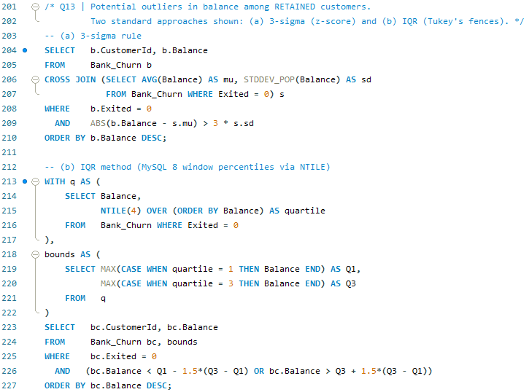
Query 13 — Balance outliers among retained customers

Objective Q14 · How many tables, and which are purely categorical
Answer. Seven tables were supplied. Two are fact tables at customer grain (Bank_Churn and CustomerInfo); the other five — Geography, Gender, CreditCard, ActiveCustomer and ExitCustomer — are lookup tables holding only categorical values (an ID paired with its label). So five of the seven consist solely of categorical variables (see the Data Overview table above).
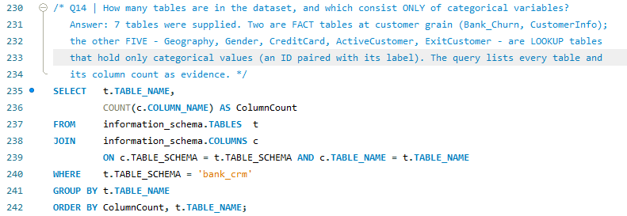
Query 14 — How many tables, and which are purely categorical

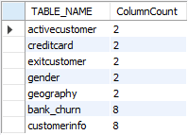
Table 13 — How many tables, and which are purely categorical

Objective Q15 · Gender-wise average income per region, ranked
Answer. Ranked within each region, women out-earn men in Spain and Germany, while men lead only in France. German women post the highest average income of any group (€102,446).
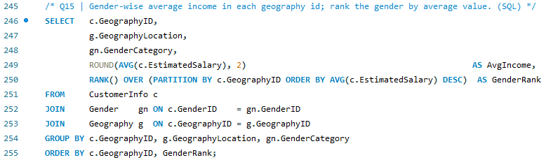
Query 15 — Gender-wise average income per region, ranked

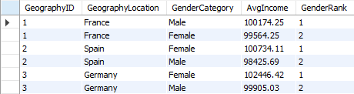
Table 14 — Gender-wise average income per region, ranked

Objective Q16 · Average tenure of leavers by age bracket
Answer. Tenure at exit is flat — about 4.8–4.9 years in every age bracket. Age decides whether customers leave, not when; once they go, they go at a similar point in the relationship.
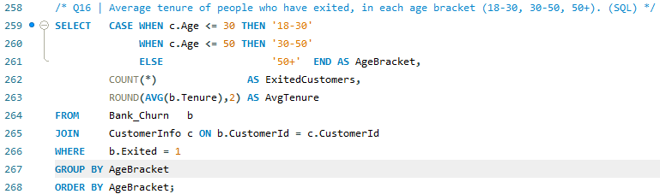
Query 16 — Average tenure of leavers by age bracket

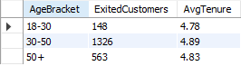
Table 15 — Average tenure of leavers by age bracket

Objective Q17 · Correlation between salary and balance
Answer. There is no meaningful link — overall r = 0.013, and it stays near zero for both leavers (-0.013) and stayers (0.017). Salary tells you nothing about how much a customer keeps in the bank.
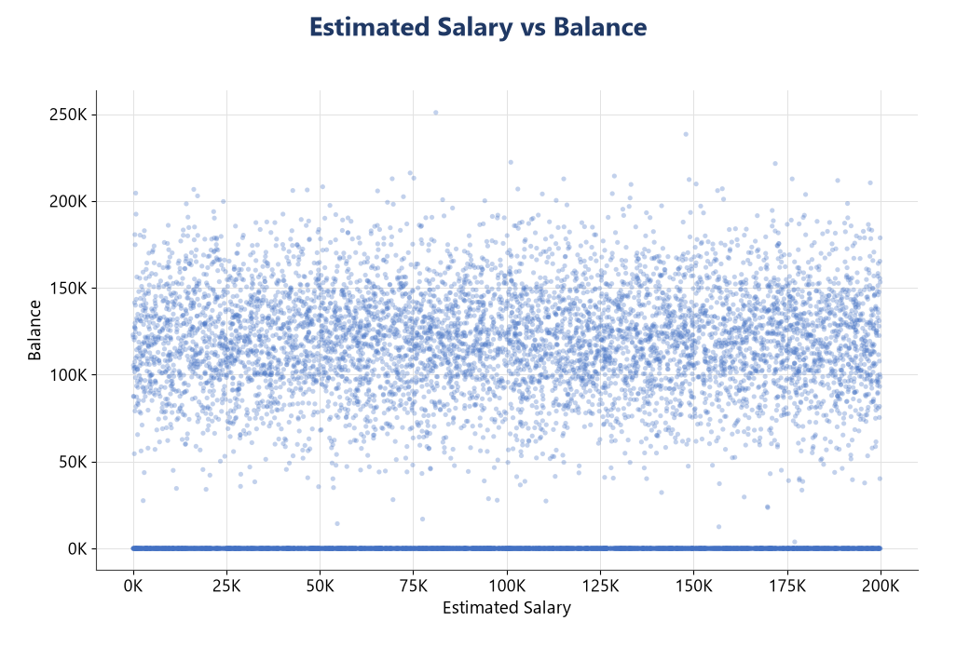
Figure 11 — Estimated salary vs balance — no linear pattern.
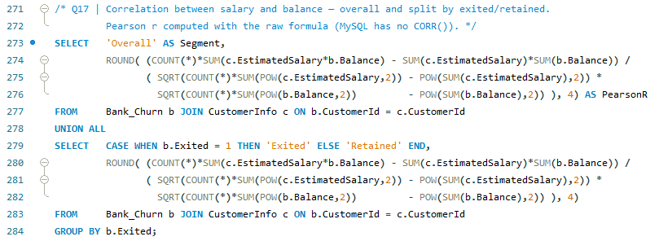
Query 17 — Correlation between salary and balance

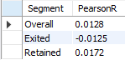
Table 16 — Correlation between salary and balance

Objective Q18 · Correlation between salary and credit score
Answer. None — r = -0.0014. Estimated salary and credit score move completely independently here.
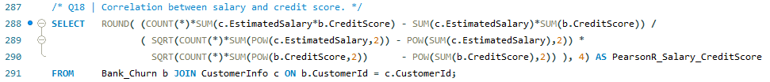
Query 18 — Correlation between salary and credit score

Objective Q19 · Rank credit-score buckets by churned count
Answer. By raw numbers the Fair (580–669) band loses the most, 685 customers, then Poor (520) and Good (452). The mid-to-low credit bands are where the bank bleeds most, simply because that is where most customers sit.
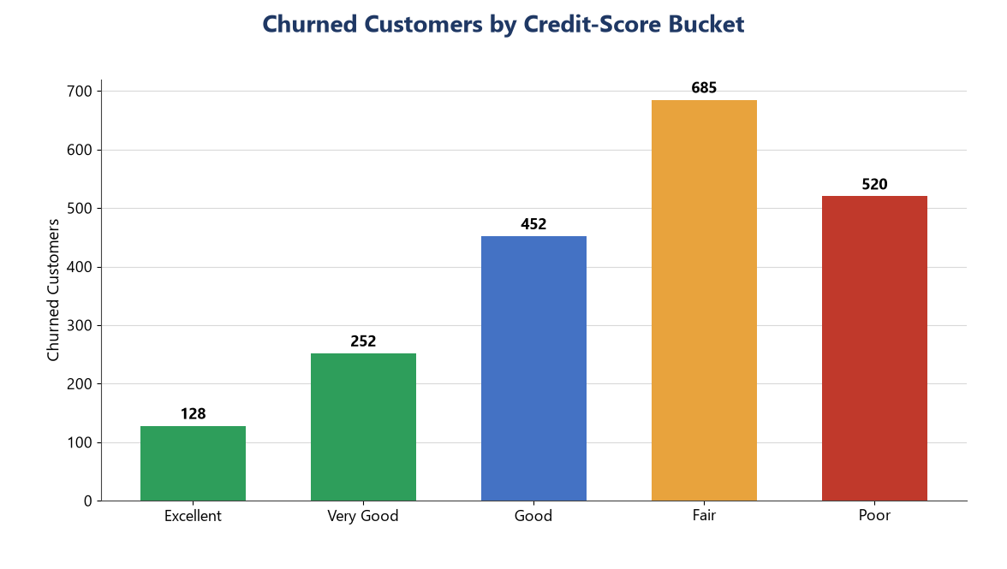
Figure 12 — Churned customers by credit-score bucket.
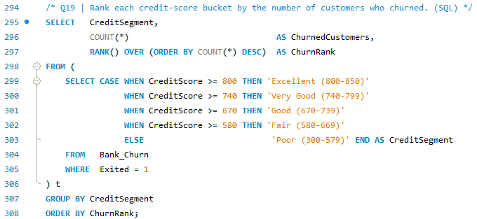
Query 19 — Rank credit-score buckets by churned count
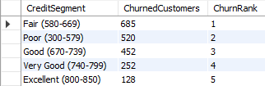
Table 17 — Rank credit-score buckets by churned count

Objective Q20 · Credit cards per age bucket (below average)
Answer. Card holders by bucket: 18–30 = 1,400, 30–50 = 4,781, 50+ = 874, averaging 2,352 per bucket. The 18–30 and 50+ buckets fall below that average — the youngest and oldest are under-carded, a clear cross-sell gap.
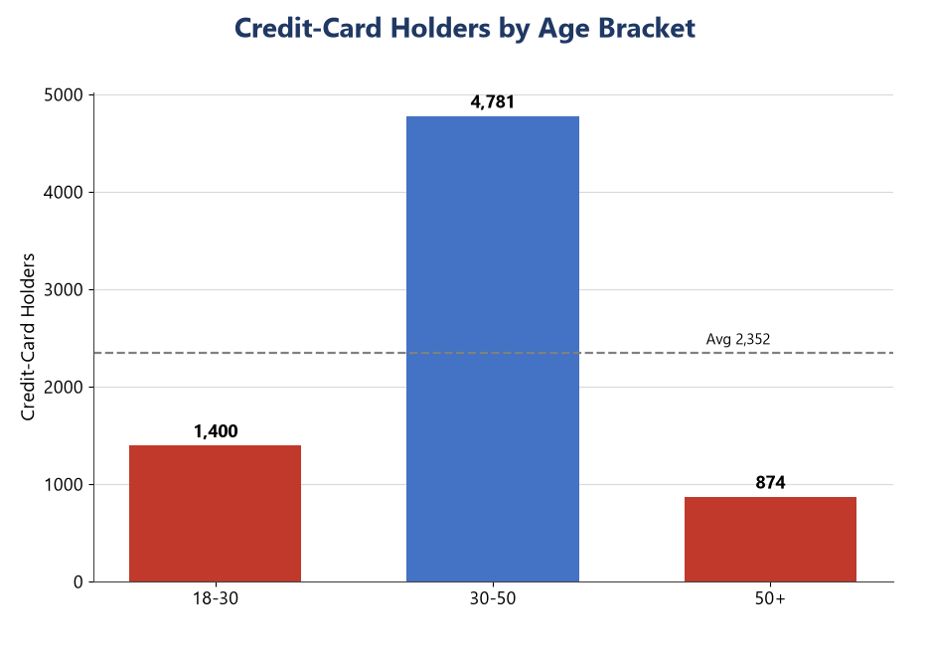
Figure 13 — Credit-card holders by age bracket (dashed line = average).
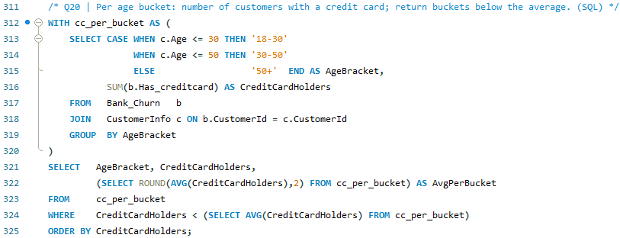
Query 20 — Credit cards per age bucket (below average)

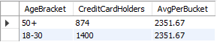
Table 18 — Credit cards per age bucket (below average)

Objective Q21 · Rank locations by churned count and average balance
Answer. Germany tops both league tables — most churned customers (814) and highest average balance (€119,730). It loses the most people and the most money per head, making it the obvious first target. France is a close second on churn volume but on far thinner balances.
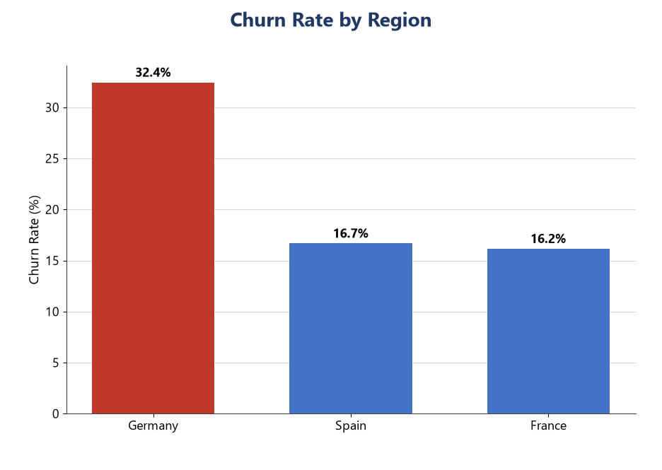
Figure 14 — Churn rate by region.
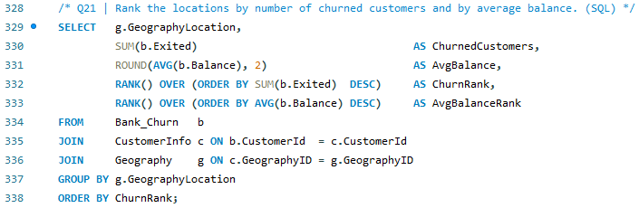
Query 21 — Rank locations by churned count and average balance

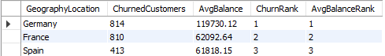
Table 19 — Rank locations by churned count and average balance

Objective Q22 · Create a CustomerID_Surname key
Answer. Concatenate the two fields. In SQL: ADD COLUMN CustomerID_Surname, then UPDATE … SET CustomerID_Surname = CONCAT(CustomerId,'_',Surname). In Power Query / DAX: [CustomerId] & "_" & [Surname] (e.g. 15634602_Hargrave). The key is included in the delivered model so CustomerInfo can join tables whose key is CustomerId + Surname.
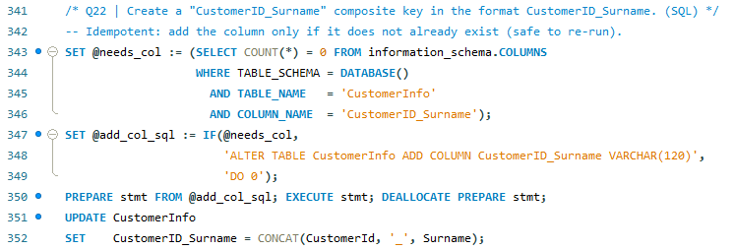
Query 22 — Create a CustomerID_Surname key

Objective Q23 · Get ExitCategory without using JOIN
Answer. Yes. Because Exited is already 1/0, a CASE returns the label with no join: CASE WHEN Exited=1 THEN 'Exit' ELSE 'Retain'. A correlated sub-query on ExitCustomer also avoids the JOIN keyword; in Power BI, LOOKUPVALUE does the same.
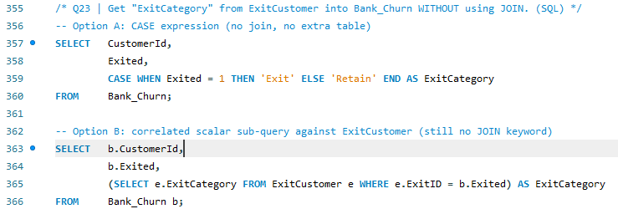
Query 23 — Get ExitCategory without using JOIN
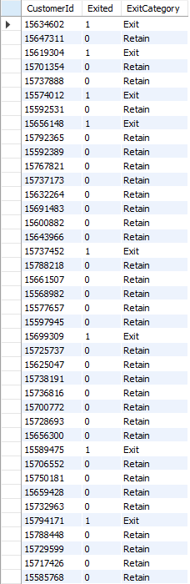
Table 21 — ExitCategory derived without a JOIN

Objective Q24 · Missing values and how to handle them
Answer. After consolidating the seven tables a null-check returned zero missing values, so nothing needed replacing. Where they do occur, Power Query (Replace Values / Fill Down / Remove Rows) or SQL COALESCE/UPDATE handle them.
Standard options for handling missing data:
- Deletion — drop rows or columns when missingness is small and random.
- Mean / median / mode imputation — median for skewed numerics, mode for categoricals.
- Forward / backward fill — for ordered or time-series data (Power Query 'Fill Down').
- Model-based imputation — regression or KNN from correlated fields.
- Business-rule constant — e.g. set a null balance to 0 where it means 'no funds'.
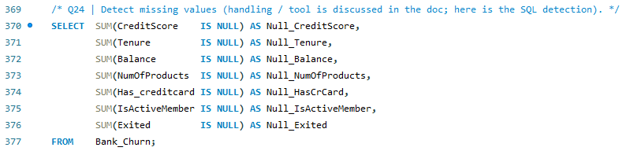
Query 24 — Missing values and how to handle them

Objective Q25 · Customers whose surname ends in 'on'
Answer. 704 customers have a surname ending in 'on'. A single join returns their ID, last name and active status (sample below).
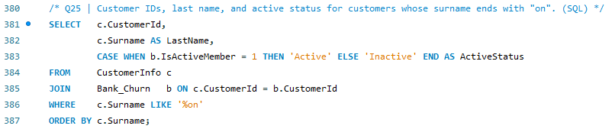
Query 25 — Customers whose surname ends in 'on'
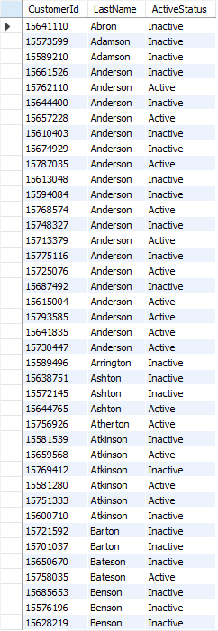
Table 22 — Customers whose surname ends in 'on'

Objective Q26 · Data discrepancy: IsActiveMember vs Exited
Answer. Yes — 735 customers show Exited = 1 yet IsActiveMember = 1, which is impossible: someone who has left cannot be active. As Exited is authoritative, those flags are set to 0 in the cleaned model (UPDATE Bank_Churn SET IsActiveMember = 0 WHERE Exited = 1 AND IsActiveMember = 1).
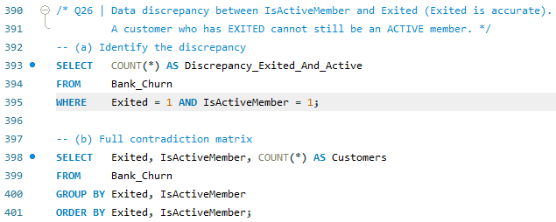
Query 26 — Data discrepancy: IsActiveMember vs Exited

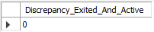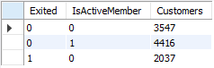
Table 23 — Data discrepancy: IsActiveMember vs Exited

Subjective Questions — Insights & Recommendations

Subjective S1 · Customer behaviour — long-term vs new
Answer. Tenure here spans only 3–7 years, and the two ends behave almost identically — long-term (6–7 yr) and newer (3–4 yr) customers hold similar balances (~€77,308 vs €76,650), the same ~1.5 products, comparable activity, and near-identical churn (20.1% vs 19.7%). Loyalty is not compounding with time, which points to an engagement gap: the bank must earn stickiness through second products and activity, not wait for it.

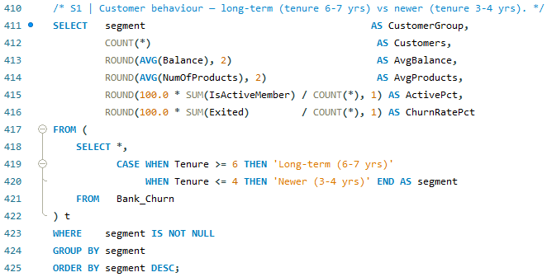Query 27 — Customer behaviour — long-term vs new

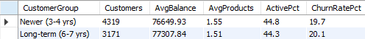
Table 24 — Customer behaviour — long-term vs new

Subjective S2 · Product affinity & cross-selling
Answer. The data records product count, not named products, so affinity shows up in the count-vs-churn curve. Two products is the clear sweet spot (7.6% churn) — a second product makes customers roughly four times stickier than one (27.7%). Beyond that it collapses (3 products 82.7%, 4 products 100%), which reads as over- or mis-selling. Cross-sell should move single-product customers to a well-matched second product and stop there; pairing the widely-held credit card with a savings or deposit product is the natural play.
Figure 15 — Product count vs churn — two products is the retention sweet spot.
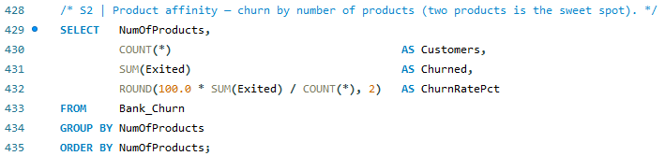Query 28 — Product affinity & cross-selling

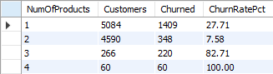
Table 25 — Product affinity & cross-selling

Subjective S3 · Geographic market trends
Answer. Germany is the paradox market — the highest balances (€119,730, ~2× France and Spain) but the highest churn (32.4%) and the fewest long-tenured actives. That 'rich but restless' profile fits an affluent, rate-sensitive customer who is easily poached in a competitive market. France is the mirror image: larger, lower-balance and stickier. Joining external indicators — regional interest rates, disposable income, competitor density — would explain the gap and let the bank price each market differently.
Figure 16 — Germany: highest balances but highest churn.
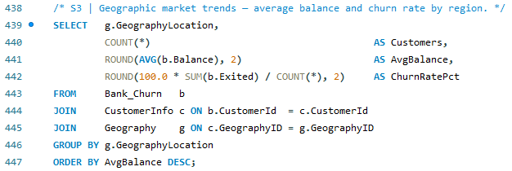Query 29 — Geographic market trends

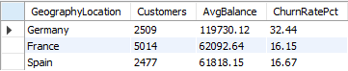
Table 26 — Geographic market trends

Subjective S4 · Risk management — highest-risk segments
Answer. The real risk is not headcount but money-at-risk — churn probability multiplied by balance. Three segments stand out: 3–4-product holders (86% churn on €78,822 average), 50+ inactive customers (85% churn on €89,074), and Germany broadly (32% churn on €119,730). Losing one of these costs far more than losing a zero-balance single-product youngster, so risk scoring should weight balance, not just churn.

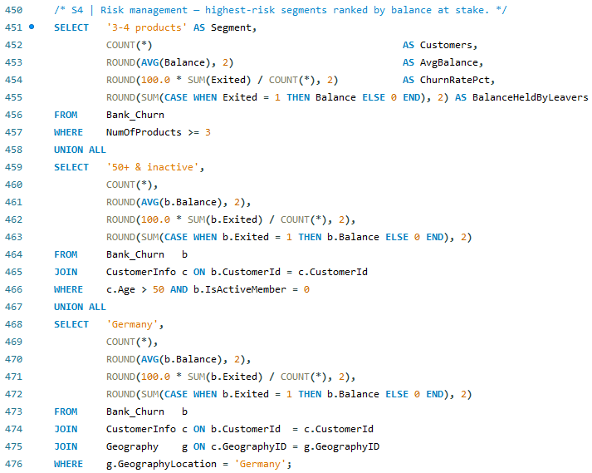Query 30 — Risk management — highest-risk segments

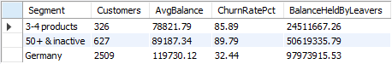
Table 27 — Risk management — highest-risk segments

Subjective S5 · Customer tenure / lifetime-value forecast
Answer. A workable model: Value = (average balance × net interest margin + product fees) × expected retained years, where expected years ≈ tenure ÷ segment churn probability. Segment by the strongest drivers (products, age, geography, activity), attach each segment's churn rate from this report, and rank. A 2-product active French customer models far higher than a 3-product German one. Transaction volume, fees and acquisition cost would sharpen the estimate and enable a proper survival model.

Subjective S6 · Marketing-campaign effectiveness
Answer. The dataset carries no campaign fields, so impact cannot be measured directly yet. To do it properly we would need campaign IDs and dates, treated-vs-control groups, channel, spend and response flags — then effectiveness is the retention lift of treated over control and ROI is retained value minus cost, over cost. As a proxy, the Sep/Nov/Dec joining spikes (Q11) suggest acquisition drives already run; A/B-testing retention offers on the high-risk segments would quantify the rest.

Subjective S7 · Common characteristics of leavers
Answer. Leavers share a consistent signature — older (50+), German, inactive, female, and holding either one product or an over-stuffed three or four. Read together, the reasons cluster into disengagement (inactivity is the loudest flag), product mismatch, and life-stage (the 50+ wealth-transfer years). These are service and product-fit failures more than price.

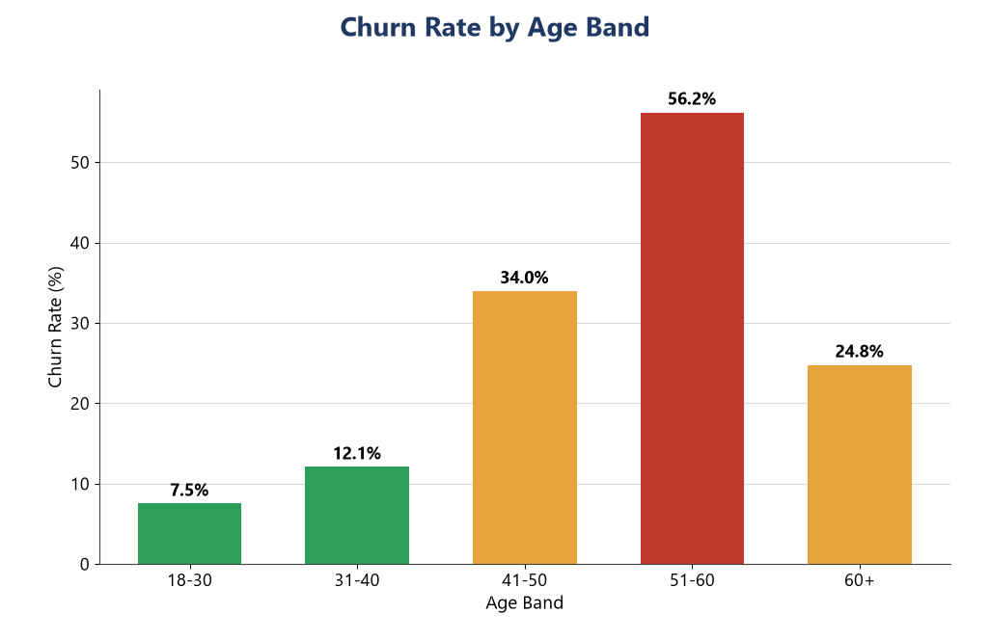
Figure 17 — Churn accelerates with age.
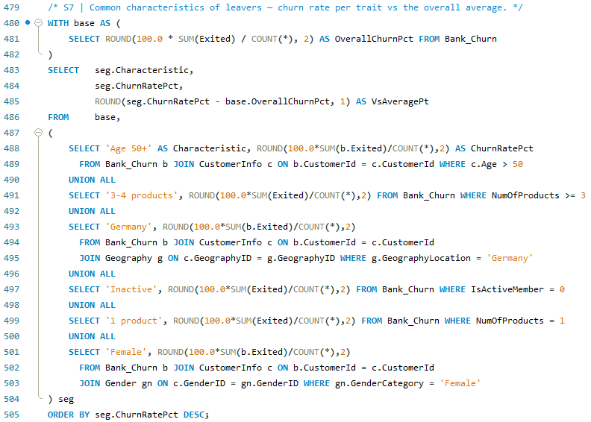Query 31 — Common characteristics of leavers

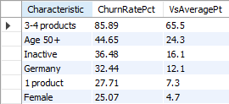
Table 28 — Common characteristics of leavers

Subjective S8 · Are Tenure, Products, Activity & Salary predictive?
Answer. Two of the four matter, two barely. NumOfProducts is the single strongest signal (7.6% → 100% across counts) and IsActiveMember is strong (~2× difference). Tenure is weak — it only spans 3–7 years and churn is flat across it — and EstimatedSalary is effectively useless (r ≈ 0 with churn and balance). A churn model should lead with products, activity, age and geography, and can down-weight tenure and salary.
Feature | Signal | Evidence | Keep in model?
NumOfProducts | Very strong | Churn 7.6% → 100% across counts | Yes — top feature
IsActiveMember | Strong | Inactive 26.9% vs active 14.3% | Yes
Tenure | Weak | Flat ~20% across 3–7 yrs | Low value
EstimatedSalary | None | r ≈ 0 with churn & balance | Drop
Table 29 — Predictive value of the four candidate features.

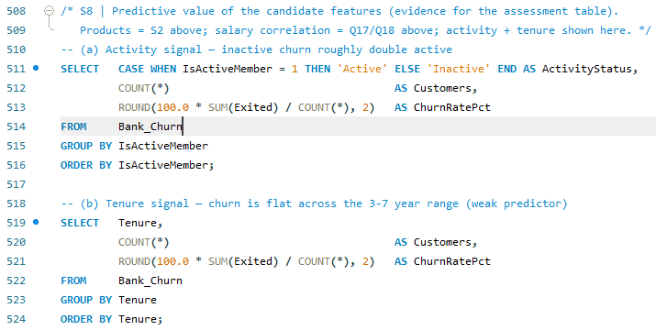Query 32 — Predictive evidence — churn by activity & tenure

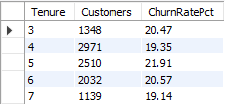
Table 30 — Predictive evidence — churn by activity & tenure

Subjective S9 · SQL segmentation by demographics & account
Answer. A demographic × account segmentation query (in the SQL file, section 'Subjective — supporting SQL') groups Geography × Gender × Age-bracket × Activity and returns counts, average balance, average salary and churn rate per micro-segment. It surfaces cells like 'Germany · Female · 50+ · Inactive' at the top of the churn table — exactly what the dashboard slicers then let managers drill into.
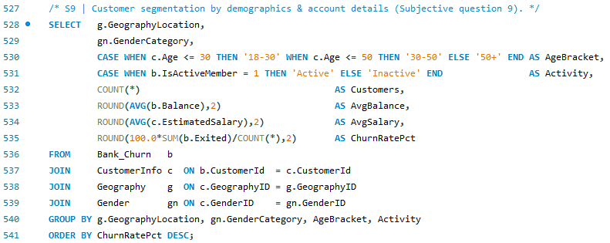Query 33 — SQL segmentation by demographics & account

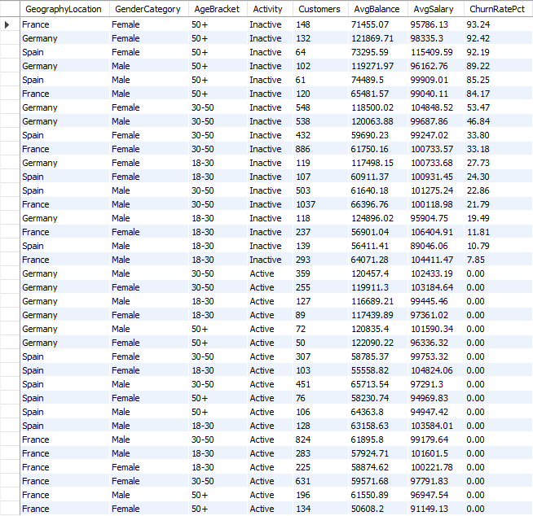Table 31 — SQL segmentation by demographics & account

Subjective S10 · Conditional formatting for at-risk customers
Answer. Build a Risk Score in Power BI and colour a customer table by it, then read the reward effect off the same table:
Risk Score = IF(NumOfProducts>=3,3,0) + IF(IsActiveMember=0,2,0) + IF(Age>50,2,0) + IF(GeographyLocation="Germany",1,0)
- Rule-based colour — Format › Cell elements › Background colour by rules: ≥5 red, 3–4 amber, <3 green — an at-a-glance watch-list.
- Data bars / icons — add a data bar on Balance and colour ExitCategory (Exit = red).
- Reward impact — today card-holders and non-holders differ by only 0.6 pt (Q9); once a rewards flag exists, compare retention of rewarded vs non-rewarded holders to measure true lift.

Subjective S11 · Churn per year, and strategies to cut it
Answer. Churn is a steady one-in-five, not a spike: 20.37% overall and 19.3% / 22.4% / 20.2% / 19.9% across 2016–2019. The likely leavers are multi-product (3–4), 50+, inactive, German and female.

Strategies to reduce churn:
- Deepen to a second product — move the single-product majority (the biggest churn volume) toward the 2-product sweet spot.
- Audit 3–4-product churn — 82–100% churn is a red flag for mis-selling, hidden fees or forced bundling.
- Re-engage on inactivity — trigger nudges and RM calls the moment a customer goes inactive.
- Germany retention taskforce — protect high-balance German customers with dedicated service and competitive rates.
- 50+ life-stage programme — pension and wealth-transfer products for the highest-churn age group.
- Predictive watch-list — operationalise the risk score for prioritised, proactive outreach.
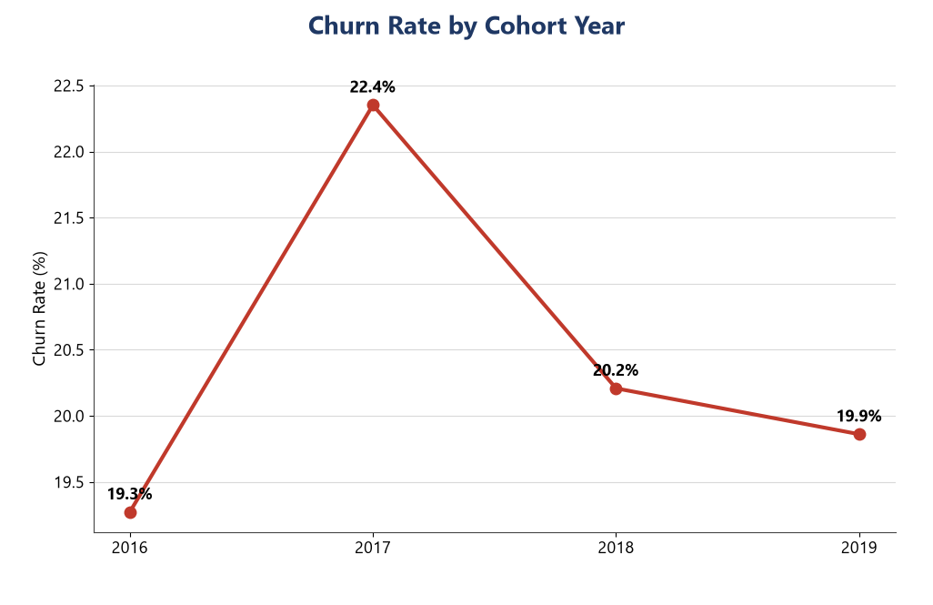
Figure 18 — Churn rate by cohort year — broadly stable near 20%.
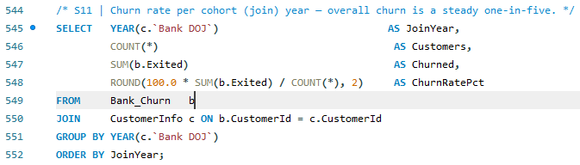Query 34 — Churn per year, and strategies to cut it

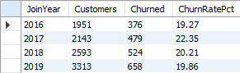
Table 32 — Churn per year, and strategies to cut it

Subjective S12 · Dashboard with KPIs and a slicer
Answer. The delivered Power BI dashboard puts it on one interactive view — a KPI band (total customers, churn rate, active %, average balance, average credit score and more) over churn broken down by product, age, region, gender, activity and credit band, with Region, Gender, Age and Product slicers filtering every visual. Build steps and all DAX are in the Power BI Build Guide.
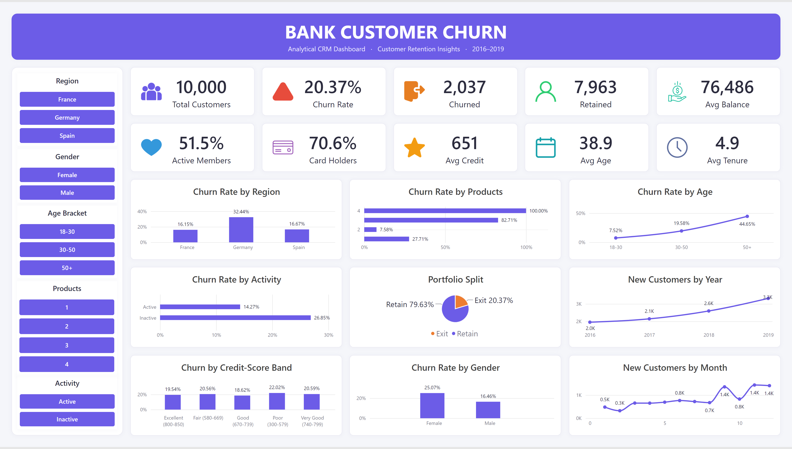
Figure 19 — Bank Customer Churn — the interactive Power BI dashboard delivered for this project.

Subjective S13 · Approach if no questions were given
Answer. I would run the CRISP-DM cycle end to end:
- Business understanding — frame the goal (cut churn, protect value) and agree the KPI and target.
- Data understanding — profile every table: grain, keys, ranges, missing values and anomalies.
- Data preparation — consolidate to a clean star schema and fix issues like the IsActiveMember contradiction.
- Analysis & modelling — test every attribute against churn, rank the drivers and segment.
- Evaluation — quantify value-at-risk (churn × balance) and validate across cohorts.
- Deployment — ship a dashboard plus a prioritised action list and a churn-risk watch-list.

