
Royal Challengers Bangalore
IPL Strategy & Mega-Auction Analytics
A data-driven blueprint for picking top-performing, value-for-money players
SQL analysis executed in MySQL Workbench 8.0 | Charts built in Microsoft Excel
Dataset: IPL ball-by-ball, seasons 2013-2016 | RCB Team_Id = 2

Executive Summary
Royal Challengers Bangalore go into the 2017 mega-auction chasing a first title. This report interrogates four seasons of ball-by-ball data (2013-2016) to answer the brief's objective and subjective questions and to convert the findings into a concrete buying strategy. Every query was run in MySQL Workbench; the result grids are shown as screenshots, and each visualisation is a native Microsoft Excel chart built from the same query output.
Headline findings:
- RCB score fast but leak at the death - they bat at an 8.37 run-rate (league 7.70) yet concede 9.76 runs/over in overs 16-20, the single clearest weakness.
- Chinnaswamy is a batting fortress - RCB win 59.3% at home vs 45.5% away; the squad must be built to win high-scoring games.
- Toss is not destiny, but chasing helps - electing to field wins 55.6% vs 43.0% batting first, and the effect swings heavily by venue.
- Buy proven two-way value - genuine all-rounders and specialist death bowlers are the scarce assets that fix RCB's biggest gap.

Data & Methodology
The relational schema contains 20 tables. The five that drive the analysis are Ball_by_Ball (60,223 deliveries), Matches (255), Wicket_Taken (2,943), Extra_Runs (3,110) and Player (469), linked through dimension/look-up tables. Batsman runs come from Ball_by_Ball.Runs_Scored; extras from Extra_Runs; balls faced for strike rate exclude wides; bowler wickets count only bowler-credited dismissals. All queries were authored for MySQL 8 (INFORMATION_SCHEMA, CTEs, window functions) and executed in MySQL Workbench; the full script is ipl_solution.sql.

Database Schema
The dataset is a normalised star schema of 20 tables. A core of six fact tables records every delivery and match; these link out to master tables (Player, Team, Venue, Season) and to a ring of look-up tables that resolve coded ids to readable labels. RCB is Team_Id 2 throughout.
Table | Keys (PK / FK) | Role in the analysis
FACT & TRANSACTION TABLES · THE EVENTS BEING MEASURED
Ball_by_Ball | PK Match_Id, Over_Id, Ball_Id, Innings_No  FK Striker, Non_Striker, Bowler → Player; Team_Batting, Team_Bowling → Team | Ball-level fact — 60,223 deliveries; carries Runs_Scored, striker, bowler and both teams.
Batsman_Scored | PK Match_Id, Over_Id, Ball_Id, Innings_No | Runs off the bat for each delivery (1:1 with Ball_by_Ball).
Extra_Runs | PK Match_Id, Over_Id, Ball_Id, Innings_No  FK Extra_Type_Id → Extra_Type | Extras conceded per delivery — 3,110 rows.
Wicket_Taken | PK Match_Id, Over_Id, Ball_Id, Innings_No  FK Player_Out → Player; Kind_Out → Out_Type | Dismissals per delivery — 2,943 rows; feeds bowler-credited wickets.
Matches | PK Match_Id  FK Season_Id → Season; Venue_Id → Venue; Team_1, Team_2, Toss_Winner, Match_Winner → Team; Toss_Decide → Toss_Decision; Man_of_the_Match → Player; Win_Type → Win_By | One row per match — 255 games; result, toss, venue and season.
Player_Match | PK Match_Id, Player_Id  FK Player_Id → Player; Match_Id → Matches; Team_Id → Team; Role_Id → Rolee | Bridge — the line-up of players in each match.
MASTER / DIMENSION TABLES · THE ENTITIES BEING ANALYSED
Player | PK Player_Id  FK Batting_hand → Batting_Style; Bowling_skill → Bowling_Style; Country_Name → Country | Player master — 469 players; DOB, batting/bowling style, country.
Team | PK Team_Id | Franchise master — Team_Name (RCB = Team_Id 2).
Venue | PK Venue_Id  FK City_Id → City | Grounds — Venue_Name and host city.
Season | PK Season_Id  FK Orange_Cap, Purple_Cap, Man_of_the_Series → Player | Seasons 2013–2016 — Season_Year and award winners.
LOOK-UP / REFERENCE TABLES · CODES RESOLVED TO LABELS
Batting_Style | PK Batting_Id | Batting-hand codes (right / left-hand bat).
Bowling_Style | PK Bowling_Id | Bowling-style codes (e.g. right-arm medium).
Extra_Type | PK Extra_Id | Extra categories — wide, no-ball, bye, leg-bye.
Out_Type | PK Out_Id | Dismissal kinds — bowled, caught, lbw, run-out…
Toss_Decision | PK Toss_Id | Toss choice — bat or field.
Win_By | PK Win_Id | Result-margin type — runs or wickets.
Rolee | PK Role_Id | Player match-role — captain, keeper, player.
City | PK City_Id  FK Country_id → Country | Cities that host the venues.
Country | PK Country_Id | Player and umpire nationalities.
Umpire | PK Umpire_Id  FK Umpire_Country → Country | Match officials.
PK = primary key FK = foreign key → referenced table. Bold red table names are the five that drive the analysis.

Part A - Objective Questions

Q1. Data types of the columns in ball_by_ball
Approach. query INFORMATION_SCHEMA.COLUMNS filtered to the table; all eleven columns are integer identifiers plus the integer Runs_Scored.
SQL code snippet:
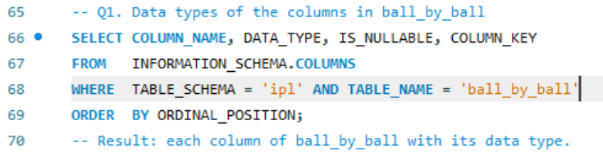
Query output (result grid):
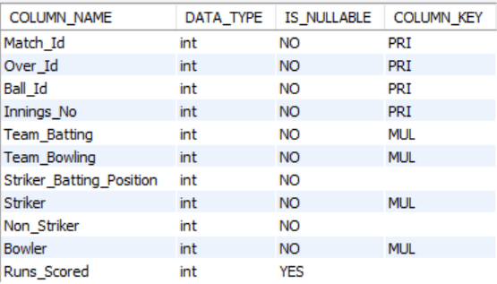
Answer. 11 columns - Match/Over/Ball/Innings ids, teams, striker/non-striker/bowler and Runs_Scored - all INTEGER; Runs_Scored is nullable.

Q2. Total runs scored by RCB in the 1st season (with extras)
Approach. sum off-the-bat runs where Team_Batting = RCB for the earliest season, then add extras from Extra_Runs joined back to those deliveries.
SQL code snippet:
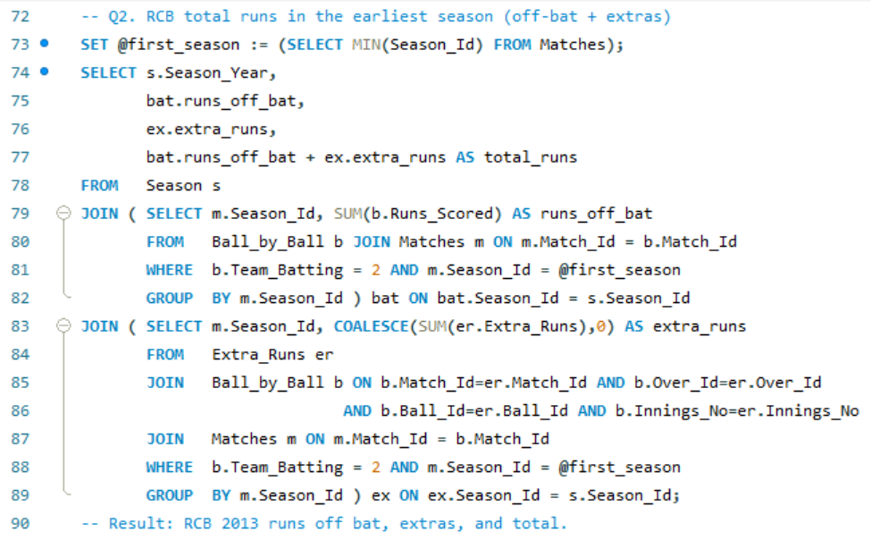
Query output (result grid):
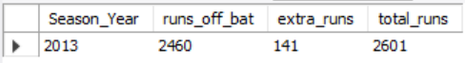
Answer. RCB 2013: 2,460 off the bat + 141 extras = 2,601 total runs (the dataset's earliest season is 2013).

Q3. How many players were older than 25 during season 2014?
Approach. restrict to players who actually featured in 2014 (via Player_Match), then keep those born more than 25 years before the season start.
SQL code snippet:
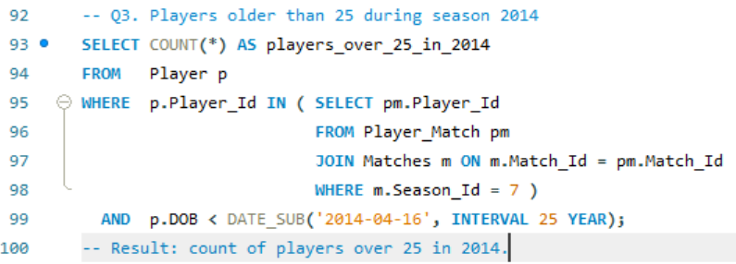
Query output (result grid):
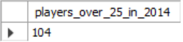
Answer. 104 players who featured in season 2014 were older than 25 (of 152 who played that season).

Q4. How many matches did RCB win in 2013?
Approach. count matches in season-year 2013 whose Match_Winner is RCB.
SQL code snippet:
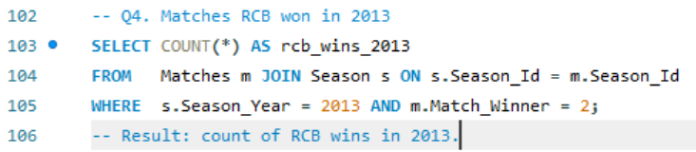
Query output (result grid):
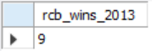
Answer. RCB won 9 matches in 2013.

Q5. Top 10 batsmen by strike rate (last 4 seasons)
Approach. strike rate = 100 x runs / balls faced (wides excluded), with a 200-ball qualification so tiny samples do not distort the ranking.
SQL code snippet:
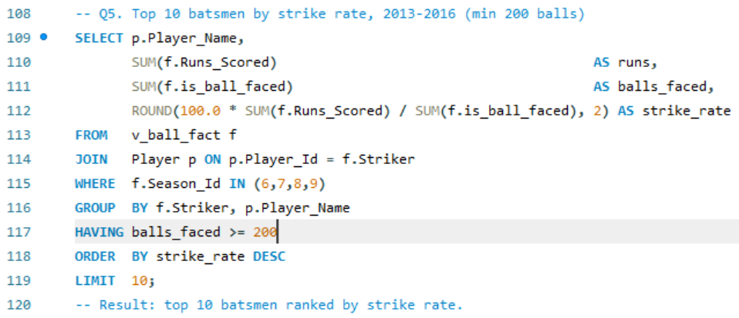
Query output (result grid):
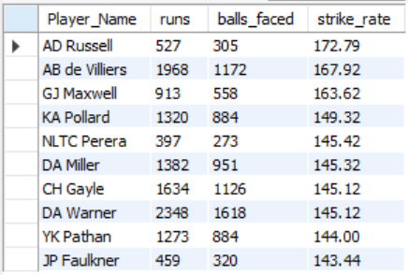
Excel visualisation
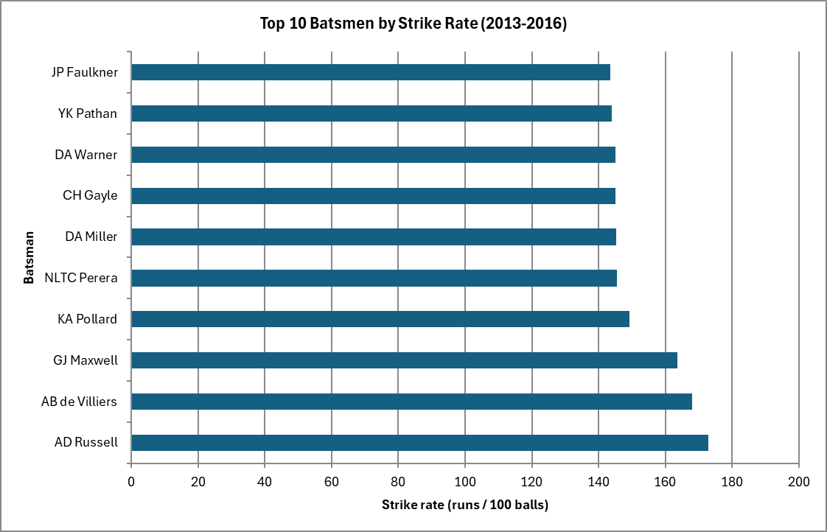
Answer. Highest strike rate: AD Russell (172.79), ahead of AB de Villiers (167.92) and GJ Maxwell (163.62).

Q6. Average runs scored by each batsman (all seasons)
Approach. runs per innings = total runs / innings batted; the table shows the leading run-getters.
SQL code snippet:
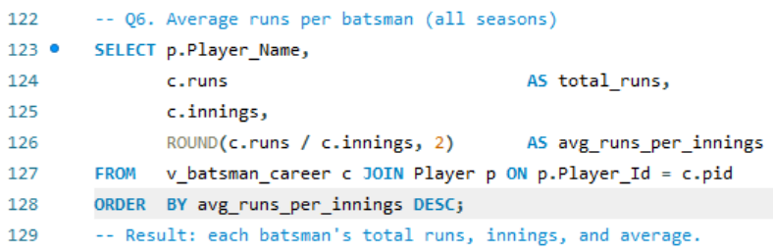
Query output (result grid):
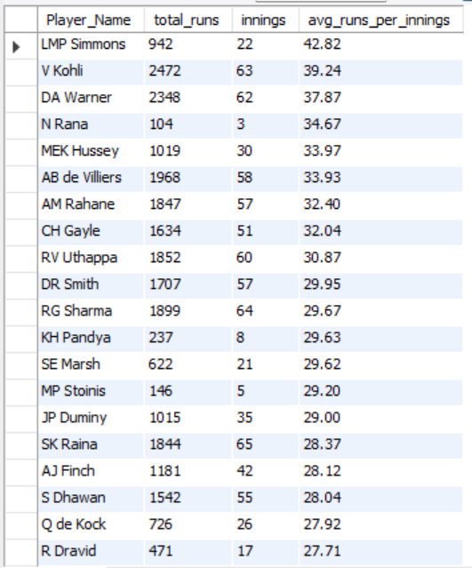
Answer. Top runs-per-innings: LMP Simmons 42.8, V Kohli 39.2, DA Warner 37.9; overall mean of averages = 12.50 across 259 batsmen.

Q7. Average wickets taken by each bowler (all seasons)
Approach. bowler-credited wickets / innings bowled; the volume leader is DJ Bravo (75 wickets).
SQL code snippet:
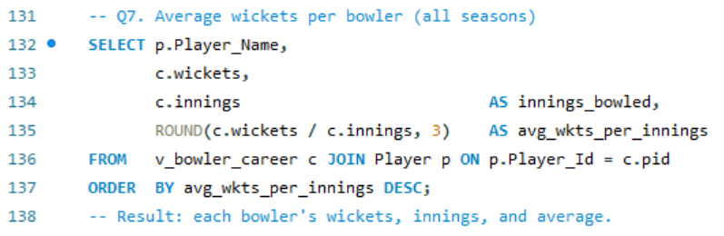
Query output (result grid):
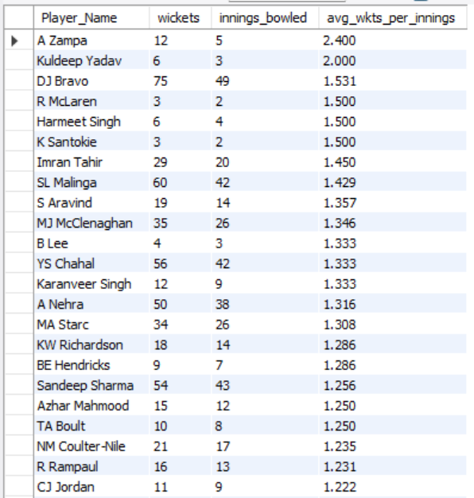
Excel visualisation
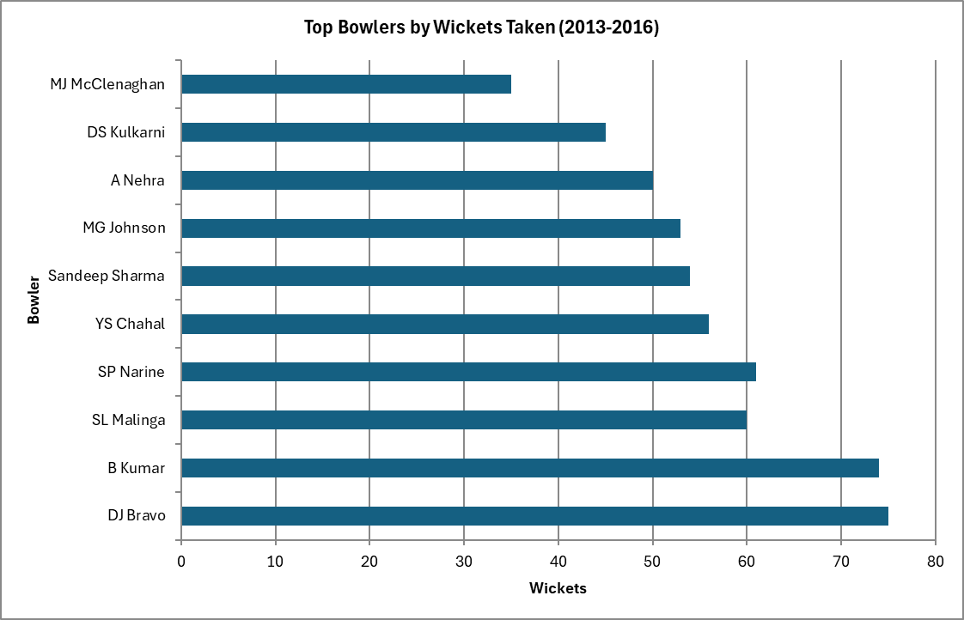
Answer. DJ Bravo leads on volume (75 wickets); overall mean of bowler averages = 0.729 wickets/innings across 200 bowlers.

Q8. Players above the overall average in BOTH runs and wickets
Approach. compute each player's average runs and average wickets (min 10 innings each), then keep those clearing both league-wide averages - the definition of a genuine all-rounder.
SQL code snippet:
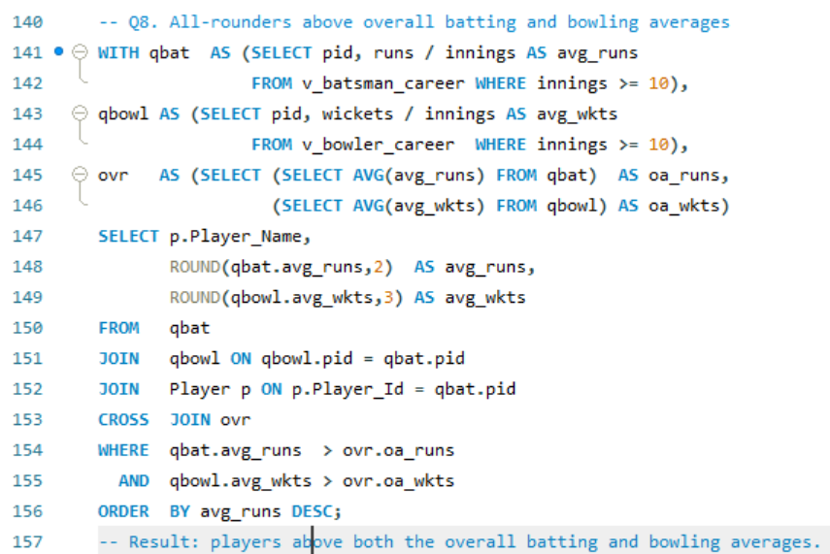
Query output (result grid):
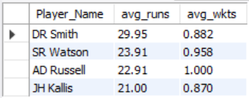
Answer. 4 genuine all-rounders clear both bars: DR Smith, SR Watson, AD Russell and JH Kallis (overall bars ~18.83 runs / 0.865 wkts).

Q9. rcb_record - RCB wins & losses by venue
Approach. a CREATE TABLE ... AS SELECT materialises RCB's win/loss/played counts per venue.
SQL code snippet:
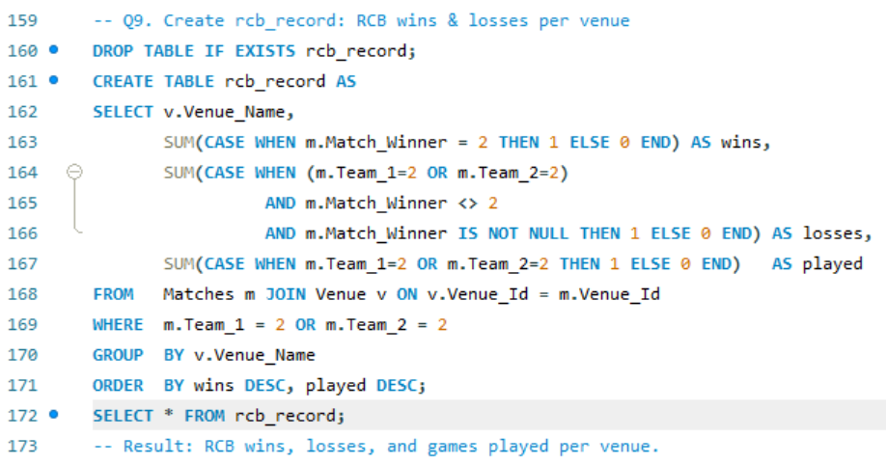
Query output (result grid):
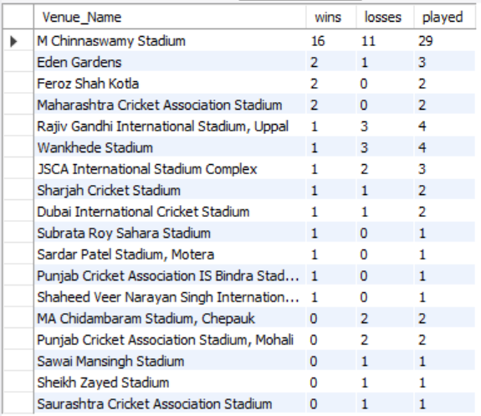
Excel visualisation
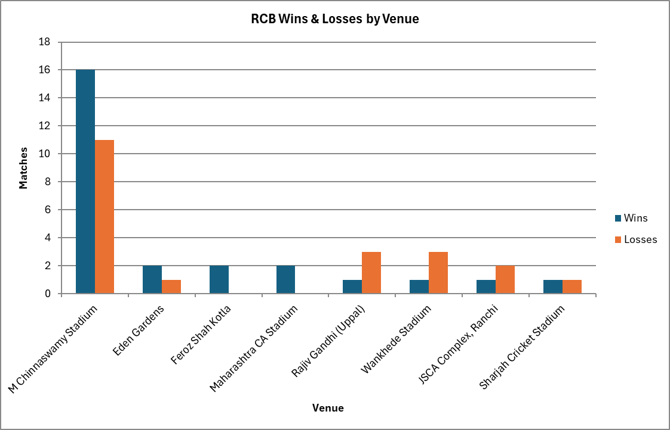
Answer. RCB played across 18 venues; the strongest is M Chinnaswamy Stadium (16 wins, 11 losses in 29) - the home fortress.

Q10. Impact of bowling style on wickets taken
Approach. attribute each bowler-credited wicket to the bowler's registered style; pace dominates volume.
SQL code snippet:
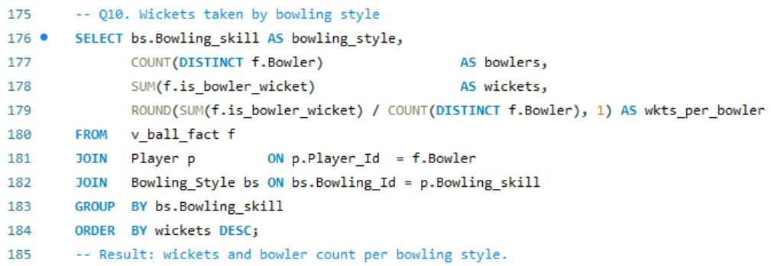
Query output (result grid):
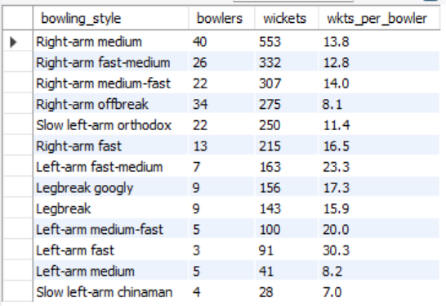
Excel visualisation
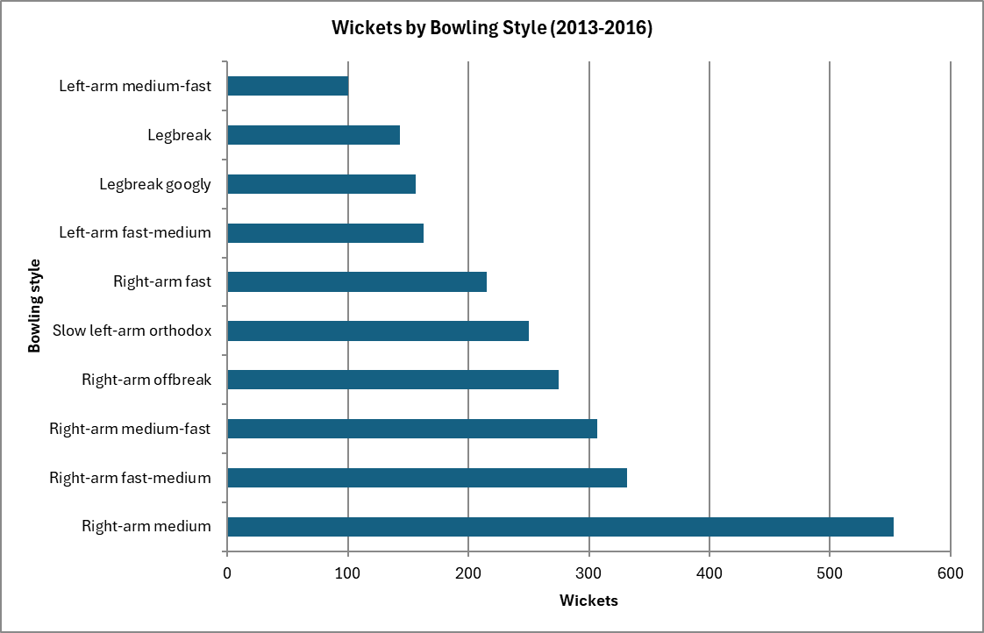
Answer. Right-arm medium takes the most wickets (553); pace out-strikes spin, and left-arm fast is the most efficient per bowler.

Q11. Is each season better than the previous one? (runs & wickets)
Approach. aggregate RCB's team runs (incl. extras) and wickets per season, then compare with the prior year using the LAG() window function to label Better / Worse / Mixed.
SQL code snippet
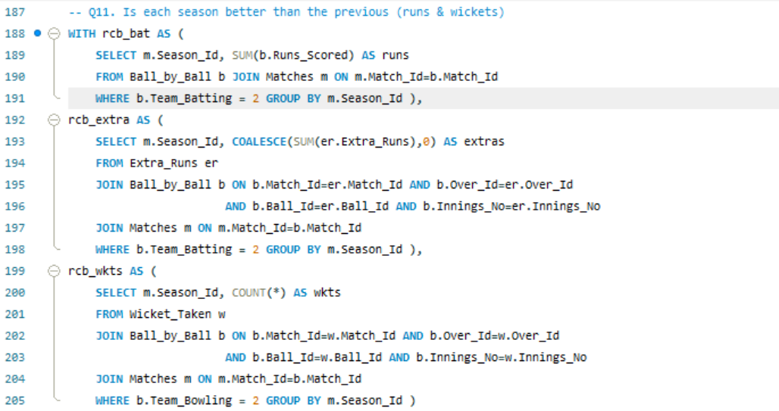
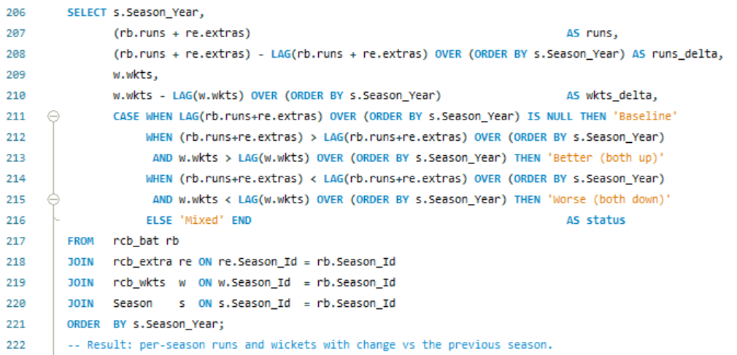

Query output (result grid):
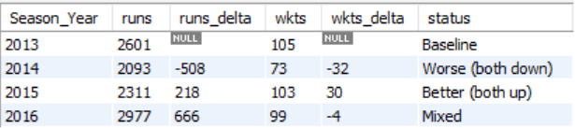
Excel visualisation
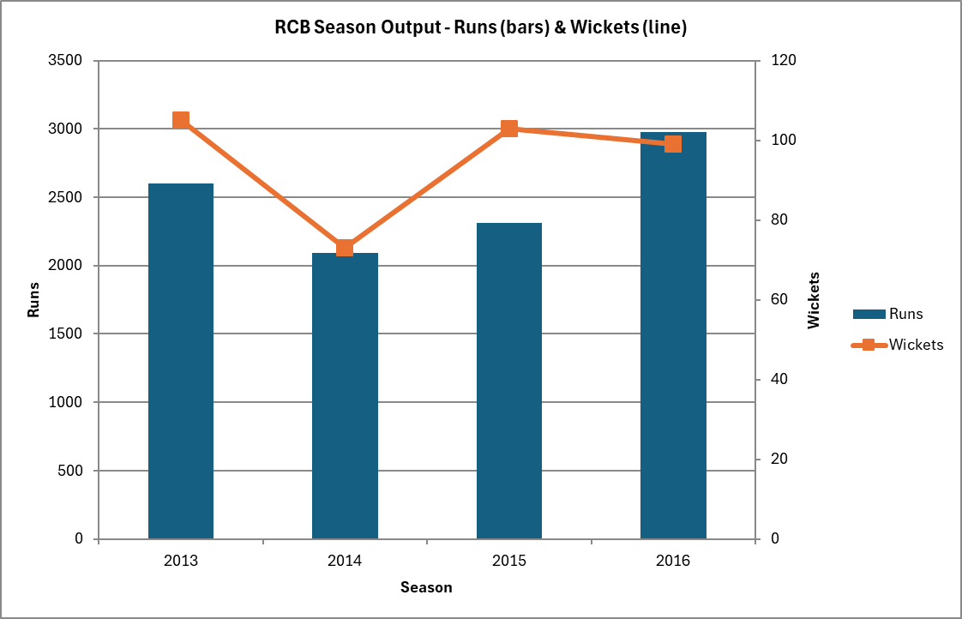
Answer. 2013 baseline; 2014 Worse (both down); 2015 Better (both up); 2016 Mixed (runs up, wickets flat) - computed with LAG().

Q12. Additional KPIs for team strategy
Approach. beyond runs and wickets, the KPIs that win T20s are scoring tempo and phase control - boundary %, dot %, run-rate, and phase-wise batting run-rate vs bowling economy.
SQL code snippet:
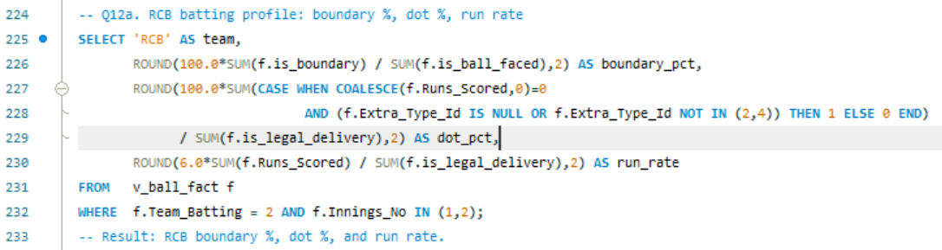
Query output (result grid):
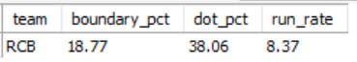
Excel visualisation
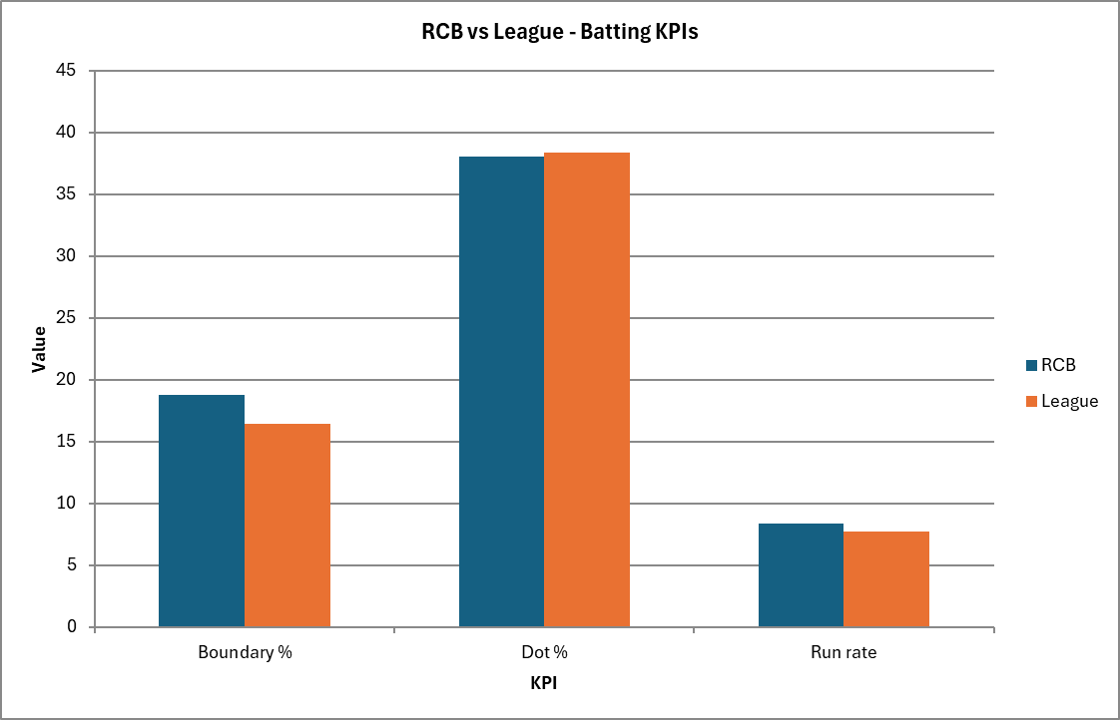
Answer. RCB boundary% 18.77 vs league 16.39; run-rate 8.37 vs 7.70. RCB out-hit the league.

Phase KPIs - batting run-rate vs bowling economy (powerplay / middle / death)
SQL code snippet:
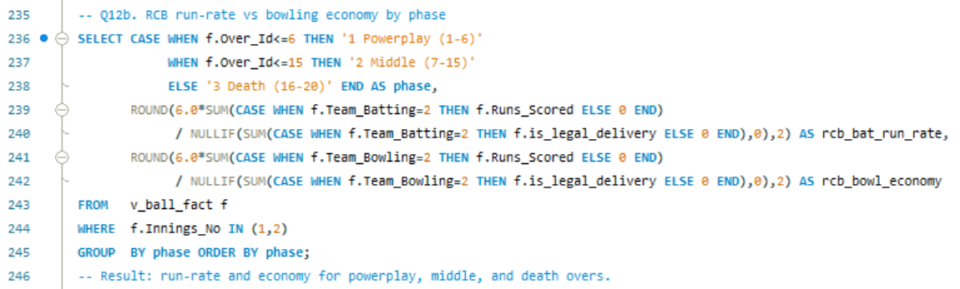
Query output (result grid)
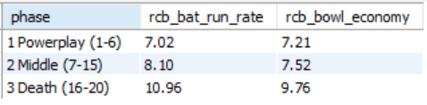
Excel visualisation
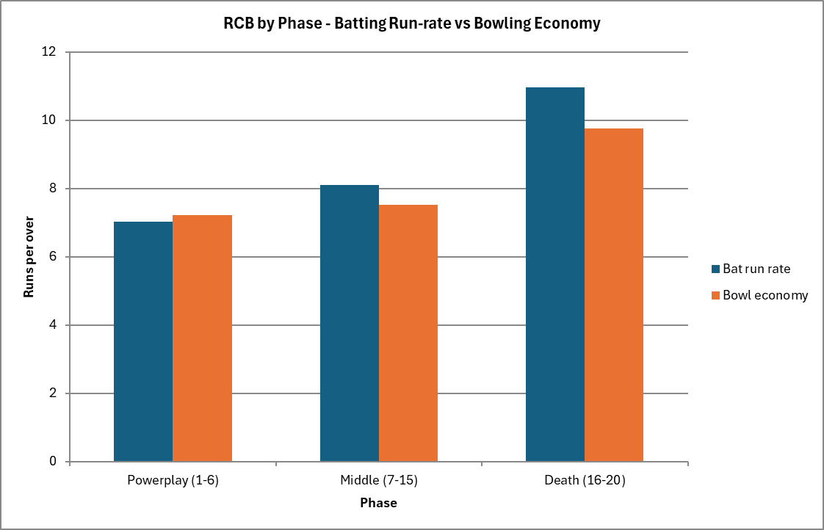
Answer. RCB accelerate through the innings (10.96 rpo at the death) but concede 9.76 rpo in the same phase - the death-overs economy is the key weakness.

Q13. Average wickets per bowler at each venue (ranked)
Approach. average bowler-credited wickets per venue, ranked within each ground with RANK(). The schema has no gender attribute, so the brief's "rank the gender" is not answerable; ranking bowlers within a venue is delivered instead.
SQL code snippet
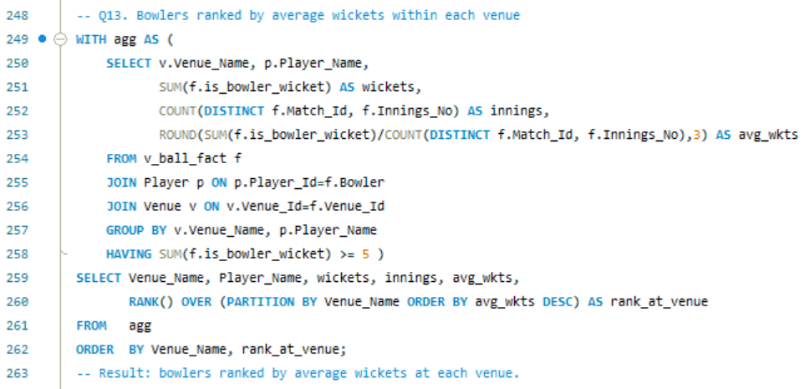
Query output (result grid):
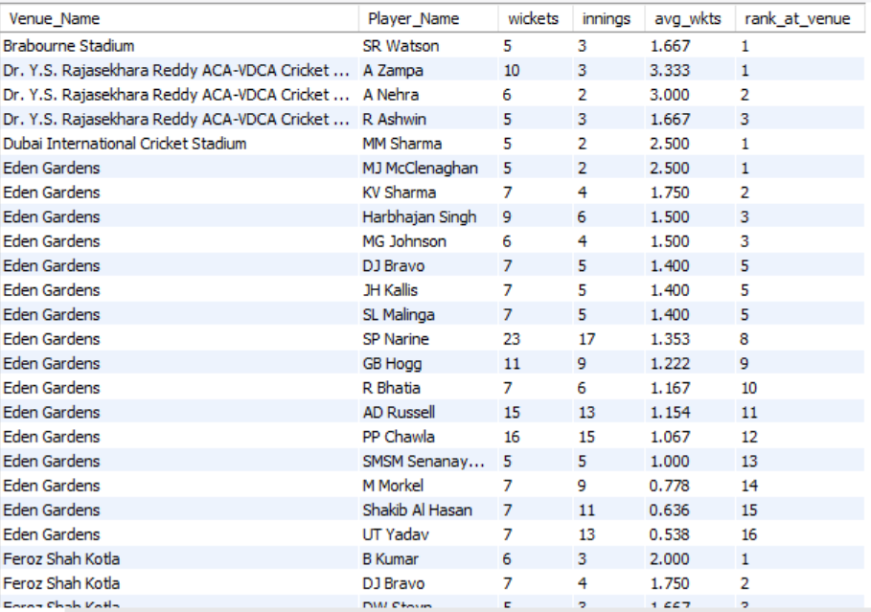
Answer. RANK() orders bowlers within each venue by average wickets (e.g., at Eden Gardens KV Sharma ranks 1st). The dataset has no gender column, so "rank the gender" cannot be computed.

Q14. Which players performed consistently across seasons?
Approach. batsmen who scored 250+ in every one of the four seasons; a low spread-ratio (range / mean) marks the most metronomic. Best read as a multi-season chart.
SQL code snippet:
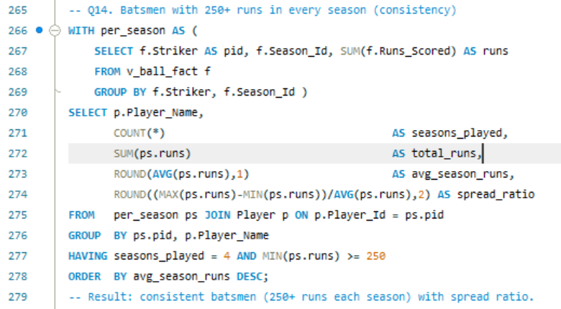
Query output (result grid):
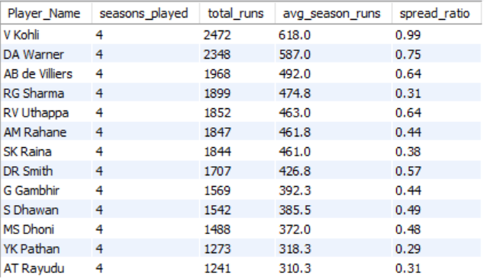
Excel visualisation
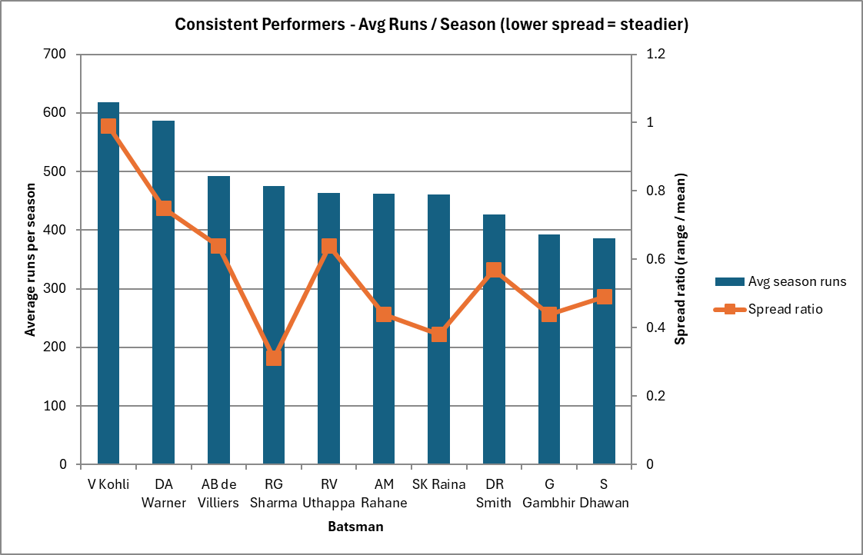
Answer. Consistently strong: V Kohli, DA Warner, AB de Villiers, RG Sharma (Rohit is the steadiest, spread ratio 0.31).

Q15. Players suited to specific venues (venue specialists)
Approach. batsman x venue run totals surface clear hotspots; only combinations with 250+ runs are kept.
SQL code snippet:
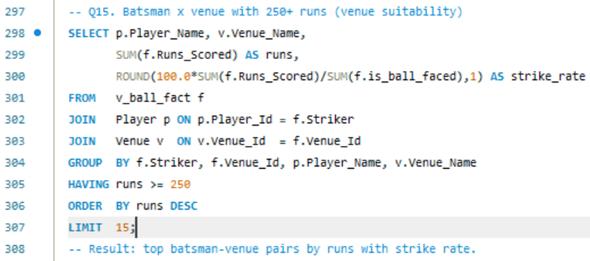
Query output (result grid)
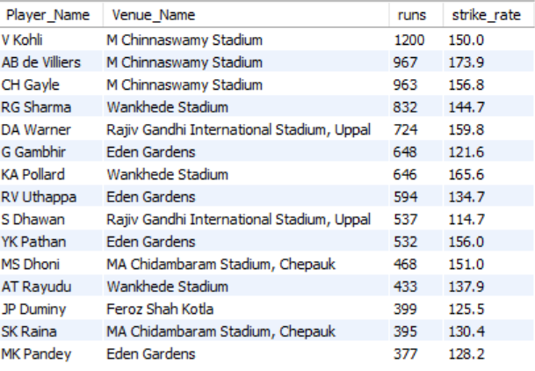
Excel visualisation
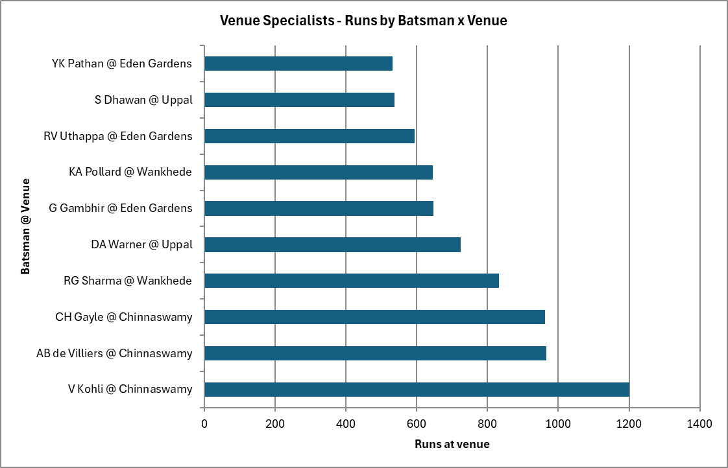
Answer. Clear venue hotspots exist - e.g., V Kohli at M Chinnaswamy Stadium (1,200 runs), AB de Villiers (967) and CH Gayle (963) at the same ground.

Part B - Strategy & Subjective Analysis

1. How does the toss decision affect results - and is it venue-specific?
Approach. compare the toss winner's success when electing to bat vs field, then note the venue spread.
SQL code snippet:
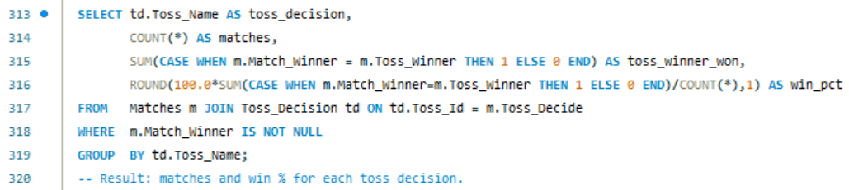
Query output (result grid):
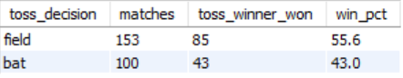
Excel visualisation
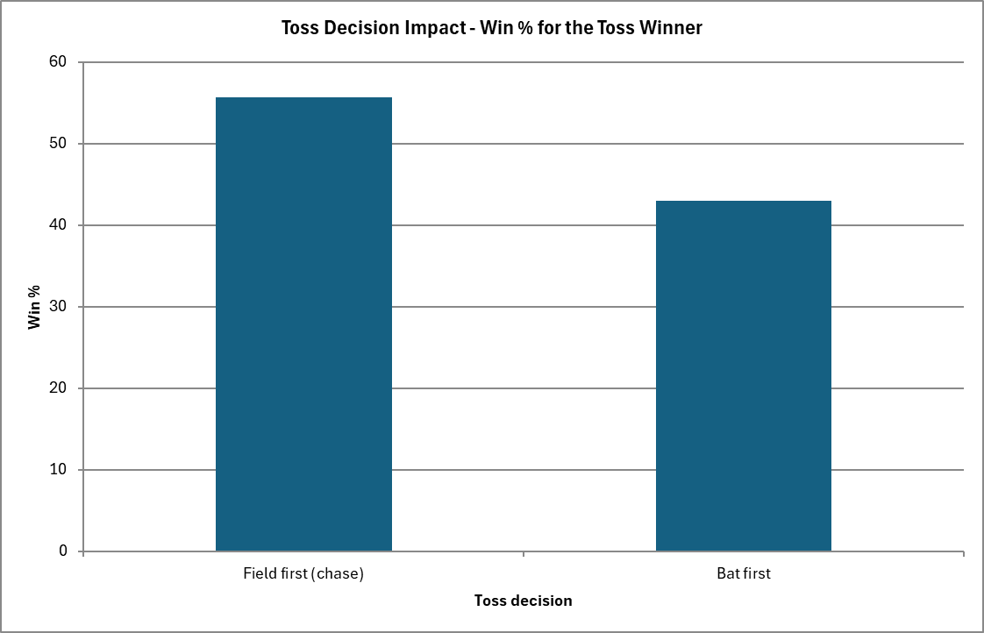
Answer. Electing to field (chase) wins 55.6% vs 43.0% batting first; the effect swings widely by venue (~35% at Uppal to ~62% at Pune/Chepauk), so the call must be venue-specific.

2 & 6. Best-fit players and what to do before the mega-auction
RCB's home ground rewards fearless stroke-play and punishes expensive death bowling, so the buying priorities follow directly from the data: an anchor-plus-accelerator top order (strike rate >= 140: AB de Villiers, CH Gayle, V Kohli, DA Warner, GJ Maxwell); two death-over specialists to plug the 9.76 rpo leak (Malinga/Steyn/Bhuvneshwar profiles); and one elite all-rounder (Watson/Russell/Jadeja) to balance the XI. Spend big on 3-4 match-winners and fill the rest with value picks.

3. Parameters that should drive player selection
- Batting: strike rate and boundary % (impact), plus average and balls faced (reliability & volume).
- Bowling: economy - especially death-overs economy - and wickets per innings, not just raw wickets.
- Consistency: performs every season (low spread ratio), not one purple patch.
- Role/phase and venue fit, and value for money (performance per unit auction spend).

4. Versatile players who contribute with bat AND ball
Approach. filter for genuine two-way volume (500+ runs and 25+ wickets) to isolate the all-rounders who let RCB field a balanced XI.
SQL code snippet
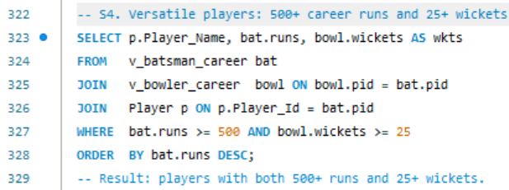
Query output (result grid):
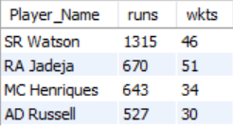
Excel visualisation
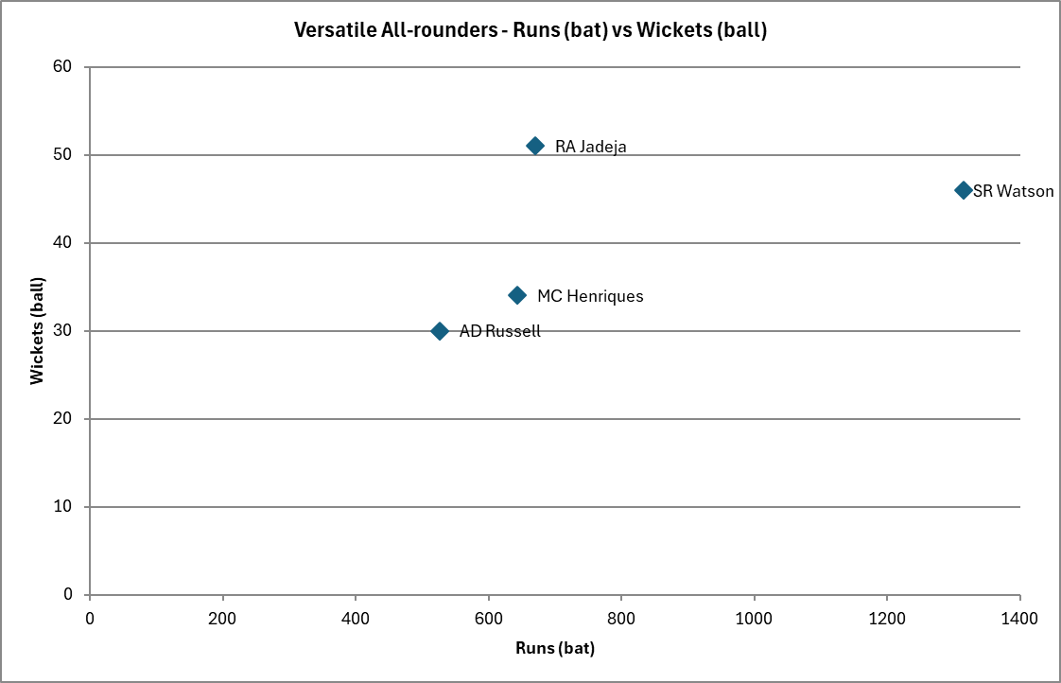
Answer. Elite two-way value: SR Watson (1,315 runs / 46 wkts), RA Jadeja (670 / 51), MC Henriques (643 / 34) and AD Russell (527 / 30).

5. Players whose presence lifts team performance (influence)
Approach. Man-of-the-Match awards are a fair proxy for match-defining influence; the leaders are the consistent match-winners to build around and retain.
SQL code snippet
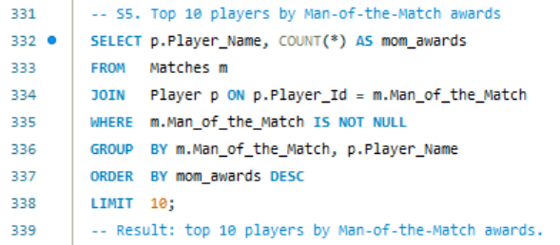
Query output (result grid)
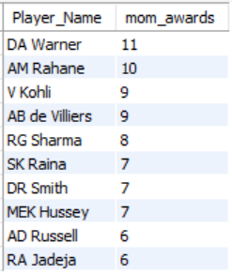
Excel visualisation
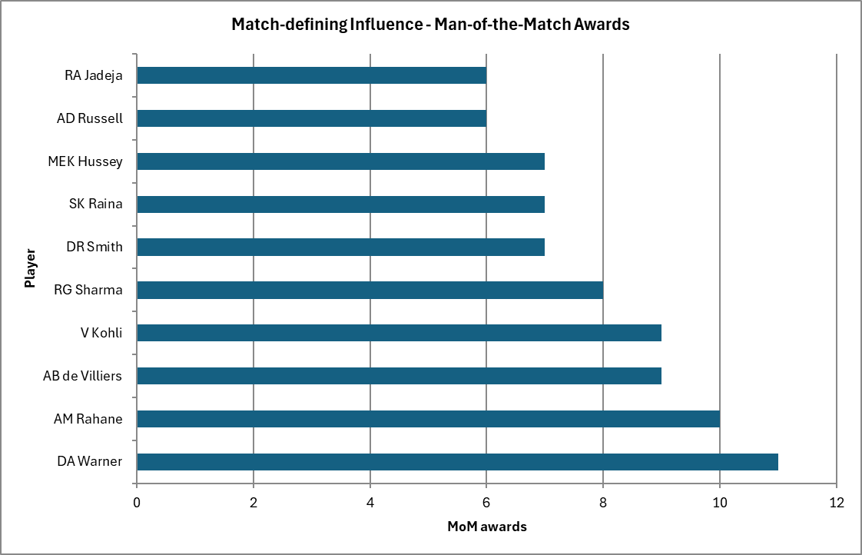
Answer. Match-defining influence leaders: DA Warner (11), AM Rahane (10), AB de Villiers (9) and V Kohli (9).

8. Home-ground advantage and how to maximise it
Approach. compare RCB's win rate at Chinnaswamy vs away/neutral grounds.
SQL code snippet:
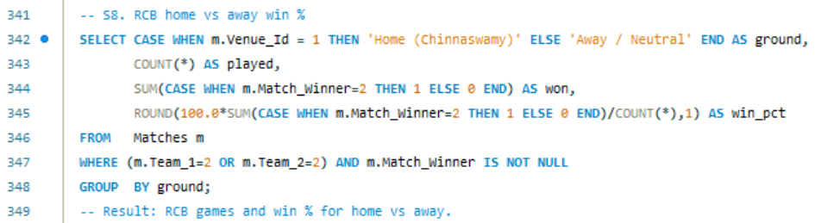
Query output (result grid)
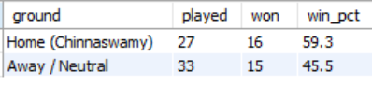
Excel visualisation
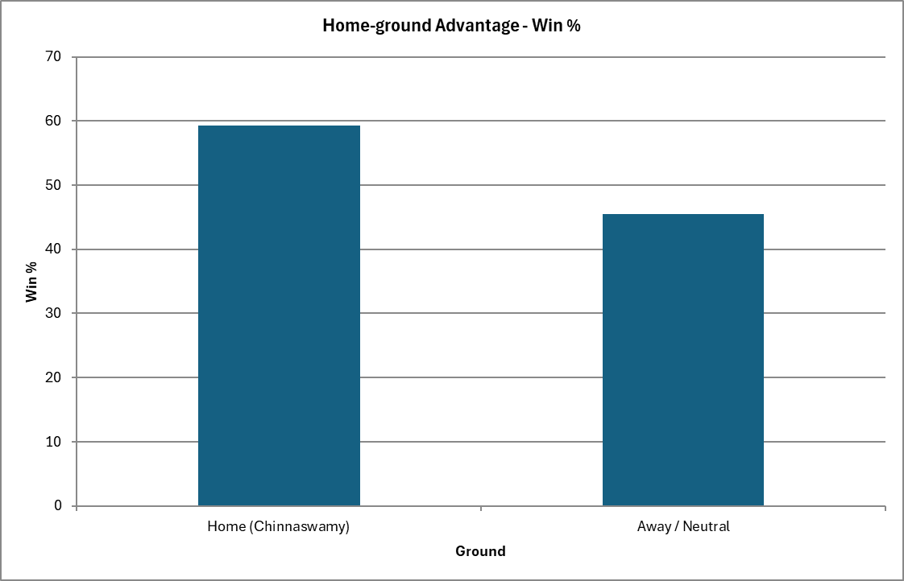
Answer. RCB win 59.3% at home vs 45.5% away - a decisive edge to weight the squad toward power hitters and cutter/spin bowlers who exploit the short square boundaries.

9. Why hasn't RCB won a trophy? A data view
Approach. summarise RCB's per-season record; the recurring theme is elite batting undermined by expensive bowling, especially at the death.
SQL code snippet:
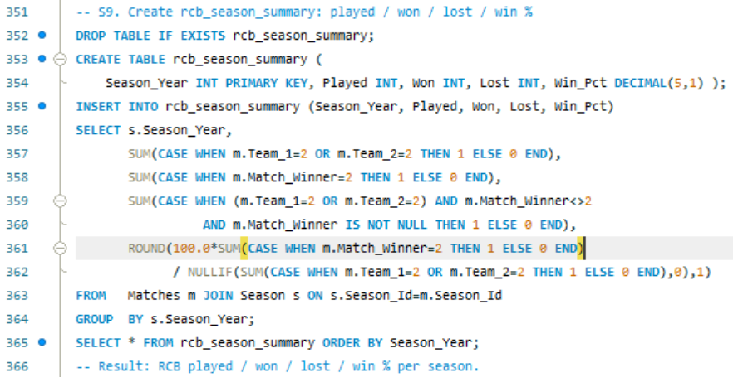
Query output (result grid):
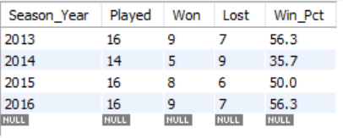
Excel visualisation
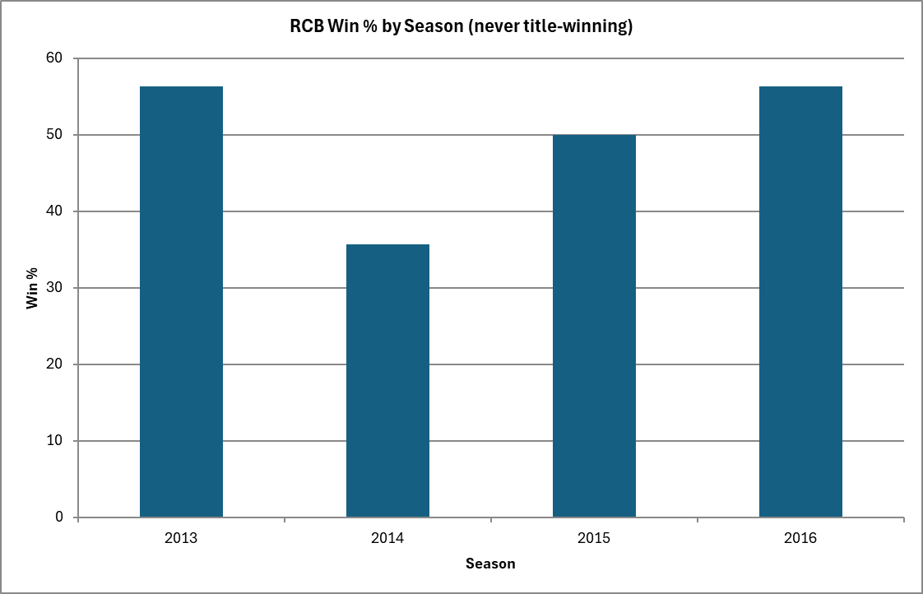
Answer. Win% 2013=56.3, 2014=35.7, 2015=50.0, 2016=56.3 - competitive but never the league's top side. Titles require closing games, and RCB's death bowling repeatedly failed to defend.

11. Data-correction query (Delhi franchise renaming)
Approach. in this normalised schema team names live once in the Team table (matches reference Team_Id), so the correct fix updates that single row.
SQL code snippet
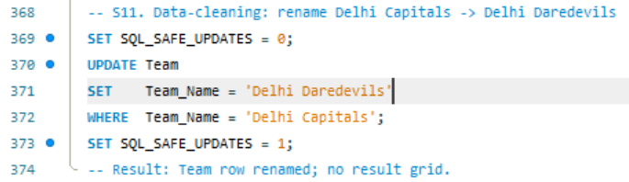
Answer. One row in Team is corrected. MySQL Workbench's default safe-update mode blocks an UPDATE whose WHERE is not on a key column, so SQL_SAFE_UPDATES is toggled off for the statement. If a denormalised text column existed (e.g., Matches.Opponent_Team), the literal fix would be UPDATE Matches SET Opponent_Team='Delhi_Daredevils' WHERE Opponent_Team='Delhi_Capitals'.

Recommendations - The RCB Auction Blueprint
- Win the toss? Bowl. Default to chasing, but override at venues where batting first wins; set 180+ as par when batting first at Chinnaswamy.
- Fix the death overs first - invest in two specialist death bowlers; this is the highest-leverage spend.
- Build the batting around power + consistency - retain the Kohli-de Villiers-Gayle core profile; add one explosive finisher (SR >= 150).
- Buy one balancing all-rounder to lengthen the batting and add a sixth bowling option.
- Exploit the fortress - skew recruitment to players who thrive on flat, high-scoring pitches.
- Spend on match-winners, save on depth - concentrate budget on 3-4 game-changers.
Bottom line: RCB do not need to score more - they need to concede less when it matters. Pair the league's best batting with even league-average death bowling and the title math changes.

