How to Setup Project in your Local System:
Prerequisites:
Install Required Tools:
Docker and Docker Compose: Install Docker
Git: Install Git
Any code editor (e.g. VSCode, IntelliJ)
Get Access Credentials:
GitHub repository access (clone URL).
PostgreSQL database connection details (e.g., host, port, username, password, database name).
Apache Superset URL and access credentials.
Steps to Set Up the Project
1. Clone the Repository
- Open your terminal and navigate to the directory where you want the project.
Clone the GitHub repository:
git clone <repository-url>
cd <repository-folder>
- Build Jar file using command:
mvn clean install
- Go to /target folder and copy app.jar file to /docker_setup folder.
2. Build and Start Docker Containers
- Run the following commands to build and start the project:
docker compose up –d
This command will: will create two containers.
- Trello-db container to store all pulled data from trello api.
- Dataextraction-app – This is Java application which pull the data at every 10 hours.
For more Detail follow CO-AX Progress Tracker document for reference.
3. Test Connectivity to the Database
- Use a PostgreSQL client (e.g., psql or a GUI tool like pgAdmin) to connect to the PostgreSQL database.
- Test the connection with the credentials provided.
- Trouble shooting:
If connection issues arise:
Ensure the Hetzner firewall rules allow your local IP address.
Confirm the database credentials are correct.
Adding a Hetzner Server to pgAdmin 4 (PostgreSQL GUI Tool) and Managing Database Objects
Step-by-step guide for adding a Hetzner server to pgAdmin 4 and creating a database, schema, tables, views, and materialized views. Follow these instructions to set up and manage the trello-db database.
Step 1: Add Hetzner Server to pgAdmin 4
  - Open pgAdmin 4
Launch pgAdmin 4 from your system.
  - Create a New Server Connection
In the left navigation pane, right-click on Servers and select Register > Server....
  - Enter General Information
Name: Provide a recognizable name for the server, e.g., Hetzner Server.
  - Configure Connection Settings
- Navigate to the Connection tab.
- Fill in the following fields:
  - Host name/address: Enter the IP address or hostname of your Hetzner server.
  - Port: Default PostgreSQL port is 5432. Update if different.
  - Maintenance database: Use postgres (default admin database).
  - Username: Enter your PostgreSQL username (e.g., postgres).
  - Password: Enter the corresponding password.
- Check the "Save Password" box for convenience.
  - Test Connection
- Click Save.
- Expand the Servers node to verify that the connection is successful.
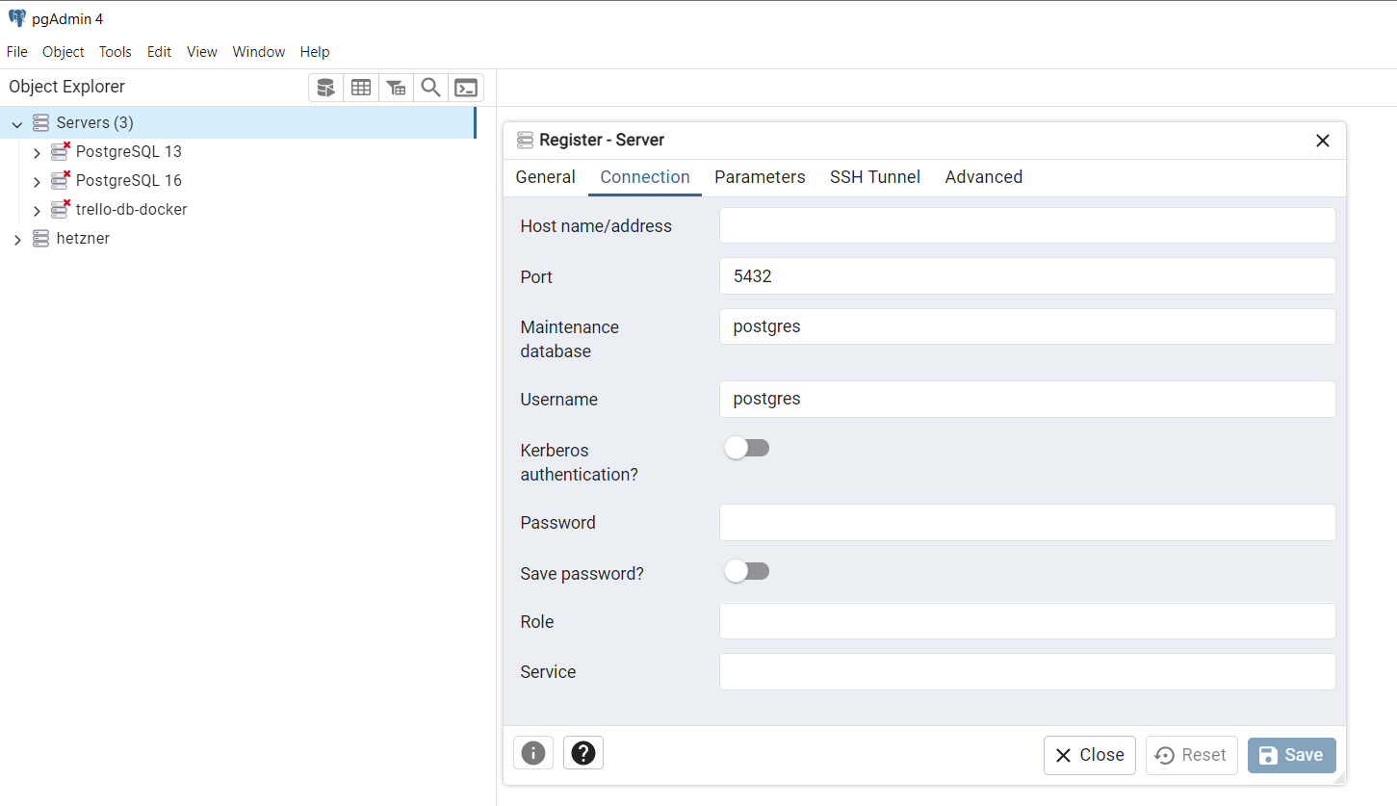

Step 2: Create the Database
2.1 Create a New Database
- Right-click on the Databases node under your Hetzner server in pgAdmin.
- Select Create > Database....
2.2 Configure Database Settings
- Database Name: Enter trello-db.
- Owner: Select the appropriate user (default is postgres).
  - Save Changes
- Click Save to create the database
Step 3: Create Tables
  - Navigate to Schemas
- Expand the trello-db node and navigate to Schemas > public.
  - Create Tables
- Right-click on Tables and select Create > Table....
  - Configure Table Settings
- Table Name: Enter name for the first table. Repeat this process for other tables.
- Add columns as needed for your data model:
Column Name: Define the column name (e.g., id, name, etc.).
Data Type: Choose the appropriate data type (e.g., INTEGER, TEXT).
Set constraints like PRIMARY KEY if necessary.
  - Save Changes
- Click Save to create each table.
Step 4: Create Views
4.1 Navigate to Views
- Expand the Schemas > public node and right-click on Views.
  - Create Views
- Select Create > View....
  - Configure View Settings
- View Name: Enter card_completion_view for the first view. Repeat for other views.
- Definition: Write the SQL query for the view.
  - Save Changes
Step 5: Create Materialized View
5.1 Navigate to Materialized Views
- Expand the Schemas > public node and right-click on Materialized Views.
  - Create Materialized View
- Select Create > Materialized View....
  - Configure Materialized View Settings
- Name: Enter card_quarterly_progress_view.
- Definition: Write the SQL query for the materialized view.
  - Save and Populate
- Click Save to create the materialized view.
- To populate the view, run:
REFRESH MATERIALIZED VIEW card_quarterly_progress_view;
Step 6: Verification
6.1 Verify Database Structure
- Expand Schemas -> public to check the presence of tables, views, and the materialized view.
6.2 Test Queries
- Run test queries to ensure tables and views are functioning as expected.
SELECT * FROM card_tab;
SELECT * FROM card_completion_view;
SELECT * FROM card_quarterly_progress_view;
PostgreSQL Database Manual Steps required:
- Refresh Materialised view which are used for charts in Apache Superset:
Go to Schemas -> Public -> Materialized Views -> card_quarterly_progress_view
Run Command: REFRESH MATERIALIZED VIEW public.card_quarterly_progress_view

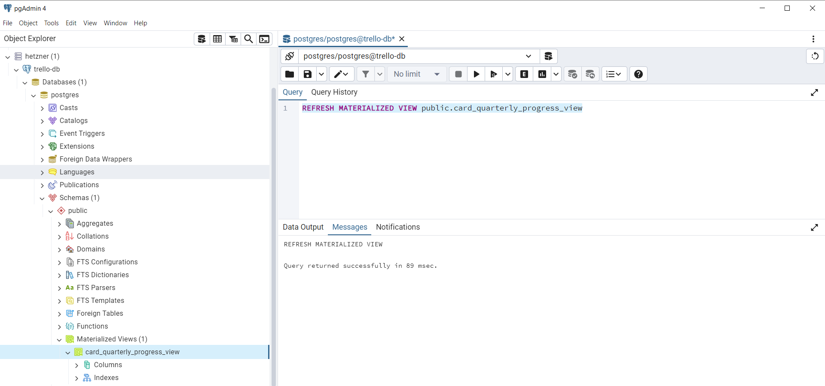

- While new User is register in Trello SSP Mother Board:
Go to Schemas -> Public -> Tables -> card_tab (table) -> (Column) join_date add date manually for newly added company.
