Assignment – 1

Task-1: - Prepare a document and with the following screenshot

Report View

Data View

Model View

Power Query Editor

Advance Editor

Report View: -

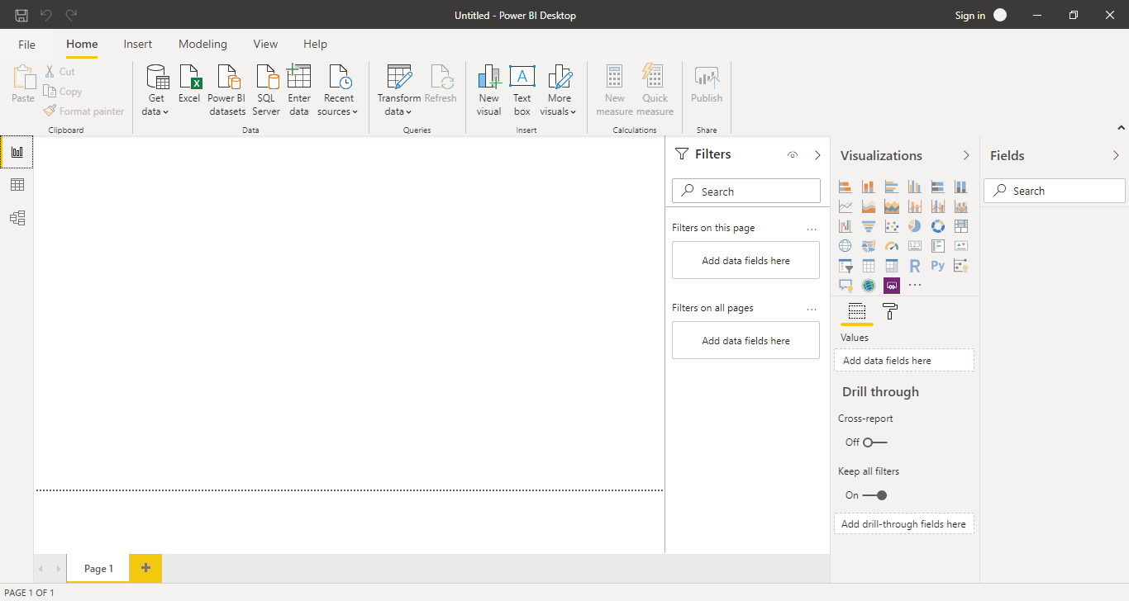

Data View: -

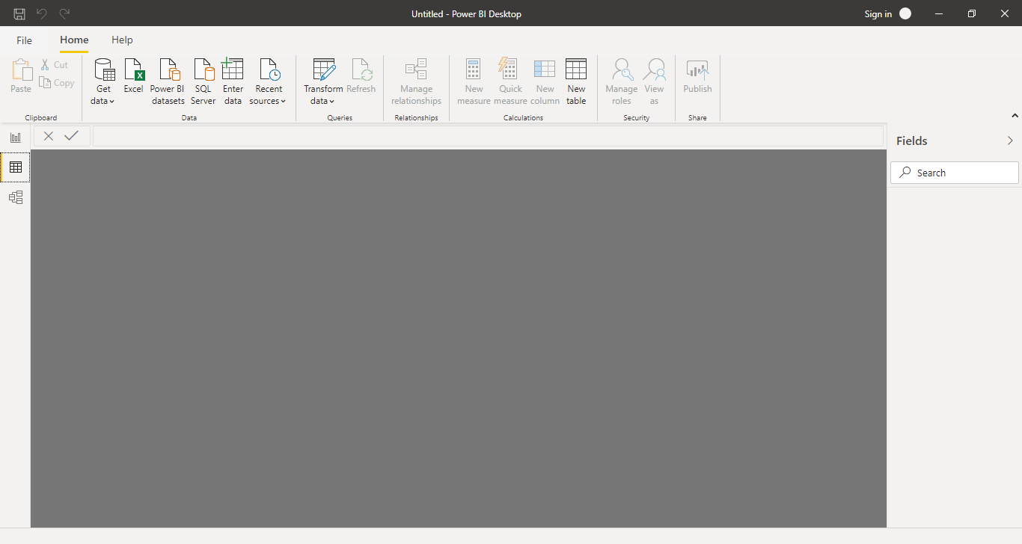

Model View: -

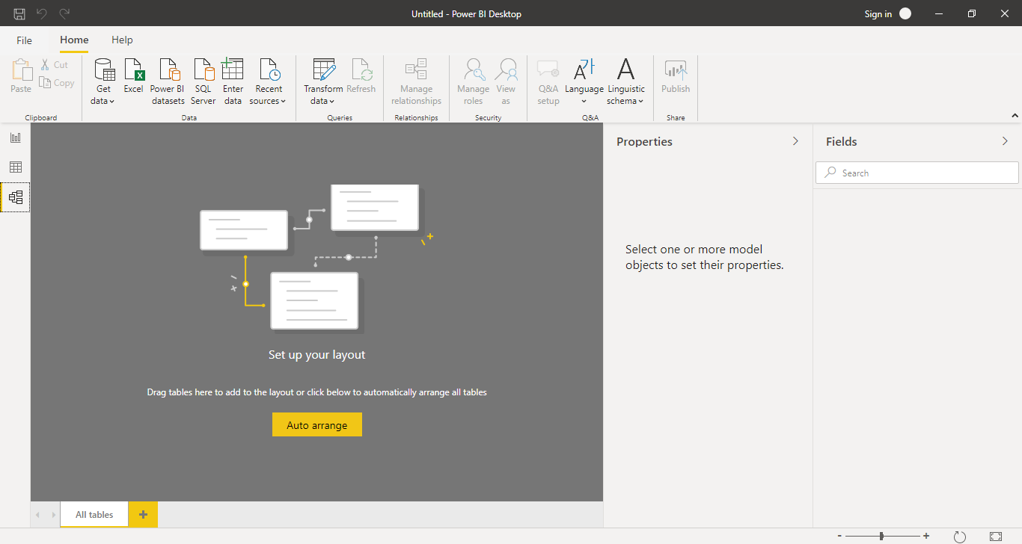

Power Query Editor: -

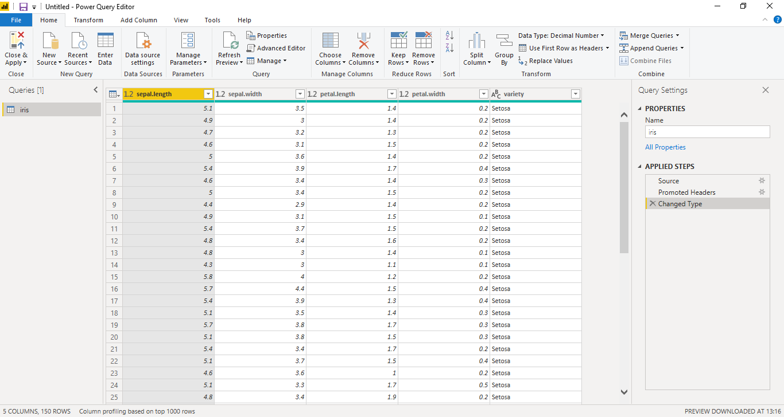

Advance Editor: -

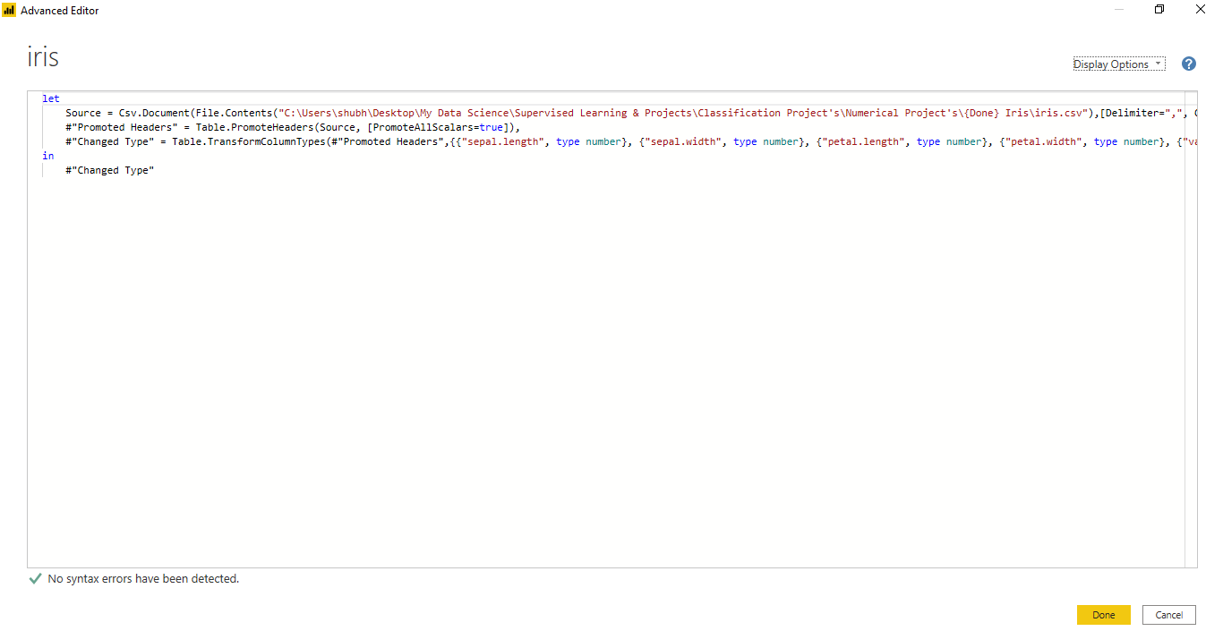

Task 2: - Prepare a document with details of the following along with their prices

Power BI Desktop

Power BI Pro

Power BI Premium

Power BI Desktop: -
Power BI Desktop is a free application you install on your local computer that lets you connect to, transform, and visualize your data. With Power BI Desktop, you can connect to multiple different sources of data, and combine them into a data model. This data model lets you build visuals, and collections of visuals you can share as reports, with other people inside your organization. Most users who work on business intelligence projects use Power BI Desktop to create reports, and then use the Power BI service to share their reports with others.
Benefits of Power BI Desktop are as follows:
- You can connect and import data from over 70 cloud-based and on-premises sources
- The same rich visualisations and filters from Power BI Pro
- Auto-detect that finds and creates data relationships between tables and formats
- Export your reports to CSV, Microsoft Excel, Microsoft PowerPoint and PDF
- Python support
- Save, upload and publish your reports to the Web and the full Power BI service
- Storage limit of 10 GB per user
Limitations with Power BI Desktop:
- Can’t share created reports with non-Power BI Pro users
- No App Workspaces
- No API embedding
- No email subscriptions
- No peer-to-peer-sharing
- No support to analyse in Excel within Power BI Desktop
Price: - The Power BI Desktop level is free for individual users.
Power BI Pro: -
Power BI Pro is an individual user license that lets users read and interact with reports and dashboards that others have published to the Power BI service. Users with this license type can share content and collaborate with other Power BI Pro users. Only Power BI Pro users can publish or share content with other users or consume content that's created by others.
Benefits of Power BI Pro other than the benefits of Power BI Desktop:
- Ability to embed Power BI visuals into apps (Power Apps, SharePoint, Teams, etc.)
- Native integration with other Microsoft solutions (Azure Data Services)
- Share datasets, dashboards and reports with other Power BI Pro users
- Can create App Workspaces and peer-to-peer sharing
Price: - The Power BI Pro level costs ₹660 per month per user.
Power BI Premium: -
Power BI Premium consists of capacity in the Power BI service exclusively allocated to each organization. The capacity is supported by dedicated hardware fully managed by Microsoft. Organizations can choose to apply their dedicated capacity broadly, or allocate it to assigned workspaces based on the number of users, workload needs, or other factors—and scale up or down as requirements change.
Benefits of Power BI Premium other than the benefits of Power BI Pro & Desktop:
- Increased data capacity limits and maximum performance
- Access to one API surface
- Larger storage sizes for extended deployments
- Geo distribution, higher refresh rates, isolation, pin to memory, read-only replicas
- Power BI Report Server
Price: - The Power BI Premium level costs ₹3,30,190 a month per dedicated cloud compute and storage resource with annual subscription.



