Logging COA Jobs & Client Review Rounds
Cethos staff guide - admin portal (portal.cethos.com/admin)
Use this to record a client's COA job and EVERY review/feedback round in the portal, so the full history is traceable (ISO 17100 / IQVIA). The portal is the system of record - email + ShareFile alone is not enough.
Part A - Create a job (Direct order)
For Welocalize / TransPerfect / RWS and other invoice-on-delivery (AR) clients.
1. Start a new order
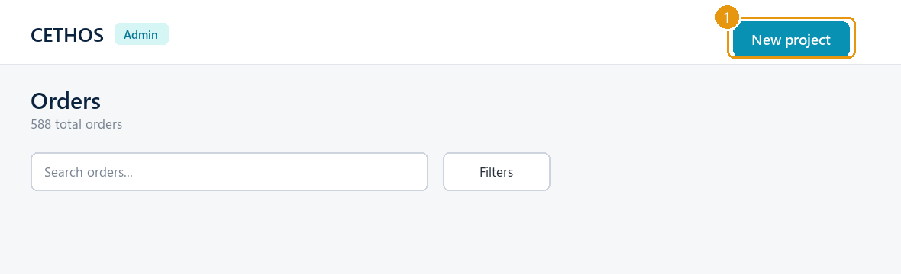
- Go to Orders (left menu), then click New project (top-right).
2. Choose Direct order, the client and the service
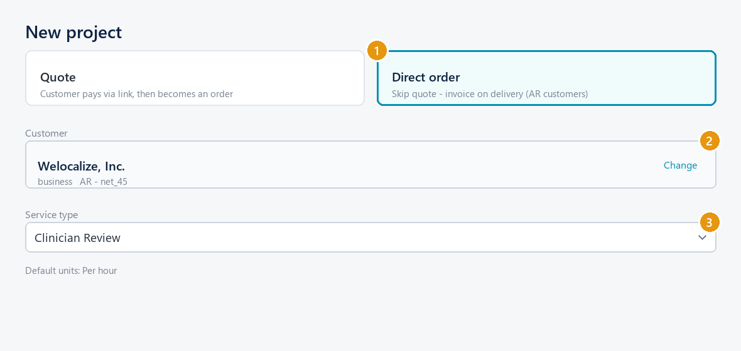
- Pick the Direct order card (skip quote - invoice on delivery).
- Search and select the customer, e.g. Welocalize, Inc.
- Set the Service type, e.g. Clinician Review.
3. Set the language pair, delivery date and workflow
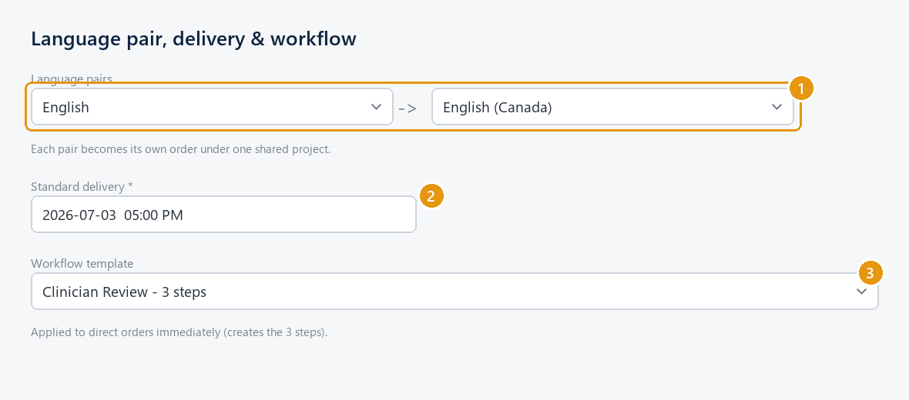
- Set Source and Target (e.g. English -> English (Canada)). Use + Add language pair for more - each pair becomes its own order.
- Set the Standard delivery date.
- Pick the Workflow template (e.g. Clinician Review - 3 steps) - this builds the steps automatically.
4. Fill the admin fields and create
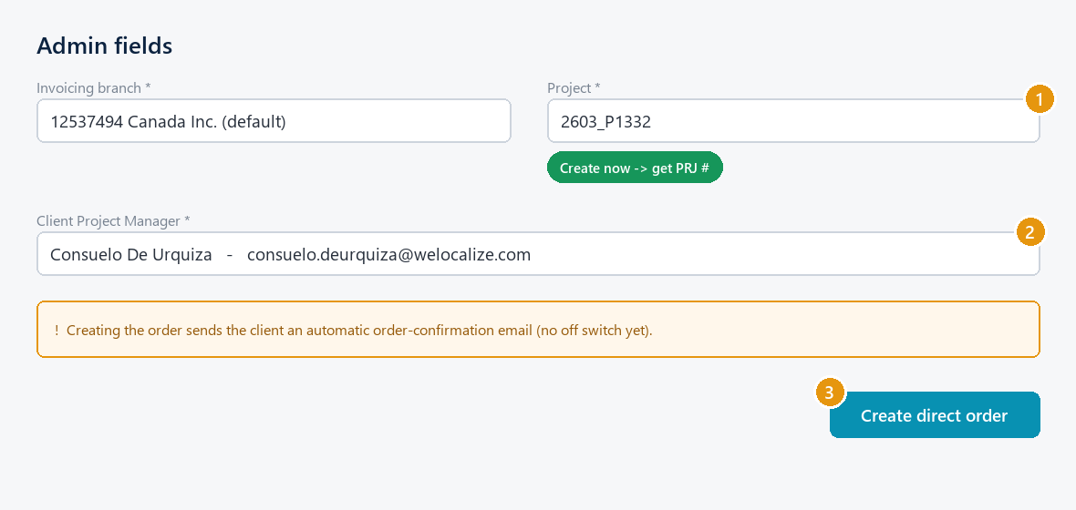
- Project: type the client's project code (e.g. 2603_P1332). If it's new, click Create now -> get PRJ #.
- Client Project Manager: search the client's directory and pick the PM (e.g. Consuelo De Urquiza), or + Add new project manager.
- Click Create direct order. (This emails the client a confirmation - check with your manager before back-entering jobs they didn't expect an email for.)
- After creating: set Order Status to In Production, and add the rate/PO on the Finance tab when you have them.

Part B - Log a client review / feedback round
Do this EVERY time the client emails feedback, a revision request, or a clinician feedback round (CLNFBR).
5. Open Client Communications and add the email
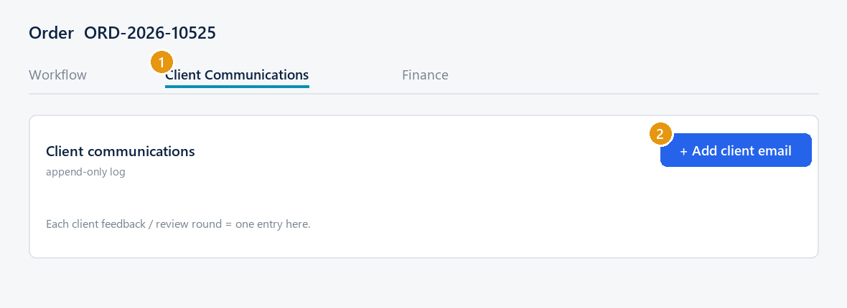
- On the order, open the Client Communications tab.
- Click + Add client email.
6. Paste the round and save
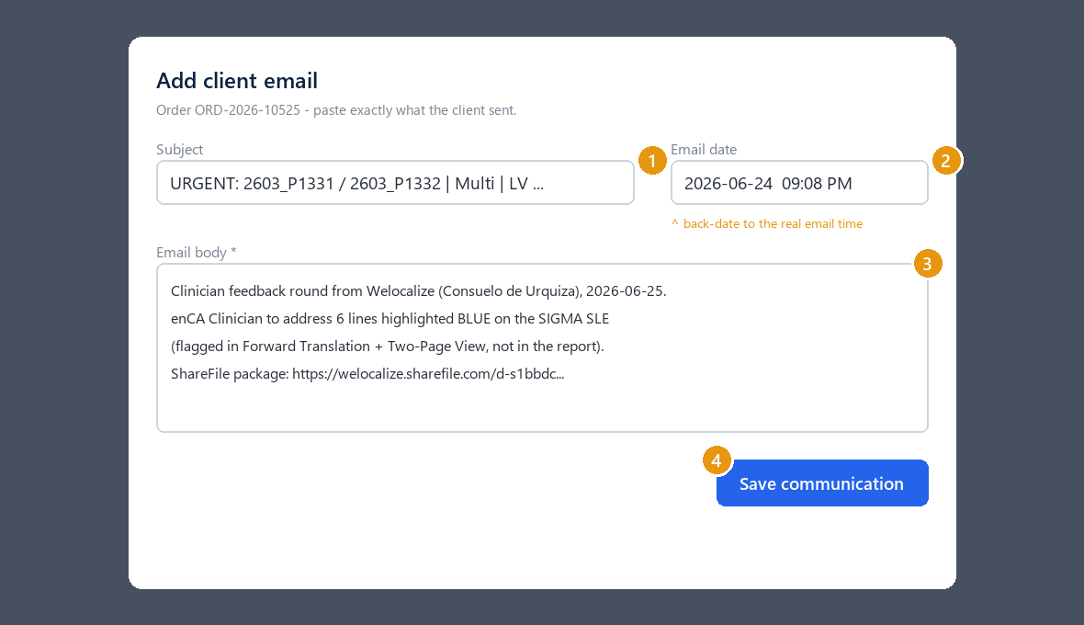
- Subject: the client email's subject line.
- Email date: back-date it to when the client actually sent it (not now).
- Email body: paste/summarise exactly what they asked - instrument, what to fix, how many lines/where, deadline, ShareFile link.
- Click Save communication. It joins the append-only log (cannot be deleted - that's intended, for audit).
Part C - Adding more review rounds
- Each new round = a NEW entry (repeat steps 5-6). Never overwrite the previous one - the log keeps every round in order, which is exactly what auditors want.
- Label each clearly (e.g. "Round 2 - remaining 3 lines").
- After a new round you can click Generate to refresh the vendor's job-instructions brief; approve it before the vendor sees it.
Remember
- Client Communications = logging what the client sent (no email goes out). The Messages panel (right side) actually emails the client - don't mix them up.
- Always back-date the email date so the timeline is accurate.
- One project (PRJ) per client project code; each language pair is its own order.

Cethos internal - generated 2026-06-25

