

SOP-019 — Qualification of Linguists for COA Linguistic Validation
Verification guide — confirm the SOP matches the live system (portal.cethos.com/admin)
Reviewer: Fayza El Bezzari · Version 1.0 · 26 June 2026 · Doc CTH-VRF-019
Use this guide to confirm that SOP-019 (Qualification of Linguists for COA Linguistic Validation) describes what the portal actually does, ahead of the IQVIA audit. Every step has a real screenshot of the live system — you only read and confirm.
Golden rule
Look only. You are confirming that the qualification requirements are published and that a real COA-qualified vendor shows the correct status on their QUALITY tab. If something doesn't match, write it in the Notes box.

What we already checked (validation summary)
Validated on the live portal. SOP-019 defines the five cumulative gates a linguist must meet before being assigned to any COA Linguistic Validation workflow: (1) role qualification with ISO §3.1.4 basis + Tier-2 verified evidence; (2) subject-matter qualification in Life Sciences / clinical area; (3) active NDA; (4) COA LV training on record; (5) competence assessed at ≥90% + graded sample translation. All five gates are enforced by the portal QMS assignment gate. Cross-references verified: §1 references SOP-003 (Vendor Qualification), §5 references SOP-014 (Data Security).
Confirmed on a real vendor record: a COA-qualified vendor shows a green COA Linguistic Validation Status panel on their QUALITY tab in the admin portal. Result: PASS.

SOP | SOP-019 — Qualification of Linguists for COA Linguistic Validation
Version / status | v3 active (effective 25 June 2026) — cross-references corrected: §1 SOP-003 (vendor qualification), §5 SOP-014 (data security)
Where | Portal → QUALITY → SOPs; and a vendor's QUALITY tab in Admin → Vendors
Owner | Acting Quality Manager / Managing Director
ISO / regulation | ISO 17100:2015 §3.1.4, §6.1; ISPOR COA Linguistic Validation guidelines; ICH GCP

Walkthrough — confirm it in the live system

1. Open SOP-019 and read the five qualification gates (§2)
- Log in to portal.cethos.com. Left menu QUALITY → SOPs, open SOP-019 — COA Linguistic Validation Qualification. Confirm it is active v3 (25 Jun 2026). Read §2 — five gates must ALL be met: (1) role qualification (ISO §3.1.4, Tier-2 evidence); (2) subject-matter qualification (Life Sciences or clinical sub-area); (3) active NDA; (4) COA LV training on record; (5) competence assessed (≥90% pass, graded sample). Also verify §1 cross-references SOP-003 and §5 references SOP-014.
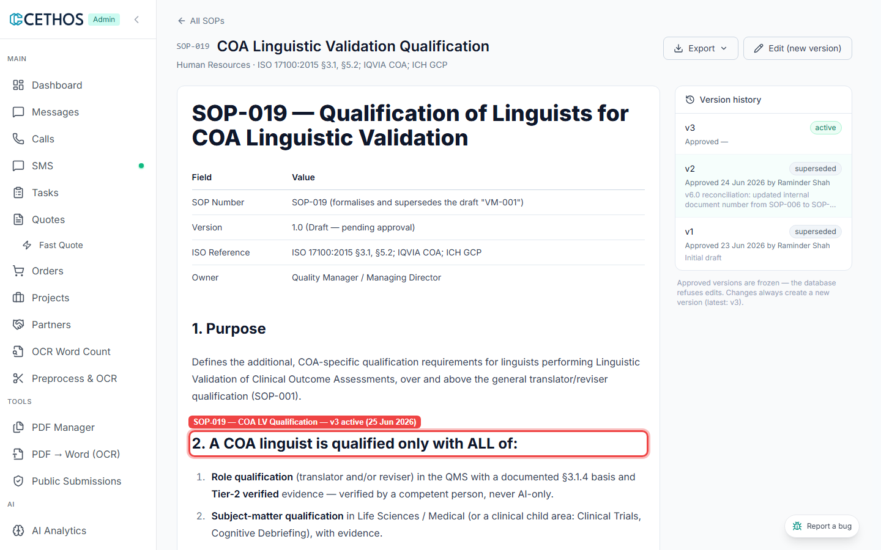
SOP-019 — COA LV Qualification — v3 active (25 Jun 2026)

2. Confirm a COA-qualified vendor shows the correct portal status
- In the admin portal, search for a COA-qualified vendor (e.g. from the IQVIA COA roster). Open their profile → QUALITY tab. Confirm the COA Linguistic Validation Status panel appears near the top: a green panel confirms an active COA-qualifying role or subject-matter qualification in the QMS. Amber = qualifications under review. Grey = none. The panel lists the qualifying qualification(s) and language pair.
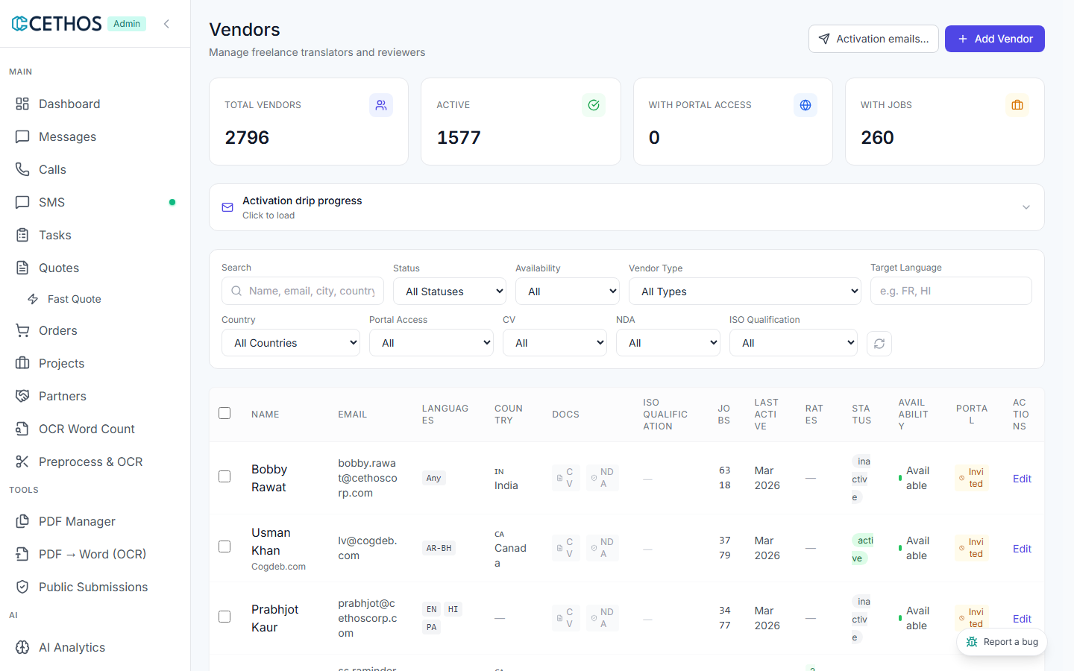
Vendor QUALITY tab — COA Linguistic Validation Status panel (green = fully qualified)

Your result
If everything matched, tick Matches. If anything was different or missing, tick Doesn't match and describe it — that's the most valuable part for Raminder.
Your result (tick one)
[ ] Matches — the SOP describes what I saw in the system.
[ ] Doesn't match — I found a difference (describe it below).
[ ] Refer to Raminder — I'm not sure / it's a technical point.
Notes (write anything that didn't match):
________________________________________________________________
________________________________________________________________
Reviewed by: ____________________ Date: ______________
Screenshots are the live admin portal as of June 2026. Cethos is ISO 17100-aligned (not certified).

