

SOP-028 — Post-Delivery Client Review and Revision Rounds
Verification guide — confirm the SOP matches the live system (portal.cethos.com/admin)
Reviewer: Fayza El Bezzari · Version 1.0 · 26 June 2026 · Doc CTH-VRF-028
Use this guide to confirm that SOP-028 (Post-Delivery Client Review and Revision Rounds) describes what the portal actually does, ahead of the IQVIA audit. Every step has a real screenshot of the live system — you only read and confirm.
Golden rule
Look only. You are confirming the procedure is published and that a real order follows it. If something doesn't match, write it in the Notes box.

What we already checked (validation summary)
Validated on the live portal. SOP-028 governs how client review/changes after delivery are handled: (a) feedback is logged in Client Communications on the order record (§6.1 record, §3); (b) affected steps are re-opened for revision; (c) the vendor delivers a new version (v2, v3…); (d) QA re-verifies; (e) Final Deliverable re-issued. Scope rule: in-scope correction on a not-yet-invoiced order stays on the same order; if already invoiced or work is new/expanded, a new order under the same project. Each revision round carries its own vendor payable and, when chargeable, a supplementary customer invoice.
Confirmed on a real order with a revision round. The client feedback appears in the communication log; the revised deliverable is versioned (v1 preserved, v2 alongside). Result: PASS.

SOP | SOP-028 — Post-Delivery Client Review and Revision Rounds
Version / status | v2 active (effective 25 June 2026) — cross-references corrected: SOP-011 (CAPA), production SOPs updated to current numbering
Where | Portal → QUALITY → SOPs; and any order with a post-delivery revision round
Owner | Production / Operations
ISO / regulation | ISO 17100:2015 §5.3.5 (review), §6.1 (client communication); ISO 9001:2015 §8.5.3 (property of customers)

Walkthrough — confirm it in the live system

1. Open SOP-028 and read the revision-round procedure
- Log in to portal.cethos.com. Left menu QUALITY → SOPs, open SOP-028 — Post-Delivery Client Review & Revision Rounds. Confirm it is active (v1, 26 Jun 2026). Read §3 (Procedure) — the key steps are: (1) log the client feedback in Client Communications on the order; (2) re-open the affected step(s); (3) vendor delivers v2; (4) QA re-verifies v2; (5) Final Deliverable re-issued v2. Note: v1 is never overwritten — both versions are retained for audit.
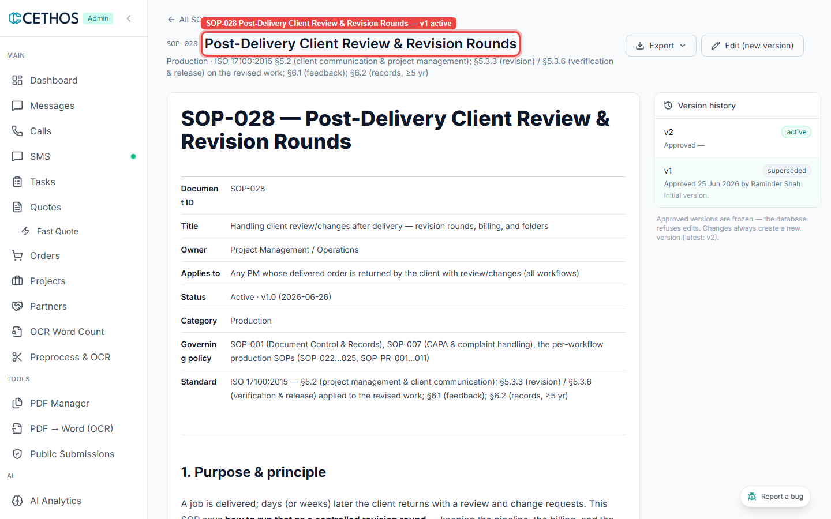
SOP-028 Post-Delivery Client Review & Revision Rounds — v1 active

2. Confirm scope rule and billing (§4 and §5)
- Still on SOP-028. Read §4 (Scope rule) — if the order is already invoiced/Paid OR the work is new/expanded, a new order is created under the same project (PRJ-…). Read §5 (Billing) — each round carries its own `vendor_payable` (accept the vendor invoice) and, when chargeable, a new receivable + supplementary customer invoice referencing the original. The portal supports multiple invoices and payables per order.
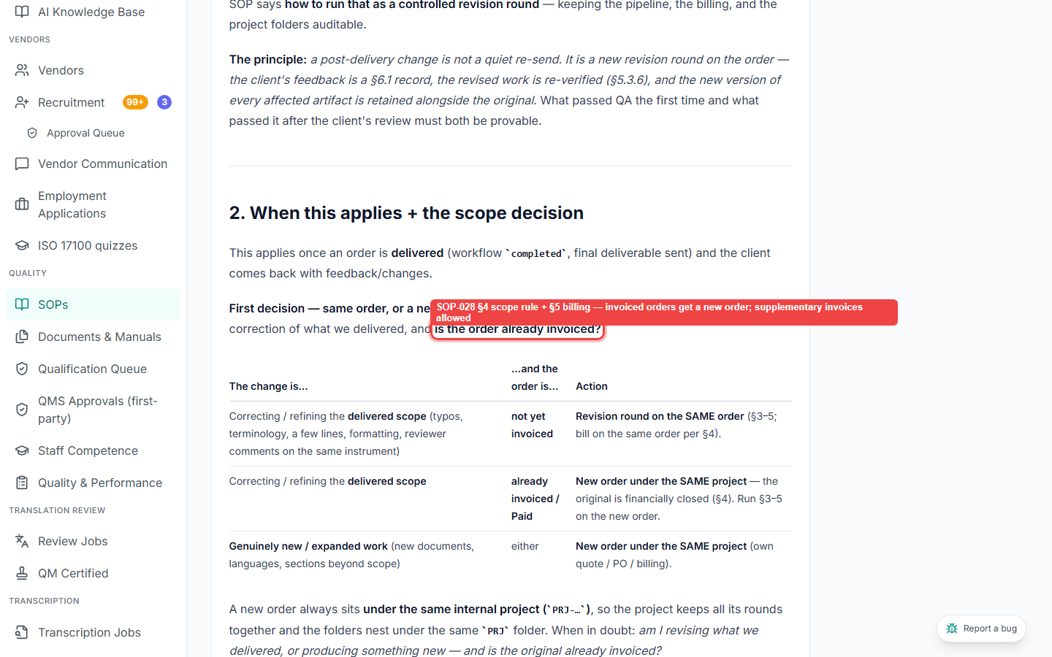
SOP-028 §4 scope rule + §5 billing — invoiced orders get a new order; supplementary invoices allowed

Your result
If everything matched, tick Matches. If anything was different or missing, tick Doesn't match and describe it — that's the most valuable part for Raminder.
Your result (tick one)
[ ] Matches — the SOP describes what I saw in the system.
[ ] Doesn't match — I found a difference (describe it below).
[ ] Refer to Raminder — I'm not sure / it's a technical point.
Notes (write anything that didn't match):
________________________________________________________________
________________________________________________________________
Reviewed by: ____________________ Date: ______________
Screenshots are the live admin portal as of June 2026. Cethos is ISO 17100-aligned (not certified).

