

SOP-001 — Document Control & Records Management
Verification guide — confirm the SOP matches the live system (portal.cethos.com/admin)
Reviewer: Fayza El Bezzari · Version 1.0 · 25 June 2026 · Doc CTH-VRF-001
Use this guide to confirm that SOP-001 (Document Control & Records Management) describes what the portal actually does, ahead of the IQVIA audit. Every step below already has a real screenshot of the live system — you only read, click along, and confirm. It takes about 5 minutes.
Golden rule
Don't change anything — you are only checking. The screenshots are already taken for you, so you never need to capture your own. If something doesn't match, write it in the Notes box at the end; don't try to fix it.

What we already checked and fixed (validation summary)
This SOP was validated end-to-end on the live portal. The document-control controls it describes all work: numbered, versioned documents; a control block with approval signatures; approved versions frozen by the database; audience-based publishing; and append-only, tamper-evident records.
Two issues were found during validation and have already been fixed and re-checked:
1) Older SOP versions were still labelled “active” instead of “superseded” (10 SOPs) — corrected, so the previous version now reads superseded.
2) Approved records had no delete-protection — a database guard was added so a recorded version can no longer be deleted.
Result: PASS — the system now matches the SOP. Your walkthrough below will show the corrected behaviour.

SOP | SOP-001 — Document Control & Records Management
Version / status | v1.0 — active (effective 24 June 2026)
Where | Portal → QUALITY → SOPs (and Documents & Manuals)
Owner | Acting Quality Manager
ISO / regulation | ISO 9001 §7.5; ISO 17100 §4.2; 21 CFR Part 11

Part 1 — Read what SOP-001 says

1. Open the SOPs registry
- Log in to portal.cethos.com with your own account. In the left menu, scroll to the QUALITY section and click SOPs.
- You'll see every Standard Operating Procedure, grouped by department, each with a version, ISO reference, status and effective date.
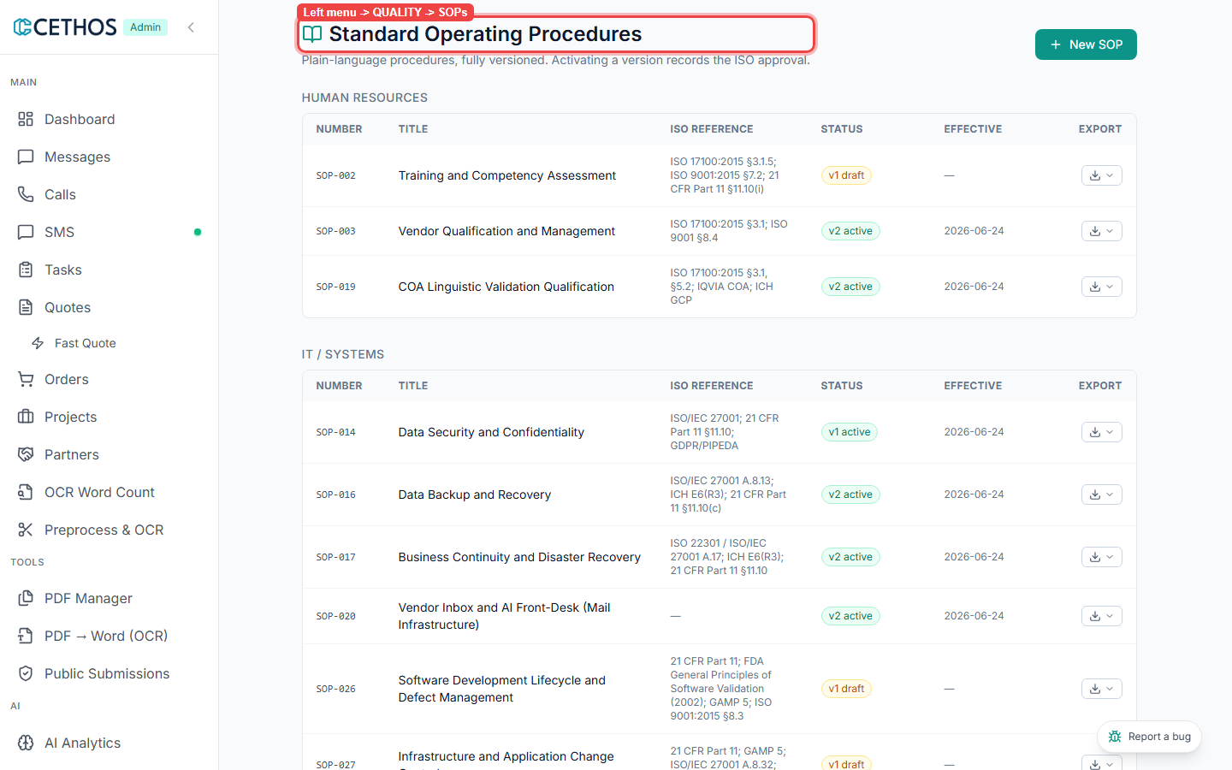
Left menu → QUALITY → SOPs — the Standard Operating Procedures registry.

2. Find SOP-001 — Document Control & Records Management
- Scroll to the QUALITY ASSURANCE group. Find SOP-001 — Document Control and Records Management.
- Confirm it shows a version badge (v1 active) and an effective date (June 24, 2026).
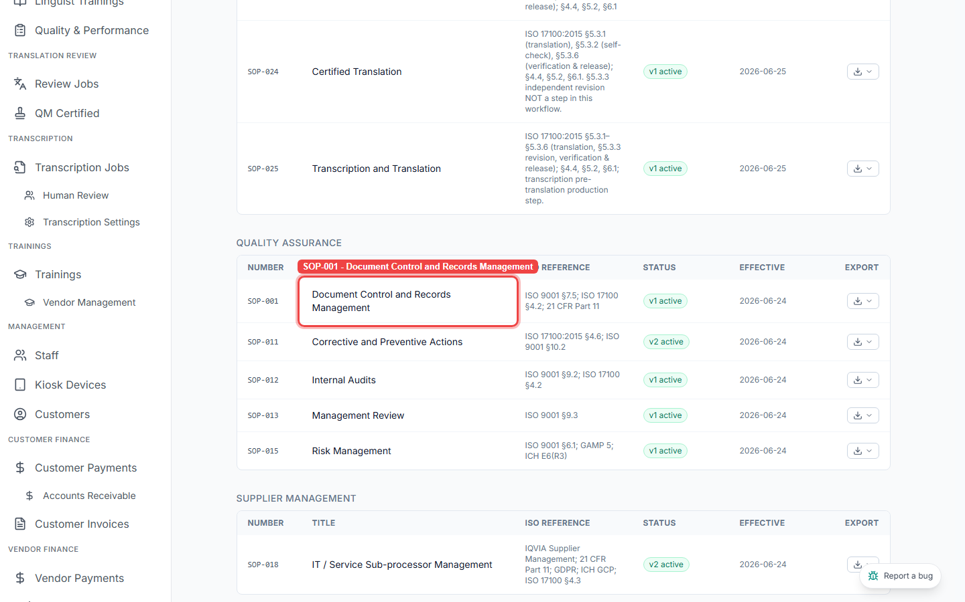
The Quality Assurance group — SOP-001, v1 active.

3. Open it and read the control block
- Click the row to open the SOP. At the top is its control block — document number, version, effective date, owner, and the Prepared / Reviewed / Approved signatures.
- On the right, the Version history panel says “Approved versions are frozen — the database refuses edits.” That is document control working — an approved procedure can't be quietly changed.
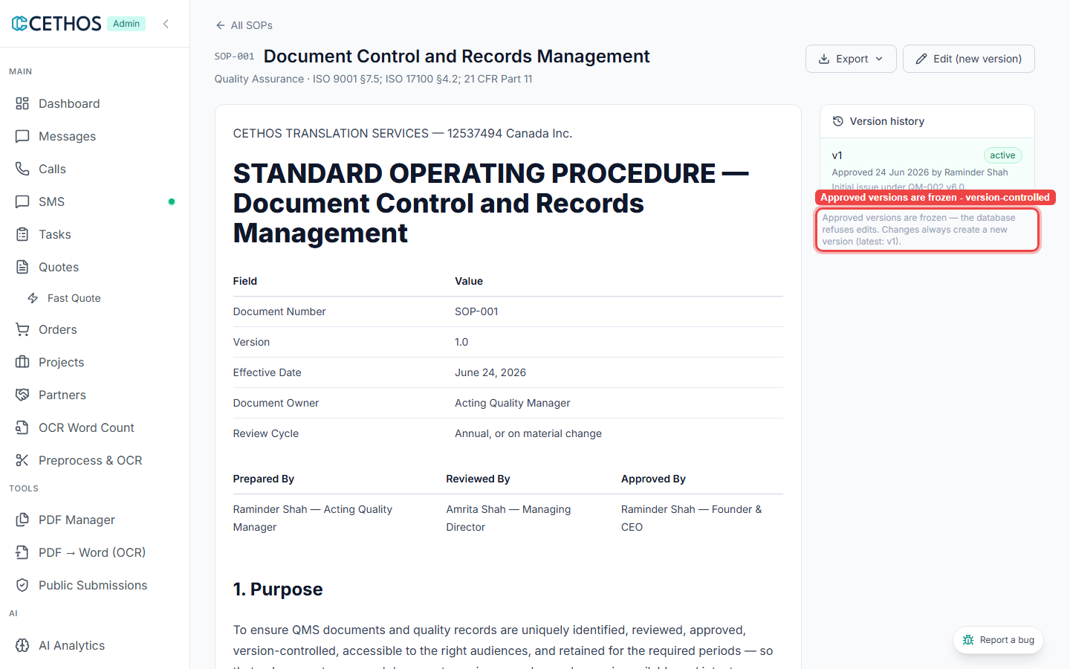
SOP-001 open — control block (number, version, signatures) and the frozen, version-controlled record.

Part 2 — See the controls working
Now confirm the document-control behaviours the SOP describes are real in the system.

4. Controlled export
- On the SOP, click Export. Confirm the controlled output formats — Word (.docx) and PDF. (You don't need to download anything.)
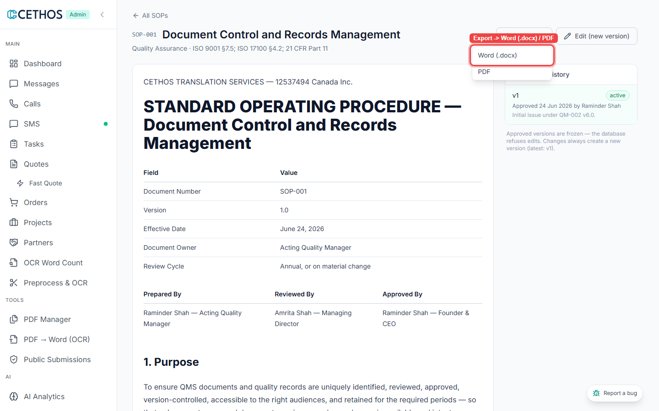
Export → Word (.docx) / PDF — controlled distribution of the approved document.

5. A change always makes a NEW version
- Click Edit (new version). An editor opens with a “What changed and why” box and a Save draft button — a change creates a new version, it never edits the approved one. Click Cancel — don't save.
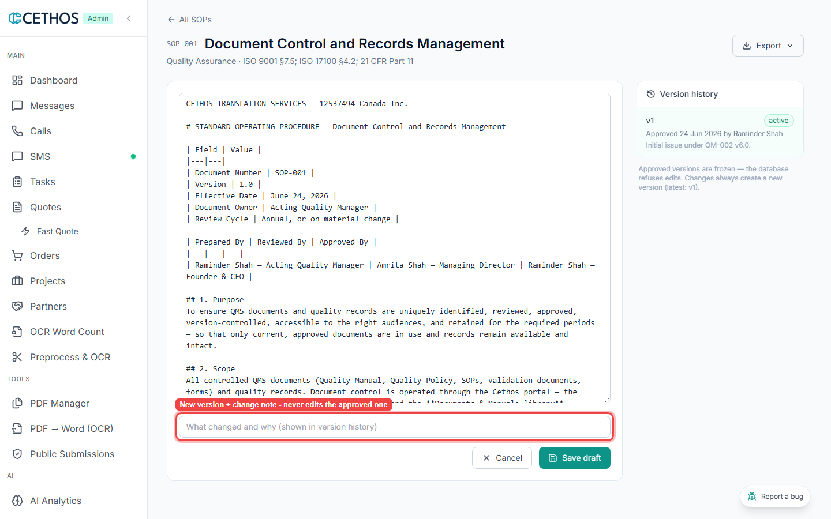
Editing opens a new draft version with a change note — the approved version stays frozen.

6. Old versions are clearly marked superseded
- Go back to All SOPs and open SOP-011 — Corrective and Preventive Actions (it has a version 2).
- In the Version history panel, confirm v2 active (green) and v1 superseded (grey). Only the current approved version is in use; older ones are kept but clearly marked.
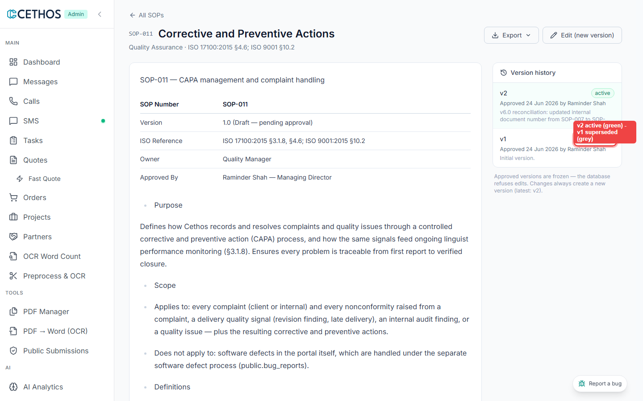
SOP-011 — v2 active (green), v1 superseded (grey). This is the corrected behaviour.

7. The Documents & Manuals library
- Back in the left menu under QUALITY, click Documents & Manuals — the controlled library where manuals, policies and records live, each tagged with an audience and Published.
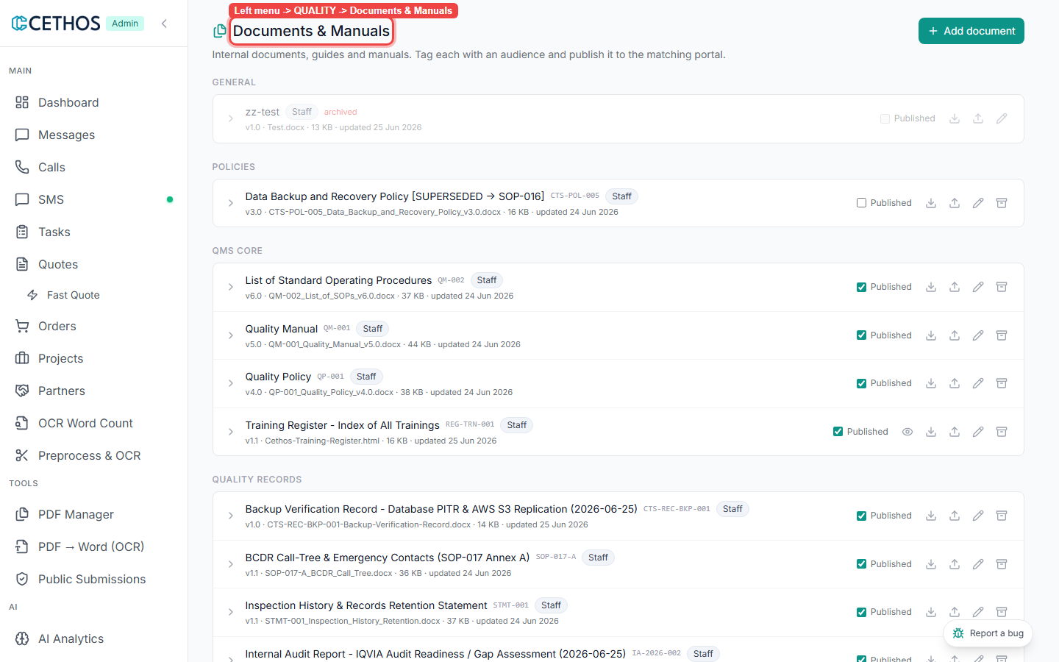
Documents & Manuals — the controlled library (audience + Published per item).

8. Superseded documents are withdrawn and marked
- Scroll to the POLICIES group. The old backup policy is titled [SUPERSEDED → SOP-016] and is not published — obsolete documents are kept for history but clearly marked and withdrawn from use.
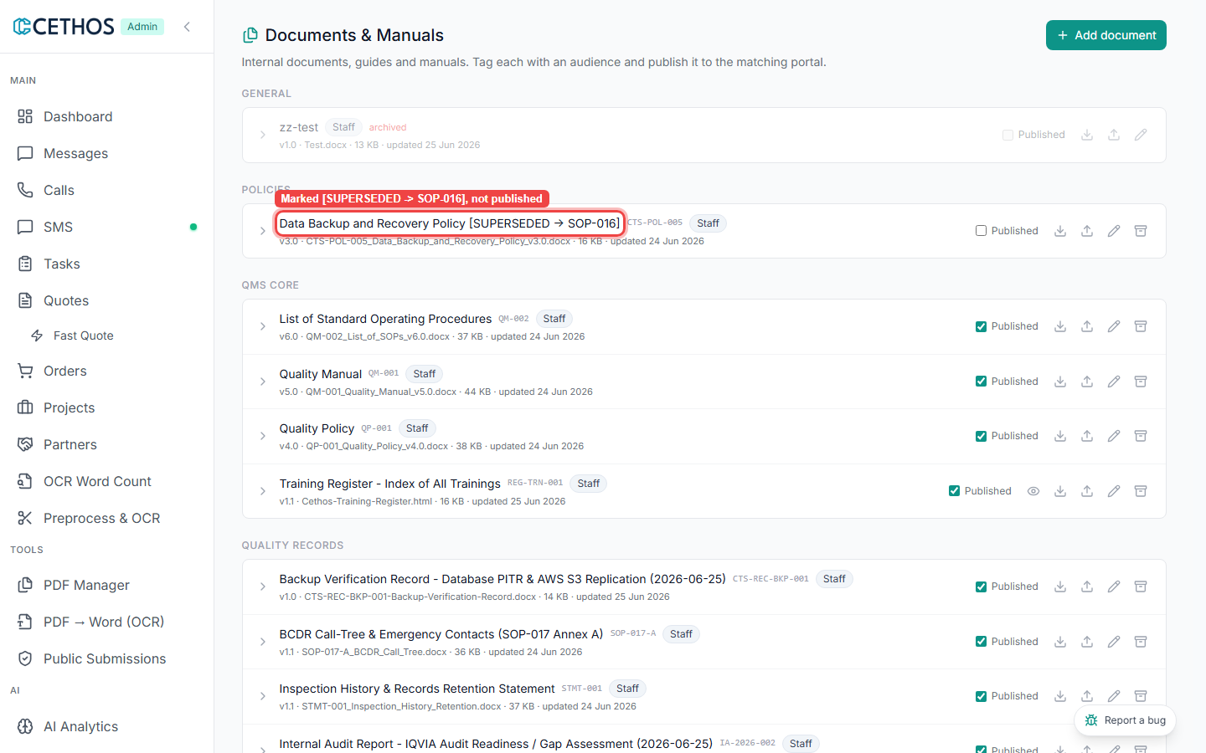
Policies — old document marked [SUPERSEDED → SOP-016] and unpublished.

9. New procedures start as a draft
- Back on SOPs, click New SOP. Notice there is no box to type a number — the system assigns SOP-### automatically. A new procedure starts as a draft and only becomes official once approved and activated. Click Cancel — don't create one.
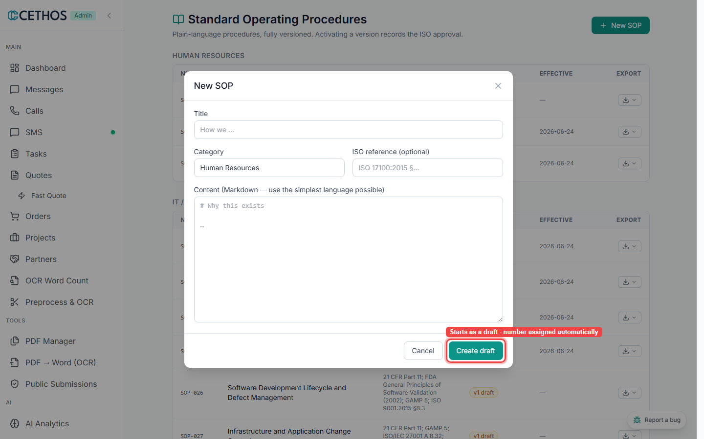
New SOP — starts as a draft; the number is assigned automatically.

Your result
If everything above matched what you saw, tick Matches. If anything was different or missing, tick Doesn't match and describe it — that's the most valuable part for Raminder.
Your result (tick one)
[ ] Matches — the SOP describes what I saw in the system.
[ ] Doesn't match — I found a difference (describe it below).
[ ] Refer to Raminder — I'm not sure / it's a technical point.
Notes (most useful part — write anything that didn't match):
________________________________________________________________
________________________________________________________________
Reviewed by: ____________________ Date: ______________
Screenshots are the live admin portal as of 25 June 2026. Cethos is ISO 17100-aligned (not certified).

