Exploring the Relationship Between Racial Demographics and Unemployment Rates

Introduction
Across the span of time, racism and prejudice have played large parts in the American experience for people of color in the United States. This bias negatively influences many facets of society and everyday life including that of the perceived working habits for many non-white individuals. One of these biases manifest as the damaging narrative that non-white individuals are less willing to participate in the workforce and are more likely to rely on government and community welfare programs, such as unemployment benefits. This narrative also pushes the agenda that if any certain area is higher in diversity, it is more likely that there are more cases of unemployment benefits being used. This stereotype is harmful as it ignores the institutional barriers and underlying bias surrounding the workplace and unemployment data (Economic Policy Institute).
In this lab report, we will be discussing whether such a relationship exists between rates of non-white residents and unemployment rates. This relationship will be viewed through the containers of US census divisions to paint a clearer picture across the country. The data being used in this lab and analysis comes from the Bureau of Economic Analysis (BEA) and contains the 1990 census date.
Research Question: Is there any relationship inferring those areas with higher percentages of non-white residents and areas with high unemployment rates?
Null Hypothesis: There is no relationship between the rates of non-white residents and unemployment rates across the US census divisions.
Alternate Hypothesis: There is a relationship between the rates of non-white residents and unemployment rates across the US census divisions.
The methods used in this analysis include the following:
- Descriptive statistics: Stacked Bar Graph and Box Chart
- Correlation
- Regression

Descriptive Statistics
In order to best understand the data prior to conducting higher level analysis, descriptive statistic methods are used; namely by creating visualizations of the data outlook.
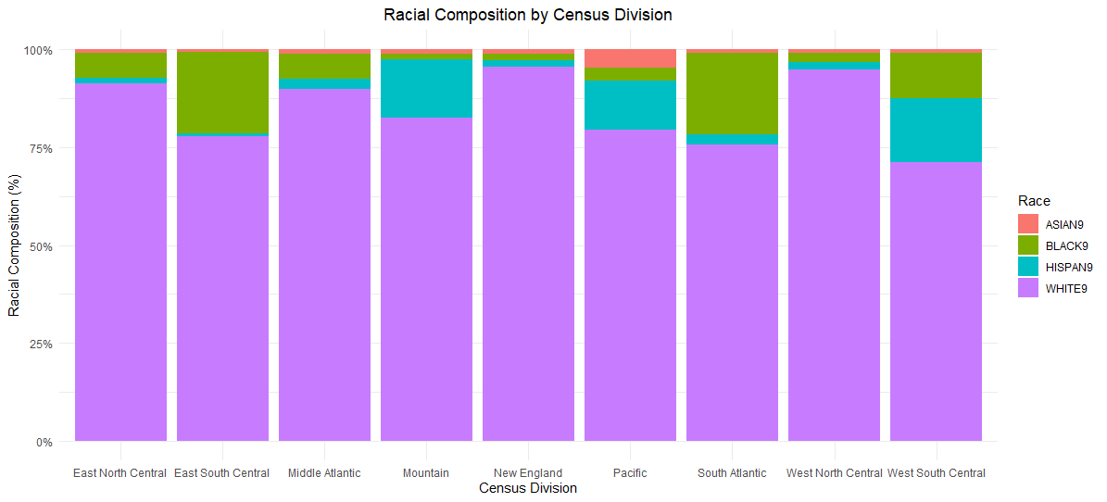
Figure 1: Racial Compositions of US Census Areas
In Figure 1, the racial compositions of the US Census Areas are shown as stacked bar graphs. The data populating this chart was transformed through normalization in order to be presented in like scales. Although this report is focused on the relationship for non-white residents, White residents were left on this visualization to accurately display the composition data. From the graph, it is noticed that there are three census areas with higher compositions of non-white residents: East South Central, South Atlantic, and West South Central.

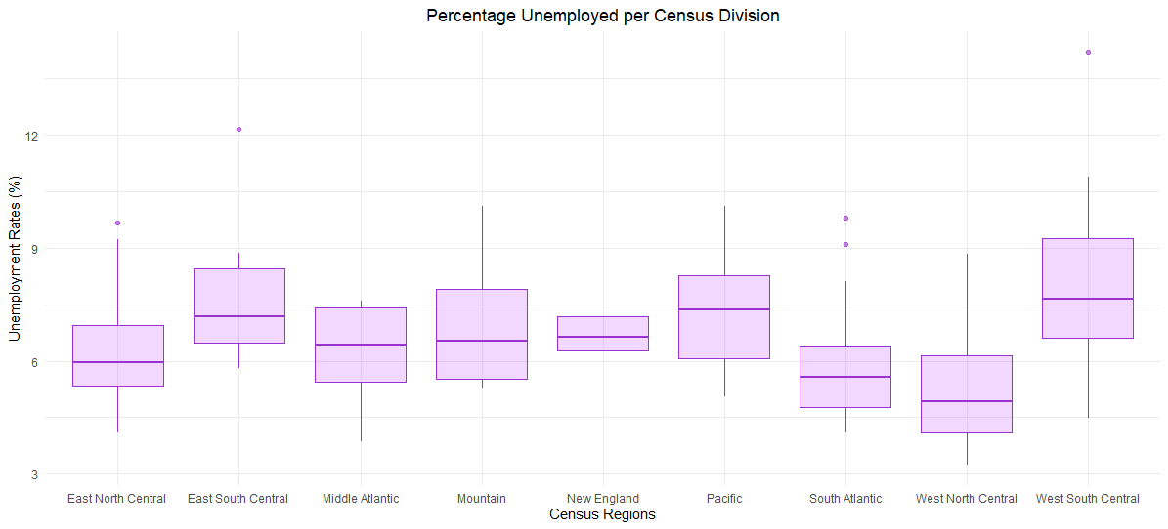
Figure 2: Unemployment by US Census Division
Figure 2 is a box-and-whisker graph showing the rates of unemployment per US census division. In this visualization, the boxes higher up on the y-axis have higher medians of unemployment. From this graph, the census areas with higher rates of unemployment include East South Central, the Pacific, and West South Central. Recalling back to the first graph of racial demographic, these three noted census divisions do not mirror across the two variables. This is our first clue in answering our research question.

Correlation
Pearson’s Correlation test was performed on the datasets to calculate potential linear correlation between unemployment rates and increased prevalence of non-white residents in census divisions. The means for both variables were calculated per division and used as inputs for this test. The output is given below:
t Value | Degrees of Freedom | p-value | 95% Confidence Interval | Pearson’s Correlation (r)
1.5537 | 7 | 0.1642 | (-0.237, 0.876) | 0.5064

This correlation test relates crucial information about the relationship between the selected variables. The p-value of 0.1642 is of note as this value is far larger than the standard alpha or significance level of 0.05, as a result of which we fail to reject the null hypothesis, meaning that any perceived relationship between unemployment levels and non-white resident levels are not statistically significant. Furthermore, the key statistics of the Pearson’s Correlation test (r) is calculated to be 0.5064. Knowing that coefficients of correlation range between – 1 and 1, this value is only moderately strong and fails to meet the general threshold of 0.8 at where the correlation would be considered strong and significant. Since correlation is concerned with determining the strength and direction of the relationship of two variables, this value tells us there is only slight and statistically insignificant strength and direction present here.
This low value for r also conveys that although some correlation exists it is not enough to claim that one variable has influence on the other i.e. that there is low predictive power of the model.

Regression
The final statistical method employed in this analysis was regression or calculating linear regression. The means of the two variables were used in this test. The output is given below:
 | Estimate | Standard Error | t Value | p-value
Intercept | 5.7628 | 0.6351 | 9.075 | 4.04E-05
Slope | 0.0625 | 0.0402 | 1.554 | 0.164

Regression line formula: y = 5.7628 + 0.0625x
Residual Standard Error: 0.8452 on 7 Degrees of Freedom
R²: 0.2564 α
F_{α, 1, 7}: 2.424
This linear regression offers more information conveying similar inferences to that observed with Pearson’s Correlation for our analysis. The key statistic from this model is the R² value which was calculated as 0.2564. The R² value denotes the effectiveness of the independent variable, here being racial composition, on effecting the dependent variable or here, unemployment rates. This value falls close to 0, indicating there is little effect between the two variables and that the independent variable should not be used as a predictor for the dependent variable.
This notion is further supported by the p-value of 0.164, which similar to in the case of correlation, and is not statistically significant when compared to the standard significance level of 0.05. Additionally, the Residual Standard Error or RSE is very high at 0.8452, meaning that 84.5% of the data values deviated from the regression line of best fit; further supporting the notion of failing to reject the null hypothesis.

Conclusion
In conclusion, through the analysis done via the chosen statistical methods, we can assertively fail to reject the null hypothesis. In the context of the research question, this means that there is not a statistically significant relationship between higher percentages of non-white individuals and unemployment rates across the US census divisions.
However, it is important to acknowledge that the methods used- in particular, correlation and regression- showed non-zero values for the relationship of the variables. By failing to reject the null, we do not subsequently claim there is no relationship; it pertains more to the idea that the variables in question are not adequate to explain one another.
So why might this relationship be occurring otherwise? As mentioned in the introduction, forces such as systematic barriers and socioeconomic bias are inherently tied to the successes and failures of marginalized groups in the US. Access to resources such as education and capital combined with racial bias are just some examples that can come into play for non-white groups in the US which have the power to affect income, industry, and employment (Pew Research). This analysis is just one step towards addressing this issue and with further data conclusion and testing, clearer insights may be procured in the future.

References
Bureau of Economic Analysis (BEA). Link: https://www.bea.gov/data
Economic Policy Institute, “Racial representation in professional occupations”. Link: https://www.epi.org/publication/racial-representation-prof-occ/
Pew Research Center, “Black workers’ views and experiences in the U.S. labor force stand out in key ways”. Link: https://www.pewresearch.org/short-reads/2023/08/31/black-workers-views-and-experiences-in-the-us-labor-force-stand-out-in-key-ways/

