|  |
| --- |
|  |
| Advanced Encryption Standard Implementation |
| For 128, 192 and 256 bits |
| **Course ID:** MSCS 630  **Course Name:** Security Algorithms and Protocols  **Professor:** Pablo Rivas-Perea |
| **Author: Sandeep Reddy Salla, Himaja Kethiri** |
| **Submitted Date:** May 2, 2016 |
|  |

|  |
| --- |
|  |

Contents

1. Introduction 2

2. Program Interface 2

Running the program from the command prompt 2

3. Screenshots 2

4. Input and Output 3

Format of Input and Output 3

Example 3

5. Program Structure 4

Encryption 4

Decryption 5

Working of Driver file 5

6. Improvements and Extensions 6

7. Conclusion 6

8. References 6

9. Appendices 6

# 1. Introduction

Advanced Encryption Standard (AES) is a symmetric block cipher that can process the 128bit data using key length of 128,192 and 256 bits. This document describes the encryption and decryption process of AES. In the encryption process 128-bit block cipher is encrypted using a key length of 128bits.In the standard, the encryption algorithm is referred to as the cipher and the decryption algorithm as the inverse cipher.

# 2. Program Interface

The main goal of this program is to provide an encryption and decryption operation. This program accepts input from the console or from the input file.

## Running the program from the command prompt

* Compile the java program from the command prompt. Command for compilation is
  + - javac Driver.java
* Once the compilation is successful, give an input file consisting of plaintext and the key.
* Command for accepting input file is
  + - java Driver < *inputfilename*
* Output with cipher text and the plain text is displayed (fig 1).

# 3. Screenshots

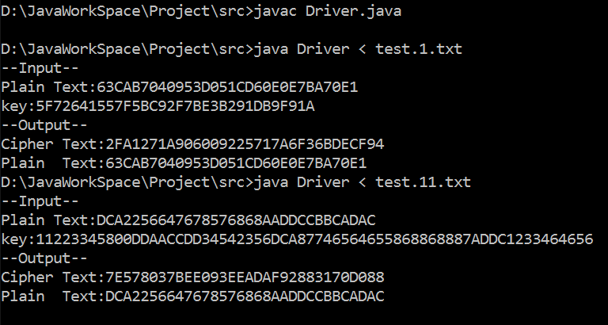

***Fig 1: running the program from command prompt***

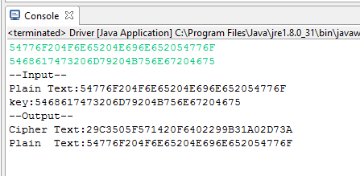

***Fig 2: running the program from console***

# 4. Input and Output

## Format of Input and Output

* For 128-bit AES encryption and decryption, the length of the hexadecimal plaintext, ciphertext and the length of the key must be equal to 32bits.
* For 192-bit AES encryption and decryption, the length of the hexadecimal plaintext, ciphertext must be equal to 32 bits and the length of the key must be equal to 48 bits.
* For 256-bit AES encryption and decryption, the length of the hexadecimal plaintext, ciphertext must be equal to 32 bits and the length of the key must be equal to 60 bits.

One can also read input from input files and can redirect to the output file. For performing encryption operation, provide the inputs like selecting an option, plaintext and the key.

## Example

In the example a, one performs the Encryption Operation by providing plaintext and key to get the ciphertext as output.

1. Encryption operation

**Input:** 63CAB7040953D051CD60E0E7BA70E18C (Plain Text)

5F72641557F5BC92F7BE3B291DB9F91A (Key)

**Output**: A52D12429C45282D4DF3682363713FEB (Cipher Text)

In the example b, one performs the Decryption Operation by providing ciphertext and key to get the original plain text as output.

1. Decryption Operation

**Input**: A52D12429C45282D4DF3682363713FEB (Cipher Text)

5F72641557F5BC92F7BE3B291DB9F91A (Key)

**Output**: 63CAB7040953D051CD60E0E7BA70E18C (Plain Text)

# 5. Program Structure

## Encryption

**AESEncrypt.java**

In the encryption process different methods are used to encrypt the data.

1. aesRoundKeys()
2. aesNibbleSub()
3. aesShiftrows()
4. aesRcon()
5. aesSbox()
6. computeXOR()
7. getWmatrix()
8. aesMixColumns()
9. aes()

aesRoundKeys() will take input as the plaintext which is the 4*4 matrix and it will split the string for every 2 bytes and stores in the matrix format.

aesNibbleSub() will take input from the aesRoundKeys() and it will substitute the values with the corresponding values from the S-BOX lookup table.

aesShiftrows() will take input from the aesRoundKeys() and perform the left shift operation .

aesRcon() calculates the round value. The value corresponding to the round will fetched from the R-CON lookup table. It will be used to generate 4*44 matrix.

aesSbox()- will take input as the hexadecimal and convert the values into integer and send as the input to the S_BOX to fetch the values.

getWmatrix() will be used to generate the 4*44 matrix. This 4*44 matrix will be generated based on some conditions. WMatrix [][] is the 4*44 matrix that can be generated using previous column.

1. If the column (j) value in WMatrix [j] is not a multiple of 4. Then XOR the values based on below equation.

W[j] =W [j-4] ^ W [j-1]

1. If the value of the column(j) is multiple of 4.Then
2. Perform the transpose of the column matrix and store it in temporary column matrix.
3. Then perform the left shift operation on newly generated matrix
4. Transform the each byte of the matrix using S-BOX
5. Perform the XOR operation using corresponding round constant(Rcon(i)) that calculated using aesRcon() method
6. Finally calculate the W[j] using,

W[j] = W [j-4] ^ WNEW

Similar logic is used for WMatrix for 192 and 256-bits but with the change of column values.

computeXOR() it will XOR the bytes . It can be used in getWmatrix () method to compute the XOR of the new matrix with rcon (value fetched from the lookup table) value.

aesMixColumns() In this method Mul2, Mul3 look-up tables are used that are introduced by Rijndael. It also makes use of Hash maps to map the values to the lookup tables. These lookup tables are having constant values that can be used to XOR the values.

aes() - In this method stateXOR(), NibbleSub(), ShiftRows() and MixColumns() are performed based on the round. For the last round MixColumns () will not be used. In this method cipher text will be produced.

## Decryption

**AESDecrypt.java**

Decryption process provides the input as cipher text that produced in encryption. The key is used to decrypt it. The main goal of decryption is to reproduce the plain text using both the cipher text and key.

This uses the following method:

1. MatrixSelection()
2. aesRoundKeys()
3. InvNibbleSub()
4. InvShiftrows()
5. aesRcon()
6. aesSbox()
7. computeXOR()
8. getWmatrix()
9. InvMixColumns()
10. InvAes()

MatrixSelection()-This method facilitates to select the length of the key and the matrix should be selected based on the value provided in the column Size variable. The number of rounds are based on the key length 128, 192, and 256-bits.

aesRoundKeys()-This method takes 4*4 key matrix as input and splits it for every 2 sub bytes. In this input is provided in the form of string matrix.

InvNibbleSub ()-This method takes input from aesRoundKeys and fetches the corresponding values from INV_SBOX and substitutes it.

InvShiftrows() - This method performs Right shift on the key matrix and stores it in to the input matrix.

aesRcon() -This method calculates the round value and based on the round it fetches rcon (round constant) corresponding round value from the R_CON table which will be used in the getWmatrix() to generate the 4*44 matrix.

aesSbox()- This method fetches the corresponding S-Box value from the lookup table. Before that it converts the hexadecimal value in to integer.

computeXOR ()- This method will take as two hexadecimal values and performs XOR operation on those values. If the length of the value is 1 then it appends ‘0’ to it.

getWmatrix()- This method will take the input as 4*4 matrix and generates 4*44 based on the WMatrix[][] conditions that have been used in encryption getWmatrix(). Each time, the column value will be decremented. Every column can be calculated by using the previous column.

InvMixcolumn ()- This method takes input from InvShiftRows() and performs the mixcoulmns operations by using mul9,mul11, mul13, mul15 look-up tables. These values can be mapped or get from the lookup tables based on hash maps. The corresponding values get XORed with the values present in the input matrix.

InvAes ()-This method will take input matrix and performs a series of operations based on the round. For the first and last round it will perform all operations like (InvNibbleSub (), InvShiftrows, and except InvStateXOR () except InvMixcolumn (). All rounds remaining makes use of all operations. This method produces the plaintext.

## Working of Driver file

The driver file accepts input in two ways.

* Using standard input
* Using test cases (text file)

1. One gives the input using standard input that is using command prompt by entering the

Either plain or cipher text and key.

2. Using test cases (text file)-In this one gives the input using text file. The file should contain 2 lines i.e., plain text and the key (128, 192 and 256-bits) based on its length. The driver file will take the text file as input and produces the output on the console. If the length of the given input plain text is less than 32, then padding strategy is used to make its length to 32 bits followed by encryption and decryption operations are performed.

# 6. Improvements and Extensions

**Improvements:** Extension of encryption algorithm from 128-bit to 192 and 256-bits

Decryption algorithm for 128, 192, and 256-bits

**Padding Strategy:** Zero padding can be used to make the plaintext suitable to make it a 128-bit. But, zero padding is not reversible. It’s better not to use the zero padding strategy.

In this program, a simple padding technique has been used for the text that are not of suitable length.

1. First determine the length of the text plain text to find the number of bits needed to pad.
2. The number of bits (n) required and the length of the text should be multiple of 32 (128-bits).
3. Then the text will be padded n times with n values.

**Authentication Strategy:**

* SHA-3 will be the best authentication strategy to be used to avoid the unauthorized modifications to the messages when they transmit through the network.
* HMAC can be used. It provides authentication by hashing the message itself. At the end the output is hashed again with the key.

# 7. Conclusion

This document describes the extension of the key length 128 bit to 192 and 256-bits. These key lengths are used in both encryption and decryption. Based on the length of the key the round values will be increased. AES is an efficient algorithm which uses iterative approach unlike DES that uses fiestel cipher structure. The best authentication strategy we would like to suggest is SHA-3.It is used in many algorithms to provide authentication.

# 8. References

<http://csrc.nist.gov/publications/fips/fips197/fips-197.pdf>

<https://engineering.purdue.edu/kak/compsec/NewLectures/Lecture8.pdf>

<https://www.rivier.edu/journal/ROAJ-Fall-2010/J455-Selent-AES.pdf>

# 9. Appendices

**  **