test16

SASIWIPHA SRIKUEAKUN

2023-05-21

## 0.1 Step 2 from branch2 modify

This is an R Markdown document. Markdown is a simple formatting syntax for authoring HTML, PDF, and MS Word documents. For more details on using R Markdown see <http://rmarkdown.rstudio.com>.

When you click the **Knit** button a document will be generated that includes both content as well as the output of any embedded R code chunks within the document. You can embed an R code chunk like this:

summary(cars)

## speed dist   
## Min. : 4.0 Min. : 2.00   
## 1st Qu.:12.0 1st Qu.: 26.00   
## Median :15.0 Median : 36.00   
## Mean :15.4 Mean : 42.98   
## 3rd Qu.:19.0 3rd Qu.: 56.00   
## Max. :25.0 Max. :120.00

[ABS](https://www.abs.gov.au/census/find-census-data/geopackages?release=2016&geography=VIC&topic=ATSIP&type=ATSIP)

Question3 from main

library(ggplot2)  
mpg

## # A tibble: 234 × 11  
## manufacturer model displ year cyl trans drv cty hwy fl class  
## <chr> <chr> <dbl> <int> <int> <chr> <chr> <int> <int> <chr> <chr>  
## 1 audi a4 1.8 1999 4 auto… f 18 29 p comp…  
## 2 audi a4 1.8 1999 4 manu… f 21 29 p comp…  
## 3 audi a4 2 2008 4 manu… f 20 31 p comp…  
## 4 audi a4 2 2008 4 auto… f 21 30 p comp…  
## 5 audi a4 2.8 1999 6 auto… f 16 26 p comp…  
## 6 audi a4 2.8 1999 6 manu… f 18 26 p comp…  
## 7 audi a4 3.1 2008 6 auto… f 18 27 p comp…  
## 8 audi a4 quattro 1.8 1999 4 manu… 4 18 26 p comp…  
## 9 audi a4 quattro 1.8 1999 4 auto… 4 16 25 p comp…  
## 10 audi a4 quattro 2 2008 4 manu… 4 20 28 p comp…  
## # ℹ 224 more rows

summary(mpg)

## manufacturer model displ year   
## Length:234 Length:234 Min. :1.600 Min. :1999   
## Class :character Class :character 1st Qu.:2.400 1st Qu.:1999   
## Mode :character Mode :character Median :3.300 Median :2004   
## Mean :3.472 Mean :2004   
## 3rd Qu.:4.600 3rd Qu.:2008   
## Max. :7.000 Max. :2008   
## cyl trans drv cty   
## Min. :4.000 Length:234 Length:234 Min. : 9.00   
## 1st Qu.:4.000 Class :character Class :character 1st Qu.:14.00   
## Median :6.000 Mode :character Mode :character Median :17.00   
## Mean :5.889 Mean :16.86   
## 3rd Qu.:8.000 3rd Qu.:19.00   
## Max. :8.000 Max. :35.00   
## hwy fl class   
## Min. :12.00 Length:234 Length:234   
## 1st Qu.:18.00 Class :character Class :character   
## Median :24.00 Mode :character Mode :character   
## Mean :23.44   
## 3rd Qu.:27.00   
## Max. :44.00

library(kableExtra)  
library(knitr)

sue this graph 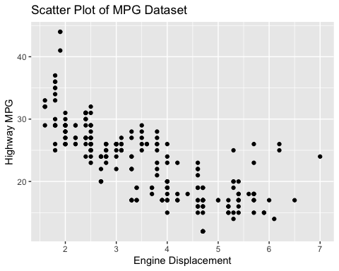 ## Figure ?? shows a scatter plot of the MPG dataset.